Contents

Master Screens 2

Savings Account 2

Credit Card Account 5

Investment Account 9

Payee List 12

Account Details Register 14

# Master Screens

## Savings Account

## Credit Card Account

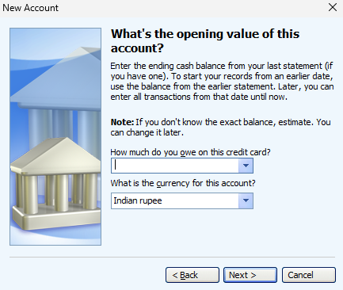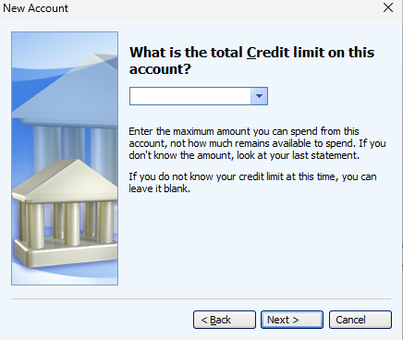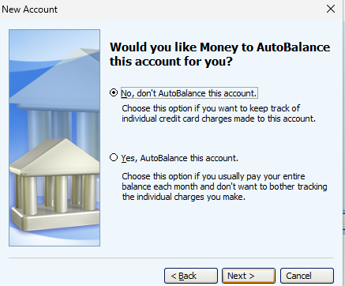

## Investment Account

## Payee List

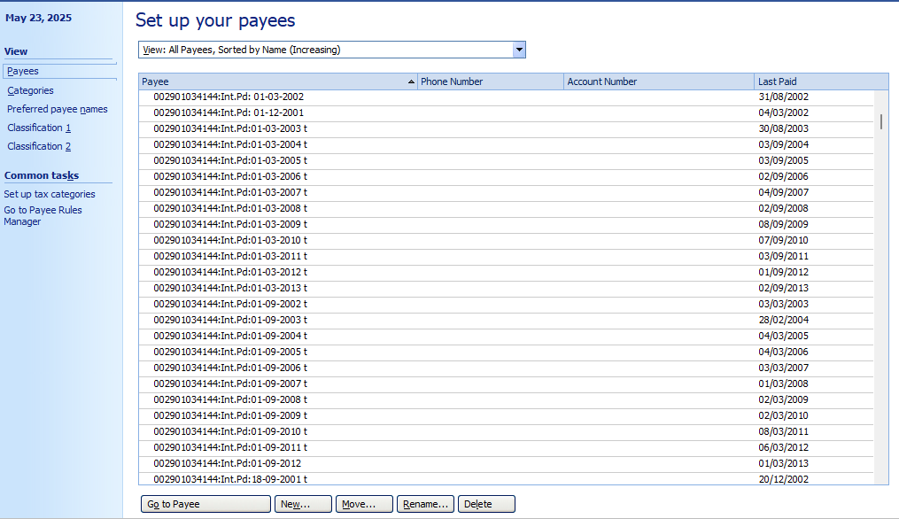

# Account Details Register

