JENKINS INTEGRATION FOR AUTOMATED REPORT GENERATION

STEPS :

1. JENKINS INSTALLATION :

Pre -requisites : Java Development Kit (JDK) or Java Runtime Environment (JRE)

Install Jenkins .war file from https://jenkins.io/

Steps to Install Jenkins :

1. Press the download button
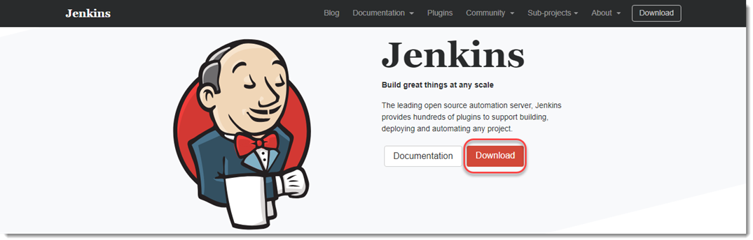
2. Download the Generic Java Package (war file) located the end of the list
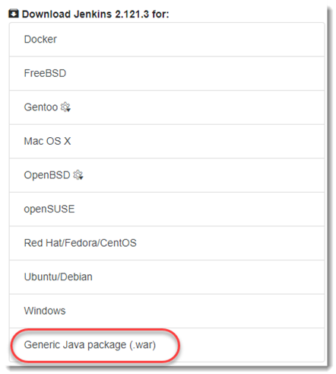

3. Remember the directory in which you have downloaded the file.
4. Go to the shell of your system and navigate to the directory in which you downloaded the file.
5. Type the following command:
java -jar jenkins.war
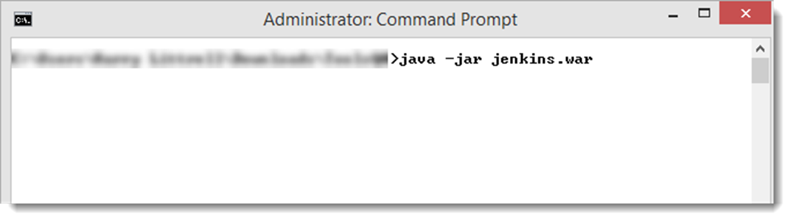
Note: Make sure that you run the above command in the folder where did you install the Jenkins.war.

6. Now you can see that Jenkins has started installing. After installation you will see the password of your Jenkins, which is required in the later steps, so you better copy it.
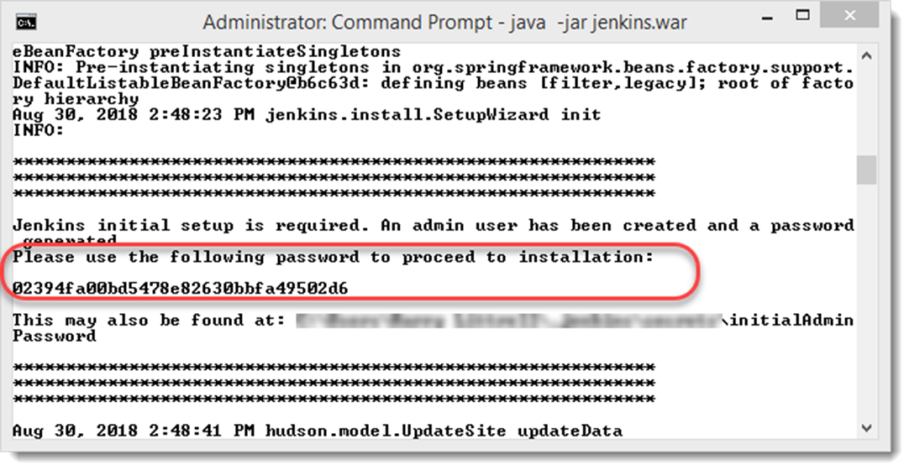
Note: Everyone will have a different password and this is required to enter only once.

7. Open port 8080 in your browser by typing the following in your browser
localhost:8080
8. You will see Jenkins running on your system with it’s first time default page. Paste the same password, copied from above step. Press Enter.

NOTE : If command prompt doesn’t display any password, go to log file and copy the password.

9. You will be redirected to this screen where you are asked about the plugins. Just press Install suggested plugins and let them install.
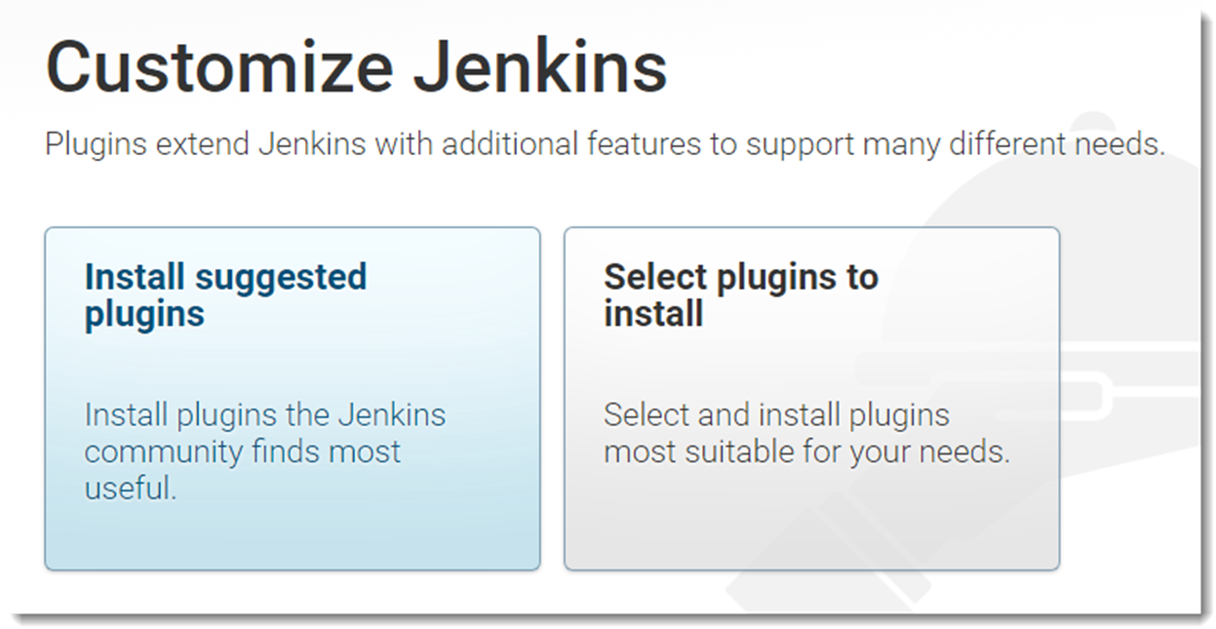

12. After all the plugins are installed, you will be redirected to the account creation page

You can Continue as Admin or you can fill the details for further logins. If you Continue as Admin, you would be required the same password that we just entered to initialize Jenkins.

2. Create a Job :

1.Click on New Item
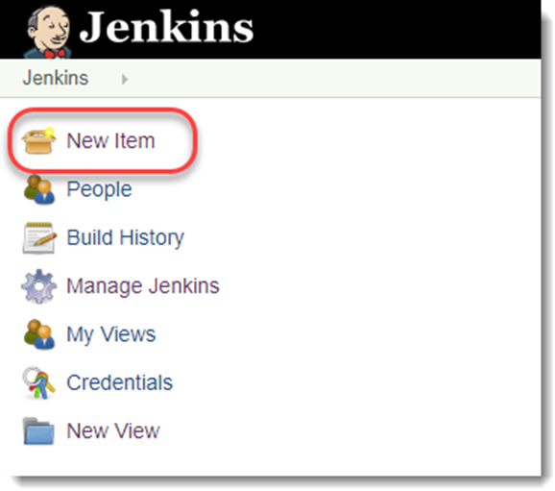

2.Write any name you like and click on Freestyle Project.
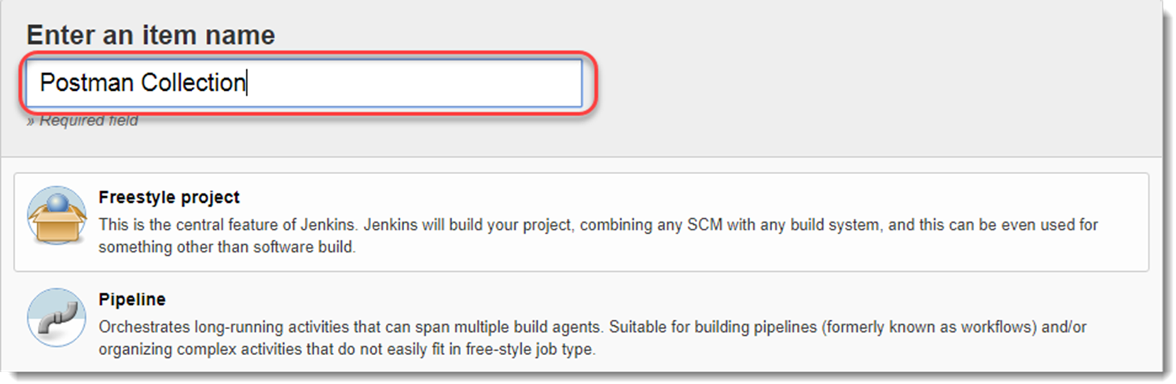

3. Configure Jenkins Job :

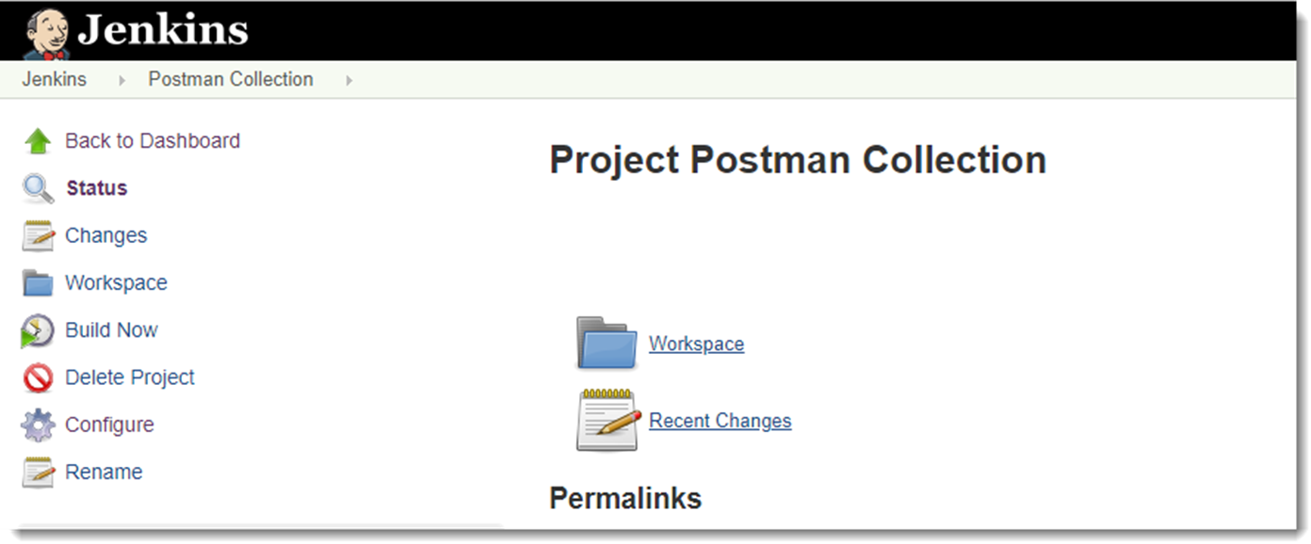
1.Go to Configure.
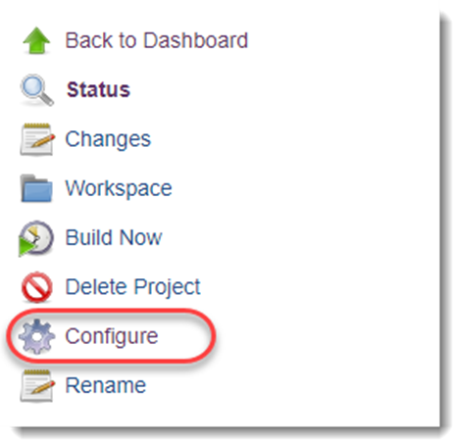

2.Go to Build.

3. Open the dropdown in the batch section and click on Execute Windows Batch Command
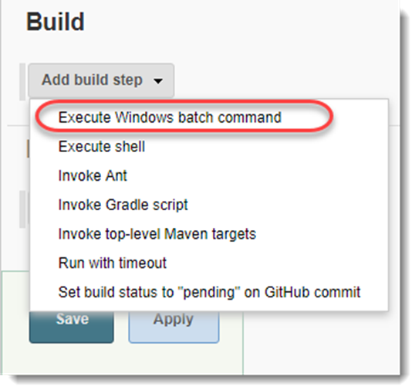

4. After selecting the option, a box will appear to enter the commands. So for now, just for testing we will run the command to check if we have Newman installed on the machine or not which is required to run Jenkins with Newman. This can be done using command newman –version
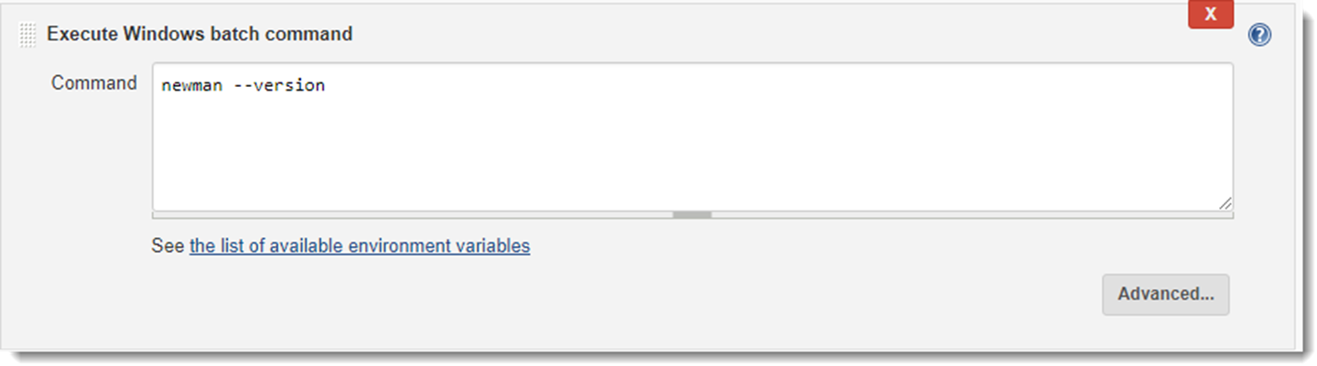

5. Click on Save and the command will be saved.
6. Click on Build Now.
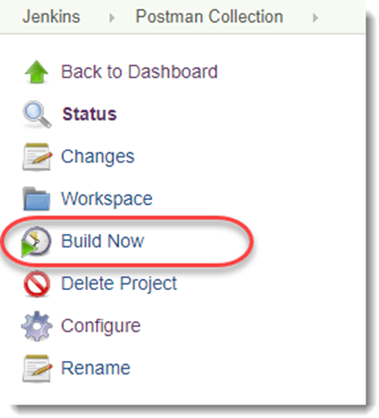

7. You will see the build being run below the above menu
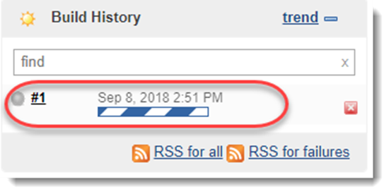

8. Once the build is complete, click on the ball located in the left of the Build Number. It will take you to the console.
9. Now you can see the command run successfully and the output shown successfully.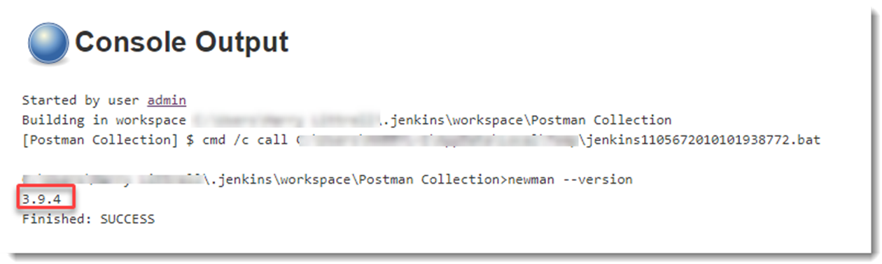

4.Run Postman Collection on Jenkins :

1. Select the project / job created
2. Go to CONFIGURE
3. Go to BUILD section.
4. Write command : newman run “Link_copied_from_postman”
5. Click on Save
6. Click on BUILD NOW
7. In console output you can now see the run report as seen when run through newman.

- To view the output in more readable format : We can add command “--disable-unicode” at the end, like :
newman run “Link_copied_from_postman” --disable-unicode

- To run the collection and environment file :
newman run path_collectionFile_is_saved\collectionFile_name.postman_collection.json -e
path_environmentFile_is_saved\environment_file_name.postman_environment.json --disable-unicode

- To generate .html report :
Add command --reporters cli,junit,html --reporter-html-export "newman1/Myreport.html" at the end.

The above command creates newman1 folder (if not present) in the Workspace and saves the report at the same location.
NOTE : Always refresh before viewing report.
- By default Jenkins executes the command excluding CSS formatting. That is the reason initially the report displays all the content in a column. To add CSS formatting :
  - Go to Jenkins.
  - Go to MANAGE PLUGINS
  - Go to MANAGE NODES
  - Go to GEAR ICON shown on right
  - Go to SCRIPT CONSOLE
  - Copy -paste : System.setProperty("hudson.model.DirectoryBrowserSupport.CSP", "")
  - Click on RUN
  - On successful execution, it will display a RESULT header.
This process will include the CSS formatting while generating html report.
  - Re-build the project and see the chnages.

5. SENDING REPORT AS AN ATTACHMENT OVER EMAIL :
1. First we need to install Email plugin. Go to Jenkins > Manage Plugins
2. Install Email Extension Plugin . It will be present in Available tab.
3. Then click on Install without Restart button.
4. The plugin will successfully be installed when it shows Success.
5. After installation, go to Manage Jenkins > Configure System and go down to Extended E-mail Notification configuration. Click Advanced and provide following information:

SMTP server: smtp.gmail.com (to send emails using gmail)
Use SMTP Authentication: checked
User Name: email@gmail.com (sender’s email address and password)
Password: password
Use SSL: checked
SMTP Port: 465
Default Content Type: HTML
Default Recipients: email@email.com email2@email.com (recipient’s email address)

6. Then click Default Triggers and set to Always to always receive build notifications.
7. Another thing that you would want to do is to set system admin e-mail address so your emails will have default sender. Do it in Jenkins Location configuration for System Admin e-mail address.

Note: If you are not getting emails, Google probably blocked sign in attempt from Jenkins. You will need to allow access to less secure apps in your account settings.
Go to Account > Security > Turn ON Allow Access to less secured APP

6.Configure Email Notifications For Your Project :

1. Go into your project, click configure and scroll down to Post-build Actions. Then click Add post-build action and select Editable Email Notifications.
2. Fill in the details.

3. If you want to attach the report, then mention absolute path of your report in the attachment field.

4. If you want to also attach log , then select attach log from the drop-down.

5. Click on Save

6. Build the project again.

7. You should be receiving the email after build.

NOTE : If Jenkins is closed, then always run java -jar jenkins.war command in command prompt before opening Jenkins. Let the command propmpt be open till we access Jenkins in browser.

7.SETTING SCHEDULER :
1. Go to build triggers in configure.
2. Check “Build periodically” check box
3. Go to Schedule text field and add the expression.
Refer : https://stackoverflow.com/questions/12472645/how-do-i-schedule-jobs-in-jenkins
for learning scheduler expressions.

