

SONAURUS - A MUSIC DATABASE

Department of Computer Science and Engineering

**Ramaiah Institute of Technology**

Members:

Prashant Krishnan V (1MS15CS091)

Meghana Murthy (1MS15CS068)

MVS Viswanadh (1MS15CS074)

**CONTENTS**

Sl. No. Page No.

1. Abstract 3
2. ER Diagram 4
3. Relational Mapping 5
4. Screenshots 6

1. Product Deliverables 9
2. References 10

**ABSTRACT**

This is a Music Database in which users have their individual profiles and have access to the database of songs, artists, albums and playlists. The database contains a huge collection of songs of varying genres and artists.

The project aims to make the experience of a music enthusiast better. The user can search and enjoy any song he wants based on its name, artist, genre, etc. The user can acquire all the details they want about different artists and albums.

The user also obtains playlists based on his favourite genre. Thus, there’s a personalised experience as each user gets a playlist of his choice. A list of songs he can enjoy and doesn’t have to bother searching for each song, each time.

**ER DIAGRAM**

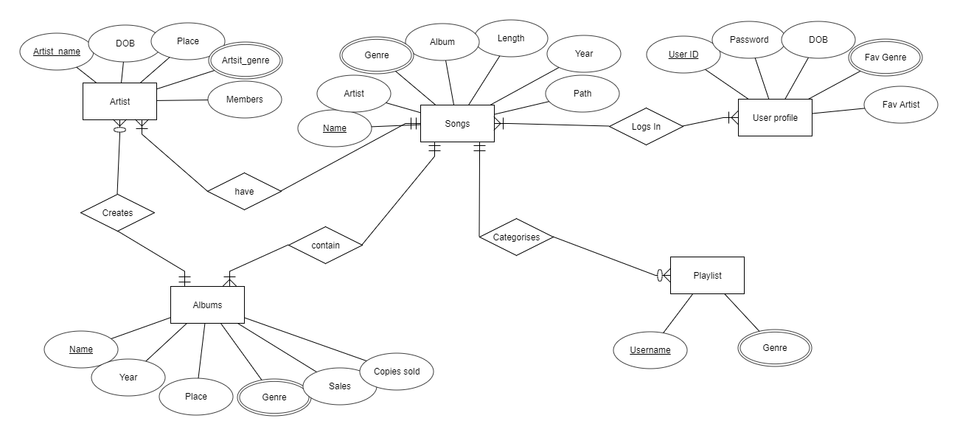

**Entities:**

User profile, Songs, Artist, Albums, Playlist

**RELATIONAL MAPPING**

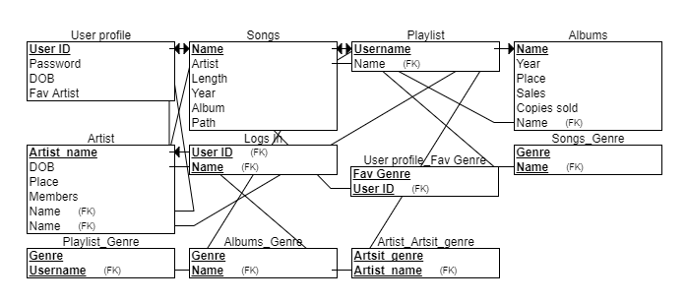

**SCREENSHOTS**

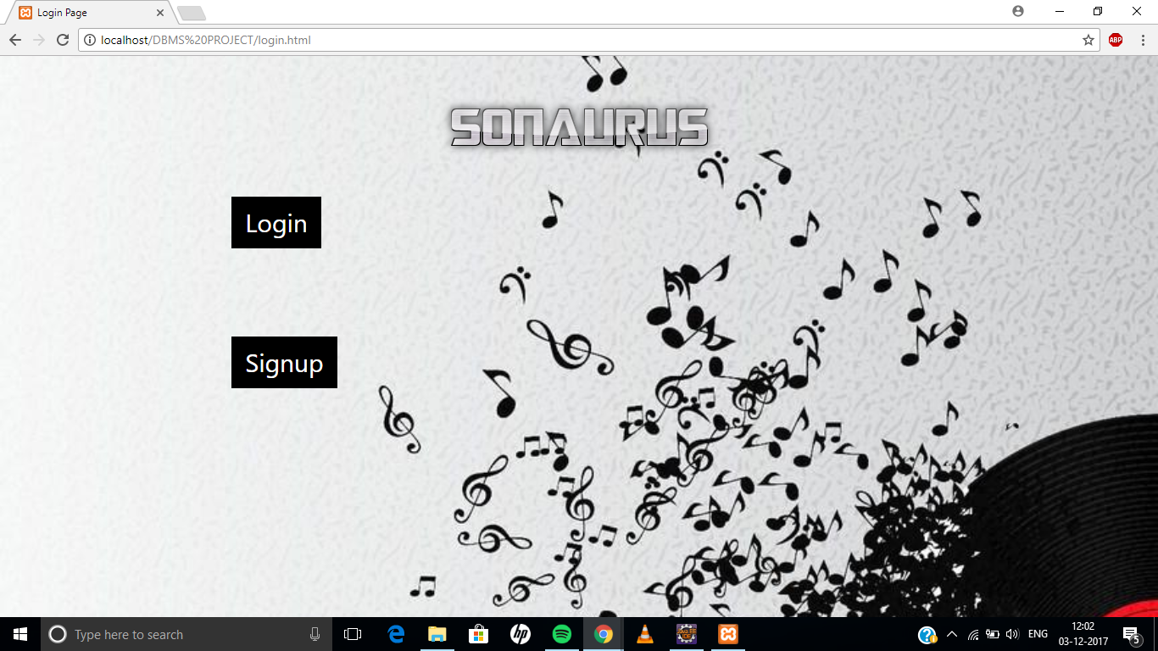

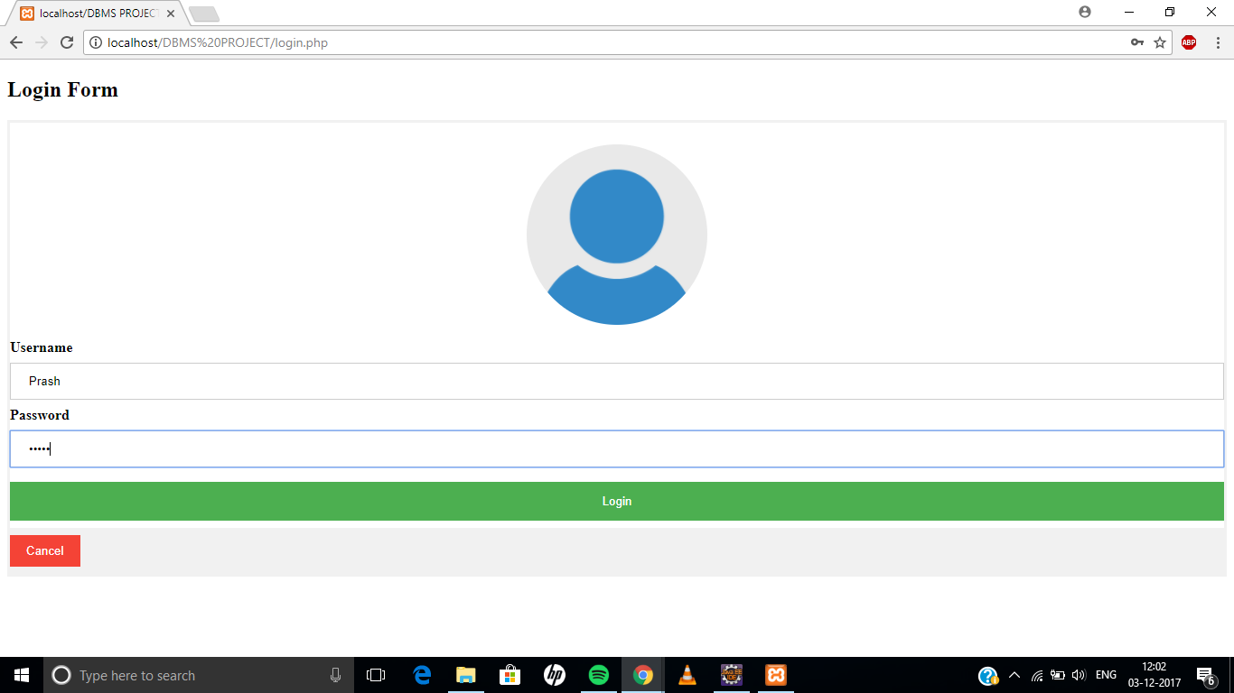

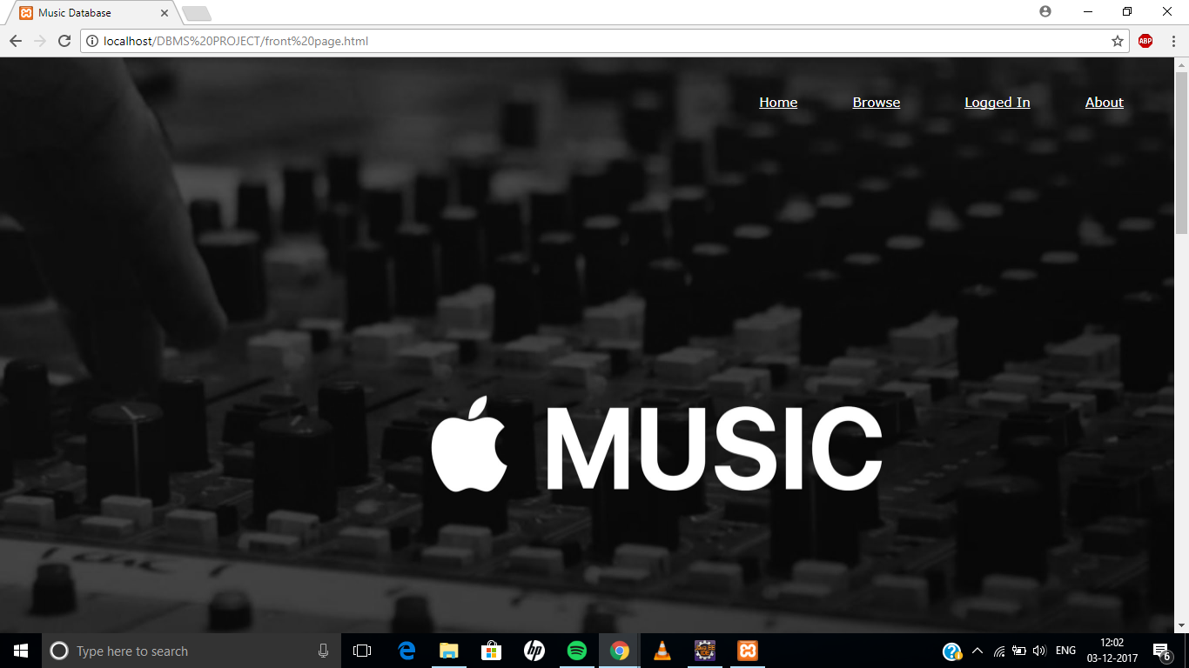

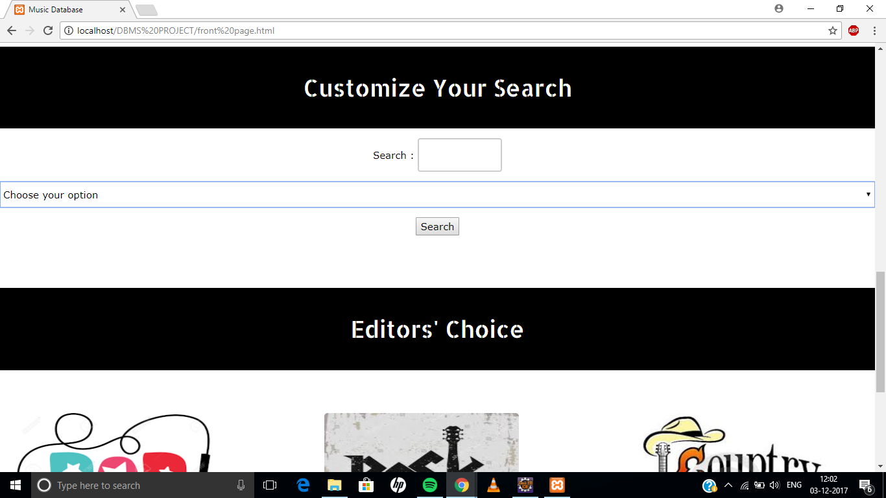

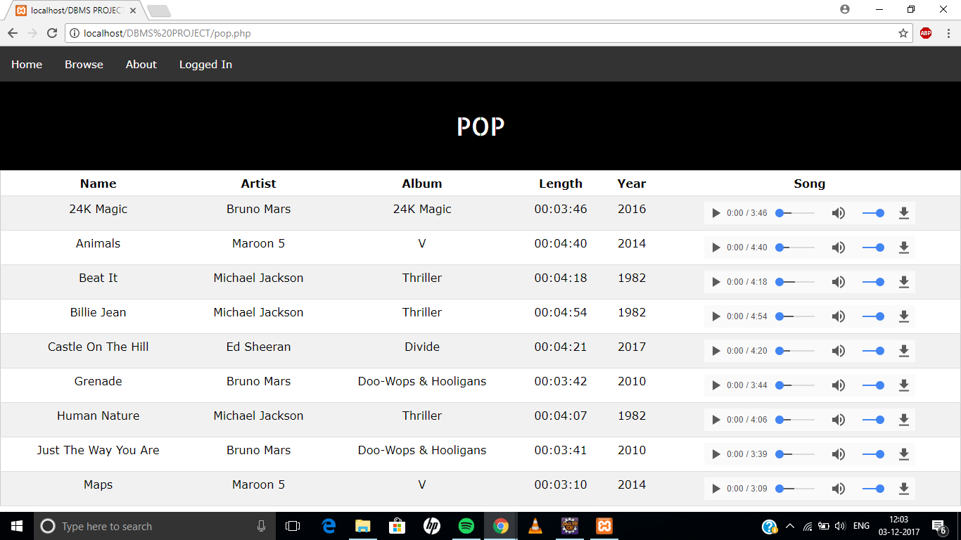

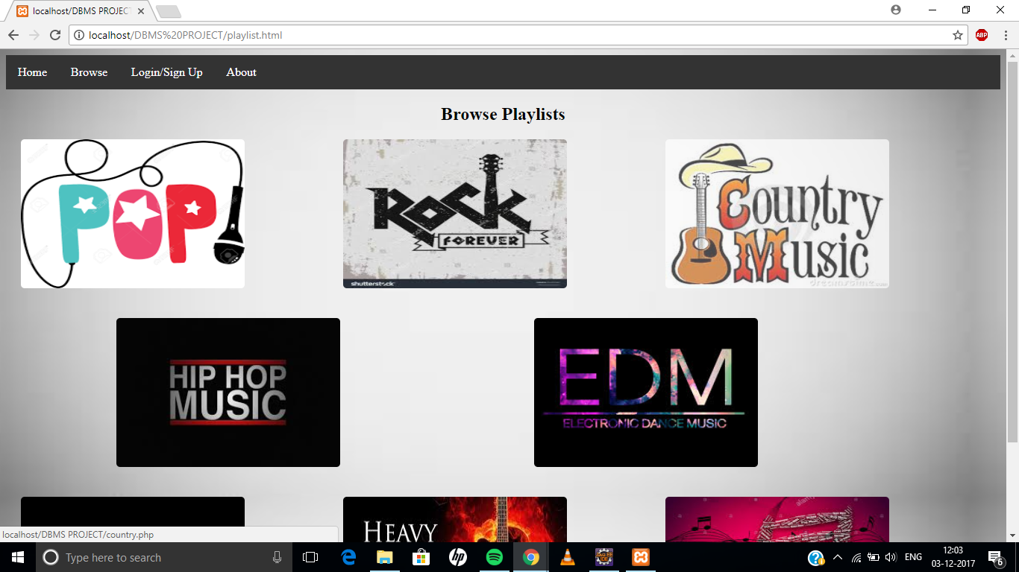

**PRODUCT DELIVERABLES**

This is a music database which allows users to have a personalised experience. What we see is that music data in general is very scattered, which makes it extremely difficult for an individual to find the right kind of music that he/she needs. Also, it’s hard to get other details about a particular song, artist or an album. This is the reason, when all the details are at one place, it makes it extremely easy for a user to access this.

We can see a rise in these kind of music apps, and this project is a small prototype. When extended to a large scale product, it can involve various technologies like machine learning, data analytics to make the personalised experience better by learning and analysing his/her activities on the application. Also, certain applications of affluent companies look to include a sort of a music collection or player as a part of their product. So this could be an asset to the product of these companies.

**REFERENCES**

1. Used ERDplus to draw ER diagram and to obtain the relational schema (<https://erdplus.com>)
2. Stack Overflow
3. W3 Schools