Low Level Design

Project Code | Group 1
Project Name | Employee Maintenance System

Prepared / Modified by | Role | Date of preparation/ Modification
Sunil Mullagiri | Designer | 22-Oct-2018
Reviewed by | Role | Date of review
Tanmaya K Acharya | Mentor
Approved by | Role | Date of Approval
Tanmaya K Acharya | Mentor
Circulation List | aniruddh.chatterjee@capgemini.com  shubham.k.kumar@capgemini.com  neeraj.jain@capgemini.com  rounak.sarkar@capgemini.com  saad.ahmad@capgemini.com  sunil.mullagiri@capgemini.com  sheetal.agrawal@capgemini.com | Version Number : 1.0
Version number of the work product | Version 1.0

Table of Contents

1. Description Of The Unit 3
2. References 4
3. Dependencies / Assumptions 5
4. Class Diagrams 6
5. Sequence Diagrams 7
6. Design Components 8
6.1 List of UI Components…….………………………………………….…………………………………8
6.2 List of Design Classes…………………………………………………………………………………….10

7. Reusable Routines/Components……………………………………………………. 11
8. Messages 12
9. Configuration Files 13
10. Crud Matrix Table 14
11. Data Mapping Matrix 15
12. Action Flow Matrix 16
13. Stored Procedures 17
14. Program Specification / Pseudo Code 18
REVISION HISTORY OF THE WORK PRODUCT 21
Description Of The Unit

This project is aimed at developing Online Employee Maintenance System. This is a Web based application that can be accessed over the web. This system can be used to search for Employees based on search condition, add individual employee, modify an existing employee details and display all employee details across locations within an organization. This is an integrated system that contains both the user (Employee) component and the Admin component

There are two categories of people who would access the system viz. Admin & Employee. Each one of them would have some exclusive privileges (for e.g. Employees can just search an employee details based on search condition.)

- Admin should be able to
- Login to the system using his/her credentials
  - Add individual employee details by accepting all the field values from end user as listed below and inject the values into database table if data are valid else display an appropriate error messages.
  - Modify Employee details
  - Display all Employee details

- Employee should be able to

  - Login to the system using his/her credentials
  - Search an employee details based on any of the fields - ID, First Name, Last Name, department, Grade, Marital Status.
  - Apply for Leave.

References

Reference | Description
Repository reference | https://10.219.32.200/21Oct18PLPTeam1_JEE
Class Diagram | D:\Rjt\PLP\PLP Documents\ProjectDocuments\DesignDocuments\HLD\Class Diagram\EmployeeMaintenanceSystem_AddEmployeeInformation_ClassDiagram.jpg
URS | D:\Rjt\PLP\PLP Documents\ProjectDocuments\Requirements\CaseStudy\EmployeeMaintenance System.doc
UTP | D:\Rjt\PLP\PLP Documents\Testing\UTP\Test_Case_EmployeeMaintenanceSystem_AddEmployeeInformation.xls
DB Design | D:\Rjt\PLP\PLP Documents\ProjectDocuments\DesignDocuments\HLD\DB Design\DB Design.xls

Dependencies / Assumptions
Dependencies:
The Admin should be logged in.
All fields in AddEmployeeHome page are filled correctly.

Assumptions:
The Admin details are stored in the database.
The Employee Information will get store in the database.

Class Diagrams
Class Diagram

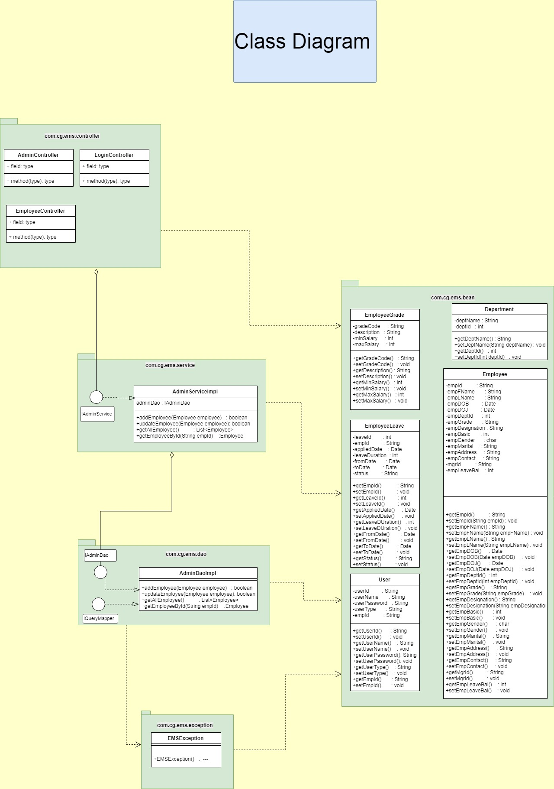

Sequence Diagrams

Sequence Diagram

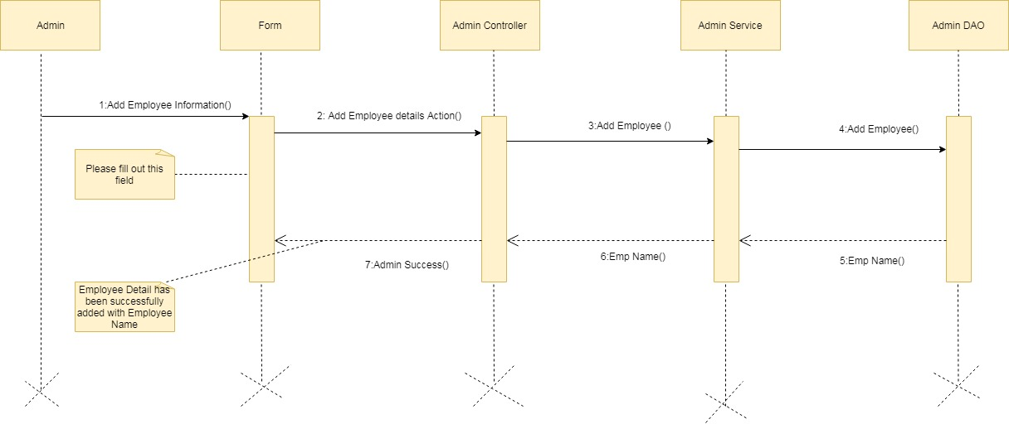

Design Components

List Of UI Components

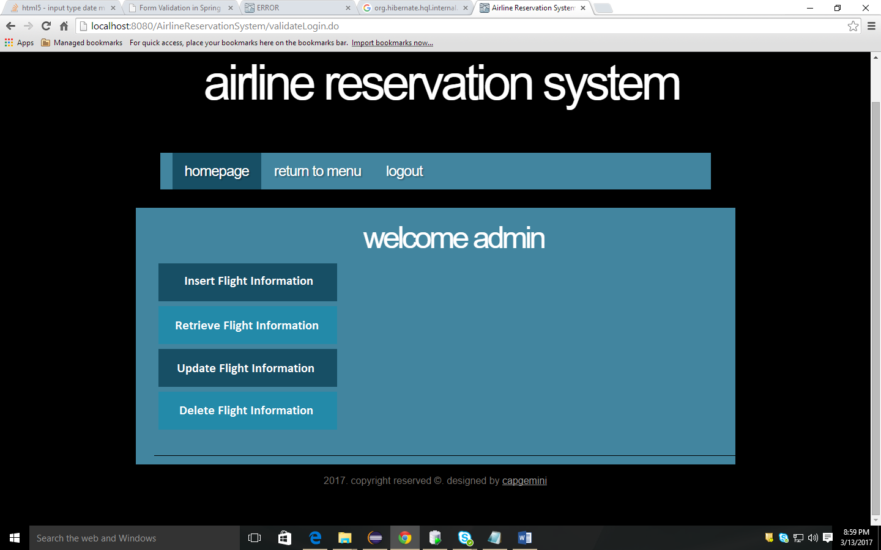

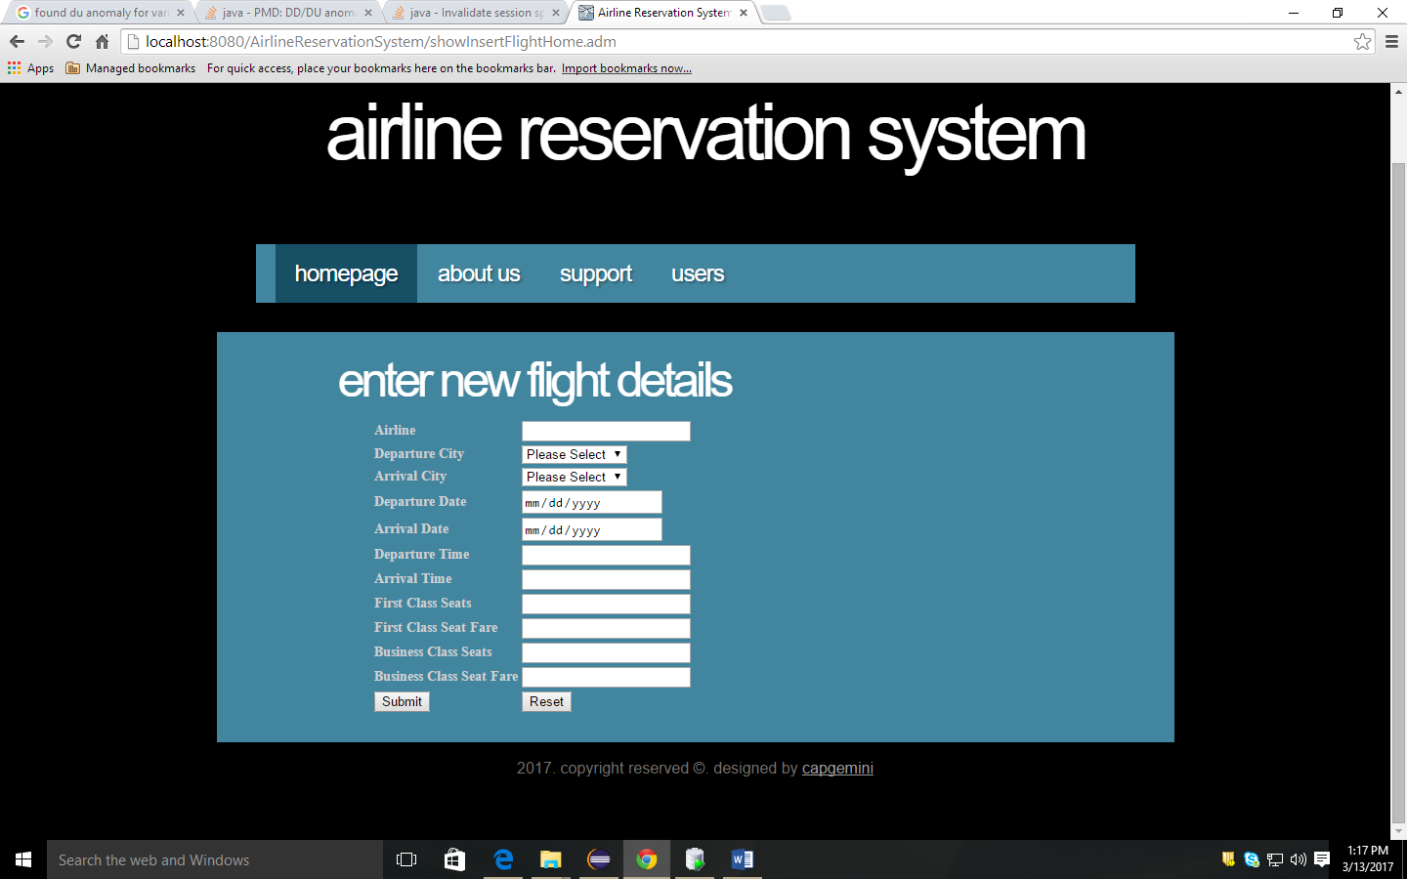

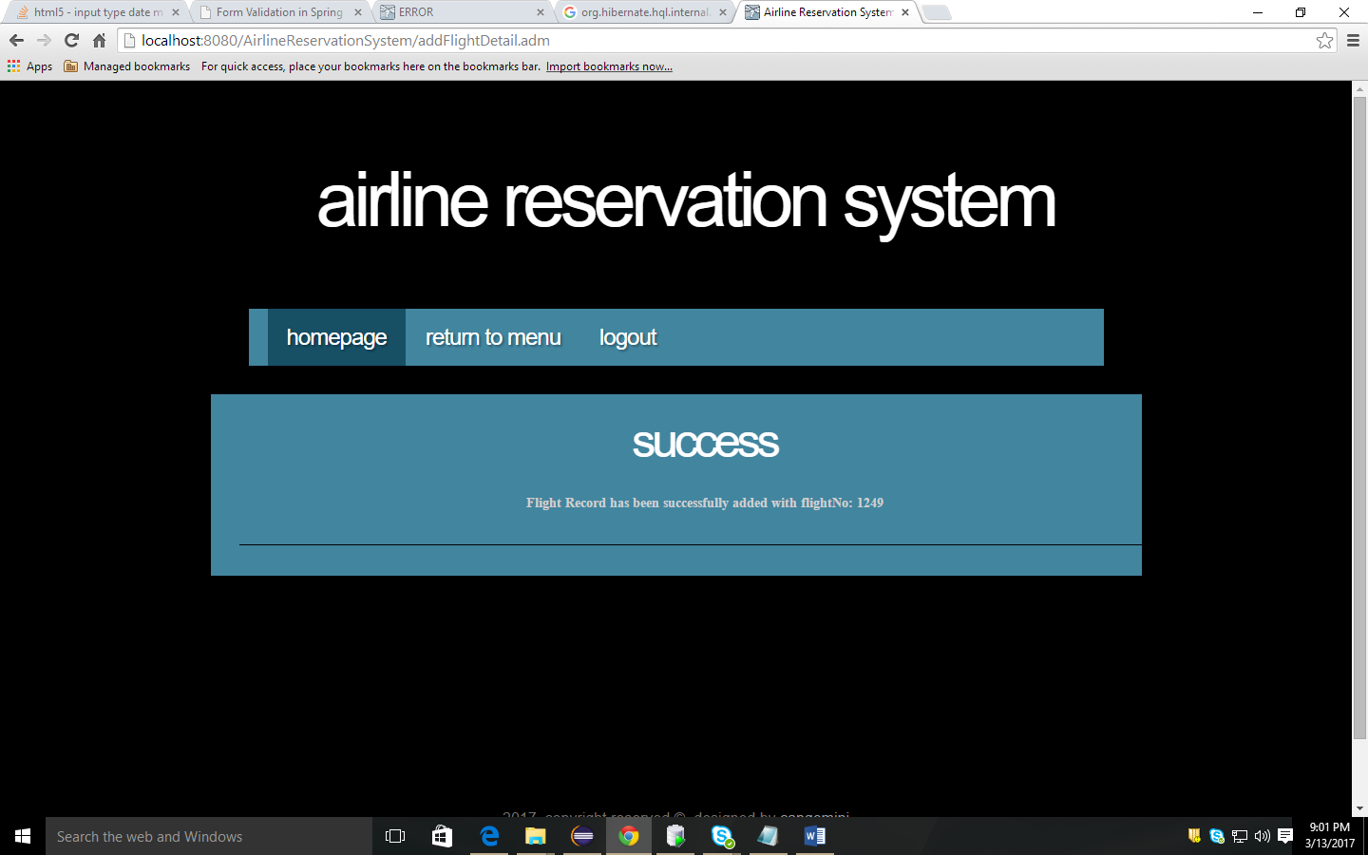
Sr. No. | LLD Name | Class Name | Method Name | Method Description
1 | Add Employee Information`Module | EmployeeBean | Appropriate getters and setters methods | Getters retrieve the property values and setters set the property values
2 | Add Employee Information Module | AdminController | private void addEmployeeDetailsAction(HttpServletRequest request,HttpServletResponse response) throws ServletException, IOException, EMSException | Sets the model attribute.  Calls the Service layer method to add the Employee details in to the database
3 | Add Employee Information Module | EmployeeServiceImpl | public boolean addEmployee(EmployeeBean employeeInfo)throws EMSException | Calls the DAO layer method to add the employee details in to the database
4 | Add Employee Information Module | EmployeeDaoImpl | public boolean addEmployee(EmployeeBean employeeInfo) throws EMSException ) | Inserts the employee information into the database and returns the result to EmployeeServiceImpl

List Of Design Classes

Re-Usable Routines/Components
Re-Usable Routines/Components

- CSS files
- DataAccessException class

Messages

#. | Type | Message Text
M1 | Error | Please fill out this field
M2 | Error | Must be in characters only in range of 5 to 30!!
M3 | Error | Please select an item in the list!!
M4 | Error | Must be a valid future date!!
M5 | Error | Must be entered in format: HHMM!!
M6 | Error | Must be in 2 digits only!!
M7 | Error | Must be in digits in range of 3 to 6!!

Configuration Files

File Name | Path | Description
oracle.properties | /Development/Source | To configure database connection.
Web.xml | /Development/Source | To configure the bean properties.
ems-servlet.xml | /Development/Source | To configure the request mapping and view resolver.

Crud Matrix Table

# | Table Name | Create | Read | Update | Delete
1 | Employee Information | Y | Y | Y | Y

Data Mapping Matrix

Sr. No. | Screen Label | Field Source | Field Type | Data Type | Max Length | Data Flow | Mandatory
1 | Id | EmployeeBean.id | Text Box | String | 30 | UI→D | Yes
2 | First Name | EmployeeBean.firstName | Combo Box | String | NA | UI→D | Yes
3 | Last Name | EmployeeBean.lastName | Combo Box | String | NA | UI→D | Yes
4 | Date Of Birth | EmployeeBean.DOB | Text Box | Local Date | NA | UI→D | Yes
5 | Date Of Joining | EmployeeBean.DOJ | Text Box | Local  Date | NA | UI→D | Yes
6 | Department Id | EmployeeBean.deptId | Text Box | String | 4 | UI→D | Yes
7 | Grade | EmployeeBean.grade | Text Box | String | 4 | UI→D | Yes
8 | Designation | EmployeeBean.designation | Text Box | int | 2 | UI→D | Yes
9 | Basic Salary | EmployeeBean.basic | Text Box | double | 6 | UI→D | Yes
10 | Gender | EmployeeBean.gender | Text Box | int | 2 | UI→D | Yes
11 | Marital Status | EmployeeBean.marital | Text Box | double | 6 | UI→D | Yes
12 | Address | EmployeeBean.address | Text Box | String |  | UI→D | Yes
13 | Contact | EmployeeBean.contact | Text Box | double |  | UI→D | Yes
14 | Manager Id | EmployeeBean.mgrId | Text Box | String |  | UI→D | Yes
15 | Leave Balance | EmployeeBean.leaveBal | Text Box | String |  | UI→D | Yes

Legend

UI (User Interface Only)
UI → D (User Interface to Database)

Action Flow Matrix

Sr. No. | Action | Description | Process
1 | On click Add Employee Information in Admin Home page | Redirected to the Add Employee Home form | The Admin clicks on the Add in the Admin Home page and gets redirected to the Add Employee Home form.
2 | On click of Submit button in Add Employee Home Form | The employee information is added into the database. | Data is entered in the fields by the Admin which gets added into the database when Submit button is pressed.
3 | On click Reset button in Add Employee Home form | Redirected to Add Employee Home page | On click reset button by the Admin in register form redirected to Add Employee Home page

Stored Procedures

# | Stored Procedure Name  (with Description) | Input/Out Parameters | Type | Size
1. | NA

Program Specification / Pseudo Code

<ACTION: ADD_EMPLOYEE_INFORMATION >

Pseudo Code:
- Client Side Scripting:
None

- Server Side Scripting:
BEGIN
Call the Service Layer for adding the employee details into the database.
END

Pseudo Code:
14.2 <ACTION: RAISE_REQUISITION >

- Server Side Scripting:
IF Id is Empty
Print Error Message M1
ELSE IF Id is not in specified format
Print Error Message M2
IF First Name is Empty
Print Error Message M1
ELSE IF First Name is not in specified format
Print Error Message M3
IF Last Name is Empty
Print Error Message M1
ELSE IF Last Name is not in specified format
Print Error Message M3
IF Date Of Birth is Empty
Print Error Message M1
ELSE IF Date Of Birth is not in specified format
Print Error Message M4
IF Date Of Joining is Empty
Print Error Message M1
ELSE IF Date Of Joining is not in specified format
Print Error Message M4
IF Department Id is Empty
Print Error Message M1
ELSE IF Department Id is not in specified format
Print Error Message M5
IF Grade is Empty
Print Error Message M1
ELSE IF Grade is not in specified format
Print Error Message M5
IF Designation is Empty
Print Error Message M1
ELSE IF Designation is not in specified format
Print Error Message M6
IF Basic Salary is Empty
Print Error Message M1
ELSE IF Basic Salary is not in specified format
Print Error Message M7
IF Genderis Empty
Print Error Message M1
ELSE IF Gender is not in specified format
Print Error Message M6
IF Marital is Empty
Print Error Message M1
ELSE IF Marital is not in specified format
Print Error Message M7
IF Address is Empty
Print Error Message M1
ELSE IF Address is not in specified format
Print Error Message M7
IF Contact is Empty
Print Error Message M1
ELSE IF Contact is not in specified format
Print Error Message M7
IF Manager Id is Empty
Print Error Message M1
ELSE IF Manager Id is not in specified format
Print Error Message M7
IF Leave Balance is Empty
Print Error Message M1
ELSE IF Leave Balance is not in specified format
Print Error Message M7

- Server Side Scripting:
BEGIN
Call addEmployeeDetailsAction (@ModelAttribute (“addEmployee") @Valid EmployeeBean addEmployee, BindingResult result, Model model) in Controller class in Presentation Layer
BEGIN
Call addEmployee (EmployeeBean addEmployee) in EmployeeServicempl class in Service Layer
BEGIN
Call addEmployee (EmployeeBean addEmployee) in class EmployeeDaoImpl in Data Access Layer
BEGIN
Create query for adding employee details into EmployeeInformation table
Return String value.
END
Return String value to Service Layer
END
Return String value to Presentation Layer

END
IF successful then navigate to AdminSuccess page and show success message.
Else navigate to Error page and show error.
END

REVISION HISTORY OF THE WORK PRODUCT
<To be maintained by projects>

# | Date | Version # | Section Changed | Details of changes made | Approved By
1
2

