American-Community-Survey-Exercise.R

sheetal

2022-12-18

# Assignment: ASSIGNMENT 3.1  
# Name: Munjewar, Sheetal  
# Date: 2022-12-11  
  
## Check your current working directory using `getwd()`  
getwd()

## [1] "E:/Data_Science_DSC510/DSC520-Statistics/dsc520/assignments/assignment03"

## List the contents of the working directory with the `dir()` function  
dir()

## [1] "American-Community-Survey-Exercise.html"   
## [2] "American-Community-Survey-Exercise.pdf"   
## [3] "American-Community-Survey-Exercise.R"   
## [4] "American-Community-Survey-Exercise.spin.R"   
## [5] "American-Community-Survey-Exercise.spin.Rmd"  
## [6] "American Community Survey Exercise.R"   
## [7] "assignment_03_MunjewarSheetal.pdf"   
## [8] "assignment_03_MunjewarSheetal.R"   
## [9] "data-visualization-2.1.pdf"

## If the current directory does not contain the `data` directory, set the  
## working directory to project root folder (the folder should contain the `data` directory  
## Use `setwd()` if needed  
setwd("E:\\Data_Science_DSC510\\DSC520-Statistics\\dsc520")  
  
## Load American Community Survey Exercise survey excel `data/acs-14-1yr-s0201.csv` to `acs_df` using `read.csv`  
## Get summary for data frame 'acs_df'suing summary()`  
acs_df <- read.csv("data/acs-14-1yr-s0201.csv")  
summary(acs_df)

## Id Id2 Geography PopGroupID  
## Length:136 Min. : 1073 Length:136 Min. :1   
## Class :character 1st Qu.:12082 Class :character 1st Qu.:1   
## Mode :character Median :26112 Mode :character Median :1   
## Mean :26833 Mean :1   
## 3rd Qu.:39123 3rd Qu.:1   
## Max. :55079 Max. :1   
## POPGROUP.display.label RacesReported HSDegree BachDegree   
## Length:136 Min. : 500292 Min. :62.20 Min. :15.40   
## Class :character 1st Qu.: 631380 1st Qu.:85.50 1st Qu.:29.65   
## Mode :character Median : 832708 Median :88.70 Median :34.10   
## Mean : 1144401 Mean :87.63 Mean :35.46   
## 3rd Qu.: 1216862 3rd Qu.:90.75 3rd Qu.:42.08   
## Max. :10116705 Max. :95.50 Max. :60.30

##Run the following functions and provide the results: str(); nrow(); ncol()  
## Examine the structure of `acs_df` using `str()`  
str(acs_df)

## 'data.frame': 136 obs. of 8 variables:  
## $ Id : chr "0500000US01073" "0500000US04013" "0500000US04019" "0500000US06001" ...  
## $ Id2 : int 1073 4013 4019 6001 6013 6019 6029 6037 6059 6065 ...  
## $ Geography : chr "Jefferson County, Alabama" "Maricopa County, Arizona" "Pima County, Arizona" "Alameda County, California" ...  
## $ PopGroupID : int 1 1 1 1 1 1 1 1 1 1 ...  
## $ POPGROUP.display.label: chr "Total population" "Total population" "Total population" "Total population" ...  
## $ RacesReported : int 660793 4087191 1004516 1610921 1111339 965974 874589 10116705 3145515 2329271 ...  
## $ HSDegree : num 89.1 86.8 88 86.9 88.8 73.6 74.5 77.5 84.6 80.6 ...  
## $ BachDegree : num 30.5 30.2 30.8 42.8 39.7 19.7 15.4 30.3 38 20.7 ...

nrow(acs_df)

## [1] 136

ncol(acs_df)

## [1] 8

## Create a Histogram of the HSDegree variable using the ggplot2 package.  
## 1. Set a bin size for the Histogram that you think best visuals the data (the bin size will determine   
## how many bars display and how wide they are)  
## 2. Include a Title and appropriate X/Y axis labels on your Histogram Plot.  
  
library(ggplot2)  
  
ggplot(acs_df, aes(HSDegree)) + geom_histogram(bins = 50)

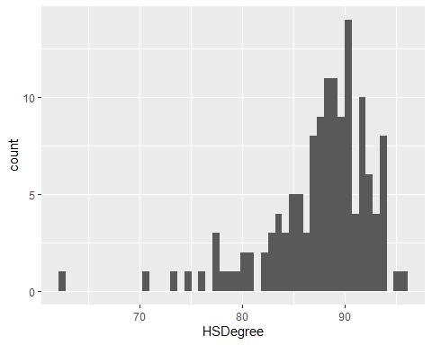

ggplot(acs_df, aes(HSDegree)) + geom_histogram(bins = 50) + ggtitle("ACS HSDegree Score Report") + xlab("HSDegree") + ylab("HeadCounts")

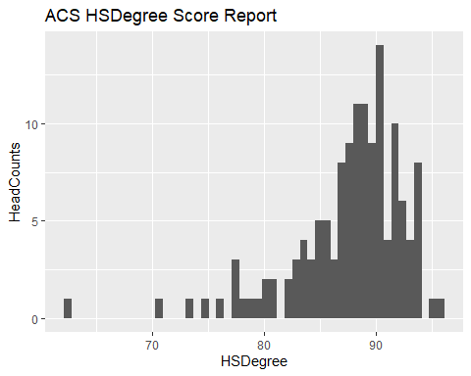

## Answer the following questions based on the Histogram produced:  
## Based on what you see in this histogram, is the data distribution unimodal?  
# Answer- Plot is unimodal  
## Is it approximately symmetrical?  
# Answer- Plot is asymmetrical  
## Is it approximately bell-shaped?  
# Answer- Plot is relatively bell shaped  
## Is it approximately normal?  
# Answer- Plot is not relatively normal  
## If not normal, is the distribution skewed? If so, in which direction?  
# Answer- Plot is skewed left ( left skew or Negative skew )  
## Include a normal curve to the Histogram that you plotted.  
# Reference link :   
## https://statisticsglobe.com/normal-density-curve-on-top-of-histogram-ggplot2-r  
## http://www.sthda.com/english/wiki/ggplot2-histogram-plot-quick-start-guide-r-software-and-data-visualization  
  
 ggplot(acs_df, aes(HSDegree)) + geom_histogram(bins=30,binwidth=.5, aes(y=..density..), position="identity", alpha=0.5) + geom_density(alpha=0.6)

## Warning: The dot-dot notation (`..density..`) was deprecated in ggplot2 3.4.0.  
## ℹ Please use `after_stat(density)` instead.

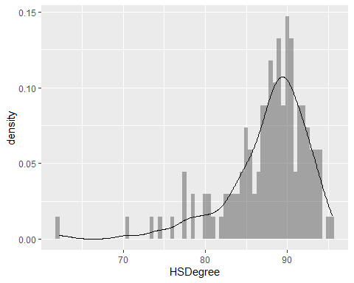

## Explain whether a normal distribution can accurately be used as a model for this data.  
# Answer - Normal distribution properties expect symmetrical data distribution and majority of the data points  
# within the std. deviation, and data skewness must be zero. Plot drawn is relative to normal distribution   
# but not be accurate.  
   
   
# Create a Probability Plot of the HSDegree variable.  
 ggplot(acs_df, aes(sample = HSDegree)) + stat_qq() + stat_qq_line() + theme(legend.position="top")

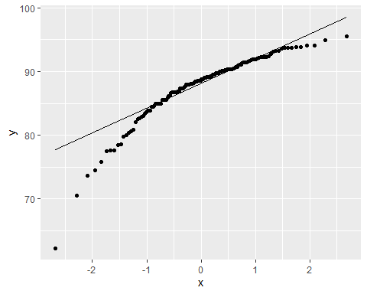

# reference - https://www.geeksforgeeks.org/normal-probability-plot/  
 # reference - https://towardsdatascience.com/q-q-plots-explained-5aa8495426c0  
# Answer the following questions based on the Probability Plot:  
# 1. Based on what you see in this probability plot, is the distribution approximately normal? Explain how you know.  
# Answer - Points plotted on the graph are not perfectly lies on a straight line to indicate distribution is not Normal.  
  
# 2. If not normal, is the distribution skewed? If so, in which direction? Explain how you know.  
# Answer - Noticed more deviation at the Bottom end of the QQ plot from straight line, indicate longer tail towards left,  
# Left Skewed or Negatively Skewed.  
   
# Now that you have looked at this data visually for normality,   
# you will now quantify normality with numbers using the stat.desc() function.   
# Include a screen capture of the results produced.  
 # Reference : https://stats.oarc.ucla.edu/r/faq/how-can-i-get-a-table-of-basic-descriptive-statistics-for-my-variables/  
 library(pastecs)  
 options(scipen=100)  
 options(digits=2)  
   
 #-kurtosis  
 stat.desc(acs_df)

## Id Id2 Geography PopGroupID POPGROUP.display.label  
## nbr.val NA 136.00 NA 136 NA  
## nbr.null NA 0.00 NA 0 NA  
## nbr.na NA 0.00 NA 0 NA  
## min NA 1073.00 NA 1 NA  
## max NA 55079.00 NA 1 NA  
## range NA 54006.00 NA 0 NA  
## sum NA 3649306.00 NA 136 NA  
## median NA 26112.00 NA 1 NA  
## mean NA 26833.13 NA 1 NA  
## SE.mean NA 1323.04 NA 0 NA  
## CI.mean NA 2616.56 NA 0 NA  
## var NA 238057576.23 NA 0 NA  
## std.dev NA 15429.11 NA 0 NA  
## coef.var NA 0.58 NA 0 NA  
## RacesReported HSDegree BachDegree  
## nbr.val 136.00 136.000 136.00  
## nbr.null 0.00 0.000 0.00  
## nbr.na 0.00 0.000 0.00  
## min 500292.00 62.200 15.40  
## max 10116705.00 95.500 60.30  
## range 9616413.00 33.300 44.90  
## sum 155638535.00 11918.000 4822.70  
## median 832707.50 88.700 34.10  
## mean 1144400.99 87.632 35.46  
## SE.mean 93510.28 0.439 0.82  
## CI.mean 184934.56 0.868 1.61  
## var 1189207460962.57 26.193 90.43  
## std.dev 1090507.89 5.118 9.51  
## coef.var 0.95 0.058 0.27

stat.desc(acs_df$HSDegree, norm = TRUE)

## nbr.val nbr.null nbr.na min   
## 136.0000000000 0.0000000000 0.0000000000 62.2000000000   
## max range sum median   
## 95.5000000000 33.3000000000 11918.0000000000 88.7000000000   
## mean SE.mean CI.mean.0.95 var   
## 87.6323529412 0.4388597852 0.8679296080 26.1933159041   
## std.dev coef.var skewness skew.2SE   
## 5.1179405921 0.0584024098 -1.6747666105 -4.0302539978   
## kurtosis kurt.2SE normtest.W normtest.p   
## 4.3528564623 5.2738853364 0.8773635436 0.0000000032

#-- Finding z-scores  
 zscore <- ( acs_df$HSDegree - mean(acs_df$HSDegree)) / sd(acs_df$HSDegree)  
 zscore

## [1] 0.2868 -0.1626 0.0718 -0.1431 0.2281 -2.7418 -2.5659 -1.9798 -0.5925  
## [10] -1.3741 -0.1626 -1.7648 -0.2017 0.0914 -1.9602 0.0914 -0.0454 -0.0063  
## [19] -1.8039 -0.7879 0.8339 -0.4166 1.0097 1.2637 0.4235 0.3258 0.3649  
## [28] 0.4822 0.5017 0.7752 0.1500 0.2672 -0.0649 -0.2603 -1.3154 0.0523  
## [37] 0.0132 0.4822 -0.5339 0.2477 0.5212 0.1500 0.7166 0.0718 0.8143  
## [46] -0.4166 0.9120 -0.9247 0.5212 0.5994 -0.5143 1.5373 0.2281 0.1695  
## [55] 0.8339 0.5408 0.6385 -0.4166 -0.6316 -1.0028 0.2868 0.9120 1.2637  
## [64] 0.8925 -0.7293 0.4822 0.2868 0.3258 1.1660 -0.5339 1.0879 0.4431  
## [73] 0.4626 1.0879 0.1109 -0.6120 0.7557 0.1305 -0.4166 -0.8270 0.2868  
## [82] 1.0683 0.7948 -0.7488 -0.2799 0.0718 -3.3475 0.5799 -1.4913 0.5212  
## [91] 0.5994 -0.1626 -1.4131 0.4235 -0.0454 0.2672 0.3649 0.9316 0.0914  
## [100] 0.4626 0.5603 0.4040 0.6775 -0.1626 0.1891 0.6775 0.5017 1.2246  
## [109] 1.2246 0.9120 0.7557 -0.5339 1.1856 -0.9833 -1.1005 -0.1822 -0.0454  
## [118] -0.9051 1.1856 -1.9602 0.8339 -2.3119 0.1891 -1.5304 -4.9693 -0.3385  
## [127] -0.5339 0.1891 0.3649 1.1856 0.7557 0.9120 0.5212 0.8534 1.4200  
## [136] -0.1431

#stat.desc(acs_df, basic=F)  
 #stat.desc(acs_df, desc=F)  
 #data(acs_df)   
 #-kurtosis  
 #stat.desc(acs_df$HSDegree, norm = TRUE)  
 #or   
 #stat.desc(acs_df[,7], norm = TRUE)  
   
   
   
# In several sentences provide an explanation of the result produced for   
# skew, kurtosis, and z-scores. In addition, explain how a change in the sample size may change your explanation?  
  
  
# Results and Explaination :   
#   
# Plotted graph for the 2014 American Community Survey dataset is negatively skewed,   
# Mode exceeds Mean and Median. visual observation shows the plot tailed at the left;   
# even the probability QQ plot indicates more deviation at the bottom of the graph   
# from a straight line. Another indicator using stat.desc() clearly show skewness negative value.  
#   
# Kurtesis measures the degree of peak ness of a frequency distribution, plot   
# derived on HSDegree can be categorized as MesoKurtic and stat.desc() positive   
# value indicates high peaks.  
#   
# z-score is the number of standard deviations a given data point lies above   
# or below the mean, to get the z-score, mean and std deviation need to know   
# for a given data point. z-score values derived using the below formula for   
# HSDegree data point shows positive and negative values. Results of zero   
# show the point and the mean equal,a result of the positive value indicates   
# the deviation above the mean, and negative values indicate below the mean.  
#   
# zscore <- ( acs_df$HSDegree - mean(acs_df$HSDegree)) / sd(acs_df$HSDegree)  
#   
# Adding,subtracting, multiplying and dividing contant may not impact sample   
# data, however addting new data points, will impact the balancing point i.e mean.   
# In fact, adding a data point to the set, or taking one away, can effect   
# the mean, median, and mode.  
#   
# example If we add a data point that’s above the mean, or take away a data  
# point that’s below the mean, then the mean will increase. If take away a   
# data point that’s above the mean, or add a data point that’s below the mean,   
# the mean will decrease.  
#   
# It’s also important that we realize that adding or removing an extreme   
# value from the data set will affect the mean more than the median.  
# example : data set (1,2,3) Mean=2 and Medin=2, adding extreme data   
# point like 1000,will change mean=250 and median=2.5