**JumpLyfe Resort Weeks**

*6 SIMPLE STEPS*

1. *Contact Agent*
2. *Choose one of two time frames (within 60 days, up to 12 months)*
3. *Choose from our list of available destinations*
4. *Choose the month you would like to take your vacation*
5. *Select from the available vacation weeks*
6. *Book your vacation*

**Within 60 Days of Travel**

Last minute resort weeks (travel within 60-days or less), offered at unbelievably DEEP DISCOUNTED RATES - sometimes as low as $100 per week!

SAMPLE:

WYNDHAM REEF RESORT – CAYMAN ISLANDS – STUDIO (sleeps 2)

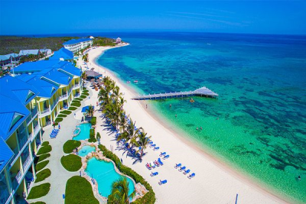

You Pay: $ 150.00 after savings

*Some resorts have a mandatory All-Inclusive rate*

*Example:*

*“The mandatory all-inclusive rate is $380.00 USD per day and covers 4 guests, but each additional guest is $45.00 USD per day, regardless of age (rates are subject to change).”*

**Up to 12 Months in Advance**

*BOOK A WEEK AT A TIME AND SAVE THOUSANDS!*

Resort vacation weeks at the guaranteed lowest rates.

These wholesale-direct prices can save you over $4,000.00 on a single vacation!

SAMPLE:

GRAND OASIS PALM – CANCUN MEXICO – 2BD (sleeps 8)

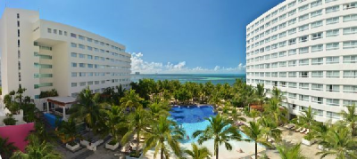

You Pay: $ 300.00 after savings

*Some resorts have a mandatory All-Inclusive rate*

*Example:*

*“The mandatory all-inclusive rate is $380.00 USD per day and covers 4 guests, but each additional guest is $45.00 USD per day, regardless of age (rates are subject to change).”*

|  |
| --- |
|  |
|  | **DESTINATIONS:**  Antigua & Barbuda  Arizona (Scottsdale / Phoenix |
|  | Arizona (Sedona) |
|  | Aruba |
|  | Austria |
|  | Bahamas (Abaco Islands) |
|  | Bahamas (Freeport |
|  | Bahamas (Nassau) |
|  | Barbados |
|  | Belize |
|  | Brazil |
|  | British Virgin Islands (Tortola |
|  | California (Anaheim) |
|  | California (Big Bear |
|  | California (Capistrano Beach) |
|  | California (Carlsbad / Oceanside |
|  | California (Lake Tahoe) |
|  | California (Mammoth Lakes) |
|  | California (Monterey) |
|  | California (Napa) |
|  | California (Palm Desert / Palm Springs) |
|  | California (San Clemente) |
|  | California (San Diego Area) |
|  | California (San Francisco) |
|  | Canada (Alberta) |
|  | Canada (British Columbia - Fairmont Hot Springs) |
|  | Canada (British Columbia - Kelowna) |
|  | Canada (British Columbia - Osoyoos) |
|  | Canada (British Columbia - Radium Hot Springs) |
|  | Canada (British Columbia - Vancouver Island) |
|  | Canada (British Columbia - Whistler) |
|  | Canada (Ontario - Calabogie) |
|  | Canada (Ontario - Horseshoe Valley) |
|  | Cayman Islands |
|  | Colorado (Avon / Beaver Creek) |
|  | Colorado (Breckenridge) |
|  | Colorado (Estes Park) |
|  | Colorado (Granby) |
|  | Colorado (Steamboat Springs) |
|  | Costa Rica |
|  | Dominican Republic (Bayahibe) |
|  | Dominican Republic (Cabarete) |
|  | Dominican Republic (Puerto Plata) |
|  | Dominican Republic (Punta Cana) |
|  | Fiji |
|  | Florida (Cape Haze / Englewood) |
|  | Florida (Daytona) |
|  | Florida (Destin) |
|  | Florida (Fort Lauderdale) |
|  | Florida (Fort Meyers) |
|  | Florida (Indian Shores) |
|  | Florida (Key West / Key Largo) |
|  | Florida (Miami) |
|  | Florida (Orlando Area) |
|  | Florida (Panama City) |
|  | Florida (Pompano Beach) |
|  | Florida (Treasure Island) |
|  | France |
|  | Hawaii (Big Island) |
|  | Hawaii (Kauai) |
|  | Hawaii (Maui) |
|  | Hawaii (Oahu) |
|  | Idaho (Blanchard) |
|  | Italy |
|  | Louisiana (New Orleans) |
|  | Mexico (Acapulco) |
|  | Mexico (Cabo San Lucas/San Jose del Cabo) |
|  | Mexico (Cancun/Riviera Maya) |
|  | Mexico (Manzanillo) |
|  | Mexico (Mazatlan) |
|  | Mexico (Northern Baja California) |
|  | Mexico (Puerto Penasco) |
|  | Mexico (Puerto Vallarta/Nuevo Vallarta) |
|  | Mexico (Rosarito Beach) |
|  | Missouri (Branson) |
|  | Montana (West Yellowstone) |
|  | Nevada (Lake Tahoe) |
|  | Nevada (Las Vegas) |
|  | New York (New York City) |
|  | Oregon (Depoe Bay) |
|  | Pennsylvania (Pocono Mountains) |
|  | Puerto Rico |
|  | South Carolina (Hilton Head) |
|  | South Carolina (Myrtle Beach) |
|  | South Carolina (Surfside Beach) |
|  | St. Kitts and Nevis |
|  | St. Lucia |
|  | St. Maarten |
|  | Turks and Caicos Islands |
|  | U.S. Virgin Islands (St. Thomas) |
|  | Utah (Park City) |
|  | Utah (Salt Lake City) |
|  | Utah (St. George) |
|  | Virginia (Williamsburg)  TRAVEL IN GROUPS AND TAKE ADVANTAGE OF EVEN BIGGER SAVINGS |