东 南 大 学 考 试 卷（ A 卷）
学号 姓名
封
封
线
课程名称 | 程序设计基础及语言2 |  | 考试学期 | 11-12-3
适用专业 | 计算机科学与技术  软件工程 | 考试形式 | 半开卷 | 考试时间长度 | 笔试  120分钟
机试
100分钟
总分：100分

试题 | 得分 | 评阅人
第一部分：笔试
第二部分：机试
成绩合计：

东 南 大 学 考 试 卷（ A 卷）
课程名称 | 程序设计基础及语言2 |  | 考试学期 |  | 11-12-3 |  | 卷面 | 60分
适用专业  学号 姓名  密  封 | 计算机科学与技术  软件工程 | 考试形式 |  | 半开卷 |  | 考试时间长度 |  |  | 笔试  120分钟
仅 允 许 携 带 课 程 指 定 教 材
请将答案写在答题纸上
第一部分 笔试

Note: All answers must be written on answer sheet!
I．To answer the following questions and read the following programs：（20 scores）
1．What does the following program output? (5 scores)
#include <iostream>
using namespace std;
class X {
public:
X(){ cout << “X::Hello world!” << endl; }
X(X& x){ cout << “X::Copy!” << endl; }
~X(){ cout << “X::Good Bye!” << endl; }
};
class Y : public X {
public:
Y(){ cout << “Y::Hello world!” << endl; }
Y(Y& x){ cout << “Y::Copy!” << endl; }
~Y(){ cout << “Y::Good Bye!” << endl; }
private:
X x;
};
Y y;
X x = y;
int main()
{ }

2．What does the following program output? (3 scores)
#include <iostream>
using namespace std;
void f2( )
{
double a=0;
try
{ throw a; }
catch(double)
{ cout<<”OK2!”<<endl; throw; }
cout<<”end2”<<endl;
}
void f1( )
{
try
{ f2( ); }
catch(char)
{ cout<<”OK1!”<<endl; }
cout<<”end1”<<endl;
}
int main( )
{
try
{ f1( ); }
catch(double)
{ cout <<”OK0!”<<endl; }
cout<<”end0”<<endl;
return 0;
}

3．What does the following program output? ( 12 scores)
#ifndef TEST_H
#define TEST_H
class A {
friend void f7( A*, A* );
public:
A( int, int );
void f1( );
void f5( );
virtual void f2( );
static int m;
protected:
void f3( );
int x;
private:
void f4( );
int y;
};
class B : protected A {
public:
B( int, int b = 4 );
void f1( );
void f2( );
void f4( );
private:
int x;
int y;
};
class C : public A {
public:
C(int,int);
void f1 ( ) ;
void f2 ( ) ;
};
class D : private A {
public:
D( int, int );
void f1 ( );
void f2 ( );
void f6 ( );
};
class E : private B {
public:
E( int, int );
void f1 ( );
};
#endif
//------------------------------
#include <iostream>
#include "test.h"
using namespace std;
int A::m = 88;
A::A( int a, int b ): x (a), y(b) { }
void A::f1( ){ cout << "f1 in A" << endl; }
void A::f2( ){ cout << "f2 in A" << endl; }
void A::f3( ){ cout << "f3 in A" << endl; }
void A::f4( ){ cout << "f4 in A" << endl; }
void A::f5( ){ A::f4(); cout << "f5 in A" << endl; }
B::B( int a, int b ) : A( a, b ), x(a), y(b){ }
void B::f1( ){ cout << "f1 in B" << endl; }
void B::f2 (){ cout << "f2 in B" << endl; }
void B::f4 (){ A::f1(); cout << "f4 in B" << endl; }
C::C( int a, int b ) : A (a, b) { }
void C::f1 ( ) { cout << "f1 in C" << endl; }
void C::f2 ( ) { cout << "f2 in C" << endl; }
D::D( int a, int b ) : A (a, b) { }
void D::f1 ( ){ A::f5(); cout << "f1 in D" << endl; }
void D::f2 ( ){ cout << "f2 in D" << endl; }
void D::f6 ( ){ f1(); A::f1();}
E::E( int a, int b ) : B (a, b) { }
void E::f1 ( ){ A::f1(); B::f1(); cout << "f1 in E" << endl; cout << A::x << endl; }
void f7( A* a, A* b ){ cout << "friend:" << a->x + b->x << endl; }
//-----------------------------
#include <iostream>
#include "test.h"
using namespace std;
int main()
{
A a( 1, 2 ), *p1, *p2, *p3, *p4;
B b( 3 );
f7( &a, (A*)&b );
C c( 5 ,6 );
D d( 7, 8 );
E e( 9, 10 ), *p5;
f7( (A*)&b, (A*)&c );
cout << A::m << " " << c.m << endl;
b.f1( );
b.f4( );
p1=&a;
p2=(A *)&c;
p3=(A *)&d;
p4=(A *)&e;
p5=&e;
p1->f2( );
p2->f2( );
p3->f2( );
(*p4).f2( );
d.f1( );
p4->f5( );
p5->f1( );
}

II．To fill in the following blanks to complete program segments. （20 score）
1．The definition of generic stack class. (10 scores)
template < _______ T >
class stack {
public:
stack( int s= 10 );
~stack( ){ delete [ ] stackPtr; }
bool push ( ______ T & );
bool pop( ) ( T& );
……
private:
int size, top;
T * ______;
};
template < typename T >
stack___::stack( int s ) : size(s), top( -1 ), stackPtr( ______ )
{ }
……
2．Operator overloading (10 scores)
// member function implementation
BigInt BigInt::operator++( )
{
IncrementBigInt(); // increment BigInt
return _______;
}

BigInt BigInt::operator++( _____ )
{
BigInt temp = *this;
IncrementBigInt(); // increment BigInt
return temp;
}
// friend function implementation
BigInt operator++( BigInt & t )
{
t.IncrementBigInt(); // increment BigInt
return _______;
}

BigInt operator++( _____ , int )
{
BigInt temp = ______;
t.IncrementBigInt(); // increment BigInt
return temp;
}

III．To write programs or program segments according to the requirements（20 score）
1．To write a program that creates a string array, sorts and outputs the array. (8 scores)
Hint: you must use the standard string class.

2．According to the following requirements, designing and using some classes: (12 scores)
1) To implement two derived classes Rectangle and Circle from base class Shape which is defined as following;
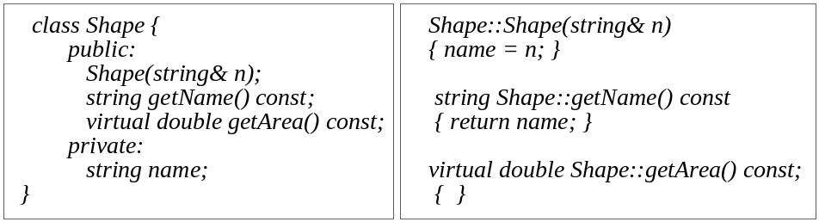
2) Each derived class must re-implement all member function;
3) Writing main function which defines a pointer array Shape * p[6], assigns corresponding addresses of instance to its each element according to input, access the array by a loop statement and call the member function getName(), getArea();
4) Separating interface from implementation.

东 南 大 学 考 试 卷（ A 卷）
课程名称 | 程序设计基础及语言2 |  | 考试学期 |  | 11-12-3 |  | 卷面 | 40分
适用专业 | 计算机科学与技术  软件工程 | 考试形式 |  | 半开卷 |  | 考试时间长度 |  |  | 机试  100分钟
仅 允 许 携 带 课 程 指 定 教 材

第二部分 机试
要求：
- 编程：
  - 在本地D：或E：盘中，建立自己的文件夹，用来完成程序的编写和调试。
  - 可以：第一题Project(项目名)为Pro1，第二题Project(项目名)为Pro2，以此类推。
- 提交：
考试结束后，在10分钟之内完成以下操作：
  - 在虚拟Z：盘上建立一个以自己的学号命名的文件夹，用于保存上交的考试程序的源文件。
  - 将每题的所有源程序文件“*.cpp”、自定义头文件“*.h”和可执行程序“*.exe”存入Z：盘自己的目录中。
IV. To write and test programs according to the requirements（40 scores）
1．(20 scores) To write a program that implements: 1) getting a string from file stream; 2) constructing a string object based it; 3) counting each character; 4) outputting the result to file stream according to the following format. (By separating interface from implementation)
A 4
B 0
C 1
….

2. (20 scores) Array is often used in our program, but it can not support conveniently the insert and delete of element. So you can use the dynamic method to organize data in your program. In order to do it, you may define two classes CNode and CList. The class CNode has two private data members data and next. Here next is used to maintain the logical relationship of data. Class CList creates a dynamic data organizing structure. In this project, can you help to implement class CNode and CList, and test them?
Some hints are given in Fig. 1. Your program must separate interface from implementation.
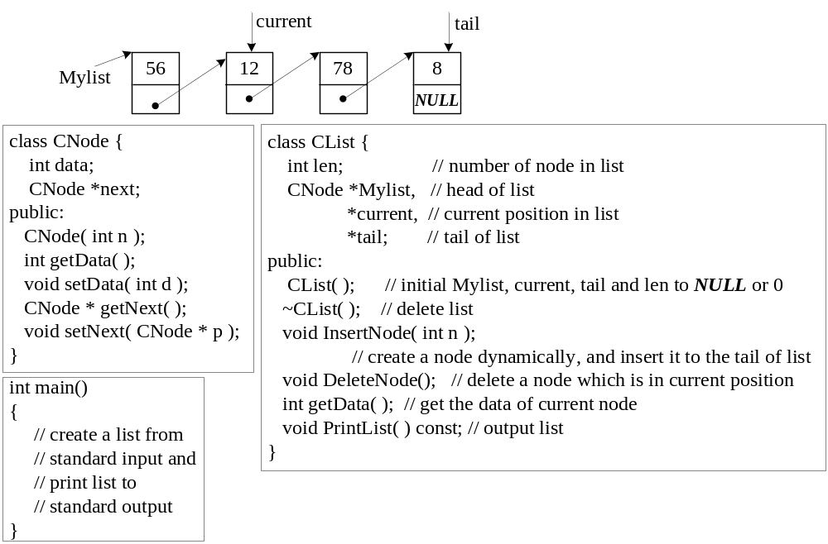
Fig. 1

东 南 大 学 考 试 答 题 纸 ＡＮＳＷＥＲ ＳＨＥＥＴ

