1. <https://github.com/smurray117/Triangle567>
2. I used PyLint as the static code analyzer tool for this assignment. Below are the outputs of before and after.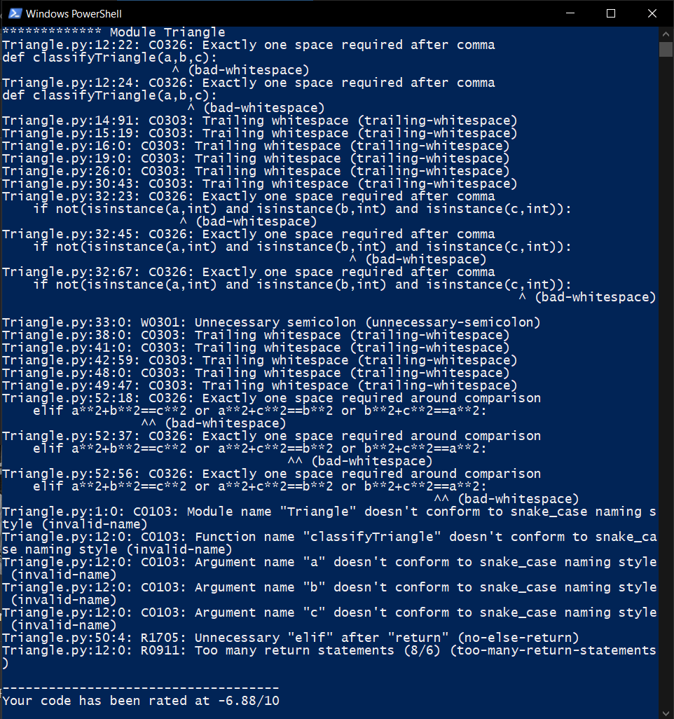 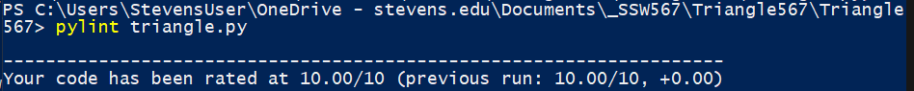
3. The Coverage tool I used for this assignment is Coverage. Below is the output.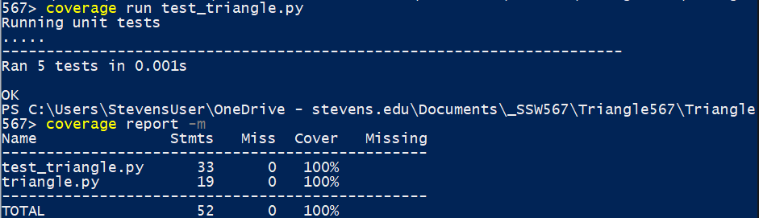
4. After running the coverage analyzer tool without makin any changes, I received 100% coverage. To achieve this, I run 5 overarching tests. The first test is to ensure it can correctly classify 3 different right triangles. Second, classifying 3 different equilateral triangles. Third, classifying 3 different isosceles triangles. Fourth, classifying 3 different scalene triangles. The fifth and final test checks a multitude of potential errors. This includes using an input that is out of range, an input that is not a number, and side lengths that would not make triangles. Three instances of each were tested.