Predicting QualComm Stock Price using Machine Learning Models

John W. Smutny, Ben C. Johnson, Anagha Mudki, James A. Ensminger

***Abstract* — In this paper, four different Machine Learning (ML) models are trained and tested to see which model could most accurately predict the closing stock price of the QualComm corporation twenty-eight days in the future. The four models tested were 1) Multivariate Linear Regression, 2) Logistic Regression, 3) Artificial Neural Network, and 4) a Random Forest (ensemble) model. The best model is determined by which model had the lowest average Mean-Square Error (MSE) value after training the model 100 unique times.**

**The dataset used to train the model’s predicted future stock price is a combination of the daily QualComm corporation stock behavior, the company’s interpolated quarterly earnings, general long-term and short term US economic indicators, global trade indicators, and the values of these features from previous days. All of the four models described were trained using this identical dataset, but with different random seeds and different data entries taken as the Train and Test sets. After evaluating all four models, the Linear Regression model had the lowest average MSE at 89.**

**It is important to note that each model had a relatively acceptable accuracy prediction on the QualComm Stock price. Each model tackles the dataset differently. Most notably, logistic regression predicted a boolean value of whether or not to invest, rather than predicting the actual stock price. The ANN neural network model had a very large range of MSE which should be considered when making a decision on the best model**

***Index Terms*— Linear Regression, Logistic Regression, Artificial Neural Network, Random Forest, Machine Learning.**

# I. INTRODUCTION

Predicting the stock market is extremely risky as unforeseen events can create deep regret and extreme success. No one can predict real-life, but by understanding a company’s fundamentals and the factors affecting its industry. This report attempts to explore how best to use known factors to make the stock market a little less risky. Specifically, when investing in the QualComm semiconductor corporation.

## A. QualComm Corporation

The QualComm international corporation is an American company that specializes in the semiconductor and telecommunications industry. QualComm’s self-described primary market is in the sale of integrated circuit chips for phone and wireless devices, giving access to wireless communications like fifth generation spectrum (5G), bluetooth and long-term evolution (LTE). They directly sell to telecom companies like T-Mobile and Verizon. The company uses ‘fabless manufacturing’, meaning that the company imports all of the semiconductors that it produces from overseas factories and thus are impacted by international law and trade relations [1]. In their industry, QualComm is a direct competitor with semiconductor producers Ericsson, NXP Semiconductors and Samsung [2].

# II. Data Discovery

## A. Methodology

Qualcomm stock price modeling consists of the careful collection and preparation of input feature data followed by an iterative model analysis and selection process. Per the specification, base datasets include the five core daily stock price metrics. To augment these values the researchers gathered available datasets of industry verticals, company performance trends, and global financial trends. Following data collection, data analysis is performed for compliance with the intended supervised machine learning models. This process is performed first by using the standard data quality report, and then by examining preliminary model performance achieved with different candidate data sets.

Given the error introduced into the model’s highly correlated features; the previous step’s goal is to create a small yet impactful feature set. Following final feature selection, the four candidate models are run repeatedly to better understand the target feature (price 28 days in the future) over time. As shown in appendix section *‘B. Other Model 5 Year Stock Predictions Against Actual Close Price’*; the model performance provides feedback used to refine input data and select the final model. Using the final model, a simulation of daily investment decisions is run to exemplify the expected financial gains of an investor. Finally, results are analyzed for further understanding of the model architecture as well as the statistical nature of stock price prediction.

## B. Datasets Used

Based on QualComm’s company background and business competitors; several external datasets were added to the general daily stock trading information to improve the ML models’ ability to predict the company’s stock price.The datasets described below were chosen based on their perceived correlation with the company’s future stock value. However, it is very likely that each model placed varying importance on the included features. Table DD1 on the following page highlights the exact list of datasets used. The list below describes the general categories of information added for analysis.

1. QualComm Stock Information
2. QualComm Quarterly Business Earnings
3. Competitor/Customer Stock Information
4. Economic Indicators for the United States of America
5. Economic Indicators affecting Global Trade

### 1. QualComm Stock Information

The basic statistics that are provided for every day on the NASDAQ stock exchange for every company. The daily QualComm stock ‘Close Price’ and ‘Volume of Shares Traded statistics are valuable to understanding an outside investor’s value of the company and where they see it headed. ‘Close Price’ is straight forward. ‘Volume’ indicates how people think the company will be in the future. More volume means more stock price volatility.

### 2. QualComm Quarterly Business Earnings

Quarterly earnings statistics represent the actual fundamentals of a business and (in theory) have the biggest impact on stock price. Items such as the amount of profit, debt, and revenue are included here. Since this is quarterly data, the researchers used linear interpolation to extend the data points from quarterly data to daily data..

### 3. Competitor/Customer Stock Information

A list of close competitors working against QualComm and companies buying QualComm’s products. Only the close price of these company’s stocks are included. The companies added include direct semiconductor competitors like Ericsson and Samsung, as well as customers like Verizon and Intel.

### 4. Economic Indicators for the United States of America

No company ever lives in a vacuum and thus are affected by every consumer that interacts with the company. The various United States of America bond rates and reported Consumer Price Index (CPI) by the United States of America government are used to gauge the overall sentiment and health of the country’s economy. The rationale of these features is that as bond rates increase and CPI (also correlated with inflation rates) decrease, then it's a sign that the economy is thriving and consumers will spend more money. Thus increasing the stock price of QualComm.

### 5. Economic Indicators affecting Global Trade

### 

Since QualComm is an international corporation that imports a majority of the supplies; global indicators like the price of Brent crude oil and the nominal broad US dollar index help understand the price of international business. As world (Brent) oil prices increase, importing/exporting from the United States becomes more expensive and influences a company’s quarterly sales number (and future outlook). The Nominal Broad US Dollar Index is a US Treasury Department index that tracks how the value of the US Dollar compares to currencies in other countries. A high index indicates that the US Dollar is stronger than other currencies and thus importing goods to the US becomes cheaper. For QualComm, this means the cost of importing manufactured supplies would decrease.

TABLE DD1

List of datasets and features used in the training of all ml models

| **Dataset** | **Features Used** | **URL** | **Date Accessed** |
| --- | --- | --- | --- |
| QualComm Historical Data [3] | Date, Close/Last, Volume, Open, High, Low | https://www.nasdaq.com/market-activity/stocks/qcom/historical | 4/29/2022 |
| QualComm Company Quarterly Report [4] | Gross Profit,  Net Income Available to Common Shareholders,  Total Assets,  Total Liabilities,  Net Income/Starting Line,  Dividends,  Net Changes in Case | https://simfin.com/data/companies/85758 | 4/20/2022 |
| CPI (Consumer Price Index) for all Urban Consumers [5] | InflationRate for all items less food and energy in U.S. city average, all urban consumers, not seasonally adjusted | https://data.bls.gov/timeseries/CUUR0000SA0L1E?output_view=pct_12mths | 4/11/2022 |
| Market Yield 3-Month US Treasury [6] | Daily bond yield | https://fred.stlouisfed.org/series/DGS3MO | 4/29/2022 |
| Market Yield 2-Year US Treasury [7] | Daily bond yield | https://fred.stlouisfed.org/series/DGS2 | 4/29/2022 |
| Market Yield 10-Year US Treasury [8] | Daily bond yield | https://fred.stlouisfed.org/series/DGS10 | 4/29/2022 |
| Nominal Broad US Dollar Index [9] | Daily value | https://fred.stlouisfed.org/series/DTWEXBGS | 4/29/2022 |
| Global Price of Brent Crude Oil [10] | Cost per barrel | https://fred.stlouisfed.org/series/POILBREUSDM | 4/29/2022 |
| Coinbase Bitcoin Price [11] | Price per Bitcoin | https://fred.stlouisfed.org/series/CBBTCUSD | 4/29/2022 |
| AAStock Price [12] | Daily close value | https://www.nasdaq.com/market-activity/stocks/aapl/historical | 4/29/2022 |
| Google Stock Price [13] | Daily close value | https://www.nasdaq.com/market-activity/stocks/googl/historical | 4/29/2022 |
| Ericsson Stock Price [14] | Daily close value | https://www.nasdaq.com/market-activity/stocks/erixf/historical | 4/29/2022 |
| NXP Semiconductors Stock Price [15] | Daily close value | https://www.nasdaq.com/market-activity/stocks/nxpi/historical | 4/29/2022 |
| Samsung Stock Price [16] | Daily close value | https://www.nasdaq.com/market-activity/stocks/ssnlf/historical | 4/29/2022 |
| Verizon Stock Price [17] | Daily close value | https://www.nasdaq.com/market-activity/stocks/vz/historical | 4/29/2022 |
| T-Mobile Stock Price [18] | Daily close value | https://www.nasdaq.com/market-activity/stocks/TMUS/historical | 4/29/2022 |

## C. Cleaning the Datasets (Data Quality Report)

Prior to Data Quality Report (DQR) generation, each input dataset required basic formatting and data cleaning. For consistency across data sets the ‘Date’ columns were converted to Pandas DateTime objects and sorted in ascending order. After date conversion, the majority of stock data was correct, except for the simple removal of the ‘$’ prefix for prices. For the remaining datasets, a few columns also required conversion from comma formatted prices to standard floating point numbers.

Please see section *‘A. Data Quality Report of the Final Dataset’* in the appendix for the Data Quality Report representing the modified datasets. Table DD2 below shows the initial DQR for Qualcomm pricing data.

TABLE DD2

Data Quality Report of the QualComm basic stock information before processing.

| **stat** | **Date** | **Close/Last** | **Volume** | **Open** | **High** | **Low** |
| --- | --- | --- | --- | --- | --- | --- |
| **count** | 1260 | 1260 | 1260 | 1260 | 1260 | 1260 |
| **cardinality** | 1260 | 1149 | 1259 | 1156 | 1180 | 1180 |
| **mean** | * | 94.34067 | 11185564 | 94.35892 | 95.64676 | 93.06873 |
| **median** | * | 77.91 | 9396205 | 77.595 | 78.9475 | 76.685 |
| **number at median** | * | 0 | 0 | 0 | 0 | 0 |
| **mode** | 5/1/2017 | 52.49 | 11301880 | 52 | 58.49 | 52.27 |
| **number at mode** | 1 | 4 | 2 | 3 | 4 | 3 |
| **stddev** | * | 39.76462 | 8104528 | 39.82371 | 40.48734 | 39.08962 |
| **min** | * | 49.4 | 2120165 | 49.52 | 49.8 | 48.56 |
| **number at min** | * | 1 | 1 | 1 | 1 | 1 |
| **max** | * | 189.28 | 1.56E+08 | 190.304 | 193.58 | 185.1852 |
| **number at max** | * | 1 | 1 | 1 | 1 | 1 |
| **number of zeros** | * | 0 | 0 | 0 | 0 | 0 |
| **number missing** | * | 0 | 0 | 0 | 0 | 0 |

All measurements annotated with ‘*’ represents an invalid mathematical operation with a non-numeric feature

# III. Data Preparation

Before any of the models can be trained, several steps to clean and prepare the dataset can be done to improve the model’s prediction accuracy. The initial Data Quality Report above helps guide the following steps in data preparation.

Daily stock data aligns perfectly across all included companies, but economic performance measures, such as CPI and financial reportings, have varying sample frequencies and dates. To create contiguous input feature data, lower frequency data is interpolated for all days the stock market was open within the applicable time window. Interpolation using sample-and-hold, zero-filling, and linear estimation offer various methods to fill in missing data points. To minimize the effect of generated data, linear approximation between data points is used.

Data from the Federal Reserve of St. Louis’ Economic Data website contains several data points with ‘.’ as a placeholder for missing values. Per analysis of the source, and the date interpolation approach, the previous day’s value is used as a replacement. In total, the 3-month, 2-year, and 10-year Bond Maturity datasets each require 53 modifications while the Nominal Broad US Dollar Index requires 59. Bitcoin price only requires one such update. Following this step all missing or invalid values have been resolved.

With data prepared for model ingestion, the addition of a target feature and historical data are the final steps. The target feature, as mandated by the specification, requires the use of the stock price 28 days in the future of each day. To enable a valid future price for each data point, the last 28 days of the data are dropped as due to the lack of future values. Similarly, for some features such as the close price of the QualComm stock, the previous 30 days of data were used to give historical context to each data point. As a result, the 30 earliest data points are removed to account for the addition of historical data going thirty days in the past. Of note, due to the presence of multiple price values each day, the closing price is used as the future target variable.

Any additional modifications to data, such as normalization, were completed in the modeling stage due to variations in requirements for each model.

# IV. Tested Models

Four different ML models were compared to see which could predict the future QualComm company stock price the best; Multivariate Regression, Logistic Regression, Artificial Neural Network, and a Random Forest (ensemble) model. Each of these models were given the same dataset described in the previous section and trained to predict the closing stock price of the QualComm corporation twenty-eight days in the future. The best model is determined by which model has the lowest MSE.

## A. Multivariate Regression

### 1. Summary of Approach

Linear regression is a [linear](https://en.wikipedia.org/wiki/Linearity) approach for modeling the relationship between a [scalar](https://en.wikipedia.org/wiki/Scalar_(mathematics)) response and one or more explanatory variables (also known as [dependent and independent variables](https://en.wikipedia.org/wiki/Dependent_and_independent_variables)). The case of one explanatory variable is called [*simple linear regression*](https://en.wikipedia.org/wiki/Simple_linear_regression); for more than one, the process is called multiple linear regression. In m[ultivariate linear regression](https://en.wikipedia.org/wiki/Multivariate_linear_regression) multiple [correlated](https://en.wikipedia.org/wiki/Correlation_and_dependence) dependent variables are predicted, rather than a single scalar variable. Linear regression is mostly used for prediction and forecasting purposes (such as stock price).

Figure TM1

Schematic of a linear regression classifier [20]

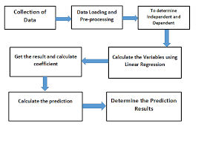

### 

### 2. Model Results

For the linear regression model, Table TM2 outlines the exact architecture used to train each model iteration.

TABLE TM2

Architecture of Linear regression model

| Parameters | Values used (default values) |
| --- | --- |
| fit_intercept | True |
| copy_X | True |
| n_jobs | None |
| positive | False |

* + After training, two measures were used to determine the error of the regression model: mean squared error (MSE) and R- squared error. The MSE shows how close a regression line is to a set of points. It does this by taking the distances from the points to the regression line (these distances are the “errors”) and squaring them. The squaring is necessary to remove any negative signs. It gives more weight to larger differences.
  + R-squared (R2) is a statistical measure that represents the proportion of the variance for a dependent variable that's explained by an independent variable or variables in a regression model.
  + The average of mean squared error for the model after 100 iterations was approximately 89 (from table TM3) which was lowest among all the models under consideration. Also the average value of R- squared error (table TM4) after 100 iterations was 0.94 which was best among the three models (For logistic MSE and R- squared was not calculated).

TABLE TM3

Linear Regression MSE Performance Metrics

| MSE Mean | 88.99348 |
| --- | --- |
| MSE Max | 157.91675 |
| MSE Min | 59.93440 |

TABLE TM4

Linear Regression R2 Performance Metrics

| R2 Mean | 0.94295 |
| --- | --- |
| R2 Max | 0.95995 |
| R2 Min | 0.89916 |

## B. Logistic Regression

### 1. Summary of Approach

Logistic regression is a process of modeling the probability of a discrete outcome given an input variable. The most common logistic regression models a binary outcome; something that can take two values such as true/false, yes/no etc. Logistic regression is used to predict the categorical dependent variable using a given set of independent variables. The full model architecture is shown below in Table TM8. The model was trained using a 0.0001 tolerance, giving no preference to weights, and using the lbfgs solver.

Figure TM5

Schematic of a logistic regression classifier [21]

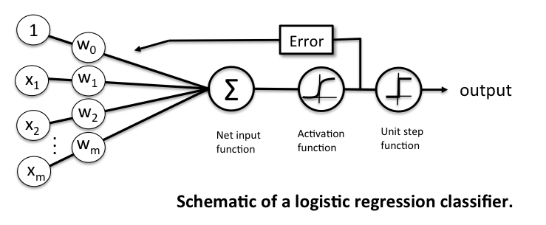

### 

### 2. Model Results

To determine the performance of the model Confusion matrix was used. There are four ways to check if the predictions are right or wrong: TN / True Negative: the case was negative and predicted negative. TP / True Positive: the case was positive and predicted positive.

On the training set; the logistic model made the correct investment decision 92% of the time. However, the model advised investors to invest when they shouldn’t have 5% of the time. That means that when told to invest; the model would be correct 87% of the time.

As seen in the Classification Report (TM6); the model made accurate predictions from classification algorithms over 90% of the time.

TABLE TM6

Logistic regression Classification Report

|  | Precision | Recall | f1-score | Support |
| --- | --- | --- | --- | --- |
| 0 | 0.93 | 0.87 | 0.90 | 158 |
| 1 | 0.90 | 0.95 | 0.92 | 201 |
| accuracy |  |  | 0.91 | 359 |
| macro avg | 0.92 | 0.91 | 0.91 | 359 |
| weighted avg | 0.91 | 0.91 | 0.91 | 359 |

TABLE TM7

Logistic regression Confusion Matrix ( 359 Test Samples)

| True Positive Rate | 38.4% |
| --- | --- |
| True Negative Rate | 53.7% |
| False Positive Rate | 5.6% |
| False Negative Rate | 3.1% |

TABLE TM8

Architecture of Logistic regression model

| Parameters | Values used (default) |
| --- | --- |
| penalty | l2 |
| Dual | False |
| Tolerance | 0.0001 |
| C | 1.0 |
| fit_intercept | True |
| intercept_scaling | 1 |
| class_weight | None |
| random_state | None |
| solver | lbfgs |
| max_iter | 100 |
| multi_class | auto |
| verbose | 0 |
| warm_start | False |

## C. Artificial Neural Network

### 1. Summary of Approach

The Artificial Neural Network (ANN) model relies on several stages of summing the results of inputs & weights together in order to find deeper meaning in large sets of information. In general an ANN model is divided into layers with a number of nodes that use a certain mathematical function (activation function) to analyze the outputs of other nodes on the same layer. Out of the four models tested, this model’s architecture is the most configurable..

The model architecture chosen for the ANN model by comparing the MSE output for each possible combination of hidden layers (1-4), nodes per hidden layer (1-10), and activation function (relu, tanh & logistic).

### 

### 2. Model Results

After initial testing, the ‘relu’ activation function with four hidden layers was the unanimous architecture for the top ten performing models. Another round of testing found the most optimal architecture (shown below in Table TM9 ) had a one time MSE of 117, an average MSE of 216, a max MSE of 1405, and a minimum MSE of 58.

TABLE TM9

Architecture of best performing ann model

| Activation Function | relu |
| --- | --- |
| # of Hidden Layers | 4 |
| Nodes per Hidden Layer | [7, 5, 8, 9] |
| Learning Rate | 0.001 |
| Tolerance | 0.001 |
| Max Iteration | 10000 |

Through 100 iterations, the ANN models had significant variation between MSE (58/1405) and R2 (-0.008/0.956) performance metrics. However, this variance caused the average MSE to be higher than other models. It is interesting to see numerous models have MSE values under 100 and then to have one above 1000. It is believed that during training, there are random weight values that either are too far from their convergence location or that the learning rate was too high and the weights eventually diverged.

TABLE TM10

ANN MSE Performance Metrics

| MSE Mean | 216.39571 |
| --- | --- |
| MSE Max | 1401.21127 |
| MSE Min | 58.45331 |

TABLE TM11

ANN R2 Performance Metrics

| R2 Mean | 0.87369 |
| --- | --- |
| R2 Max | 0.95584 |
| R2 Min | -0.00874 |

## D. Ensemble Model (Random Forest)

### 1. Summary of Approach

An ensemble model is different from other types of machine learning prediction models, because it is composed of a set of models rather than just a single model. The goal of an ensemble model is to have multiple models work together to solve an issue rather than just one model working alone. However, it is important to avoid group-think, the event where the models began to change their predictions based on the other models. This is avoided by having each model make their predictions independently. The two general ensemble model techniques are boosting and bagging. The model created to tackle this issue was a simple random forest model. A random forest model is the combination of bagging, subspace sampling and a decision tree. This ensemble model makes its predictions based on only the information required. In this case, the target features are continuous, meaning the median is preferred to the mean since the mean is affected more by outliers than the median. A random forest architecture can be seen below in TM12.

TABLE TM12

bagging and subspace sampling Example [22]

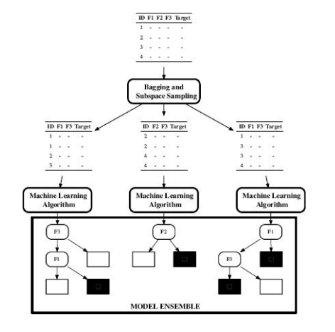

### 

### 2. Model Results

The model’s architecture was created from comparing the MSE output when varying the arguments available to the Random Forest Regressor while taking the average across 100 variations. The inputs that have changed from their default input are criterion and random_state. Increasing the n_estimators decreased the MSE output, where 10 to 100 are the available options so 100 was used which happens to be the default. The criterion can vary between squared_error, absolute_error and poisson. Squared_error was selected when attempting to determine the other arguments to use, but was switched to absolute_error since it gave a marginally lower MSE at the cost of an increase in calculation time. Random_state controls the randomness bootstrapping of the samples when creating the trees as well as the sampling of features to consider when making a split from a node. Random_state having a larger value decreased MSE reaching a saturation point around 100.

TABLE TM13

Architecture of best performing Random Forest model

| n_estimators | 100 |
| --- | --- |
| criterion | absolute_error |
| max_depth | None |
| random_State | 100 |

The following MSE and R2 performance metrics were calculated after training 100 unique models:

TABLE TM14

Random Forest MSE Performance Metrics

| MSE Mean | 240.05837 |
| --- | --- |
| MSE Max | 209.25048 |
| MSE Min | 285.29670 |

TABLE TM15

Random Forest R2 Performance Metrics

| R2 Mean | 0.84696 |
| --- | --- |
| R2 Max | 0.82890 |
| R2 Min | 0.86363 |

# V. Best Performing Model

Based on the average MSE from 100 separately trained models, the Multivariate Linear Regression model was the best for predicting the stock price of the QualComm corporation 28 days in the future. The Linear model had an average MSE of 89 while the other regression models had average MSEs around 200-250 (as seen below in Table PM1).

TABLE PM1

Summary of model performances

| Model | Avg MSE after 100 Iterations |
| --- | --- |
| **Multivariate Linear Regression** | **89** |
| Logistic Regression | x |
| Artificial Neural Network | 217 |
| Random Forest (Ensemble) | 240 |

The Logistic Regression Model was not considered for the ‘best model’ to predict stock price, because it is a classification model that does not predict the actual price of the stock in the future. The Logistic Regression model is a tool that can be used to support another model by plainly indicating when one should, or should, not invest in the QualComm corporation. A blanket ‘Yes’ or ‘No’ is a more risky investment tool by its nature of not being able to indicate to the user how much their investment is predicted to grow. Information with relative numbers yields more confidence than a plan boolean decision.

## A. Model Architecture

Please see the section Multivariate Linear Regression’ for the full details of the Multivariate Linear Regression model’s architecture.

## B. Predicting Stock Price

Line graphs detailing the Multivariate Linear Regression model’s predicted future stock price and the actual price 28 days later for the last five years and the latest 3 months are available on the other page. Please see Figure PM3 and PM4.

As seen in both figures; the linear regression model’s predictions are approximately following the general trends of the QualComm stock price. However, the model appears to be following the market instead of actively predicting ahead of the market. This is no surprise since the model is only able to predict what it has seen and cannot respond immediately to real-word results. The first year of model predictions in early 2017 is also an example of the model needing to re-align itself with reality before accurate predictions are made.

Prediction vs actual plots for the other three models (Logistic Regression, ANN, and Random Forest) can be seen in the Appendix section ‘B. Other Model 5 Year Stock Predictions Against Actual Close Price’.

## 

## C. Income Generated

Mean Square Error is the determinant of which of the models performed the best, however, the ultimate goal of this investigation is to predict the price of QualComm’s stock to make the most money. By determining a tolerance of when to invest (“Invest Tolerance”), each model has the ability to signal to an investor when they should have invested in the QualComm corporation. The amount of money that is gained/lost on an investment date is shown below in equation 1.

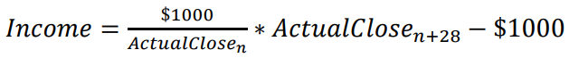 (1)

The ‘Predicted Income’ is the amount of money gained/lost based on the actual price of the stock when funds are invested (purchase price) compared to the model’s predicted stock price in 28 days (sell price). The tally for which days to invest, the amount of stock purchased for a $1000 investment, predicted price, and actual price is available for review in the appendix, section *‘C. Example Model Recommended Investment Record*’. The model that made the most money was also the model with the lowest MSE (Multivariate Linear Regression), followed by the Logistic Regression mode, then ANN, and Random Forest.

TABLE PM2

Income Generated for one instance* of each model

| Model | Number of Investments | Predicted Income | Actual Income | Difference |
| --- | --- | --- | --- | --- |
| Multivariate Linear Regression | 355 | $64347.90 | $62126.86 | 3.5% |
| Logistic Regression | 277 | NA | $60047.88 | NA |
| Artificial Neural Network | 289 | $48981.16 | $52537.31 | 6.7% |
| Random Forest (Ensemble) | 404 | $91264.66 | $43002.15 | 47.1% |

*This is not an average. The values shown are the result of a single model training for example purposes only.

It is worth noting that all of the income values shown in Table PM2 reflect investments made in hynsite (looking back at how the stock has already performed, not on future dates).

TABLE PM3

5-Year Predicted vs Actual stock price for the Multivariate linear regression model

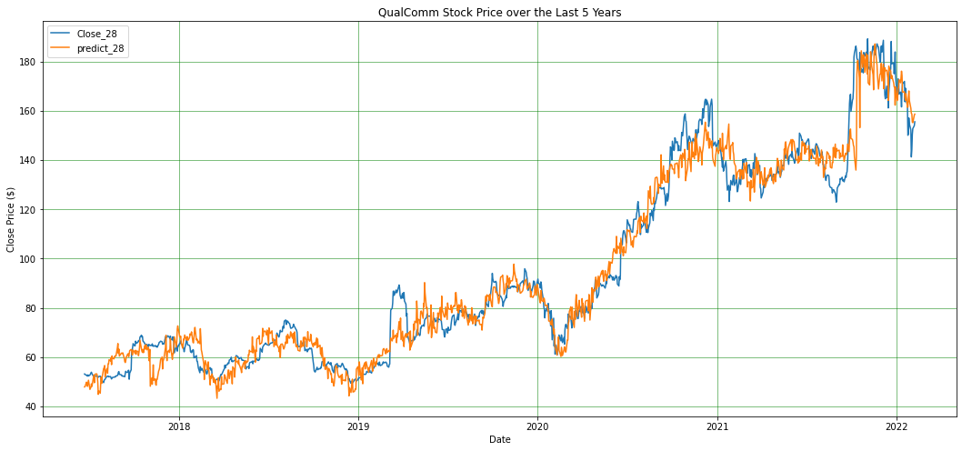

TABLE PM4

3-Month Predicted vs Actual stock price for the Multivariate linear regression model

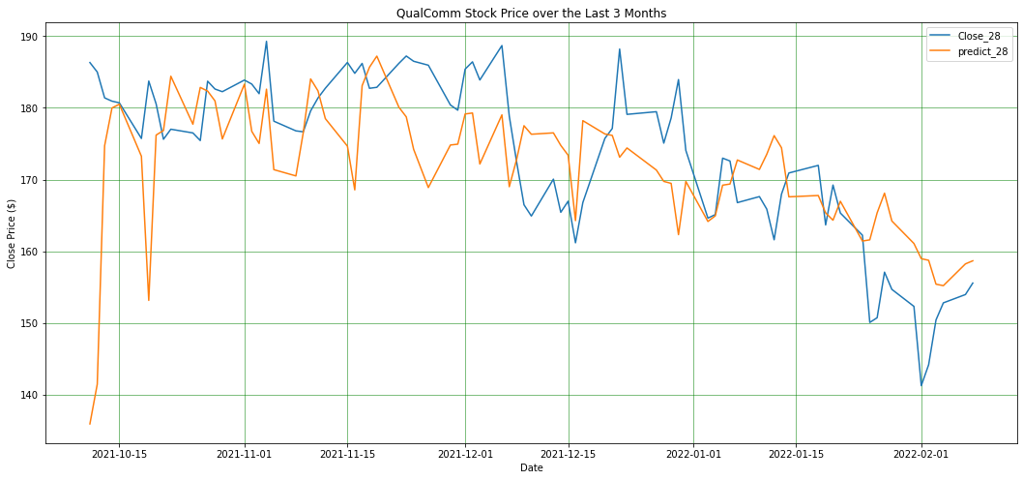

# VI. Discussion

## A. Why did you choose the model that you did?

By looking at Table PM1 & PM2, the model with the lowest MSE also made predictions that made the most money. The Multivariate Linear Regression model had the lowest MSE, being that of 89 compared to the other models and made the most actual money from investments ($62126.86). The MSE metric was chosen to decide the “best” model, because it assesses the average squared difference between the predicted and actual outcomes. When the model is closely aligned with the real-world, then investors can take full advantage of it.. See section V. Best Model for more information.

## B. Is your model good? Why or why not?

The Linear Regression models success can be viewed clearly by looking at Graph(TABLE PM3) and Graph (TABLE PM4), these graphs help show the models accuracy in predicting the QualComm stock price. Since the variation between predicted and actual stock price are so close to each other it can be argued that the Linear Regression model is good.

## C. Is the computed income a good deal? Why or why not?

The computed income was arguably a good idea because with each model the profit generated tended to be positive. It can be argued that this information may have influenced the decision making on which model is best, despite not having been how closely the model predicted the stock price. However the correlation cannot be denied.

## D. What would you do to improve this model?

The models could possibly be improved by removing features that had little to no effect on the target variable, finding the outside variables that could have a major effect on QualComm’s stock price that was not added into the dataset used for calculations, changing the models parameters to be best optimized.

# VII. Conclusion

In conclusion; predicting the fluctuation of any particular stock can be a challenging task for anyone, which is why entire careers are based around attempting to do so. The outcome of a prediction is based on a large quantity of variables, some easier to see the connection over others.

For this prediction analysis; using Linear, Logistic, Neural-Network, and Ensemble models to predict the QualComm stock priced on a large range of features tended to lead to positive investing choices. They each approached the problem in their own way. Linear focused on modeling the correlation between dependent and independent variables. Logistic used an input variable to calculate a discrete outcome, due to its binary nature to focus on when to predict versus when not to predict. Neural-Network goal is to use several stages of summing the results caused by the inputs and weights together with the end goal being to find a deeper meaning between the features in a large set of information. Ensemble makes its prediction based on the cumulative prediction of other models merged together in order to make a more “informed” prediction.

In this analysis; it was determined that by looking at a model’s MSE as well as income generated, the Linear Regression model was best fitted for predicting the stock market price. Each model's outcome could be swayed based on the parameters chosen, the data preparation and features chosen.

# Appendix

## 

## A. Data Quality Report of the Final Dataset

The following Data Quality Report does not include previous day feature columns (IE: A column dedicated to the close value x days ago). See section: ‘III. Data Preparation’ for more details.

TABLE A1

Data Quality Report of features used in model training before processing.

| **stat** | **Date** | **Close/Last** | **Volume** | **Open** | **High** | **Low** |
| --- | --- | --- | --- | --- | --- | --- |
| **count** | 1260 | 1260 | 1260 | 1260 | 1260 | 1260 |
| **cardinality** | 1260 | 1149 | 1259 | 1156 | 1180 | 1180 |
| **mean** | * | 94.34067 | 11185564 | 94.35892 | 95.64676 | 93.06873 |
| **median** | * | 77.91 | 9396205 | 77.595 | 78.9475 | 76.685 |
| **number at median** | * | 0 | 0 | 0 | 0 | 0 |
| **mode** | 5/1/2017 | 52.49 | 11301880 | 52 | 58.49 | 52.27 |
| **number at mode** | 1 | 4 | 2 | 3 | 4 | 3 |
| **stddev** | * | 39.76462 | 8104528 | 39.82371 | 40.48734 | 39.08962 |
| **min** | * | 49.4 | 2120165 | 49.52 | 49.8 | 48.56 |
| **number at min** | * | 1 | 1 | 1 | 1 | 1 |
| **max** | * | 189.28 | 1.56E+08 | 190.304 | 193.58 | 185.1852 |
| **number at max** | * | 1 | 1 | 1 | 1 | 1 |
| **number of zeros** | * | 0 | 0 | 0 | 0 | 0 |
| **number missing** | 0 | 0 | 0 | 0 | 0 | 0 |

All measurements annotated with ‘*’ represents an invalid mathematical operation with a non-numeric feature

TABLE A2

Data Quality Report of features used in model training before processing.

| **stat** | **Gross Profit** | **Net Income Available to Common Shareholders** | **InflationRate** | **Total Assets** | **Total Liabilities** | **Net Income/Starting Line** |
| --- | --- | --- | --- | --- | --- | --- |
| **count** | 1260 | 1260 | 1260 | 1260 | 1260 | 1260 |
| **cardinality** | 1238 | 1239 | 589 | 1240 | 1241 | 1238 |
| **mean** | 3826.356 | 922.0514 | 2.548702 | 43858.82 | 31443.82 | 922.1066 |
| **median** | 3172.957 | 843.8261 | 2.149194 | 37408.94 | 30194.48 | 844.1992 |
| **number at median** | 0 | 0 | 0 | 0 | 0 | 0 |
| **mode** | 6402 | 3399 | 1.7 | 42820 | 31487 | 3399 |
| **number at mode** | 20 | 20 | 111 | 20 | 20 | 20 |
| **stddev** | 1185.773 | 1631.14 | 1.241059 | 12563.45 | 4011.146 | 1630.572 |
| **min** | 2654 | -5913.26 | 1.2 | 31938 | 22341.87 | -5912.93 |
| **number at min** | 1 | 1 | 21 | 1 | 1 | 1 |
| **max** | 7521 | 3399 | 5.5 | 65473.39 | 40425.68 | 3399 |
| **number at max** | 1 | 1 | 21 | 1 | 1 | 1 |
| **number of zeros** | 0 | 0 | 0 | 0 | 0 | 0 |
| **number missing** | 0 | 0 | 0 | 0 | 0 | 0 |

TABLE A3

Data Quality Report of features used in model training before processing.

| **stat** | **Dividends Paid** | **Net Changes in Cash** | **BrentCrudeOil** | **DGS3MO** | **DGS2** | **DGS10** |
| --- | --- | --- | --- | --- | --- | --- |
| **count** | 1260 | 1260 | 1260 | 1260 | 1260 | 1260 |
| **cardinality** | 1230 | 1241 | 1136 | 221 | 244 | 253 |
| **mean** | -778.002 | -64.1719 | 62.55909 | 1.069576 | 1.338688 | 1.923952 |
| **median** | -763.234 | -142.648 | 64.50149 | 1.05 | 1.47 | 1.9 |
| **number at median** | 0 | 0 | 0 | 12 | 7 | 6 |
| **mode** | -765 | -509 | 80.76636 | 0.05 | 0.16 | 1.63 |
| **number at mode** | 20 | 20 | 125 | 78 | 83 | 17 |
| **stddev** | 55.80532 | 6477.438 | 13.79855 | 0.904571 | 0.951453 | 0.751955 |
| **min** | -911 | -25586.4 | 23.33727 | 0 | 0.09 | 0.52 |
| **number at min** | 1 | 1 | 1 | 2 | 1 | 1 |
| **max** | -705 | 19877.92 | 83.65 | 2.49 | 2.98 | 3.24 |
| **number at max** | 1 | 1 | 1 | 2 | 1 | 1 |
| **number of zeros** | 0 | 0 | 0 | 4 | 0 | 0 |
| **number missing** | 0 | 0 | 0 | 10 | 10 | 10 |

TABLE A4

Data Quality Report of features used in model training before processing.

| **stat** | **DTWEXBGS** | **CBBTCUSD** | **Close_AAPL** | **Close_ERIXF** | **Close_GOOGL** | **Close_INTL** |
| --- | --- | --- | --- | --- | --- | --- |
| **count** | 1260 | 1260 | 1260 | 1260 | 1260 | 1260 |
| **cardinality** | 1233 | 1260 | 1221 | 582 | 1250 | 968 |
| **mean** | 114.2736 | 18143.64 | 83.43226 | 9.307935 | 1562.801 | 50.62603 |
| **median** | 114.5039 | 9298.16 | 60.67375 | 8.955 | 1245.9 | 50.59 |
| **number at median** | 0 | 1 | 0 | 3 | 0 | 2 |
| **mode** | 113.6874 | 1436.5 | 43.125 | 9 | 1005.65 | 46.7 |
| **number at mode** | 2 | 1 | 3 | 19 | 2 | 4 |
| **stddev** | 3.336445 | 17716.88 | 45.11082 | 2.151958 | 633.0315 | 7.145869 |
| **min** | 106.4903 | 1436.5 | 35.5475 | 5.54 | 919.46 | 33.46 |
| **number at min** | 1 | 1 | 1 | 1 | 1 | 1 |
| **max** | 126.1428 | 67510.06 | 182.01 | 14.36 | 2996.77 | 68.47 |
| **number at max** | 1 | 1 | 1 | 1 | 1 | 1 |
| **number of zeros** | 0 | 0 | 0 | 0 | 0 | 0 |
| **number missing** | 24 | 1 | 0 | 0 | 0 | 0 |

TABLE A5

Data Quality Report of features used in model training before processing.

| **stat** | **Close_NXPI** | **Close_SSNLF** | **Close_TMUS** | **Close_VZ** | **Close_28** |
| --- | --- | --- | --- | --- | --- |
| **count** | 1260 | 1260 | 1260 | 1260 | 1260 |
| **cardinality** | 1169 | 17 | 1123 | 821 | 1129 |
| **mean** | 132.6214 | 1961.236 | 90.9945 | 54.49279 | 95.1987 |
| **median** | 115.88 | 2210 | 78.59 | 55.27 | 78.615 |
| **number at median** | 3 | 940 | 2 | 2 | 0 |
| **mode** | 97.65 | 2210 | 59.75 | 55.78 | 52.49 |
| **number at mode** | 3 | 940 | 3 | 5 | 4 |
| **stddev** | 43.37271 | 671.3485 | 28.31623 | 4.373864 | 39.79902 |
| **min** | 64.56 | 57.75 | 55.36 | 42.89 | 49.4 |
| **number at min** | 1 | 138 | 1 | 1 | 1 |
| **max** | 238.9 | 2450 | 149.41 | 62.07 | 189.28 |
| **number at max** | 1 | 138 | 1 | 1 | 1 |
| **number of zeros** | 0 | 0 | 0 | 0 | 0 |
| **number missing** | 0 | 0 | 0 | 0 | 28 |

## B. Other Model 5 Year Stock Predictions Against Actual Close Price

### Logistic Regression

Figure B1

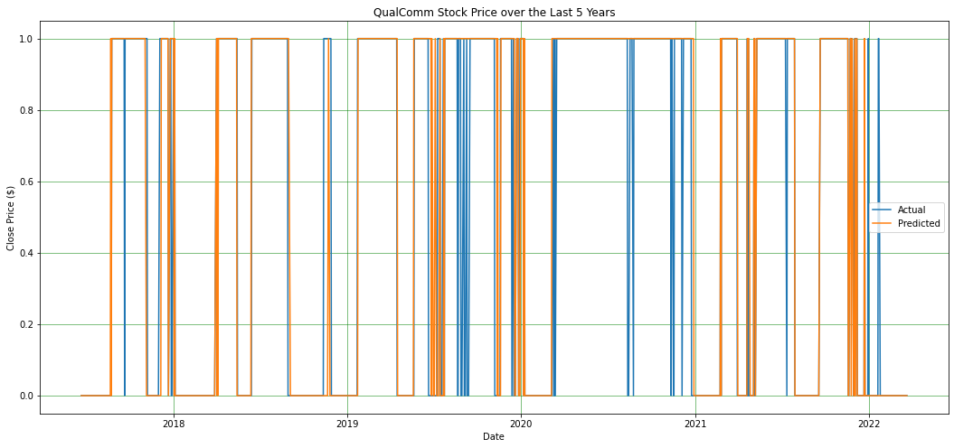

Figure B2

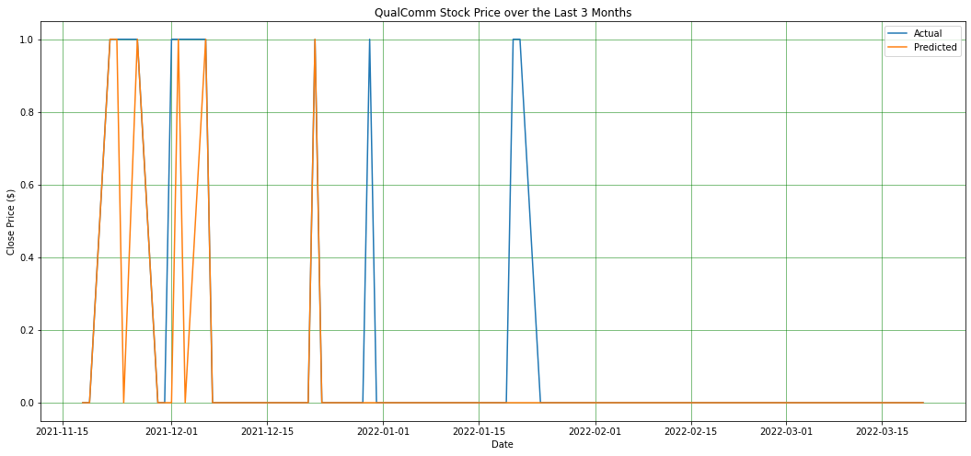

*Note: The Logistic Regression prediction vs actual close price plots are referenced in binary. ‘1 = You should Invest’ and ‘0 = You should not Invest’. Therefore, an accurate model prediction will prejudice an identical 1/0 plot.

### 

### 

### Artificial Neural Network

Figure B3

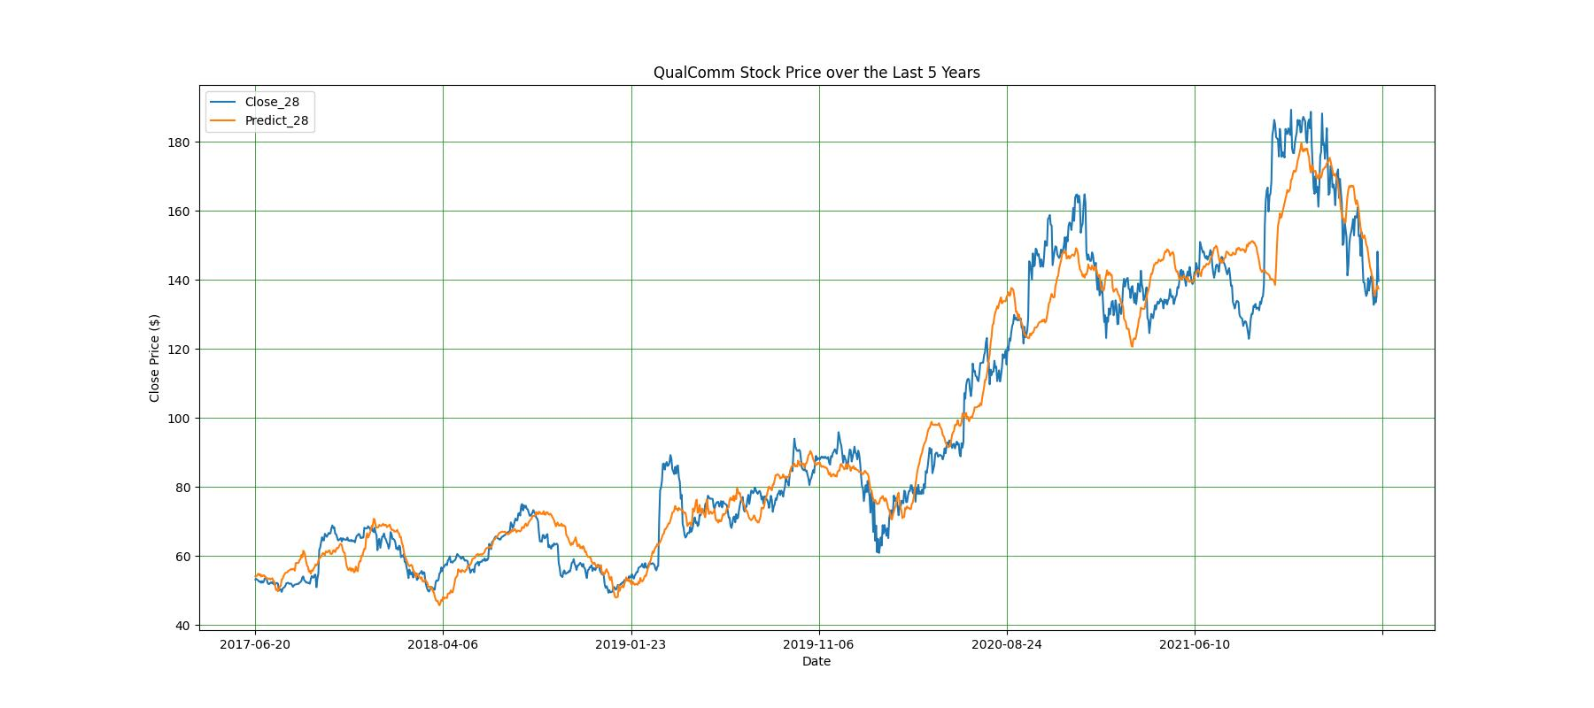

Figure B4

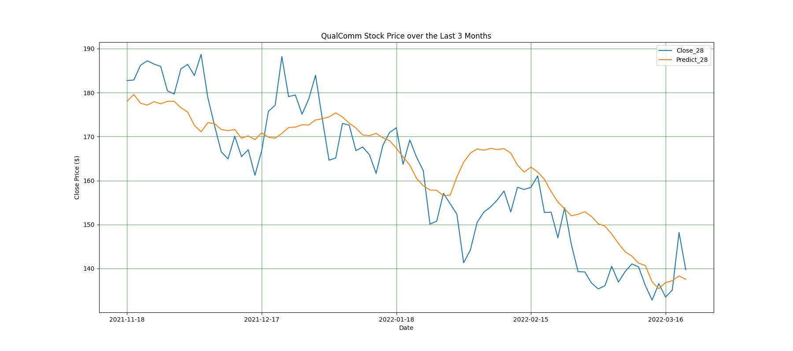

### 

### Random Forest

Figure B5

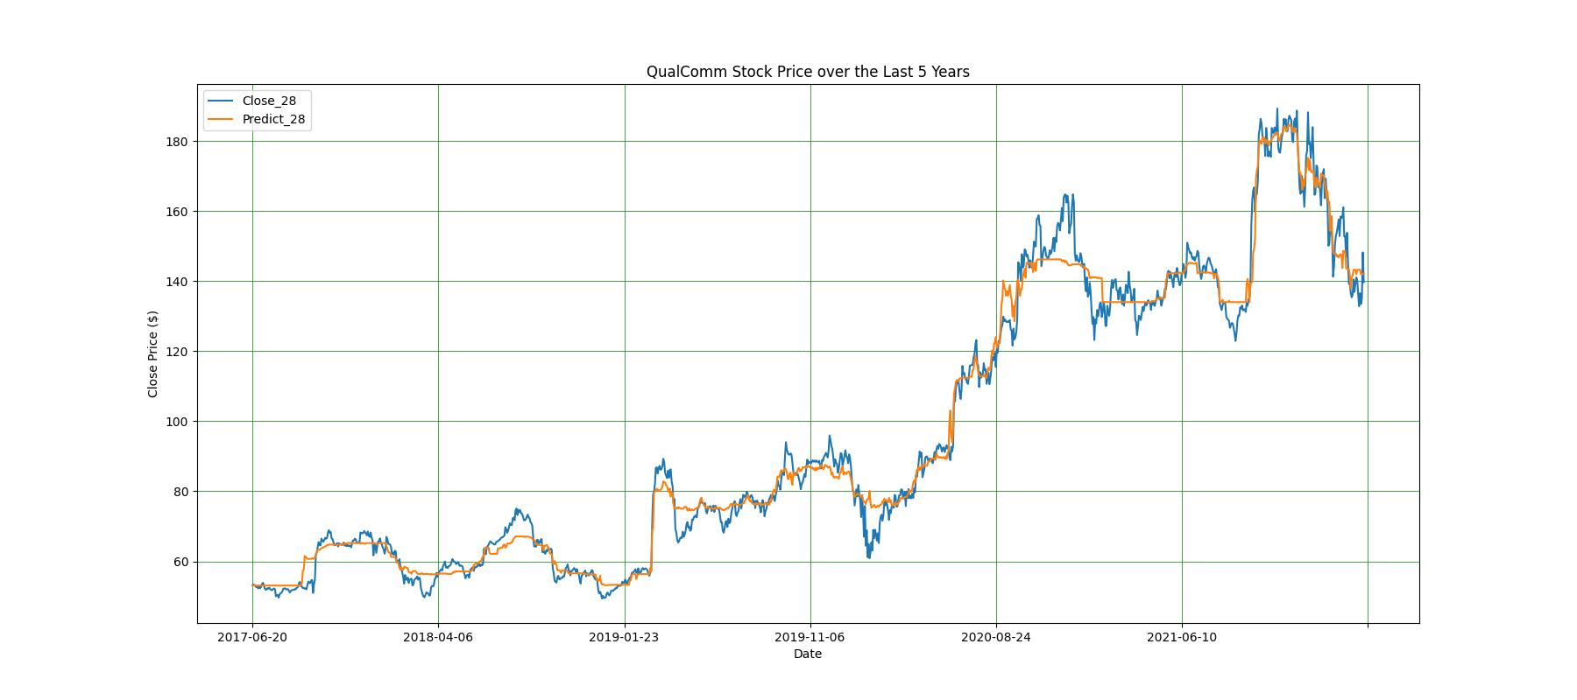

Figure B6

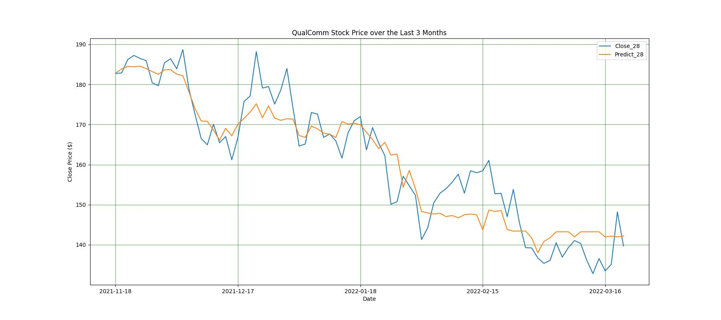

## 

## C. Example Model Recommended Investment Record

| Index | Date | Quantity | Purchase Close | Sell Close | Model Sell Close Price | Predicted Income | Actual Income |
| --- | --- | --- | --- | --- | --- | --- | --- |
| 40 | 2017-08-18 | 19.260 | 51.92 | 51.75 | 58.90 | 134.47 | -3.27 |
| 41 | 2017-08-21 | 19.238 | 51.98 | 51.84 | 57.22 | 100.95 | -2.69 |
| 43 | 2017-08-23 | 19.146 | 52.23 | 52.02 | 59.69 | 143.01 | -4.02 |
| 44 | 2017-08-24 | 19.051 | 52.49 | 51.96 | 59.43 | 132.24 | -10.09 |
| 45 | 2017-08-25 | 19.219 | 52.03 | 52.35 | 59.64 | 146.38 | 6.15 |
| ... | ... | ... | ... | ... | ... | ... | ... |
| 1100 | 2021-11-03 | 7.221 | 138.48 | 181.98 | 172.16 | 243.26 | 314.12 |
| 1101 | 2021-11-04 | 6.405 | 156.11 | 189.28 | 180.02 | 153.19 | 212.47 |
| 1105 | 2021-11-10 | 6.257 | 159.8 | 179.58 | 182.02 | 139.09 | 123.77 |
| 1106 | 2021-11-11 | 6.081 | 164.42 | 181.38 | 182.88 | 112.30 | 103.15 |
| 1107 | 2021-11-12 | 6.062 | 164.94 | 182.74 | 182.58 | 106.97 | 107.91 |

## 

## E. Python Code for Data Quality Analysis

### Flow Controls and Data Handling

# Flow control and data handling settings

steps:

## Raw base data loading

- module: process.prepare.Load

input:

name: input_raw

output:

name: raw

print: true

- module: process.dqr.DQR

input:

name: raw

output:

write: true

name: qcom_stock_daily_raw

- module: process.prepare.ConvertTypes

args:

columns:

Date: date

Close/Last: currency

Open: currency

High: currency

Low: currency

input:

name: raw

output:

name: clean

print: true

- module: process.prepare.Sort

args:

sortColumn: Date

ascending: True

input:

name: clean

output:

name: clean

- module: process.dqr.DQR

input:

name: clean

output:

write: true

name: qcom_stock_daily

## QCOM profit/loss data loading

- module: process.prepare.Load

input:

name: input_qcom_profit_loss

output:

name: qcom_profit_loss_raw

- module: process.prepare.ConvertTypes

args:

columns:

Date: date

Revenue: float

"Cost of revenue": float

"Gross Profit": float

"Operating Expenses": float

"Operating Income (Loss)": float

"Non-Operating Income (Loss)": float

"Pretax Income (Loss)": float

"Income Tax (Expense) Benefit, net": float

"Income (Loss) Including Minority Interest": float

"Minority Interest": float

"Net Income Available to Common Shareholders": float

input:

name: qcom_profit_loss_raw

output:

name: qcom_profit_loss_raw

- module: process.dqr.DQR

input:

name: qcom_profit_loss_raw

output:

write: true

name: qcom_profit_loss

## Inflation rate data loading

- module: process.prepare.Load

input:

name: input_inflation

output:

name: inflation_raw

- module: process.prepare.ConvertTypes

args:

columns:

Date: date

InflationRate: float

input:

name: inflation_raw

output:

name: inflation_raw

- module: process.dqr.DQR

input:

name: inflation_raw

output:

name: inflation

# QCOM Balance Loading

- module: process.prepare.Load

input:

name: input_qcom_balance

output:

name: qcom_balance_raw

- module: process.prepare.ConvertTypes

args:

columns:

Date: date

Assets: float

"Cash, Cash Equivalents & Short Term Investments": float

"Accounts & Notes Receivable": float

Inventories: float

"Other Short Term Assets": float

"Total Current Assets": float

"Property, Plant & Equipment, Net": float

"Long Term Investments & Receivables": float

"Other Long Term Assets": float

"Total Noncurrent Assets": float

"Total Assets": float

Liabilities: float

"Payables & Accruals": float

"Short Term Debt": float

"Other Short Term Liabilities": float

"Total Current Liabilities": float

"Long Term Debt": float

"Other Long Term Liabilities": float

"Total Noncurrent Liabilities": float

"Total Liabilities": float

"Preferred Equity": float

"Share Capital & Additional Paid-In Capital": float

"Retained Earnings": float

"Other Equity": float

"Equity Before Minority Interest": float

"Minority Interest": float

"Total Equity": float

"Total Liabilities & Equity": float

input:

name: qcom_balance_raw

output:

name: qcom_balance_raw

- module: process.dqr.DQR

input:

name: qcom_balance_raw

output:

write: true

name: qcom_balance

# QCOM Cashflow loading

- module: process.prepare.Load

input:

name: input_qcom_cashflow

output:

name: cashflow_raw

- module: process.prepare.ConvertTypes

args:

columns:

Date: date

"Net Income/Starting Line": float

"Depreciation & Amortization": float

"Non-Cash Items": float

"Change in Working Capital": float

"Cash from Operating Activities": float

"Change in Fixed Assets & Intangibles": float

"Net Change in Long Term Investment": float

"Net Cash From Acquisitions & Divestitures": float

"Other Investing Activities": float

"Cash from Investing Activities": float

"Dividends Paid": float

"Cash From (Repayment of) Debt": float

"Cash From (Repurchase of) Equity": float

"Other Financing Activities": float

"Cash from Financing Activities": float

"Net Cash Before Disc. Operations and FX": float

"Change in Cash from Disc. Operations and Other": float

"Net Cash Before FX": float

"Effect of Foreign Exchange Rates": float

"Net Changes in Cash": float

input:

name: cashflow_raw

output:

name: cashflow_raw

- module: process.dqr.DQR

input:

name: cashflow_raw

output:

write: true

name: cashflow

# Brent crude oil loading

- module: process.prepare.Load

input:

name: input_crude_oil

output:

name: crude_oil_raw

- module: process.prepare.Rename

args:

columns:

DATE: Date

POILBREUSDM: BrentCrudeOil

input:

name: crude_oil_raw

output:

name: crude_oil_raw

- module: process.prepare.ConvertTypes

args:

columns:

Date: date

BrentCrudeOil: float

input:

name: crude_oil_raw

output:

name: crude_oil_raw

- module: process.dqr.DQR

input:

name: crude_oil_raw

output:

write: true

name: crude_oil

## Final dataset

- module: process.prepare.Load

input:

name: input_final_post

output:

name: final_raw

- module: process.prepare.StartsWithDrop

input:

name: final_raw

args:

starts:

- Prev

- Unnamed

output:

name: final_raw

- module: process.dqr.DQR

input:

name: final_raw

output:

write: true

name: final_data_processed

**Model Functionality**

#!/usr/bin/env python3

'''

@module qcommodel.model

@info Parent module for running end-to-end stock price modeling for the ECE

5984 group K project2 effort. More to come

'''

# Python libraries

import sys

import os

import yaml

import traceback

# Third party libraries

import pandas as pd

from importlib import import_module

# Local libraries

from utils.logger import Logger

from utils.dataframe import Summarize

from utils.dataframe import Write

## Model implementation class

class Model():

''' This class performs configuration loading, data processing, model

training and final model storage with abstracted methods for

intermediate states

'''

def __init__(self, config_file):

''' Constructor

:param config_file: String path to the configuration file

'''

# Parse the configuration file

self._config = self.readConfig(config_file)

assert self._config != None, 'Failed to parse configuration data'

# Initialize class member data

self.initVariables()

# Setup logging

self.initLogger()

# Initialization complete

self.logger.info('Initialization complete')

## Data modeling functionality

############################################################################

@staticmethod

def loadSteps(steps):

''' Load and validate modeling steps

:param steps: List of step configuration dicts

:return List: Step objects

'''

result = []

for idx, step in enumerate(steps):

print(f'Loading step-{idx}')

result.append(Step(step))

return result

def run(self):

''' Data prepration wrapper method

This function uses configuration fields to load, analyze, and prepare

input data for further modeling

:return None:

'''

# Setup input data/preparation settings

self.logger.info(f"Processing input files: {self._config_input.keys()}")

steps = self.loadSteps(self._config_steps)

outputs = {}

for key in self._config_input.keys():

outputs[f'input_{key}'] = self._config_input[key]

for idx, step in enumerate(steps):

# Run the step

self.logger.info('')

self.logger.info(f'Running step-{idx}: {step.module.__name__}')

# Handle multiple input objects prior to positional arguments

inputs = []

if type(step.input.name) in [list, tuple]:

inputs += step.input.name

else:

inputs = [step.input.name]

# Get the object mapping to the input for each specified input

for idx in range(len(inputs)):

print(inputs[idx])

inputs[idx] = outputs[inputs[idx]]

# Call the function with kwargs if specified

if step.args:

output = step.module(*inputs, **step.args)

else:

output = step.module(*inputs)

self.logger.info('==================================================')

# Process the output of the step

outputs[step.output.name] = output

if step.output.write:

ofn = self._config_output['prefix'].replace('%suffix', step.output.name.lower())

self.logger.info(f'Writing data to: {ofn}')

Write(output, ofn)

if step.output.summarize:

Summarize(output, prefix=step.output.name)

if step.output.print:

print(output)

self.logger.info('==================================================')

## Class support functions

############################################################################

def initVariables(self):

''' Class member variable initialization

Initializes all class member variables with defaults/config fields

=> Configuration field requirements are defined by the method of

access. .get for optional, direct access for requried

:return None:

'''

# Utilities

self.name = self.__class__.__name__

self._config_logging = self._config.get('logging', {})

# Debug

self._config_debug = self._config.get('debug', {})

self._summarize = self._config_debug.get('summarize', False)

# Input data configuration

self._config_input = self._config['input']

# Output data configuration

self._config_output = self._config['output']

# Modeling steps configuration

self._config_steps = self._config['steps']

def initLogger(self):

''' Logger initialization function

Initializes class member 'logger'

:return None:

'''

# Just pass config file logging params through

self._config_logging['name'] = self.name

self.logger = Logger(**self._config_logging)

@staticmethod

def readConfig(fn):

''' Configuration file parser

:param fn: String path to the config file

:return dict: Config file contents

'''

result = None

assert os.path.exists(fn), 'Missing/invalid configuration: {fn}'

try:

with open(fn, 'r') as fd:

result = yaml.safe_load(fd)

except Exception as exc:

print(f'Failed to parse configuration: {fn}')

print(f'\n{traceback.format_exc()}')

return result

## Modeling 'Step' wrapper class/object

class Step:

class Input:

def __init__(self, config):

self.validate(config)

self.name = config['name']

def validate(self, config):

''' Validate input settings '''

assert type(config['name']) in [str, list, tuple], f"Invalid input name: {config['name']}"

class Output:

def __init__(self, config):

self.validate(config)

self.name = str(config['name']).lower()

self.write = bool(config.get('write', False))

self.print = bool(config.get('print', False))

self.summarize = bool(config.get('summarize', False))

def validate(self, config):

''' Validate input settings '''

assert isinstance(config['name'], str), f"Invalid output name: {config['name']}"

def __init__(self, config):

''' Constructor

:param method: String path to the python module

:param input: Python dict with data descriptor fields

- name:

:param output: Python dict with data descriptor fields

- write: Bool write to file flag

- print: Bool print object flag

- summarize: Bool pd.dataframe summary flag

- name: String name of the output for mapping to other steps

'''

self.validate(config)

module = config['module'].split('.')

method = module[-1]

module = '.'.join(module[:-1])

try:

self.module = import_module(module)

self.module = getattr(self.module, method)

except Exception:

print(traceback.format_exc())

print(f"Step - Failed to load module: {config['module']}")

raise ImportError(f"Failed to load module: {config['module']}")

self.args = config.get('args', None)

self.input = self.Input(config['input'])

self.output = self.Output(config['output'])

def validate(self, config):

''' Step configuration validation '''

assert 'module' in config, 'Step missing required field "module"'

assert 'input' in config, 'Step missing required field "input"'

assert 'output' in config, 'Step missing required field "output"'

if __name__ == '__main__':

# Create the model class

if len(sys.argv[1:]):

fn = sys.argv[1]

else:

#fn = os.path.dirname(os.path.realpath(__file__)) + '/conf/ann.yaml'

#fn = os.path.dirname(os.path.realpath(__file__)) + '/conf/model.yaml'

fn = os.path.dirname(os.path.realpath(__file__)) + '/conf/ensemble.yaml'

print(f'Using configuration file: {fn}')

model = Model(fn)

# Run the modeling steps

model.run()

'''

@module qualcomm.process.prepare

@info General data processing support

@author ece5984-groupk

'''

# Python libraries

import yaml

import os

import sys

# Third party libraries

import pandas as pd

import numpy as np

## Data preparation functions

################################################################################

def Load(data_file):

''' Static data loading method

:param data_file: String path to the data file

:return pd.DataFrame: DataFrame housing data file contents

'''

if not os.path.exists(data_file):

print(f'{data_file} not found - Searching in parent directory', file=sys.stderr)

data_file = os.path.dirname(__file__) + '/../../' + data_file

assert os.path.exists(data_file), f'Invalid data file: {data_file}'

dtype = data_file.split('.')[-1].upper()

result = None

if dtype == 'CSV':

result = pd.read_csv(data_file)

else:

raise TypeError(f'Unsupported file type: {dtype}')

return result

def Rename(df: pd.DataFrame, columns: dict):

''' Rename columns

:param df: Pandas dataframe

:param columns: Dict of format {old_name: new_name}

:return pd.DataFrame: Updated dataframe

'''

result = df.copy()

result = result.rename(columns=columns)

return result

def CapitalizeColumns(df: pd.DataFrame, upper: bool=True):

''' Capitalize column names

:param df: Pandas dataframe

:param upper: Boolean uppercase flag (default True)

:return pd.DataFrame: Updated dataframe

'''

if upper:

df.columns = [col.upper() for col in df.columns]

else:

df.columns = [col.lower() for col in df.columns]

return df

def ExpandDate(df: pd.DataFrame, column: str):

''' Expand a date string column into day month year

:param df: Pandas dataframe

:param column: String name of the column to update

:return pd.DataFrame: Updated dataframe

'''

result = df.copy()

date = pd.to_datetime(result[column])

result['year'] = date.dt.year

result['month'] = date.dt.month

result['day'] = date.dt.day

return result

def ConvertTypes(df: pd.DataFrame, columns: dict):

''' Convert problematic data types to target formats

:param df: Pandas dataframe

:param columns: Dict of format {column_name: column_type}

:return pd.DataFrame: Updated dataframe

'''

result = df.copy()

for name, type in columns.items():

type = type.lower().strip()

if type == 'currency':

result[name] = result[name].replace('[\$,]', '', regex=True).replace(',', '').astype(float)

elif type == 'date':

result[name] = pd.to_datetime(result[name]).dt.date

elif type == 'float':

result[name] = result[name].replace(',', '').replace(',', '', regex=True).astype(float)

else:

raise ValueError(f'Unsupported data type: {type}')

return result

def Sort(df: pd.DataFrame, sortColumn: str, ascending: bool=True):

''' Sort a pd dataframe in ascending/descending fashion based on a single

column's values

:param df: Pandas DataFrame object

:param sortColumn: String name of the column to sort with

:param ascending: Boolean [a/de]scending flag (default: True/Ascending)

:return pd.DataFrame: Output dataframe object

'''

result = df.copy()

result = result.sort_values(by=sortColumn, ascending=ascending, ignore_index=True)

return result

def InterpolateAndConcatByDate(

target: pd.DataFrame,

source: pd.DataFrame,

columns: list,

method: str='linear'

):

''' Method for interpolating a data set to match a target and then add

selected columns to the original

:param: target: DataFrame to match and append new columns to

:param source: DataFrame with new values

:param columns: List of string column names to append

:param method: String pandas interpolation method

:return pd.DataFrame: resulting DataFrame

'''

# Copy the target and source so we don't update the inputs

result = target.copy()

src = source.copy()

# Reindex the target to it's Date column and the source by the full date range

result.index = result.reindex(target['Date']).index

src = src.set_index('Date')

# Reindex the source or new data by the target range

# Note: The min/max functions handle deltas in start and stop date for the

# two datasets. The interpolate function handles fitting missing data

startDate = min(result.index[0], src.index[0])

stopDate = max(result.index[-1], src.index[-1])

fullIndex = pd.date_range(startDate, stopDate, freq='1D')

src = src.reindex(fullIndex, fill_value=np.nan)

# Interpolate nan values

for column in columns:

src[column] = src[column].interpolate(method=method)

# Add the applicable date value to the target and return

for column in columns:

result.insert(len(result.columns), column, src[column])

# Reset the output index back to normal

result.index = result.reindex(target.index).index

return result

def StartsWithDrop(df: pd.DataFrame, starts: list):

result = df.copy()

toDrop = []

for start in starts:

for column in result.columns:

if column.startswith(start):

toDrop.append(column)

return result.drop(columns=toDrop)

'''

@module qualcomm.dqr.DQR

@info Wrapper method for returning a data quality report dataframe given

a standard pandas dataframe

@author ece5984_groupk

'''

# Python libraries

# Third party libraries

import pandas as pd

import numpy as np

def DQR(data: pd.DataFrame) -> pd.DataFrame:

''' Given a pandas dataframe, generated a DQR table

:param data: Pandas DataFrame object

:return pd.DataFrame: Data quality report

'''

dqr = pd.DataFrame()

dqr['statistic'] = [

'count',

'cardinality',

'mean',

'median',

'n_at_median',

'mode',

'n_at_mode',

'stddev',

'min',

'n_at_min',

'max',

'n_at_max',

'n_zero',

'n_missing'

]

for column in data.columns:

mode = data[column].mode()

if not len(mode):

continue

mode = mode[0]

value_counts = data[column].value_counts()

if data.dtypes[column] in [np.object_]:

entry = [

data[column].size,

len(data[column].unique()),

np.nan,

np.nan,

np.nan,

mode,

value_counts.get(mode, 0),

np.nan,

np.nan,

np.nan,

np.nan,

np.nan,

np.nan,

data[column].isnull().sum()

]

else:

median = data[column].median()

min = data[column].min()

max = data[column].max()

entry = [

data[column].size,

len(data[column].unique()),

data[column].mean(),

median,

value_counts.get(median, 0),

mode,

value_counts.get(mode, 0),

data[column].std(),

min,

value_counts.get(min, 0),

max,

value_counts.get(min, 0),

value_counts.get(0, 0) + value_counts.get(0.0, 0),

data[column].isnull().sum()

]

dqr[column] = entry

return dqr

### Multivariate Linear Regression

###############################################  
#Multivariate Linear Regression

###############################################

import pandas as pd

import numpy as np

from sklearn.metrics import confusion_matrix

from sklearn.metrics import accuracy_score

from sklearn.model_selection import train_test_split

import matplotlib.pyplot as plt

from sklearn.preprocessing import MinMaxScaler

import seaborn as sn

from sklearn import utils

from sklearn import preprocessing as preproc

import helperFunctions

df= pd.read_csv("C:/Users/anagh/OneDrive/Desktop/ML/FINAL_MODEL_DATASET.csv")

df.head()

z=['Close/Last', 'Open', 'High', 'Low']

df= reformatDailyDates(df, True)

df

df= appendPastData( df, 2, ['Close/Last'], True )

df= addTarget(df, 'Close_28', 28, True)

df

X= df.drop(['Date','Close_28'], axis=1).to_numpy()

y= df['Close_28'].to_numpy()

scaler= MinMaxScaler(feature_range=(-1,1))

scalertrain = scaler.fit(X)

X = scalertrain.transform(X)

X_train, X_test, y_train, y_test = train_test_split(X, y, test_size=0.30, random_state= 22222)

from sklearn.linear_model import LinearRegression

model= LinearRegression()

model.fit(X_train, y_train)

prediction= model.predict(X_test)

prediction

from sklearn import metrics

from sklearn.metrics import mean_squared_error

print("Mean squared error: %.2f" % mean_squared_error(y_test, prediction))

from sklearn.metrics import r2_score

print("Coefficient of determination: %.2f" % r2_score(y_test, prediction))

import sklearn.model_selection as modelsel

mse_results = []

rs_results = []

for i in range(100):

X_train, X_test, y_train, y_test = modelsel.train_test_split(X, y, test_size=0.30)

model= LinearRegression()

model.fit(X_train, y_train)

prediction= model.predict(X_test)

print("Mean squared error: %.2f" % mean_squared_error(y_test, prediction))

mse_results.append(metrics.mean_squared_error(y_test, prediction))

print("Coefficient of determination: %.2f" % r2_score(y_test, prediction))

rs_results.append(metrics.r2_score(y_test, prediction))

mseMean = np.mean(mse_results)

mseMin = np.min(mse_results)

mseMax = np.max(mse_results)

print("\n\rLinear Regression:\nMean = {}\nMax = {}\nMin = {}".format(mseMean, mseMax, mseMin))

rsMean = np.mean(rs_results)

rsMin = np.min(rs_results)

rsMax = np.max(rs_results)

print("\n\rLinear Regression:\nMean = {}\nMax = {}\nMin = {}".format(rsMean, rsMax, rsMin))

model.predict(X)

df['predict_28'] = model.predict(X)

df

calcIncome(df,'Close_28', 1000, 28, 1.1)

plot_5yr(df, 'Date', 'Close_28', 'predict_28')

plot_3month(df, 'Date', 'Close_28', 'predict_28')

'

### Logistic Regression

###############################################  
#*Logistic Regression*

###############################################

import helperFunctions

import pandas as pd

import numpy as np

from sklearn.metrics import confusion_matrix

from sklearn.metrics import accuracy_score

from sklearn.model_selection import train_test_split

import matplotlib.pyplot as plt

from sklearn.preprocessing import MinMaxScaler

import seaborn as sn

from sklearn import utils

from sklearn import preprocessing as preproc

df= pd.read_csv("C:/Users/anagh/OneDrive/Desktop/ML/FINAL_MODEL_DATASET.csv")

df.head()

z=['Close/Last', 'Open', 'High', 'Low']

df= reformatDailyDates(df, True)

df

df= appendPastData( df, 2, ['Close/Last'], True )

TOL= 1

df["result"] = np.where(df["Close_28"]>df['Close/Last']*TOL, 1,0)

X= df.drop(['Date','result'], axis=1).to_numpy()

y= df['result'].to_numpy()

scaler= MinMaxScaler(feature_range=(-1,1))

scalertrain = scaler.fit(X)

X = scalertrain.transform(X)

X_train, X_test, y_train, y_test = train_test_split(X, y, test_size=0.30, random_state= 22222)

from sklearn.linear_model import LogisticRegression

model= LogisticRegression()

model.fit(X_train, y_train)

prediction= model.predict(X_test)

prediction

from sklearn.metrics import classification_report

report = classification_report(y_test,prediction)

print(report)

from sklearn import metrics

confusion= metrics.confusion_matrix(y_test, prediction)

print(confusion)

model.predict(X)

df['predict_28'] = model.predict(X)

df

calcIncome(df,'Close_28', 1000, 28, 1.5)

plot_5yr(df, 'Date', 'result', 'predict_28')

plot_3month(df, 'Date', 'result', 'predict_28')

### Artificial Neural Network

*'''*

*ann.py*

*@author: John Smutny*

*@team: James Ensminger, Ben Johnson, Anagha Mudki, John Smutny*

*@info: Regression artificial neural network (ann) model to predict the*

*future stock price of the Qualcomm semiconductor company.*

*The ann model cycles through several model frameworks and then*

*chooses the best architecture to maximize profit from a $1000*

*investment 28 days prior to sale.*

*'''*

**from** sklearn **import** neural_network **as** ann

**from** sklearn **import** metrics

**from** sklearn **import** preprocessing **as** preproc

**import** sklearn.model_selection **as** modelsel

**import** numpy **as** np

**import** pandas **as** pd

**import** helperFunctions **as** hf

*### Set Constants*

*#######################################*

OUTPUT_FILES = **True**

ASCENDING_DATES = **True**

INCOME_TOLERANCE = 1.10

PREDICT_FUTURE_DAY = 28

INVESTMENT = 1000

INPUT_QUALCOMM = **'../../data/QCOM_HistoricalData_5yr.csv'**

INPUT_QUALCOMM_FINAL = \

**'../../data/final_extended_data_no_past_data_clean_extended.csv'**

INPUT_FINAL = **'../../data/FINAL_MODEL_DATASET.csv'**

APPLE_FILE = **'../../data/AAPL_HistoricalData_5yr.csv'**

GOOGLE_FILE = **'../../data/GOOGL_HistoricalData_5yr.csv'**

ERICSSON_FILE = **'../../data/ERIXF_HistoricalData_5yr.csv'**

INTEL_FILE = **'../../data/INTL_HistoricalData_5yr.csv'**

NXP_FILE = **'../../data/NXPI_HistoricalData_5yr.csv'**

SAMSUNG_FILE = **'../../data/SSNLF_HistoricalData_5yr.csv'**

TMOBILE_FILE = **'../../data/TMUS_HistoricalData_5yr.csv'**

VERIZON_FILE = **'../../data/VZ_HistoricalData_5yr.csv'**

INPUT_BOND03m = **'../../data/marketYield_3monthUsTreasureySecurity_5yr.csv'**

INPUT_BOND02 = **'../../data/marketYield_2YrUsTreasureySecurity_5yr.csv'**

INPUT_BOND10 = **'../../data/marketYield_10YrUsTreasureySecurity_5yr.csv'**

INPUT_DOLLAR = **'../../data/nominalBroadUSDollarIndex-5yr.csv'**

INPUT_BITCOIN = **'../../data/CoinbaseBitcoin_5yr.csv'**

INPUT_COMPANY = **'../../data/QCOM-SimFin-data-REFORMATTED.xlsx'**

OUTPUT_INCOME = **'../../artifacts/annIncome-TOL{}.xlsx'**.format(INCOME_TOLERANCE)

IDName = **"Date"**

TARGET_NAME = **"Close_{}"**.format(PREDICT_FUTURE_DAY)

*# Artificial Neural Network Settings*

*#######################################*

TRAIN_RATIO = 0.8

TEST_RATIO = 0.2

VALID_DATA_FROM_TRAIN = 0.25

RANDOM_SEED = 10

HIDDEN_LAYERS = [7, 5, 8, 9]

ACTIVATION_FCT = **'relu'**

SOLVER = **'adam'**

MAX_ITER = 10000

LEARNING_RATE = 0.0001 * 10

TOLERANCE = 0.0001* 100

EARLY_STOPPING = **True**

*### Data Processing*

*#######################################*

**def** prepData(df: pd.DataFrame) -> pd.DataFrame:

FINANCIAL_FEATURES = [**'Close/Last'**, **'Open'**, **'High'**, **'Low'**]

*# Data cleaning of the main QualComm stock data*

*# Below is Commented out b/c of ymal ann.py script*

*#df = hf.removeDollarSign(df, FINANCIAL_FEATURES)*

df = hf.reformatDailyDates(df, ASCENDING_DATES) *# Re-order dates*

*# Add new independent variables to help model stock price.*

df = hf.addFedData(df, **'DGS3MO'**, INPUT_BOND03m, ASCENDING_DATES)

df = hf.addFedData(df, **'DGS2'**, INPUT_BOND02, ASCENDING_DATES)

df = hf.addFedData(df, **'DGS10'**, INPUT_BOND10, ASCENDING_DATES)

df = hf.addFedData(df, **'DTWEXBGS'**, INPUT_DOLLAR, **True**)

df = hf.addFedData(df, **'CBBTCUSD'**, INPUT_BITCOIN, **True**)

df = hf.addStockClosePrice(df, **'AAPL'**, APPLE_FILE, **True**)

df = hf.addStockClosePrice(df, **'ERIXF'**, ERICSSON_FILE, **True**)

df = hf.addStockClosePrice(df, **'GOOGL'**, GOOGLE_FILE, **True**)

df = hf.addStockClosePrice(df, **'INTL'**, INTEL_FILE, **True**)

df = hf.addStockClosePrice(df, **'NXPI'**, NXP_FILE, **True**)

df = hf.addStockClosePrice(df, **'SSNLF'**, SAMSUNG_FILE, **True**)

df = hf.addStockClosePrice(df, **'TMUS'**, TMOBILE_FILE, **True**)

df = hf.addStockClosePrice(df, **'VZ'**, VERIZON_FILE, **True**)

EXPAND30 = [**'Close/Last'**, **'Volume'**]

df = hf.appendPastData(df, 30, EXPAND30, ASCENDING_DATES)

EXPAND05 = [**'DGS3MO'**, **'DGS2'**, **'DGS10'**, **'DTWEXBGS'**,

**'Close_AAPL'**, **'Close_ERIXF'**, **'Close_GOOGL'**, **'Close_INTL'**,

**'Close_NXPI'**, **'Close_SSNLF'**, **'Close_TMUS'**, **'Close_VZ'**]

df = hf.appendPastData(df, 5, EXPAND05, ASCENDING_DATES)

*# Add the future price target.*

df = hf.addTarget(df, TARGET_NAME, PREDICT_FUTURE_DAY, ASCENDING_DATES)

**return** df

**def** doANN(df: pd.DataFrame):

*# Normalize and separate data into Independent & Dependent Variables.*

X = df.drop([IDName, TARGET_NAME], axis=1).to_numpy()

scalerX = preproc.MinMaxScaler()

scalerX.fit(X)

X = scalerX.transform(X)

Y = df[TARGET_NAME].to_numpy()

trainX, testX, trainY, testY = \

modelsel.train_test_split(X, Y, test_size=TEST_RATIO,

random_state=RANDOM_SEED)

*# Record and report the average mse of the ANN model*

print(**"doANN: Start modeling loop."**)

mse_results = []

r2_results = []

**for** i **in** range(100):

trainX, testX, trainY, testY = \

modelsel.train_test_split(X, Y, test_size=TEST_RATIO,

random_state=RANDOM_SEED)

*# Define Artificial Neural Network parameters*

clf = ann.MLPRegressor(hidden_layer_sizes=HIDDEN_LAYERS,

activation=ACTIVATION_FCT,

solver=SOLVER,

alpha=LEARNING_RATE,

early_stopping=EARLY_STOPPING,

max_iter=MAX_ITER,

validation_fraction=VALID_DATA_FROM_TRAIN)

*# Train and Evaluate the ANN*

clf.fit(trainX, trainY)

annPredY = clf.predict(testX)

mse_results.append(metrics.mean_squared_error(testY, annPredY))

r2_results.append(metrics.r2_score(testY, annPredY))

print(i)

**if** OUTPUT_FILES:

mseMean = np.mean(mse_results)

mseMin = np.min(mse_results)

mseMax = np.max(mse_results)

print(**"\n\rANN: MSE = %f"** % mseMean)

df_mse = pd.DataFrame({**'MSE'**:mse_results, **'Mean'**:**""**, **'Max'**:**""**, **'Min'**:**""**})

df_mse.loc[0, **'Mean'**] = mseMean

df_mse.loc[0, **'Max'**] = mseMax

df_mse.loc[0, **'Min'**] = mseMin

df_mse.to_csv(**'ANN_MSE_Results.csv'**)

r2Mean = np.mean(r2_results)

print(**"\n\rANN: AUROC = %f"** % r2Mean)

r2Mean = np.mean(r2_results)

r2Min = np.min(r2_results)

r2Max = np.max(r2_results)

print(**"\n\rANN: MSE = %f"** % mseMean)

df_mse = pd.DataFrame(

{**'MSE'**: r2_results, **'Mean'**: **""**, **'Max'**: **""**, **'Min'**: **""**})

df_mse.loc[0, **'Mean'**] = r2Mean

df_mse.loc[0, **'Max'**] = r2Max

df_mse.loc[0, **'Min'**] = r2Min

df_mse.to_csv(**'ANN_r2_Results.csv'**)

newLabel = **'predict_{}'**.format(PREDICT_FUTURE_DAY)

df[newLabel] = clf.predict(X)

hf.plot_5yr(df, IDName, TARGET_NAME, newLabel)

hf.plot_3month(df, IDName, TARGET_NAME, newLabel)

df_income = hf.calcIncome(df, TARGET_NAME, INVESTMENT,

PREDICT_FUTURE_DAY,

INCOME_TOLERANCE)

df_income.to_excel(OUTPUT_INCOME)

# Used in the automated .yaml files in the the ‘Data Handling’ section

**def** SimpleANNModel(

trainTestSplit: tuple,

layers: list=HIDDEN_LAYERS,

activation: str=ACTIVATION_FCT,

solver: str=SOLVER,

alpha: float=LEARNING_RATE,

earlyStopping: bool=EARLY_STOPPING,

maxIters: int=MAX_ITER,

validationFraction=VALID_DATA_FROM_TRAIN

):

*''' ANN Model wrapper that takes train-test split data and returns a trained model*

*See SciKitLearn docs for more information*

**:param** *trainTestSplit: Tuple of pd.DataFrames (trainX, testX, trainY, testY)*

**:param** *layers: List of node depths of length 'hiddenLayerCount' (default: ann.HIDDEN_LAYERS)*

**:param** *activation: String name of the ANN activation function (default: ann.ACTIVATION_FCT)*

**:param** *solver: String name of the ANN solver function (default: ann.SOLVER)*

**:param** *aplha: Float learning rate for the model (default: ann.LEARNING_RATE)*

**:param** *earlyStopping: Boolean flag for early stop of learning (default: ann.EARLY_STOPPING)*

**:param** *maxIters: Integer stop limit for learning iterations (default: ann.MAX_ITER)*

**:param** *validationFraction: Float fraction of training points to validate with(default: ann.VALID_DATA_FROM_TRAIN)*

**:return** *sklean.Model: Trained ANN model object*

*'''*

*# Define Artificial Neural Network parameters*

trainX, testX, trainY, testY = trainTestSplit

model = ann.MLPRegressor(hidden_layer_sizes=layers,

activation=activation,

solver=solver,

alpha=alpha,

early_stopping=earlyStopping,

max_iter=maxIters,

validation_fraction=validationFraction)

*# Train and Evaluate the ANN*

model.fit(trainX.to_numpy(), trainY.to_numpy())

annPredY = model.predict(testX)

print(**f'{**__name__**} MSE = {**metrics.mean_squared_error(testY, annPredY)**}'**)

**return** model

*### Main Processing*

*#######################################*

*# load data and add columns to expand data as necessary.*

**if** __name__ == **"__main__"**:

**if False**:

df_raw = pd.read_csv(INPUT_QUALCOMM_FINAL)

*# make changes/additions to the loaded base stock data.*

df_edit = prepData(df_raw)

**if** OUTPUT_FILES:

df_edit.to_csv(**"postDataPrep-ModelDataUsed-Preprocessing.csv"**)

**else**:

df_edit = pd.read_csv(INPUT_FINAL)

*# Do model evaluation.*

doANN(df_edit)

### Random Forest

###############################################  
#RANDOM FOREST MODE by James E

###############################################

Python Code for RandomForestModel

from operator import mod

from sklearn.ensemble import RandomForestRegressor

from sklearn.datasets import make_classification

from sklearn import metrics

import models.helperFunctions as hf

#import helperFunctions as hf

from sklearn.model_selection import train_test_split

### Set Constants

#######################################

oneHundredCalcs = 100

nEstimatorsValue = 100

criterionToUse = 'squared_error'

maxDepthToUse = 10

randomStateToUse = 100

#code based on ANN model to ensure it works with yaml

def SimpleEnsembleModel(

X, Y,

#trainTestSplit: tuple,

nEstimators: int = nEstimatorsValue,

criterionInUse: str = criterionToUse,

maxDepthInUse: int = maxDepthToUse,

randomStateInUse: int = randomStateToUse

):

'''

Ensemble model, is RandomForestRegressor, code and documentation found at

https://scikit-learn.org/stable/modules/generated/sklearn.ensemble.RandomForestRegressor.html

class sklearn.ensemble.RandomForestRegressor(n_estimators=100,

*,

criterion='squared_error',

max_depth=None,

min_samples_split=2,

min_samples_leaf=1,

min_weight_fraction_leaf=0.0,

max_features='auto',

max_leaf_nodes=None,

min_impurity_decrease=0.0,

bootstrap=True,

oob_score=False,

n_jobs=None,

random_state=None,

verbose=0,

warm_start=False,

ccp_alpha=0.0,

max_samples=None)

:param trainX: pd.DataFrame containing training predictors

:param testX: pd.DataFrame containing test predictors

:param trainY: pd.DataFrame containing training target(s)

:param testY: pd.DataFrame containing test target(s)

'''

#trainX, testX, trainY, testY = trainTestSplit

# Define RandomForestRegressor parameters

model = RandomForestRegressor(criterion=criterionInUse, random_state=100)

mseOneHundred = []

rtwoOneHundred = []

lowestMSEModel = 99999

highestMSEmodel = -1

lowestR2Model = 99999

highestR2model = -1

lowestModel = model

# Train and Evaluate the Ensamble

for x in range(oneHundredCalcs):

trainX, testX, trainY, testY = train_test_split(X, Y, test_size=0.30, random_state= x+100)

model.fit(trainX.to_numpy(), trainY.to_numpy())

ensemblePredY = model.predict(testX)

mseOneHundred.append(metrics.mean_squared_error(testY, ensemblePredY))

if(lowestMSEModel > metrics.mean_squared_error(testY, ensemblePredY)):

lowestMSEModel = metrics.mean_squared_error(testY, ensemblePredY)

lowestModel = model

if(highestMSEmodel < metrics.mean_squared_error(testY, ensemblePredY)):

highestMSEmodel = metrics.mean_squared_error(testY, ensemblePredY)

if(lowestR2Model > metrics.r2_score(testY, ensemblePredY)):

lowestR2Model = metrics.r2_score(testY, ensemblePredY)

if(highestR2model <metrics.r2_score(testY, ensemblePredY)):

highestR2model = metrics.r2_score(testY, ensemblePredY)

print(f'{__name__} MSE AVERAGE = {FindAverage(mseOneHundred)}')

print(f'{__name__} MSE MIN = {lowestMSEModel}')

print(f'{__name__} MSE MAX = {highestMSEmodel}')

print(f'{__name__} R2 AVERAGE = {FindAverage(rtwoOneHundred)}')

print(f'{__name__} R2 MIN = {lowestR2Model}')

print(f'{__name__} R2 MAX = {highestR2model}')

return lowestModel

def FindAverage(list):

return sum(list)/len(list)

*Helper Functions*

*'''*

*helperfunctions.py*

*@author: John Smutny*

*@team: James Ensminger, Ben Johnson, Anagha Mudki, John Smutny*

*@info: Various functions used to standardize the input of datasets,*

*plot results, and calculate the income from various ML Stock*

*predicting models.*

*Used as a part of the QualComm Group Project 2 Stock Predictor.*

*'''*

***import*** *pandas* ***as*** *pd*

***from*** *matplotlib* ***import*** *pyplot* ***as*** *plt*

*### Helper Functions*

*#######################################*

***'''***

***@brief Function to expand a single data entry by x columns to include***

***previous data entry values in time.***

***@input df Pandas DataFrame data to be extrapolated.***

***@input numPrevData The number of earlier entries that will be appended to***

***the last entry in the dataframe.***

***@input labels The specific labels that are going to be extrapolated***

***@input ASCENDING Whether the 'Dates' used are ascending or descending.***

***@return df Pandas DataFrame with new data columns to represent original df***

***labels for a previous day. NOTE: The numPrevData first***

***entries in the df DataFame are deleted***

***'''***

***def*** *appendPastData(df: pd.DataFrame, numPrevDays, labels, ASCENDING) -> *

*pd.DataFrame:*

*# Error check that inputted 'labels' are all in df input*

*notInDF =* ***False***

***for*** *label* ***in*** *labels:*

***if*** *list(df.columns.values).count(label) == 0:*

*notInDF =* ***True***

*print(****"ERROR: Label not in df."****)*

***if*** *notInDF:*

*print(****"Do not append any df columns with previous day's data. Some of "***

***"the labels in the of inputted list does not exist in DataFrame "***

***"df."****)*

*# Execute the Function's purpose.*

***else****:*

***for*** *label* ***in*** *labels:*

*# Create columns to extrapolate data too*

***for*** *i* ***in*** *range(numPrevDays):*

*# Create the new columns for each desired day*

*addedColName =* ***"Prev{}_{}"****.format(i + 1, label)*

*zeros = [0] * len(df.index)*

*df[addedColName] = zeros*

*#########################################*

*# Add previous day's data to new columns*

*# Isolate one column at a time.*

***for*** *entry* ***in*** *range(len(df.index)):*

***if*** *ASCENDING:*

***if*** *entry >= numPrevDays:*

*df.loc[entry, addedColName] = *

*df.loc[entry - i - 1, label]*

***else****:*

***if*** *entry < (len(df.index) - numPrevDays):*

*df.loc[entry, addedColName] = *

*df.loc[entry + i + 1, label]*

*# Delete the first x number of entries to prevent an indexing exception.*

***if*** *numPrevDays > 0:*

*print(****"::appendPastData - Deleted {} yearlest dates to avoid "***

***"segFaults."****.format(numPrevDays))*

***if*** *ASCENDING:*

*df = df.drop(range(numPrevDays), axis=0)*

***else****:*

*df = df.drop(range(len(df.index) - numPrevDays, len(df.index)),*

*axis=0)*

*df = df.reset_index(drop=****True****)*

***return*** *df*

***'''***

***@brief Function to remove any '$' characters from a pandas dataframe column.***

***@input df Pandas DataFrame data to be reviewed.***

***@input labels The specific labels that are going to be extrapolated***

***@return df Pandas DataFrame with replaced values.***

***'''***

***def*** *removeDollarSign(df: pd.DataFrame, labels) -> pd.DataFrame:*

***for*** *label* ***in*** *labels:*

*df[label] = df[label].str.replace(****'$'****,* ***''****, regex=****True****)*

***return*** *df*

***'''***

***@brief Universal function to take a dataset's DATE column and reformat it to***

***a consistent style based on the datetime python object.***

***Then sort the data based on the desired order.***

***Style = yyyy-mm-dd***

***@input df DataFrame of the full data to be reformatted.***

***@input ASCENDING Whether the 'Dates' used are ascending or descending.***

***@output a dataframe of UNCHANGED data, only re-formatted.***

***'''***

***def*** *reformatDailyDates(df: pd.DataFrame, ASCENDING) -> pd.DataFrame:*

*df[****'Date'****] = pd.to_datetime(df[****'Date'****])*

*df[****'Date'****] = df[****'Date'****].dt.date*

*df = df.sort_values(by=****'Date'****, ascending=ASCENDING, ignore_index=****True****)*

***return*** *df*

***'''***

***@brief Function that will generate the target variable of***

***'stock price x days in the future'.***

***NOTE: This function will REMOVE data from the dataset to prevent***

***exceptions or predicting the future.***

***@input TARGET label name of the target variable you are trying to model.***

***@input FUTURE_DAY How many days in the future are you looking at stock prices.***

***@input ASCENDING Whether the 'Dates' used are ascending or descending.***

***@output New data frame with the actual stock price after x days.***

***'''***

***def*** *addTarget(df: pd.DataFrame, TARGET, FUTURE_DAY, ASCENDING) -> pd.DataFrame:*

*# Add new column for the target.*

*df[TARGET] =* ***""***

*print(****"::addTarget - {} newest days will be dropped to predict {} days in "***

***"the future "****.format(FUTURE_DAY, FUTURE_DAY))*

*listOfDropEntries = []*

***for*** *x* ***in*** *range(len(df[****'Date'****])):*

*# (earliest first)*

***if*** *ASCENDING:*

***if*** *x < len(df[****'Date'****]) - FUTURE_DAY:*

*df.loc[x, TARGET] = df.loc[x + FUTURE_DAY,*

***"Close/Last"****]*

***else****:*

*listOfDropEntries.append(x)*

*# Descending (most recent first)*

***else****:*

***if*** *x > FUTURE_DAY:*

*df.loc[x, TARGET] = df.loc[x - FUTURE_DAY,*

***"Close/Last"****]*

***else****:*

*listOfDropEntries.append(x)*

*# Drop indices to prevent segfault and are out of range of prediction.*

*df = df.drop(index=listOfDropEntries, axis=0)*

*df = df.reset_index(drop=****True****)*

***return*** *df*

***'''***

***@brief Function to calculate how much you would make based on a minimum gain***

***predicted by the given model.***

***@input df The dataframe of data inputs used to train your model.***

***MUST INCLUDE THE PREDICTION OF THE MODEL***

***@input TARGET The target variable in the input 'df' that the model trained on.***

***@input INVESTMENT How much are you investing each time the model tells you.***

***@input FUTURE_DAYS How many days in the future will you sell your stock.***

***@input TOL the tolerance of when you should invest to get a minimum return.***

***Ex: TOL = 1.05 means that the model must predict 5% profit to invest.***

***@output Dataframe record of the investments made and the conditions on that day.***

***'''***

***def*** *calcIncome(df: pd.DataFrame, TARGET, INVESTMENT, FUTURE_DAYS, TOL) -> *

*pd.DataFrame:*

*print(****"WARN: You must include the model predictions for 'Close Price 28 "***

***"Days Later' for this fct to work. Please insert the following code "***

***"before calling this function:\n"***

***"\t\tdf['predict_28'] = clf.predict(X)'"****)*

*df_invest = pd.DataFrame(columns=[****'Date'****,* ***'quantity'****,* ***'close'****,*

***'sell_price'****,*

***'model_price'****,* ***'predIncome'****,*

***'actualIncome'****])*

***for*** *i* ***in*** *range(len(df[****'Date'****])):*

*close = float(df.loc[i,* ***'Close/Last'****])*

*modelClose = float(df.loc[i,* ***'predict_{}'****.format(FUTURE_DAYS)])*

*modelGain = modelClose / close*

***if*** *modelGain > TOL:*

*actualClose = float(df.loc[i, TARGET])*

*quantity = INVESTMENT / close*

*predIncome = (modelClose - close) * quantity*

*actualIncome = (actualClose - close) * quantity*

*df_invest.loc[i,* ***'Date'****] = df.loc[i,* ***'Date'****]*

*df_invest.loc[i,* ***'quantity'****] = quantity*

*df_invest.loc[i,* ***'close'****] = close*

*df_invest.loc[i,* ***'sell_close'****] = actualClose*

*df_invest.loc[i,* ***'model_close'****] = modelClose*

*df_invest.loc[i,* ***'predIncome'****] = predIncome*

*df_invest.loc[i,* ***'actualIncome'****] = actualIncome*

*print(****"TOTAL INCOME FROM {} INVESTMENTS (PREDICT/ACTUAL): "***

***"${:.2f}/${:.2f}"****.format(len(df_invest),*

*df_invest[****'predIncome'****].sum(),*

*df_invest[****'actualIncome'****].sum()))*

***return*** *df_invest*

***def*** *plot_5yr(df: pd.DataFrame, labelx, labelActual, labelPredicted):*

*df = pd.DataFrame({****'Date'****: df[labelx],*

***'Close_28'****: df[labelActual].astype(float),*

*#'Todays_Close': df['Close/Last'].astype(float),*

***'Predict_28'****: df[labelPredicted].astype(float)*

*})*

*df.plot(x=****'Date'****, y=[*

***'Close_28'****,*

*#'Todays_Close',*

***'Predict_28'***

*],*

*kind=****"line"****, figsize=(18, 8))*

*plt.grid(which=****'major'****, linestyle=****'-'****, linewidth=****'0.5'****, color=****'green'****)*

*plt.grid(which=****'minor'****, linestyle=****':'****, linewidth=****'0.5'****, color=****'black'****)*

*plt.xlabel(****"Date"****)*

*plt.ylabel(****"Close Price ($)"****)*

*plt.title(****"QualComm Stock Price over the Last 5 Years"****)*

*# plt.show()*

*plt.savefig(****"StockPrice-5Year.jpeg"****)*

***def*** *plot_3month(df: pd.DataFrame, labelx, labelActual, labelPredicted):*

*df = pd.DataFrame(*

*{****'Date'****: df[labelx],*

*#'Close': df['Close/Last'].astype(float),*

***'Close_28'****: df[labelActual].astype(float),*

***'Predict_28'****: df[labelPredicted].astype(float)})*

*# Slice data to plot only the last 3 months*

*df = df.tail(28 * 3)*

*df.plot(x=****'Date'****, y=[****'Close_28'****,*

*#'Close',*

***'Predict_28'****],*

*kind=****"line"****, figsize=(18, 8))*

*plt.grid(which=****'major'****, linestyle=****'-'****, linewidth=****'0.5'****, color=****'green'****)*

*plt.grid(which=****'minor'****, linestyle=****':'****, linewidth=****'0.5'****, color=****'black'****)*

*plt.xlabel(****"Date"****)*

*plt.ylabel(****"Close Price ($)"****)*

*plt.title(****"QualComm Stock Price over the Last 3 Months"****)*

*# plt.show()*

*plt.savefig(****"StockPrice-3Month.jpeg"****)*

*################################################################################*

*################################################################################*

*################################################################################*

*# Functions to add datasets*

*################################################################################*

*################################################################################*

*################################################################################*

***'''***

***@brief Function to add daily bond yields of the desired year to an existing***

***dataset for modeling.***

***Covers Bond yields of 3-months, 2-years, and 10-years.***

***@input BOND label given by the Treasury department stating the bond data.***

***See the datafile used for the label.***

***@input FILE Input file of bond data.***

***@input ASCENDING Whether the 'Dates' used are ascending or descending.***

***@output Dataframe now including x yr daily bond yields.***

***'''***

***def*** *addBondPrice(df: pd.DataFrame, BOND, FILE, ASCENDING) -> pd.DataFrame:*

*df_bond = pd.read_csv(FILE)*

*df_bond = df_bond.rename(columns={****'DATE'****:* ***'Date'****})*

*# Ensure that the information is the correct order*

*df_bond = reformatDailyDates(df_bond, ASCENDING)*

*# Clean data*

*valuesChanged = len(df_bond.index[df_bond[BOND] ==* ***'.'****].tolist())*

*print(****"::addBondPrice - {} values were changed to clean data."****.format(*

*valuesChanged))*

***for*** *x* ***in*** *df_bond.index[df_bond[BOND] ==* ***'.'****].tolist():*

***if*** *x != 0:*

*df_bond.loc[x, BOND] = df_bond.loc[x - 1, BOND]*

***else****:*

*df_bond.loc[x, BOND] = df_bond.loc[x + 1, BOND]*

*# Add ready values to main dataframe for models*

*df = pd.merge(df, df_bond, on=****'Date'****, how=****'left'****, validate=****'one_to_one'****)*

***return*** *df*

***'''***

***@brief Use for data from fred.stlouisfed.org***

***General function to add an economic indicator to the dataframe of data.***

***@input FILE Input file of data.***

***@input ASCENDING Whether the 'Dates' used are ascending or descending.***

***@output Dataframe now including x yr price of that indicator at the close.***

***'''***

***def*** *addFedData(df: pd.DataFrame, SYM, FILE, ASCENDING) -> pd.DataFrame:*

*df_Fed = pd.read_csv(FILE)*

*df_Fed = df_Fed.rename(columns={****'DATE'****:* ***'Date'****})*

*# Ensure that the information is the correct order*

*df_Fed = reformatDailyDates(df_Fed, ASCENDING)*

*# Clean data*

*valuesChanged = len(df_Fed.index[df_Fed[SYM] ==* ***'.'****].tolist())*

*print(****"::addBondPrice - {} values were changed to clean data."****.format(*

*valuesChanged))*

***for*** *x* ***in*** *df_Fed.index[df_Fed[SYM] ==* ***'.'****].tolist():*

***if*** *x != 0:*

*df_Fed.loc[x, SYM] = df_Fed.loc[x - 1, SYM]*

***else****:*

*df_Fed.loc[x, SYM] = df_Fed.loc[x + 1, SYM]*

*# Add ready values to main dataframe for models*

*df = pd.merge(df, df_Fed, on=****'Date'****, how=****'left'****, validate=****'one_to_one'****)*

***return*** *df*

***'''***

***@brief Use for data from NASDAQ.com***

***General function to add a stock ticker to the dataframe of data.***

***@input FILE Input file of data.***

***@input ASCENDING Whether the 'Dates' used are ascending or descending.***

***@output Dataframe now including x yr stock price at the close.***

***'''***

***def*** *addStockClosePrice(df: pd.DataFrame, SYM, FILE, ASCENDING) -> pd.DataFrame:*

*EXTRACTED_FEATURE =* ***'Close/Last'***

*ADDED_FEATURE =* ***'Close_{}'****.format(SYM)*

*df_stock = pd.read_csv(FILE)*

*df_stock = df_stock[[****'Date'****, EXTRACTED_FEATURE]]*

*df_stock = df_stock.rename(columns={EXTRACTED_FEATURE:ADDED_FEATURE})*

*df_stock = removeDollarSign(df_stock, [ADDED_FEATURE])*

*# Ensure that the information is the correct order*

*df_stock = reformatDailyDates(df_stock, ASCENDING)*

*# Add ready values to main dataframe for models*

*df = pd.merge(df, df_stock, on=****'Date'****, how=****'left'****, validate=****'one_to_one'****)*

***return*** *df*

***'''***

***@brief***

***@input FILE Input file of bond data.***

***@input ASCENDING Whether the 'Dates' used are ascending or descending.***

***@output Dataframe now including x yr daily bond yields.***

***'''***

***def*** *addSimFin(df: pd.DataFrame, FILE, ASCENDING) -> pd.DataFrame:*

*df_QualComm = pd.read_csv(FILE)*

*df_QualComm = df_QualComm.rename(columns={****'DATE'****:* ***'Date'****})*

*# Ensure that the information is the correct order*

*df_QualComm = reformatDailyDates(df_QualComm, ASCENDING)*

***return*** *df*

References

1. “Qualcomm CDMA Technologies - Investor Relations.” QUALCOMM Incorporated, Qualcomm Technologies, Inc, https://investor.qualcomm.com/segments/qct. Section 'PRODUCTION &amp; MANUFACTURING - Fabless Model'. May 3, 2022.
2. “Qualcomm Competitors.” Comparably, Comparably Inc, https://www.comparably.com/companies/qualcomm-incorporated/competitors. May 3, 2022
3. Nasdaq. 2022. QCOM Historical Data [Dataset]. https://www.nasdaq.com/market-activity/stocks/qcom/historical
4. Flassbeck, Thomas. 2022. QUALCOMM INC/DE Financial statements (Original) [Dataset]. SimFin. https://simfin.com/data/companies/85758
5. Division of Information and Marketing Services, CPI for All Urban Consumers [CUUR0000SA0L1E], retrieved from the U.S. Bureau of Labor Statistics. https://data.bls.gov/timeseries/CUUR0000SA0L1E?output_view=pct_12mths (accessed Apr. 11, 2022)
6. Board of Governors of the Federal Reserve System (US), Market Yield on U.S. Treasury Securities at 3-Month Constant Maturity [DGS3MO], retrieved from FRED, Federal Reserve Bank of St. Louis; https://fred.stlouisfed.org/series/DGS3MO, April 29, 2022.
7. Board of Governors of the Federal Reserve System (US), Market Yield on U.S. Treasury Securities at 3-Month Constant Maturity [DGS3MO], retrieved from FRED, Federal Reserve Bank of St. Louis; https://fred.stlouisfed.org/series/DGS3MO, April 29, 2022.
8. Board of Governors of the Federal Reserve System (US), Market Yield on U.S. Treasury Securities at 2-Year Constant Maturity [DGS2], retrieved from FRED, Federal Reserve Bank of St. Louis; https://fred.stlouisfed.org/series/DGS2, April 29, 2022.
9. Board of Governors of the Federal Reserve System (US), Market Yield on U.S. Treasury Securities at 10-Year Constant Maturity [DGS10], retrieved from FRED, Federal Reserve Bank of St. Louis; https://fred.stlouisfed.org/series/DGS10, April 29, 2022.
10. Board of Governors of the Federal Reserve System (US), Nominal Broad U.S. Dollar Index [DTWEXBGS], retrieved from FRED, Federal Reserve Bank of St. Louis; https://fred.stlouisfed.org/series/DTWEXBGS, April 29, 2022.
11. International Monetary Fund, Global price of Brent Crude [POILBREUSDM], retrieved from FRED, Federal Reserve Bank of St. Louis; https://fred.stlouisfed.org/series/POILBREUSDM, April 29, 2022.
12. Coinbase, Coinbase Bitcoin [CBBTCUSD], retrieved from FRED, Federal Reserve Bank of St. Louis; https://fred.stlouisfed.org/series/CBBTCUSD, April 29, 2022.
13. Nasdaq. 2022. AAPL Historical Data [Dataset]. https://www.nasdaq.com/market-activity/stocks/aapl/historical. April 29, 2022.
14. Nasdaq. 2022. GOOGL Historical Data [Dataset]. https://www.nasdaq.com/market-activity/stocks/googl/historical. April 29, 2022.
15. Nasdaq. 2022. ERIXF Historical Data [Dataset]. https://www.nasdaq.com/market-activity/stocks/erixf/historical. April 29, 2022.
16. Nasdaq. 2022. NXPI Historical Data [Dataset]. https://www.nasdaq.com/market-activity/stocks/nxpi/historical. April 29, 2022.
17. Nasdaq. 2022. SSNLF Historical Data [Dataset]. https://www.nasdaq.com/market-activity/stocks/ssnlf/historical. April 29, 2022.
18. Nasdaq. 2022. VZ Historical Data [Dataset]. https://www.nasdaq.com/market-activity/stocks/vz/historical. April 29, 2022.
19. Nasdaq. 2022. TMUS Historical Data [Dataset]. https://www.nasdaq.com/market-activity/stocks/tmus/historical. April 29, 2022.
20. N. N. Ghosalkar and S. N. Dhage, "Real Estate Value Prediction Using Linear Regression," 2018 Fourth International Conference on Computing Communication Control and Automation (ICCUBEA), 2018, pp. 1-5, doi: 10.1109/ICCUBEA.2018.8697639.
21. Raschka, Sebastian. "Logistic Regression Schematic". mlxtend. 03 May 2022
22. John D. Kelleher, Brian Mac Namee, Aoife D’Arcy, Fundamentals of Machine Learning for Predictive Data Analytics_ Algorithms, Worked Examples, and Case Studies, 2nd ed. Cambridge, Massachusetts, (London, England): The MIT Press, 2015