

**Sayyed Mohsen Vazirizade**

**23398312**

[**smvazirizade@email.arizona.edu**](mailto:smvazirizade@email.arizona.edu)

Assignment 3#

# Problem 1

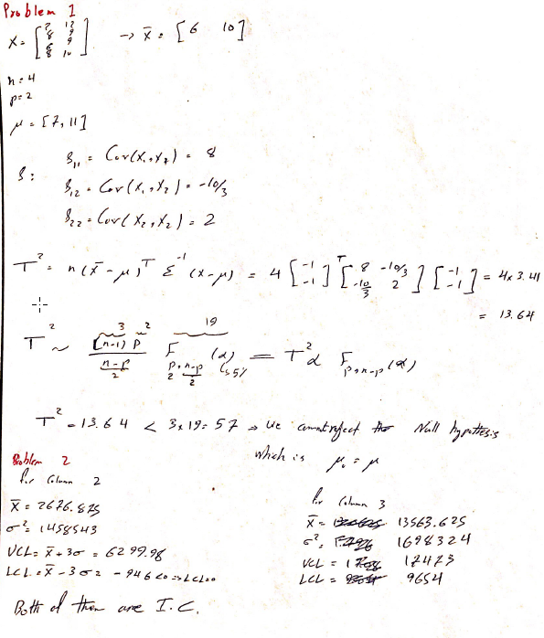

# Problem 2



For x3

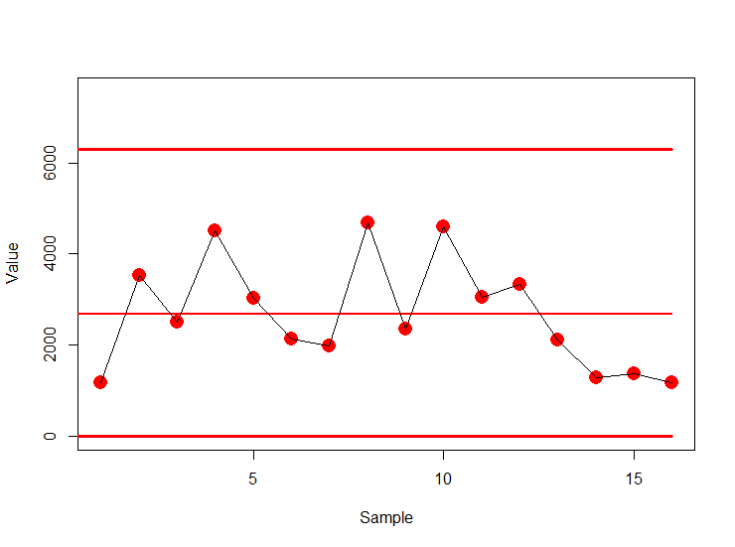

For x4

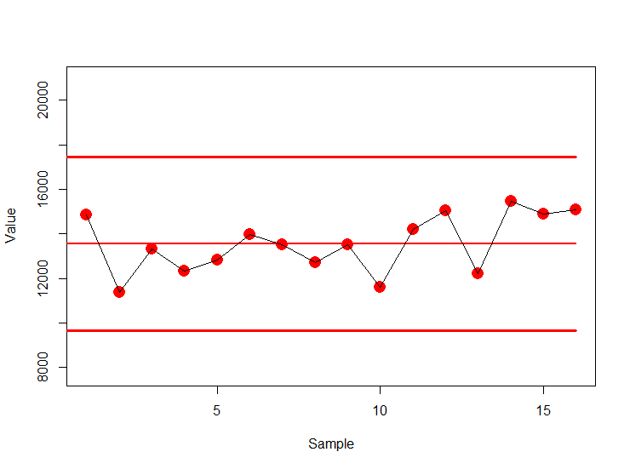

# Problem3

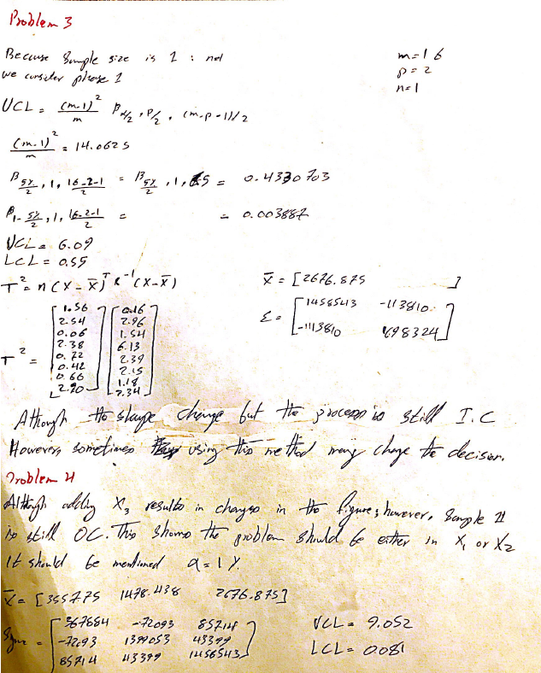

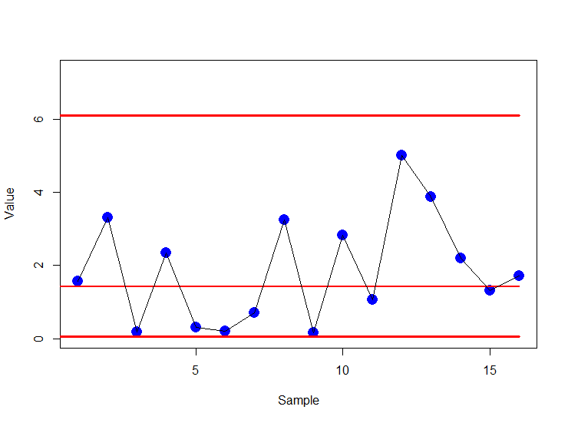

# Problem 4

# 

# Problem 5

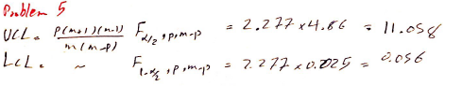

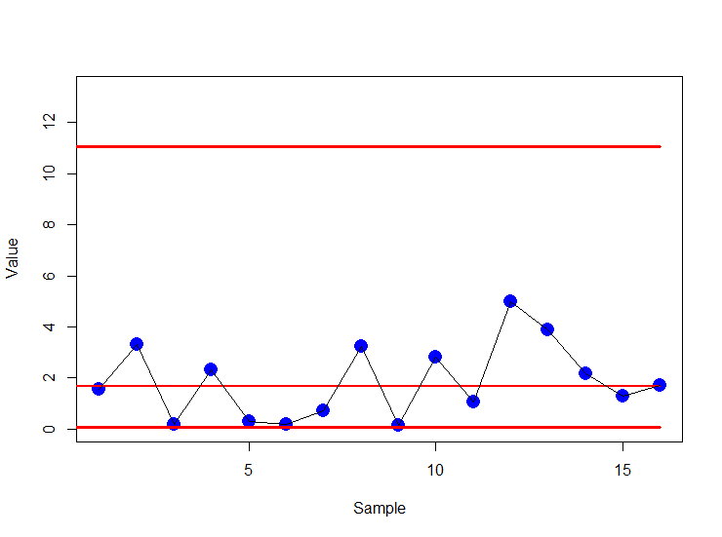

# Problem 6

The is the script results in R. The script its own is also attached.

Call:

lm(formula = Data$Literacy.Rate ~ Data$Newspapers + Data$Radios +

Data$TV)

Residuals:

Min 1Q Median 3Q Max

-0.233963 -0.069603 -0.007276 0.127095 0.188900

Coefficients:

Estimate Std. Error t value Pr(>|t|)

(Intercept) 0.5148602 0.0936762 5.496 0.00152 **

Data$Newspapers 0.0005421 0.0008653 0.626 0.55410

Data$Radios -0.0003535 0.0003285 -1.076 0.32330

Data$TV 0.0019882 0.0015503 1.282 0.24699

---

Signif. codes: 0 ‘***’ 0.001 ‘**’ 0.01 ‘*’ 0.05 ‘.’ 0.1 ‘ ’ 1

Residual standard error: 0.1865 on 6 degrees of freedom

Multiple R-squared: 0.6988, Adjusted R-squared: 0.5482

F-statistic: 4.64 on 3 and 6 DF, p-value: 0.05255

> confint(Regression,level = 1-alpha)

2.5 % 97.5 %

(Intercept) 0.285642871 0.7440774959

Data$Newspapers -0.001575298 0.0026594242

Data$Radios -0.001157286 0.0004503745

Data$TV -0.001805185 0.0057815707

The answer from R and MATLAB are exactly the same; MATLAB script is also attached.

Based on the model, the most important parameter is Intercept and after that TV. The p-value of the whole model is around 5% rather low and the R-Squared is around 0.6 rather high; therefore, we can claim the model is working good.

