ROBO WAR

ROBOT
Design a machine that can fight to another one and push another bot outside the arena
or push into the DEATH zone.

GAME ARENA

“This is where we fight, this is where we die where we survive”
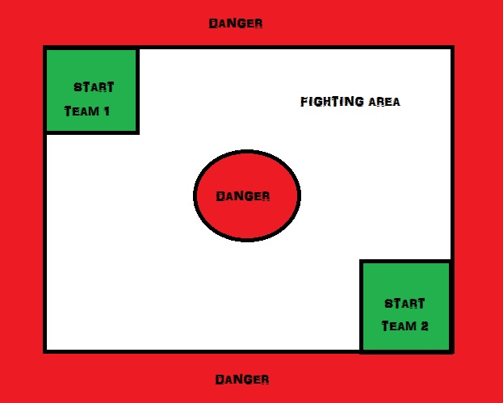

ROBOT SPECIFICATIONS

- Machine should be fit in a box of 50cm X 50cm X 50cm (lxbxh).
- Maximum weight of the machine should not increase to 12 kg., excluding power source.
- Machine can use DC source of maximum 24 v and AC source can be used and have to convert it into maximum of 24 v dc.
- The machine can be operated with wired or wireless remote.
- IC engine and electric motor can be used actuate the machine.
- Readymade base of machine would not be allowed (Readymade wheels, motor, battery, RF Remote, switch, wires can be used)

Rules
- The competition will be played on a knock-out basis.
- The maximum duration of each round will be 5 minutes. Any team that is not ready at the time specified will be disqualified from the competition automatically.
- The machine would be checked for its safety before the competition and would be discarded if found unsafe for other participants and spectators.
- The name of your machine must be prominently displayed on the machine.
- The organizers reserve the rights to change any or all of the above rules as they deem fit. Change in rules, if any will be highlighted on the website and notified to the registered teams.
- Violation of any the above rules will lead to disqualification

JUDGING

- A robot is declared victorious if its opponent is immobilized.
- A Robot is declared victorious if bot will push the other bot in death zone or danger zone.
- In case both the robots remain mobile after the end of the round then the winner will be decided subjectively.

CERTIFICATE POLICY
1. Top 10 teams will be given the certificate of excellence.
2. All the participating teams with at least 10 points will be given the participation certificate.
3. Disqualified teams will not be provided any certificate.

TEAM SPECIFICATIONS
- A team may consists of minimum of 3 participants to maximum of 4 participants.
- Students from different educational institutes can take part in the competition.

ELIGIBILITY
All the students will valid identity card of their respective institutes are eligible to participate for this event.

