URL: <https://smvijaykumar.github.io/index.html>

Narrative Visualization:

My theme of this project is to analyze IPL (Indian Premier League) Cricket Teams Win percentages from 2008 -2019. The required data was compiled from Wikipedia pages of the corresponding teams.

Ex: <https://en.wikipedia.org/wiki/Royal_Challengers_Bangalore>

The following concepts of Narrative Visualizations were demonstrated in this assignment.

1. Scene
   1. IPL Team Win Percentage Analysis (Multiple Line Chart)
   2. IPL Team Average Win Percentage so far (Bar Chart)
2. Annotation
   1. In the Multiple Line chart, Annotations were used to convey the message that two teams were suspended during period (2015-2017).
   2. Tooltips were used to provide additional details like Name, Year and Win Percentages when mouse were hovered around multiple line.
3. Parameters
   1. Name of the team. Using this parameter 5 buttons were displayed on the webpage and on click of each button, the corresponding teams were highlighted on both the charts.
4. Triggers
   1. By clicking the team buttons, corresponding teams’ lines were highlighted by increasing the stroke-width.
   2. By clicking the team buttons, corresponding teams’ lines were highlighted by filling the bar chart with black.

**When Page Loads, Line Charts were drawn using Transition**

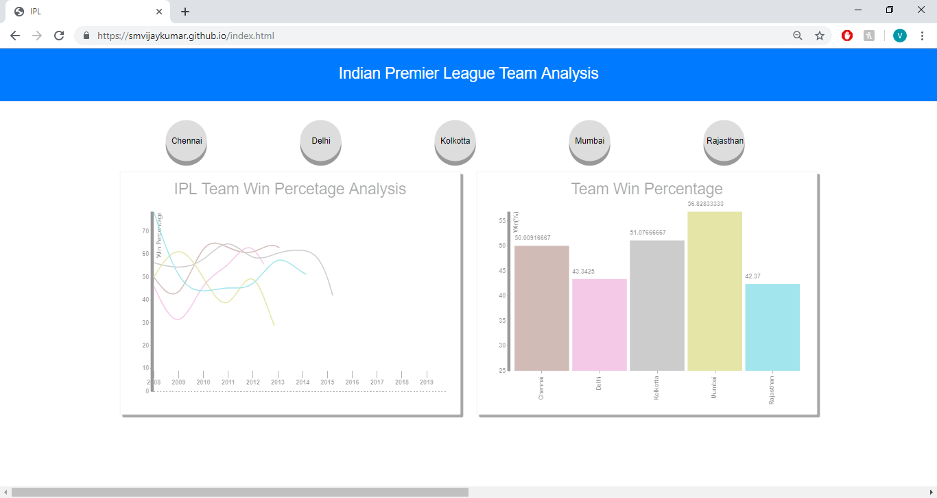

**Annotation displayed after transition completes**

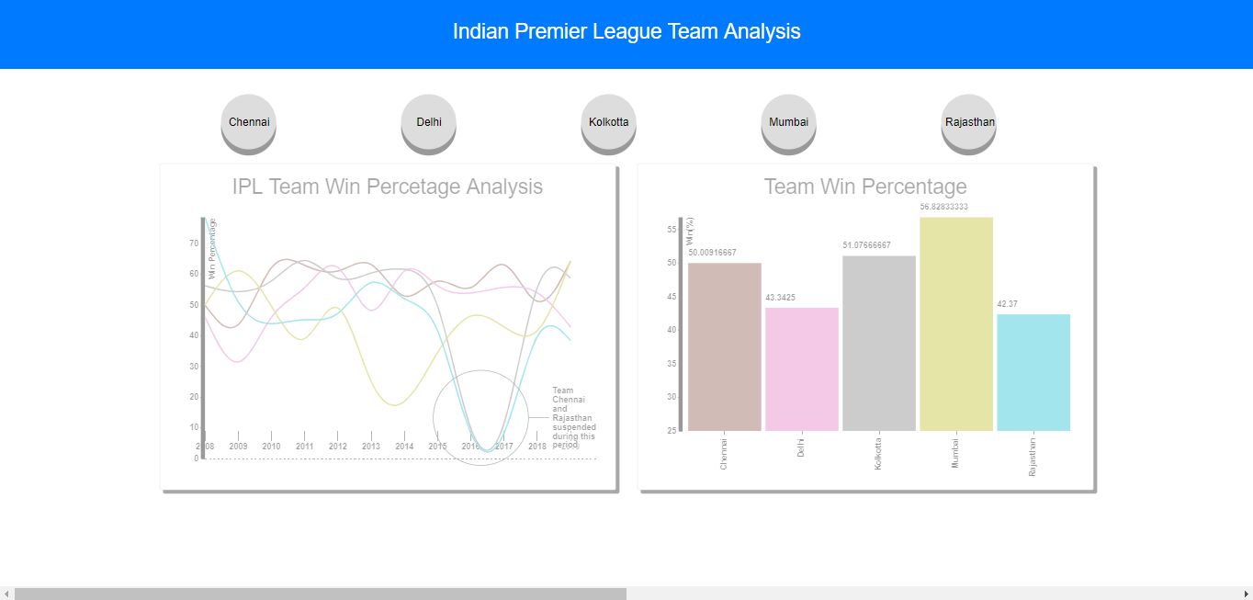

**Mouse Over tooltip for Additional Information along the line chart**

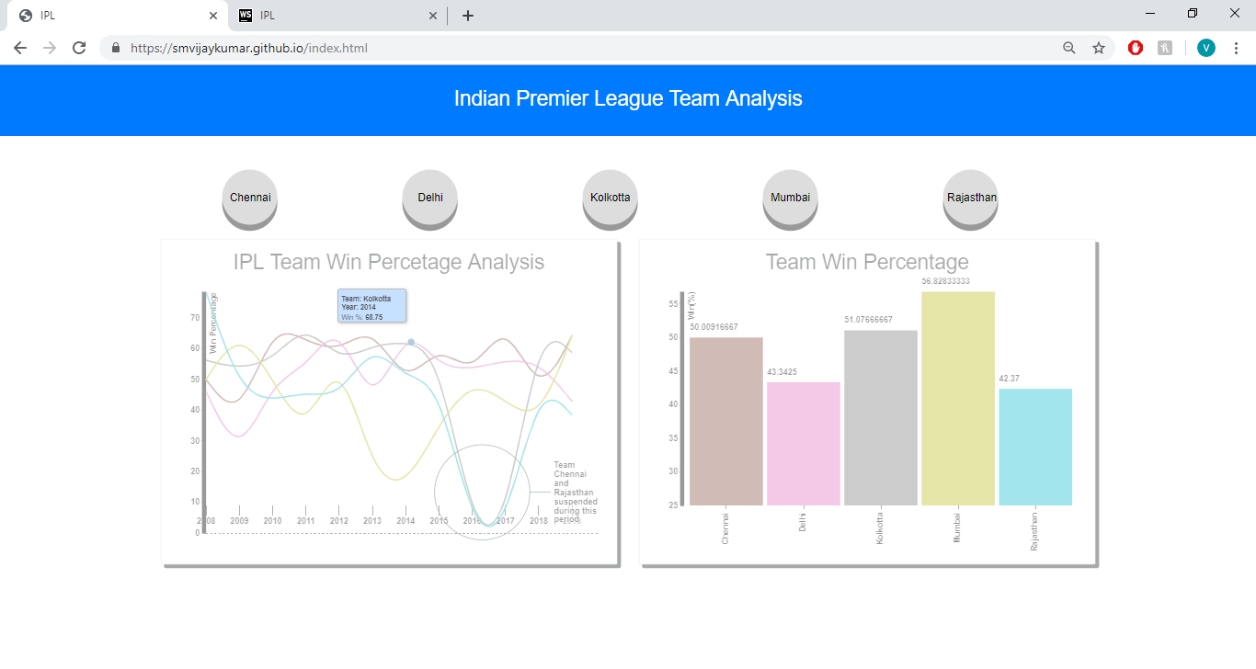

**Parameters & Triggers**

