Gold Layer Data Validation Report
Amazon Reviews Pipeline — Appliances Dataset
Layer validated: Gold (post Bronze → Silver → Gold transformation)
Dataset: Appliances product reviews
Validation date: 25 July 2026
Tool used: PySpark / Databricks notebook
Prepared by: Yash

1. Objective
The Gold layer output produced by the team's Bronze → Silver → Gold pipeline was validated to confirm data quality before downstream consumption (ML modeling, RAG pipeline, and the Streamlit review-analysis interface). The validation focused on schema correctness, row/column counts, and — most importantly — duplicate record detection, since duplicate reviews directly bias rating aggregates, review-volume features, and any model trained on this data.

2. Summary of Findings
Duplicate records were found in the Gold layer output. Two independent checks were run: (1) an exact full-row duplicate check, and (2) a business-key duplicate check using the natural key of a review (parent_asin, review_title, review_text, review_date). Both checks confirm the presence of duplicates, meaning the Silver → Gold transformation is not currently de-duplicating records.
Metric | Value
Dataset (Gold layer) | Appliances
Total rows (df.count()) | 2,055,264
Total columns | 27
Exact duplicate rows (full-row match) | 21,938
Unique rows after dropDuplicates() | 2,033,326
Duplicate groups (business key: parent_asin, review_title, review_text, review_date) | 18,545
Total records involved in composite-key duplicate groups | 40,496

3. Step-by-Step Validation & Screenshots

3.1 Load Gold Layer & Initial Preview
The Gold layer parquet output for the Appliances category was loaded and previewed to confirm the data was readable and structurally intact.
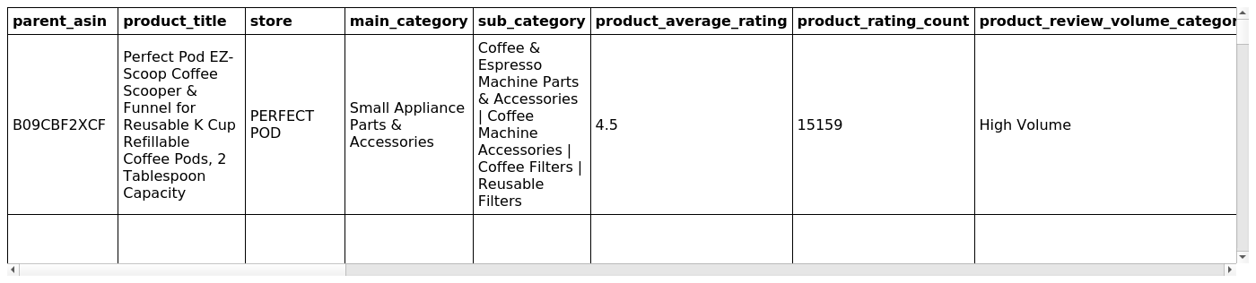
Screenshot 1 — display(df): first rows of the Gold layer Appliances dataset (27 columns).

3.2 Schema & Row/Column Count
df.printSchema() confirmed all 27 expected columns with correct types (string, double, long, boolean, date, integer). Row count returned 2,055,264 records.
Rows: 2,055,264 Columns: 27

3.3 Null Value Check
A column-wise null count was run to rule out missing-value issues alongside the duplicate check.
Screenshot 2 — Null count per column.

3.4 Exact Duplicate Row Check
Using df.count() - df.dropDuplicates().count(), 21,938 fully-duplicated rows (all 27 columns identical) were found.
Duplicate rows: 21,938
Rows where every column value (including the row's implicit grouping) repeats more than once:
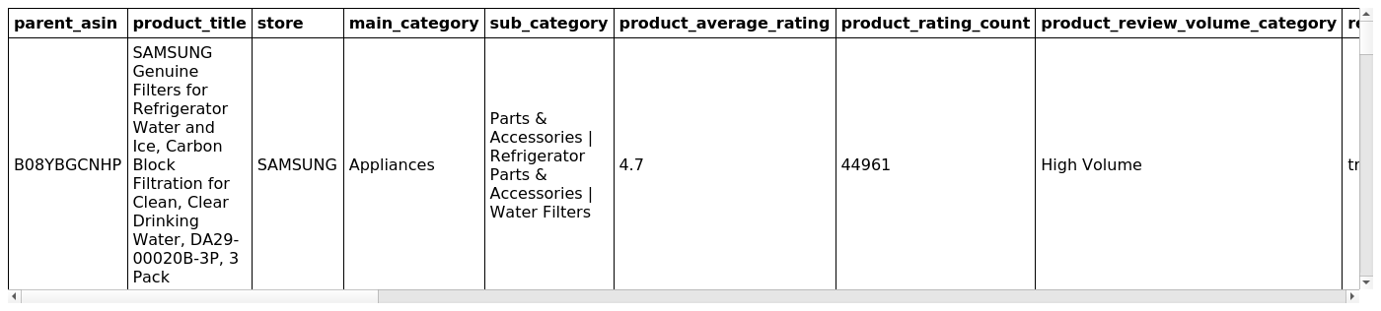
Screenshot 3 — df.groupBy(all columns).count().filter(count > 1): exact duplicate rows with their repeat count.
Joining back to the full dataframe to pull out the actual duplicate records:
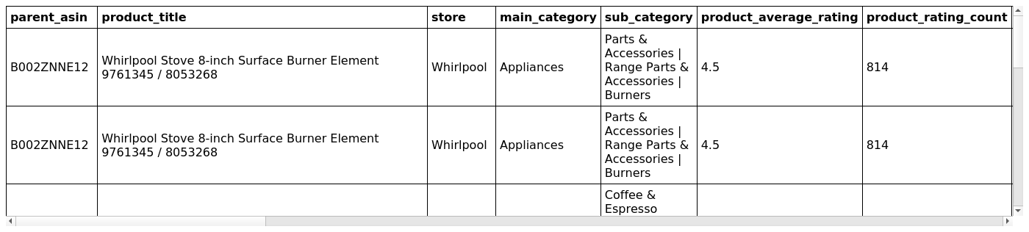
Screenshot 4 — Full duplicate records recovered via inner join on all columns.

3.5 Spot Check on a Repeated Product (parent_asin)
A single parent_asin (B002ZNNE12) was inspected directly to visually confirm duplicate reviews under the same product.
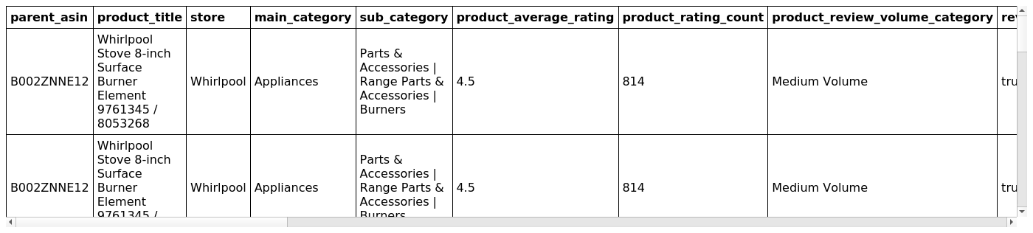
Screenshot 5 — All rows for parent_asin = B002ZNNE12, showing repeated review entries.

3.6 Business-Key (Composite) Duplicate Check
Because two genuinely different reviews could coincidentally share all 27 column values only in edge cases, a second, stricter check was run using the natural business key of a review: parent_asin + review_title + review_text + review_date. This catches duplicates even if a metadata column (e.g. helpful_vote) drifted between copies.
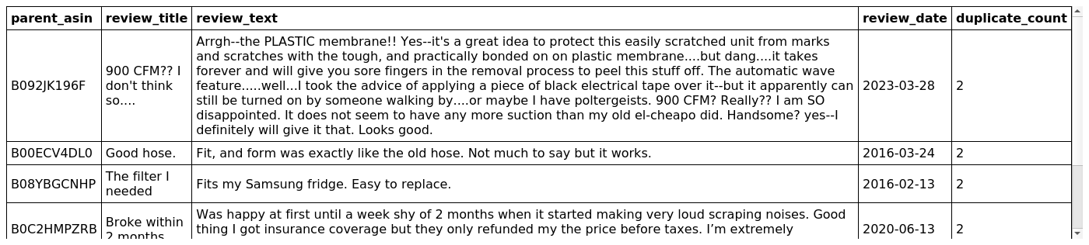
Screenshot 6 — Composite-key groups with duplicate_count > 1.
Duplicate groups (composite key): 18,545
Recovering the full duplicate records for these composite-key groups:
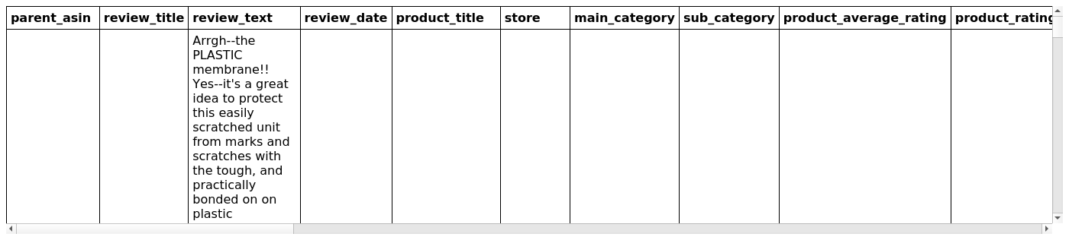
Screenshot 7 — Full records joined back on the composite business key.

3.7 Example of a Single Duplicate Group
One duplicate group was isolated to show what a duplicate pair looks like side by side.
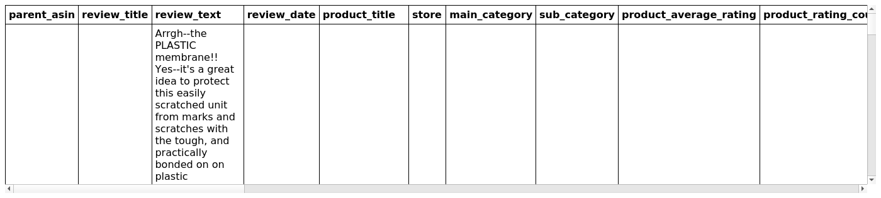
Screenshot 8 — Sample duplicate pair sharing the same parent_asin, review_title, review_text and review_date.

3.8 Duplicates by Product (parent_asin only)
As a broader check, duplicate counts were also computed at the parent_asin level alone, to see how many products have repeated review activity (expected to be high and not itself a defect, since one product legitimately has many reviews).
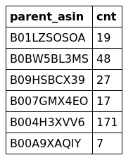
Screenshot 9 — Sample of products (parent_asin) with more than one row.

3.9 Final Confirmation
Total rows: 2,055,264
Unique rows: 2,033,326
Exact duplicates: 21,938
Duplicate composite keys: 18,545
Total records involved in duplicate composite keys: 40,496
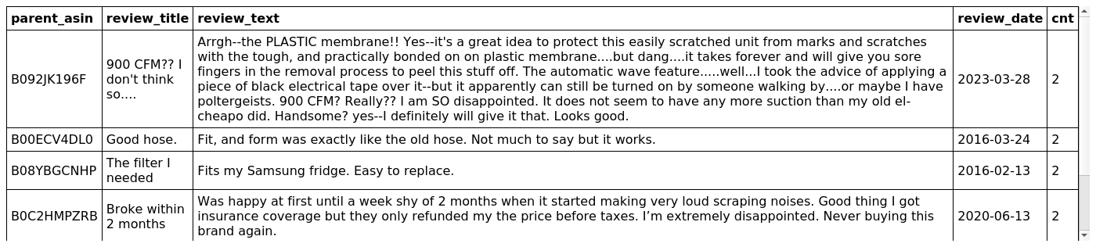
Screenshot 10 — Final re-verification of composite-key duplicate groups (cnt > 1).

4. Root Cause (Likely)
- The Bronze → Silver → Gold pipeline does not apply a dropDuplicates() / MERGE de-duplication step keyed on a stable review identifier before writing to Gold.
- 21,938 rows are duplicated on every single column, and a further ~40,496 rows are duplicated on the natural review key (parent_asin, review_title, review_text, review_date) — this pattern is consistent with the same source records being re-ingested or re-processed more than once (e.g. re-running a Bronze/Silver job without idempotent writes, or overlapping incremental loads).

5. Recommendations
- Add an explicit df.dropDuplicates() (or a composite-key dropDuplicates(["parent_asin","review_title","review_text","review_date"])) at the end of the Silver → Gold transformation, before the Gold write.
- If Gold is written incrementally, switch to a MERGE (upsert) on the review's natural key instead of an append, so repeated pipeline runs cannot reintroduce duplicates.
- Add a row-count and duplicate-count assertion as an automated data-quality check (e.g. a Great Expectations / dbt test or a simple assert) that fails the pipeline run if duplicates exceed 0, so this is caught before Gold is published rather than after.
- Re-run this validation after the fix is deployed and confirm Duplicate rows = 0 and Total rows = Unique rows.

6. Conclusion
The Gold layer for the Appliances dataset is schema-correct and complete in terms of columns, but contains 21,938 exact duplicate rows and 40,496 rows involved in business-key duplicate groups out of 2,055,264 total rows (~1.07% exact duplication, ~1.97% business-key duplication). This should be fixed at the Silver → Gold transformation stage before the data is used for the ML models, RAG pipeline, or Streamlit interface, since duplicated reviews will skew rating distributions and review-volume-based features.

Appendix A: Live Databricks Notebook Evidence
The screenshots below are captured directly from the live Databricks notebook ("gold data") session used for this validation, showing the executed code cells and their actual runtime output.

A.1 Composite-Key Duplicate Count
The business-key duplicate check (parent_asin, review_title, review_text, review_date) was executed and returned 18,545 duplicate composite keys, confirmed live in the notebook.
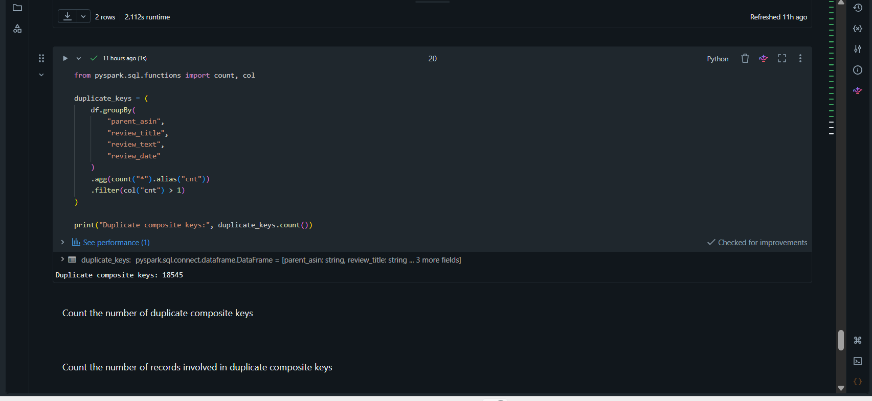
Figure A1 - Databricks notebook: duplicate_keys computation returning Duplicate composite keys: 18545.

A.2 Duplicate Sample Row Pair
A single duplicate composite key was isolated (.limit(1)) and joined back to the full dataframe, confirming two identical rows exist for the same parent_asin, review_title, review_text, and review_date.
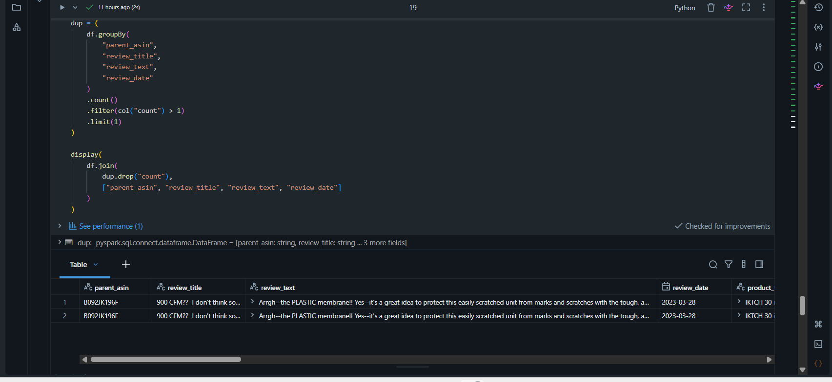
Figure A2 - Databricks notebook: sample duplicate pair for parent_asin B092JK196F, review_date 2023-03-28.

A.3 Full Duplicate Records Table
The complete set of duplicate records (all columns) recovered via the inner join on the composite business key, viewed live in the Databricks table output.
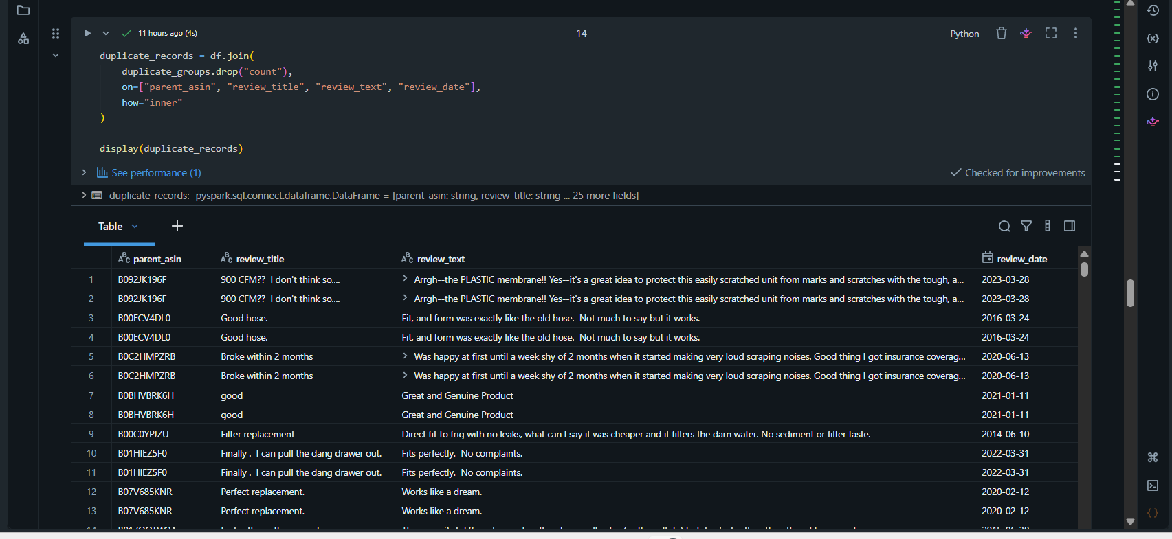
Figure A3 - Databricks notebook: duplicate_records table showing repeated row pairs (B092JK196F, B00ECV4DL0, B0C2HMPZRB, B0BHVBRK6H, B01HIEZ5F0, B07V685KNR and others).

