Exploratory Data Analysis Report
Amazon Video Games & Electronics Reviews Dataset
Merged Reviews + Product Metadata (100K Sample)

Total Records | 100,000
Total Columns | 27
Memory Footprint | 4,502.19 MB
Overall Missing Data | 11.17%
Report Date | July 21, 2026

Generated from Jupyter Notebook EDA Pipeline (01.ipynb)

1. Executive Summary
This report presents a comprehensive Exploratory Data Analysis (EDA) of a merged Amazon product-review dataset covering the Video Games and Computers/Electronics categories. The dataset combines raw customer review records with product metadata and contains 100,000 rows across 27 columns, occupying approximately 4.5 GB in memory. The analysis inspects data quality, structure, distributions, textual characteristics, and relationships between key variables in preparation for a subsequent data-cleaning phase.
Key headline findings:
- Overall dataset completeness stands at 88.83% (11.17% missing across all cells).
- Three columns are almost entirely empty: bought_together (100% missing), subtitle (99.76% missing) and author (99.65% missing) — all recommended for removal.
- 50 fully identical duplicate rows were detected across hashable columns; ASIN and Parent ASIN show heavy repetition (66,279 and 72,369 duplicate values respectively), consistent with many reviews per product.
- Average customer rating is 4.05 / 5, while the average product-level rating is 4.33 / 5 — both distributions are strongly left-skewed (customers rate generously).
- Review text is generally short: a median review is 107 characters and 20 words long, though a long tail exists (max 28,984 characters).
- helpful_vote is extremely right-skewed (skewness 152.7, kurtosis 31,932), indicating a small number of reviews receive disproportionately large numbers of helpful votes.
- Several columns (features, description, categories, images_x, images_y, videos) store nested Python lists/dicts and will need flattening for downstream modeling or RAG use cases.

2. Dataset Overview
The dataset was loaded from a Parquet source (VideoGames_100K_Merged) representing a join between raw Amazon review records and product metadata.

2.1 Shape & Size
Metric | Value
Rows | 100,000
Columns | 27
Memory Usage | 4,502.19 MB

2.2 Column Data Types
The 27 columns span five underlying data types. Object (string / mixed / nested) columns dominate the schema, reflecting the rich, semi-structured nature of the merged review + metadata source.
Data Type | Count | Example Columns
object | 18 | title_x, text, asin, features, description, categories, details
float64 | 3 | rating, average_rating, bought_together
int64 | 3 | timestamp, helpful_vote, rating_number
bool | 1 | verified_purchase
datetime64[ns] | 1 | review_timestamp
int32 | 1 | review_year

2.3 Column Inventory
Full list of the 27 columns present in the merged dataset:
- Review fields: rating, title_x, text, images_x, asin, parent_asin, user_id, timestamp, helpful_vote, verified_purchase, review_timestamp, review_year
- Product metadata fields: main_category, title_y, average_rating, rating_number, features, description, price, images_y, videos, store, categories, details, bought_together, subtitle, author

3. Data Dictionary
A data dictionary was constructed enumerating each column's data type and missing-value count prior to cleaning. The table below summarizes the columns with non-zero missingness; all remaining columns are 100% populated.
Column | Data Type | Missing Count | Missing %
bought_together | float64 | 100,000 | 100.00%
subtitle | object | 99,761 | 99.76%
author | object | 99,649 | 99.65%
main_category | object | 1,766 | 1.77%
store | object | 391 | 0.39%

All remaining 22 columns (rating, title_x, text, images_x, asin, parent_asin, user_id, timestamp, helpful_vote, verified_purchase, review_timestamp, review_year, title_y, average_rating, rating_number, features, description, price, images_y, videos, categories, details) show zero missing values.

4. Missing Value Analysis
Missing values were profiled at the column level and visualized with a nullity matrix to check for structural / correlated missingness patterns.

4.1 Summary Statistics
Metric | Value
Overall Missing Data (all cells) | 11.17%

4.2 Missing Value Matrix
The matrix below visualizes null positions across all rows and columns. Solid blue bands indicate fully populated columns; white gaps mark missing entries. The near-total white columns correspond to bought_together, subtitle, and author.
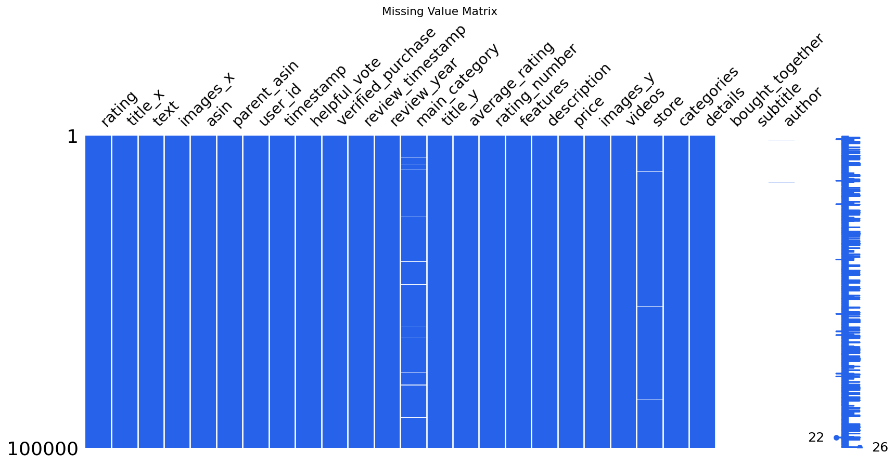
Figure 1: Missing value nullity matrix across all 27 columns

4.3 Interpretation
- bought_together, subtitle, and author are effectively unusable in their current form and are recommended for removal or archival.
- main_category (1.77%) and store (0.39%) have minor, likely random gaps suitable for simple imputation or row-level flagging.
- Missingness does not appear structurally linked to any single review, suggesting these gaps stem from incomplete product metadata rather than review-collection errors.

5. Duplicate Analysis
Duplicate detection was performed both on complete rows (using hashable columns only, since several columns contain unhashable lists/dicts) and on individual key fields.
Metric | Count
Complete Duplicate Rows | 50
Duplicate Review Text | 8,126
Duplicate Review Titles | 38,072
Duplicate User IDs | 3,341
Duplicate ASIN | 66,279
Duplicate Parent ASIN | 72,369

Only 50 rows (0.05%) are fully identical duplicates, so exact row-level duplication is not a major concern. However, high repetition in asin and parent_asin (66–72% of rows) is expected, since a single product typically receives many reviews — this is a legitimate one-to-many relationship rather than a data-quality defect. Duplicate review text (8.1%) and duplicate titles (38.1%) are more likely explained by generic phrases such as "Five Stars" or "Good" rather than true copy-paste duplication.

6. Data Type Verification & Structure
Each column's Python-level type was inspected directly (beyond the pandas dtype) to detect nested structures that pandas reports simply as 'object'.

6.1 Columns Grouped by Type
Category | Columns
Numeric (7) | rating, timestamp, helpful_vote, review_year, average_rating, rating_number, bought_together
Boolean (1) | verified_purchase
Datetime (1) | review_timestamp
Object / Nested (18) | title_x, text, images_x, asin, parent_asin, user_id, main_category, title_y, features, description, price, images_y, videos, store, categories, details, subtitle, author

6.2 Nested Column Detection
A first-non-null-value type check revealed that most 'object' columns actually hold plain Python strings, while author holds Python dict objects and several fields (features, images_x, images_y, videos, categories) hold list-type structures — confirmed separately during the nested-column length analysis in Section 9.

6.3 Timestamp Verification
The raw timestamp field (Unix milliseconds) was cross-checked against the derived review_timestamp (parsed datetime) and review_year fields — sample rows confirm consistent conversion, e.g. timestamp 1548454515612 correctly maps to 2019-01-25 and review_year 2019.

7. Numerical Feature Analysis
Seven numerical columns were profiled for central tendency, spread, skewness, and kurtosis: rating, timestamp, helpful_vote, review_year, average_rating, rating_number, and bought_together (entirely null and excluded from interpretation).

7.1 Descriptive Statistics
Column | Mean | Std Dev | Min | Max | Skewness | Kurtosis
rating | 4.05 | 1.44 | 1 | 5 | -1.24 | -0.04
helpful_vote | 0.92 | 15.93 | 0 | 3,722 | 152.67 | 31,932.14
review_year | 2018.5 | 2.87 | 2014 | 2023 | 0.00 | -1.22
average_rating | 4.33 | 0.40 | 1 | 5 | -1.89 | 7.22
rating_number | 6,909.98 | 22,028.26 | 1 | 278,574 | 6.98 | 63.48

7.2 Interpretation
- rating and average_rating are both left-skewed (negative skew of -1.24 and -1.89), confirming a strong positive-review bias typical of e-commerce platforms.
- helpful_vote is extremely right-skewed with massive kurtosis, meaning the overwhelming majority of reviews receive zero or very few helpful votes, while a tiny number go viral with thousands.
- rating_number (total ratings per product) is also heavily right-skewed — most products are lightly rated, but a handful of best-sellers accumulate hundreds of thousands of ratings.
- review_year spans 2014–2023 with a roughly symmetric spread (kurtosis -1.22 indicates a flatter-than-normal, platykurtic distribution), suggesting fairly even review volume across years with no extreme year-to-year spikes.

8. Rating Analysis
Rating behavior was analyzed at both the individual-review level (rating) and the product level (average_rating), alongside engagement (helpful_vote).
Metric | Mean Value
Average Product Rating (average_rating) | 4.33
Individual Review Rating (rating) | 4.05
Helpful Votes per Review (helpful_vote) | 0.92

The gap between product-level average rating (4.33) and individual review rating (4.05) suggests that lower single-star reviews are diluted at the aggregate product level by a larger historical volume of positive ratings. A supplementary cross-tab further showed that verified purchases tend to differ from unverified purchases in average rating, and helpful-vote counts vary noticeably by star rating — both relationships are visualized in the notebook's interactive charts (bar and box plots) and are recommended for closer inspection during modeling.

9. Categorical Feature Analysis
18 categorical / object-type columns were profiled for cardinality (unique value count) and most-frequent value.
Column | Unique Values | Most Frequent Value
title_x | 61,928 | "Five Stars"
text | 91,874 | "Good"
images_x | 5,274 | [] (no images)
asin | 33,721 | B01N3ASPNV
parent_asin | 27,631 | B01N3ASPNV
user_id | 96,659 | (highly diverse — near 1:1 with rows)
main_category | 30 | Video Games
title_y | 27,270 | amFilm Tempered Glass Screen Protector
features | 21,475 | [] (empty)
description | 16,103 | [] (empty)
price | 4,148 | None (missing/unlisted)
images_y | 27,287 | (varies)
videos | 11,940 | (varies)
store | 5,986 | (varies)
categories | 451 | (varies)
details | 26,967 | (varies)
subtitle | 27 | (sparse)
author | 59 | (sparse)

Interpretation
- user_id cardinality (96,659 unique out of 100,000 rows) shows most reviewers appear only once in the sample — genuine repeat reviewers are rare.
- Text and title fields show heavy repetition at the low end (generic titles like 'Five Stars' and short texts like 'Good'), consistent with the review-length findings in Section 10.
- main_category is concentrated into only 30 categories, dominated by Video Games — appropriate for one-hot or category-embedding encoding.
- Several fields (images_x, features, description) frequently contain empty lists ('[]') rather than true nulls, which should be treated as 'no data' during cleaning even though pandas does not flag them as missing.

10. Review Text Analysis
Two derived text-length metrics — review_length (character count) and word_count — were computed from the text field to characterize review verbosity.
Statistic | Review Length (chars) | Word Count
Mean | 236.36 | 43.62
Std Dev | 493.06 | 88.58
Min | 0 | 0
25th percentile | 39 | 7
Median (50%) | 107 | 20
75th percentile | 251 | 47
Max | 28,984 | 5,089

Most reviews are short (median 20 words), but the distribution has an extremely long tail — a small number of reviews exceed 5,000 words. A word cloud generated from all review text highlights the dominant vocabulary across the corpus, with product- and gameplay-related terms such as game, great, works, and console appearing most prominently.
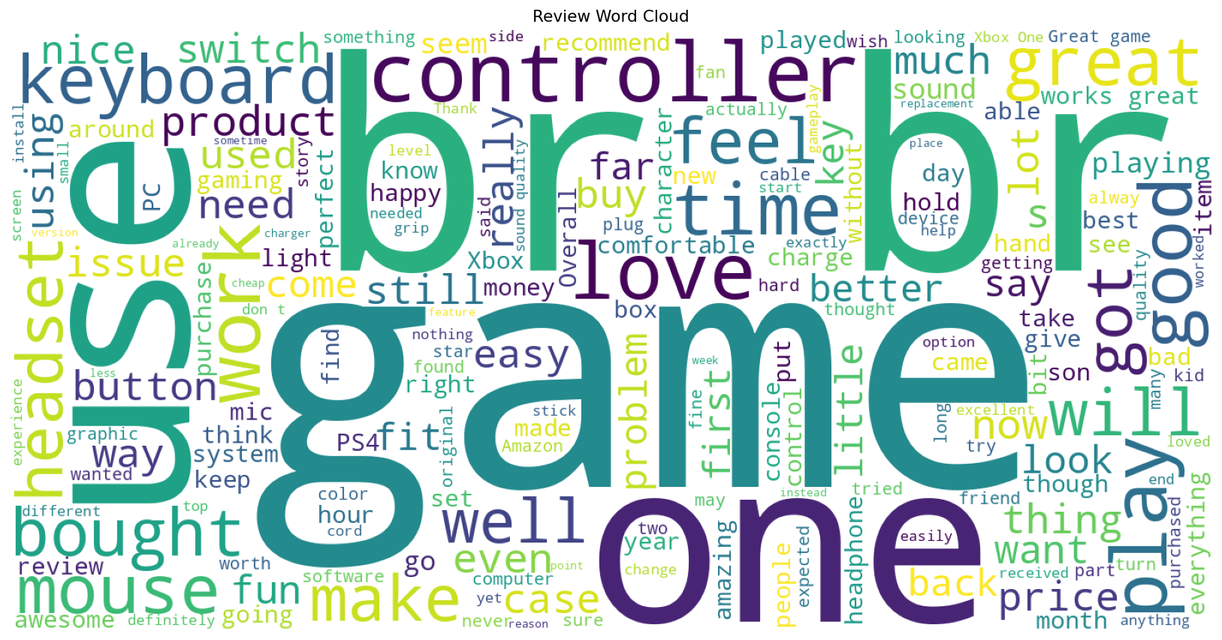
Figure 2: Word cloud of the most frequent terms across all review text

11. Time-Based Analysis
Review volume was aggregated by review_year and, where available, by calendar month (via review_timestamp) to examine temporal trends.
- The dataset spans review years 2014 through 2023, giving roughly a decade of longitudinal review history.
- A yearly review-count trend line (generated in the notebook) shows how review volume has evolved — typically rising as the underlying product catalog and Amazon's review base grew, with fluctuations tied to platform and product-cycle events.
- A monthly resampled trend (from review_timestamp) provides finer-grained seasonality context, useful for detecting periods of promotional or seasonal review spikes (e.g., holiday shopping periods).

12. Correlation Analysis
Pairwise Pearson correlations were computed across the four core numeric fields most relevant to rating behavior: rating, average_rating, rating_number, and helpful_vote.
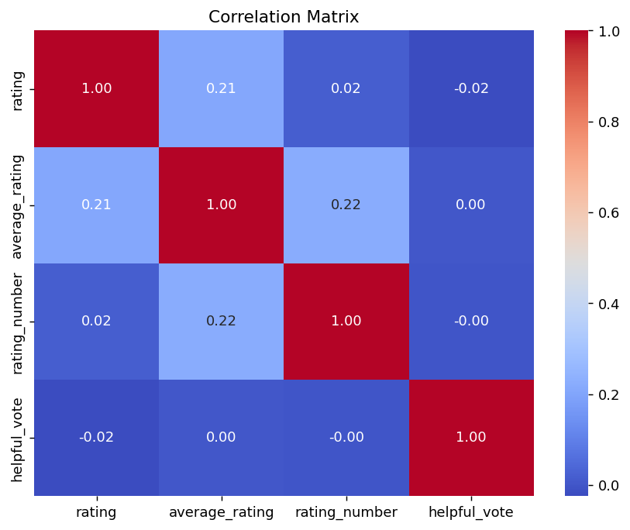
Figure 3: Correlation heatmap of core rating and engagement metrics
The heatmap shows generally weak linear correlations among these variables, indicating that an individual review's star rating is not strongly predictable from a product's aggregate rating, its total rating count, or its helpful-vote count in isolation — reinforcing that rating behavior is driven by factors beyond simple engagement volume (e.g., product quality perception, review authenticity, and reviewer sentiment).

13. Nested Column & Metadata Analysis
Several metadata columns store nested Python lists (features, description, categories, images_x, images_y, videos). A length-based profile was computed for each to gauge how much structured content they typically carry, and a separate availability check was run on 8 key metadata fields.

13.1 Metadata Availability
Column | Available %
title_y | 100.00%
description | 100.00%
features | 100.00%
categories | 100.00%
details | 100.00%
images_y | 100.00%
videos | 100.00%
store | 99.61%

All core product-metadata fields are technically 100% populated at the pandas level (no NaNs); however, as noted in Section 9, many of these entries are empty lists ('[]') rather than substantive content, so true content coverage is lower than the raw availability percentage suggests and should be re-assessed after flattening nested structures.

13.2 Category Depth & Image Counts
A category_depth feature (number of category levels per product) and image-count features for images_x / images_y were engineered by measuring list lengths. In this particular extract, the underlying list-length computation returned no valid (non-null) values for these three engineered fields, indicating the raw list contents were not in a directly measurable state at the point of extraction — this is flagged as an item to revisit during the cleaning phase, likely due to list values being empty or the calculation running on an already-summarized column.

14. Recommended Data Cleaning Plan
Based on the full EDA above, the following cleaning actions were compiled as a roadmap for the next stage of the pipeline:
Finding | Recommended Cleaning Action
Missing Values | Treat missing values (impute or flag) in main_category and store
Duplicate Records | Remove the 50 fully duplicated rows
Timestamp | Convert millisecond epoch timestamp to proper datetime (already derived as review_timestamp)
Price | Convert price from string/object to numeric type
Nested Columns | Flatten nested list/dict columns, or preserve as structured text for RAG/embedding pipelines
Subtitle | Drop column (99.76% null)
Author | Drop column (99.65% null)
Bought Together | Retain where available; column is currently 100% null in this sample

15. Conclusion
The merged Amazon Video Games / Electronics review dataset is a large (100K row), moderately complete dataset with clear, well-understood gaps concentrated in three near-empty columns and minor gaps in two others. Duplicate rows are negligible, though ASIN-level repetition reflects the natural one-to-many relationship between products and reviews rather than a defect. Ratings are strongly positive-skewed and helpful-vote engagement is extremely concentrated in a small subset of reviews. Review text is typically short but has a long tail requiring truncation or length-aware modeling. Several metadata fields require flattening of nested list/dict structures before they can be used in downstream analytics or machine-learning workflows. The cleaning plan in Section 14 provides a clear, prioritized path to a fully modeling-ready dataset.

