CauseSpec: a database of global terrestrial vertebrate cause-specific mortality

As wildlife populations continue to decline worldwide, human-caused mortality of terrestrial vertebrates is of increasing importance. However, there is a limited understanding of how direct anthropogenic mortality compares in magnitude to natural mortality. CauseSpec is a database of global terrestrial vertebrate cause-specific mortality that used telemetry to monitor terrestrial vertebrates and determine cause of death. The dataset distinguishes between anthropogenic and natural mortality and also documents the specific mortality source where possible (e.g. harvest, vehicle collision, predation, and starvation). This database consists of 1134 studies that collectively monitored the fates of 123,747 individual animals. From this, there are 43,998 deaths of known cause among 307 species. There is a separate file for amphibians, birds, mammals, and reptiles, although the sample size for amphibians and reptiles is quite a bit lower than for mammals and birds. For more information, see: https://esajournals.onlinelibrary.wiley.com/doi/full/10.1002/ecy.2865

Column descriptions for the mammal dataset:

Column information for the bird dataset

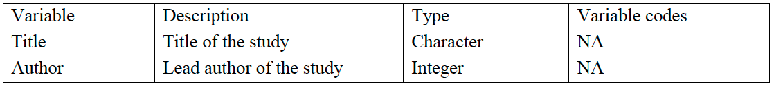

Column info for reptile datset

Column information for amphibian dataset

