DATE : 07/03/2020

PRE-SHIPMENT INSPECTION AND SAMPLING REPORT

SHIPPER | : | BIO TREASURE OVERSEAS.  478/01/01/01,BEHIND 20  INDUSTRIAL AREA,  RAU, INDORE, M.P
BUYER | : | COCFO FRANCE
COMMODITY | : | ORGANIC SOYABEAN MEAL
OFFERED QUANTITY | : | 2200 Bags (110.000 gMT) PACKED IN APPROX 50.000 KGS white PLAIN PP BAGS
NATURE OF WORK | : | PRE-SHIPMENT INSPECTION & SAMPLING
DATE & PLACE OF INTERVENTION | : | BIO TREASURE OVERSEAS., RAU, M.P DT.06.03.2020

REMARKS:

01. PRE-SHIPMENT INSPECTION AND SAMPLING HAS BEEN CARRIED OUT OF ABOVE MENTIONED CARGO

02. TOTAL 2200 BAGS AND APPROX 110 GMT CARGO OFFERED FOR PRE-SHIPMENT SAMPLING AND INSPECTION

03. DURING SAMPLING FROM THE STACK, DUST FOUND ON THE STACK AND STACK WAS NOT COVERED WITH TARPAULIN SHEET

04. APPROX 50 KGS ORGANIC SOYABEAN MEAL PACKED IN WHITE PLAIN PP BAGS AND MOUTH OF BAGS SEALED WITH SINGLE MACHINE STITCHING. (PACKING WAS NOT IN UNIFORM CONDITION)

05. ORGANIC SOYABEAN MEAL OFFERED FOR PRE-SHIPMENT INSPECTION AT BIO TREASURE OVERSEAS INDIA LTD.,
RAU, M.P
06. SAMPLE DRAWN FROM RANDOMLY SELECTED BAGS. THUS DRAWN SAMPLE MIXED THOROUGHLY AND 28
COMPOSITE SAMPLE PREPARED OF 1KGS FOR LOT NO-1 AND 21 COMPOSITE SAMPLE PREPARED OF 100 GMS FOR LOT NO-02 AND 02 SEALED SAMPLE OF LOT NO-1 AND 01 SEALED SAMPLE OF LOT NO-2 HANDOVER TO MR.DEEPAK JI THE PLANT REPRESENTATIVE OF BIO TREASURE.
PLAN SAMPLE SEALING DETAILS ARE (LOT NO.1 RCA SEAL NO.-397558,680177 & LOT NO.2 RCA SEAL NO 294341)

07. RANDOMLY 40 BAGS SELECTED FOR TEST WEIGHMENT AND AVERAGE WEIGHT OBSERVED-49.944 KGS.
ANNEXURE ENCLOSED

08.AFTER PRE-SHIPMENT INSPECTION FOR IDENTIFICATION “DACPL/IND/06.03.2020” MARKED ON STACK

09.PREVIOUS HOOK MARKS SIGHTED ON BAGS

10. PRE-SHIPMENT INSPECTION AND SAMPLING HAS BEEN CARRIED OUT IN PRESENCE OF MR. DEEPAK JI OF BIO TREASURE OVERSEAS REPRESENTATIVE

11. COLOUR/APPEARANCE WISE CARGO FOUND SATISFACTORY

Contd..2

Page : 2

GODOWN DETAIL AS UNDER:
SR. NO. | GODOWN/STACK NO | LOT NO. | QTY. IN GMT | NO. OF BAGS
1 | G.NO-01 & STACK-01 | BTO/OSM/NPOP/C/01/20 | 110.000 | 2200
TOTAL |  |  | 110.000 | 2200

NOTE: BAGS & WEIGHT DECLARED BY PLANT/ BIO TREASURE OVERSEAS REPRESENTATIVE

STACK COUNTING DETAILS ARE AS UNDER:

Bags Position in stacks
Vertical and horizontal spread In Stack (L) | Height of Stack (H) | No. of Block In Stack (W) | Total No of Bags in Stack
19 | 15 | 1 | 285
19 | 15 | 1 | 285
19 | 15 | 1 | 285
19 | 15 | 1 | 285
19 | 15 | 1 | 285
19 | 15 | 1 | 285
19 | 15 | 1 | 285
15 | 13 (10 BAGS EXTRA LYING ON STACK) | 1 | 205
Total |  |  | 2200

12. PHOTOGRAPHS TAKEN DURING PRE-SHIPMENT INSPECTION AND ATTACHED FOR REFERENCE

PHOTOGRAPHS DURING PRE-SHIPMENT INSPECTION AT BIO TREASURE OVERSEAS INDIA LTD.RAU, M.P,06.03.2020

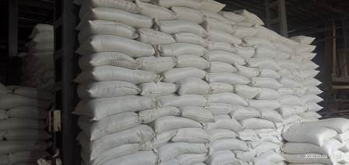  FULL VIEW OF OFFERED STACK | 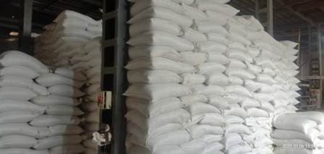  FULL VIEW OF OFFERED STACK

Page : 3

 | 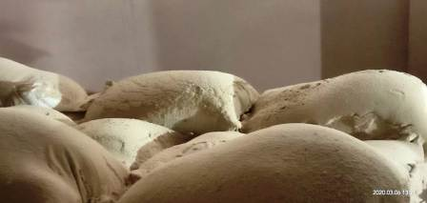  VIEW OF DUST ON THE TOP SIDE BAG OF STACK |  | 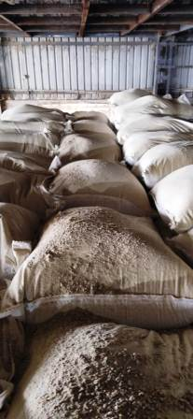  VIEW OF DUST ON THE TOP SIDE BAG OF STACK
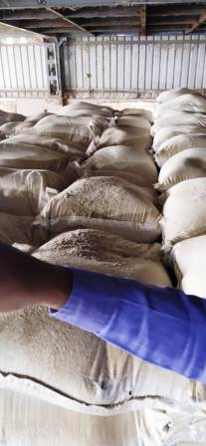  VIEW OF DUST ON THE TOP SIDE BAG OF STACK |  | 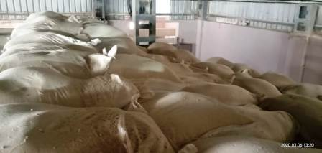  VIEW OF DUST ON THE TOP SIDE BAG OF STACK
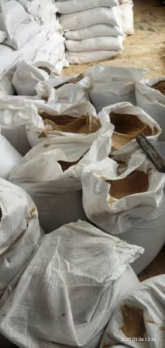  VIEW OF RANDOM SELECTED BAGS FOR SAMPLING |  | 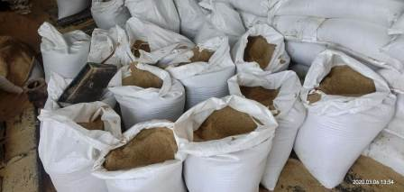  VIEW OF RANDOM SELECTED BAGS FOR SAMPLING

Page : 4

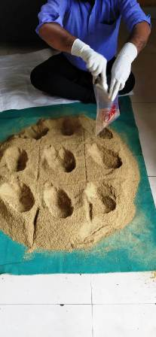  VIEW DURING SAMPLE PREPARATION | 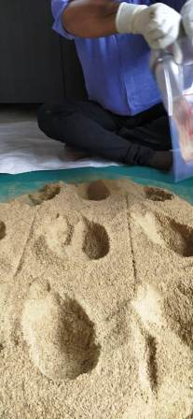  VIEW DURING SAMPLE PREPARATION

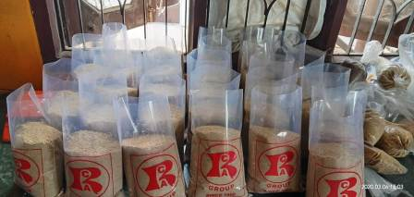  VIEW OF PREPARED SAMPLE | 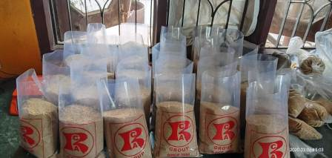  VIEW OF PREPARED SAMPLE
Contd..5

Page : 5

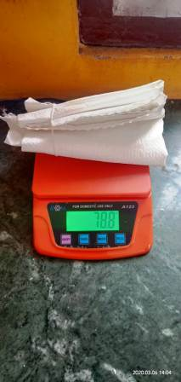  VIEW OF 10 EMPTY PP BAG TEST WEIGHMENT CHECK | 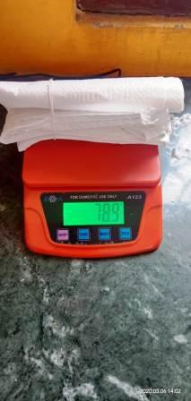  VIEW OF 10 EMPTY PP BAG TEST WEIGHMENT CHECK
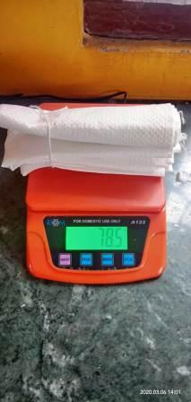  VIEW OF 10 EMPTY PP BAG TEST WEIGHMENT CHECK | 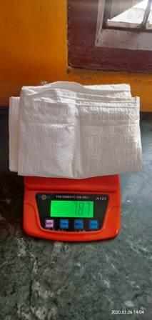  VIEW OF 10 EMPTY PP BAG TEST WEIGHMENT CHECK
Contd…6

Page : 6

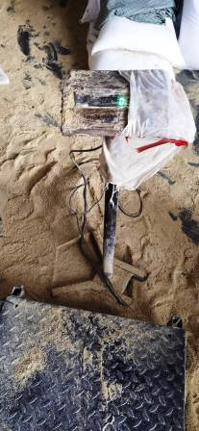  VIEW OF PLATFORM SCALE CALIBRATION CHECK ON ZERO MODE | 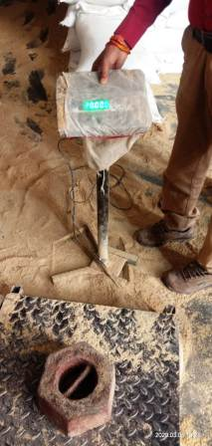  VIEW OF PLATFORM SCALE CALIBRATION CHECK WITH 20 KGS MASTER WEIGHT
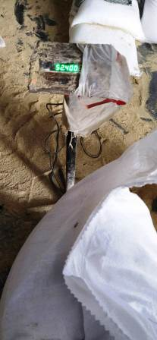  VIEW DURING PACKING CARGO TEST WEIGHMENT CHECK | 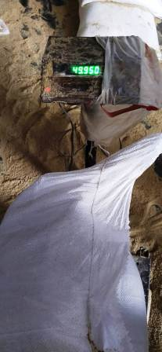  VIEW DURING PACKING CARGO TEST WEIGHMENT CHECK

Page : 7

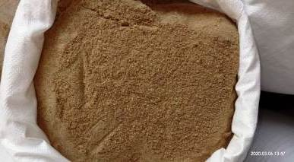  VIEW OF PACKING CARGO | 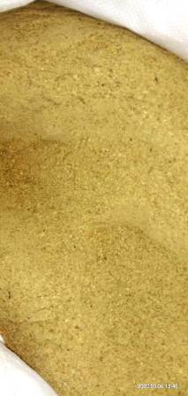  VIEW OF PACKING CARGO
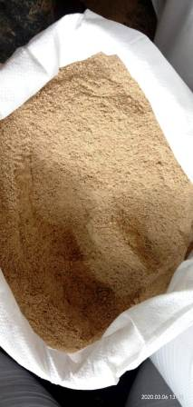  VIEW OF PACKING CARGO | 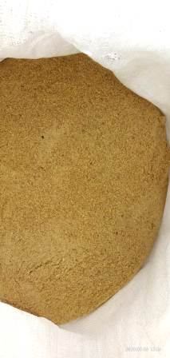  VIEW OF PACKING CARGO

