Inspection Subject: | Inspection of 3000 Litre of Tackle 720 SL – with Witnessing of Packing, Stuffing and Sampling
Exporter: | M/s. Asiatic Agricultural Industrial Pte Ltd  150 Gul Circle  Singapore - 629607
Consignee: | DAL Engineering Company Ltd  Kilo 8, Wad Madani Road PO. Box 56  Khartoum, Sudan  Sudan
Supplier: | M/s. Asiatic Agricultural Industrial Pte Ltd  150 Gul Circle  Singapore - 629607
Inspector: | Hemanth Kumar
Specification: | Clients Inspection Scope | File no | C015209-001

Offered Quantity Detail:
S.No. | Description of Products | Quantity in Liter | No. of Boxes / Drums | Batch Nos
01 | Tackle 720 (2,4D Amine 720G/L 15 Composite Drum 15 x 200 Litres  Gross Weight of each Drum (with product) – Average of 269 KG  Approximate Total Gross Weight – 4035 KG | 3000 | 15 Drums (4 Pallets) | JI20055109

Inspection Detail:
The above-mentioned items are stored in Manufacturer Storage area and offered for inspection dated 20-May-2020.

* Packing & Quantity Check :

Product Name (with Active Ingredient) – TACKLE 720SL (2,4D AMINE 720 G/L)
Product Type – Herbicide – Soluble Concentrate (SL)

The above-mentioned product (Liquid form) with the total quantity of 3000 Litres (Gross weight including drum – 4035 KG Approximately) stuffed into15 composite drums. Each drum stored 200 Liters. All the 15 drums kept in 4 pallets such as 4 drums in 3 pallets and 3 drums in a pallet respectively. Each drum sealed with plastic plug and metal cap cover at the pavement. Each pallet wrapped with shrink wrapper with relevant category signage with supplier and Consignee Details.

- 15 Drums x 200 Liters = 3000 Liters (Product Measurement)
- Approximate Total Gross Weight – 4035 KG
- Gross Weight of each Drum (with product) – Average of 269 KG
- Weight of Empty Drum – 22 KG

* Marking:
Marking on Each Drum (Marking on Product)
I label:
- Mfg name and Address
- IMCO No: / UN No:
- First-Aid / Storage and Disposal Instructions
- Notice to Buyer (Info to Consignee)

II label:
- Consignee name & Address
- UN No: / Class
- Product Name and Type
- Nett Weight / Gross Weight

III label :
- Warning
- Hazard and Precautionary Statements

IV label : (Arabic Language)
- Product Name
- Active Ingredients
- Pictorial Warnings / Information
- Mfg name and Address
- Consignee name & Address
- Quantity in Liters
- Batch Number
- Registration
- Date of Manufacture and Expiry
- Country of Origin

* Sampling: TACKLE 720 SL samples taken from product and sealed in 500 ml Plastic Bottle (2 sets). both the sample bottle sealed and endorsed by the Inspector. 1 drawn sample will be kept by Asiatic Agricultural Industrial PL retention purpose and another will be sent to client or third party.

Drum Opened for Inspection. :

Sl.  No. | Description of Products | Batch Number / Registration Number
01 | Tackle 720 (2,4D Amine 720GL | JI2005129 / 1496

Weighment Check :

As per the packing list,

- Gross Weight / Drum – 269.20 KG
- Total Gross Weight (15 Drums) – 4038 KG

As per the inspector check,
- Approximate Total Gross Weight – 4035 KG
- Gross Weight of each Drum (with product) – Average of 269 KG
- Weight of Empty Drum – 22 KG

Note: During the weight, found the drums weight from 268.6 KG to 269 KG

Documents Enclosed :
- Quality Control Form – AAI (SL) - Annexure 1
- Invoice - Annexure 2
- Packing list - - Annexure 3
- Material safety data sheet - Annexure 4
- check list - Annexure 5

Photos:

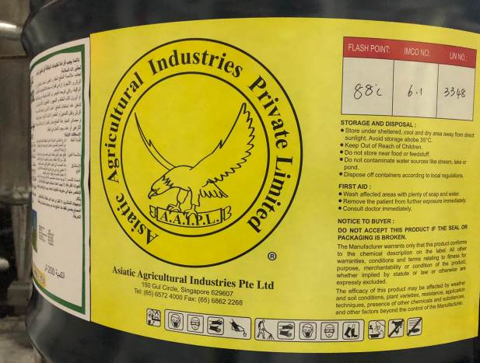 | 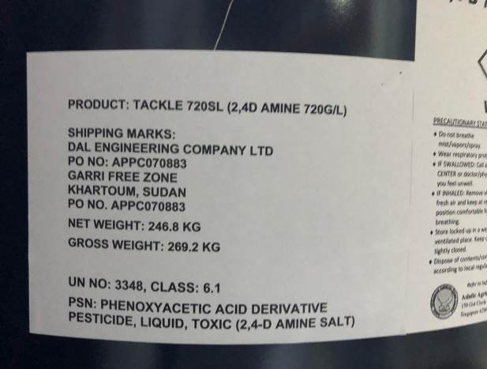
Markings and Label I | Markings and Label II
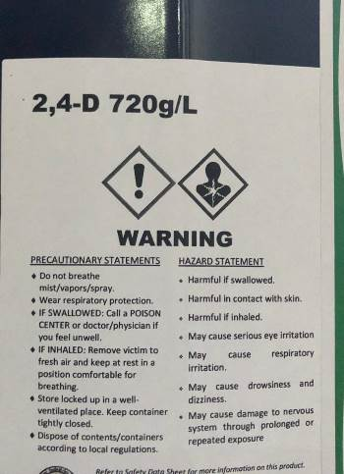 | 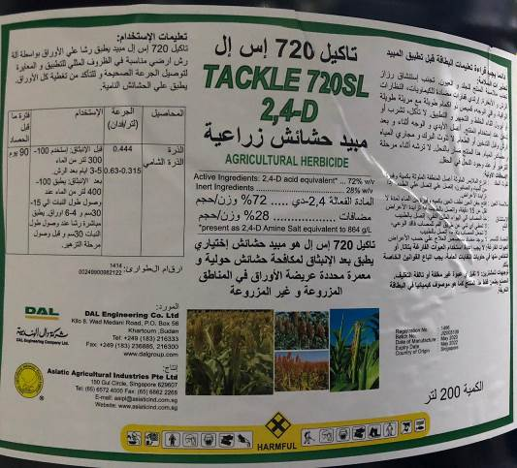
Markings and Label III | Markings and Label IV
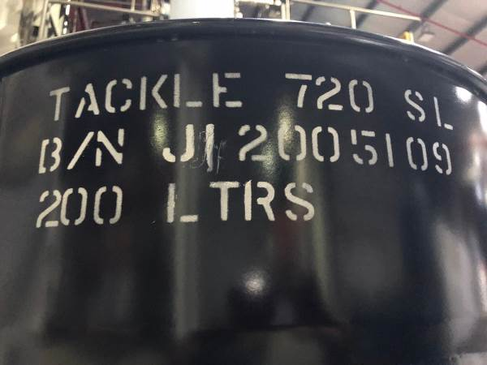 | 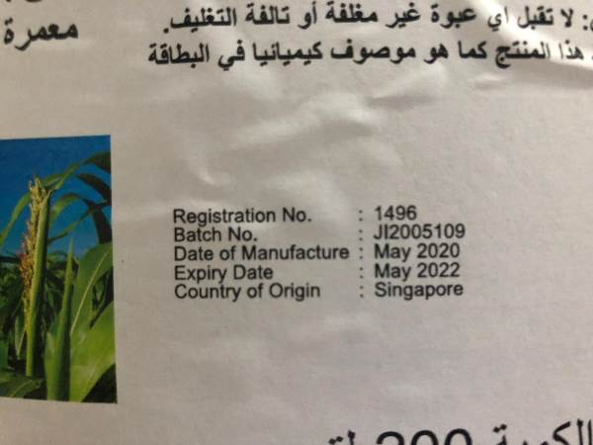
Typical View of Batch No. Identification at the Drum | Close-up view of Batch Details
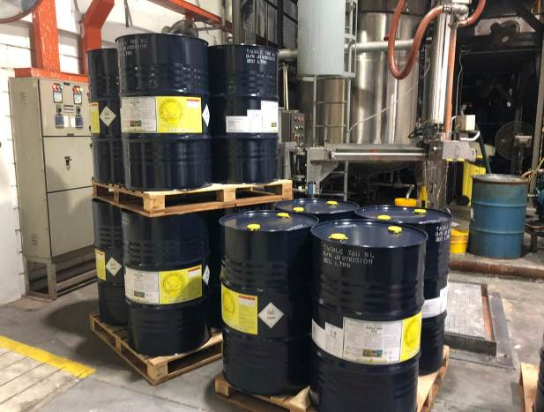 | 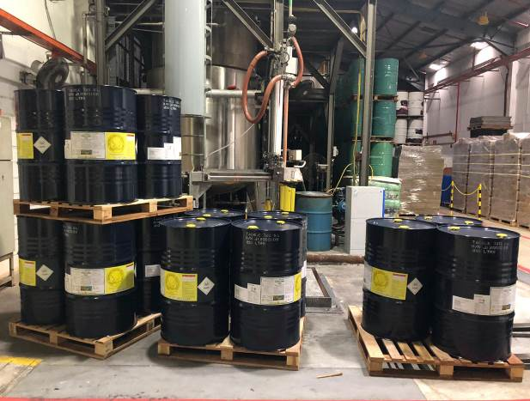
Quantity check
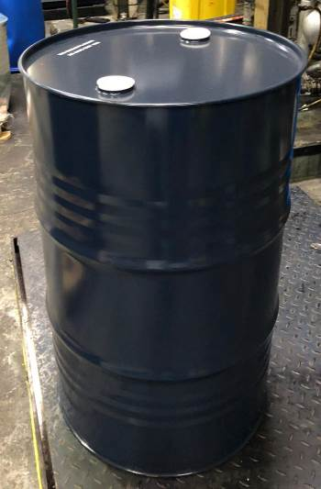 | 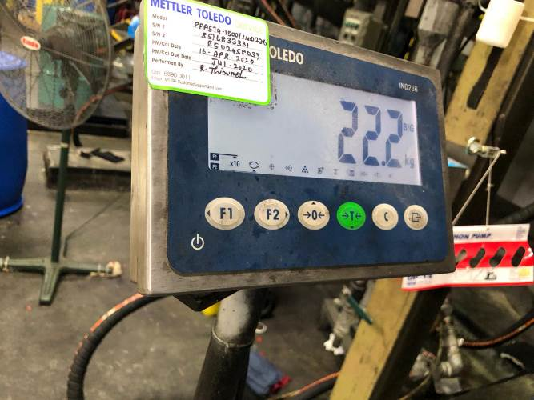
Empty Drum | Empty Drum Weight
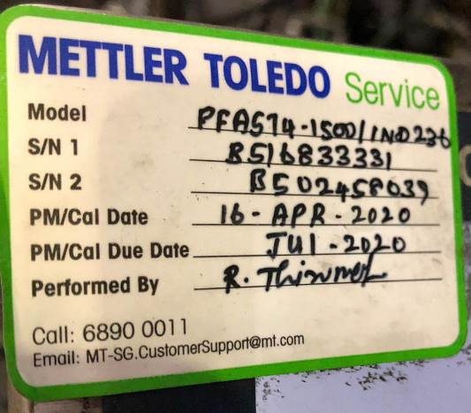 | 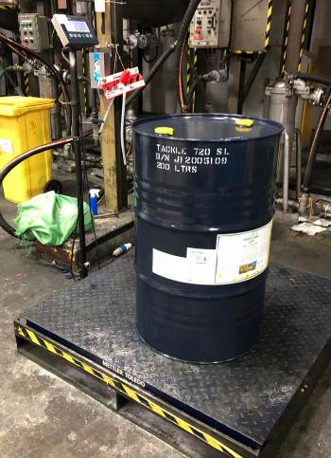
Weighing Scale Details | Typical view of Weighing a Drum
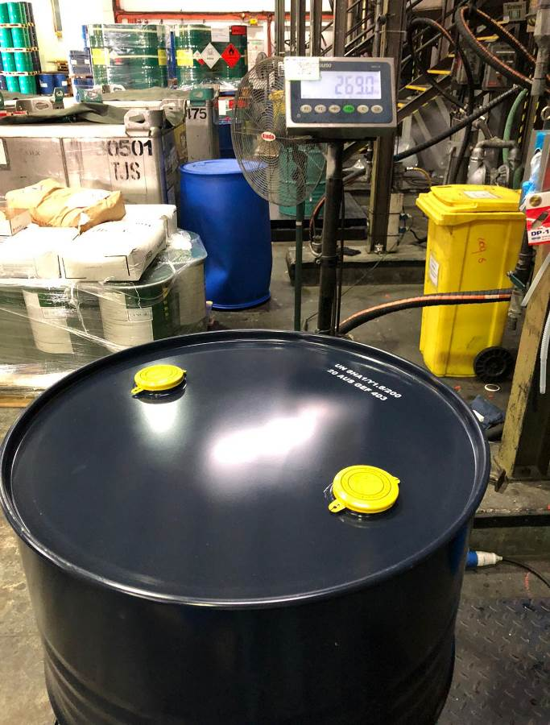 | 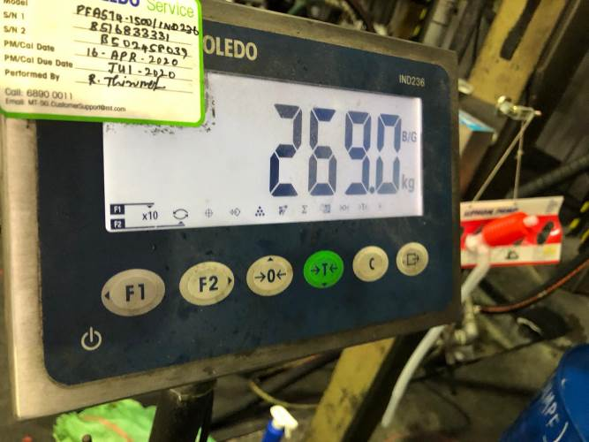
Weight Check with Product | Weight Measurement
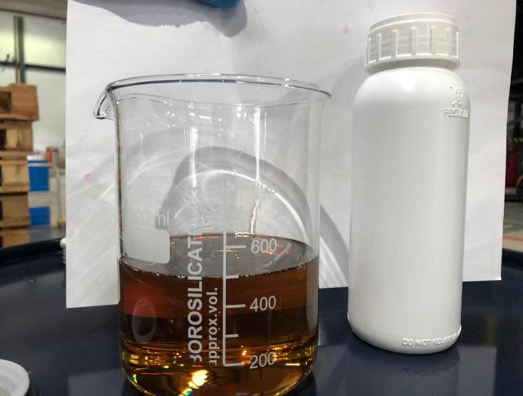 | 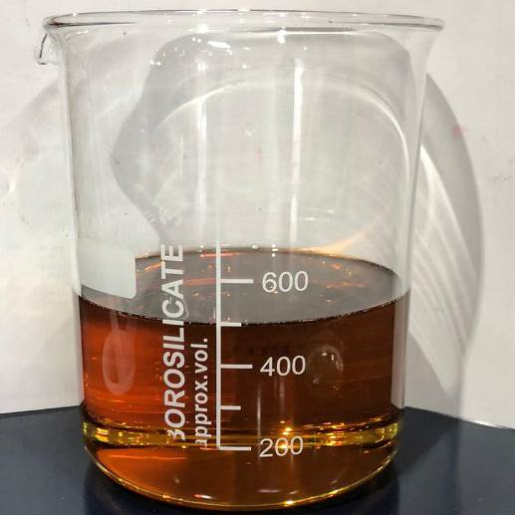
Sampling Taken in the beaker with storage bottle | Sampling – 500 ML Measurement
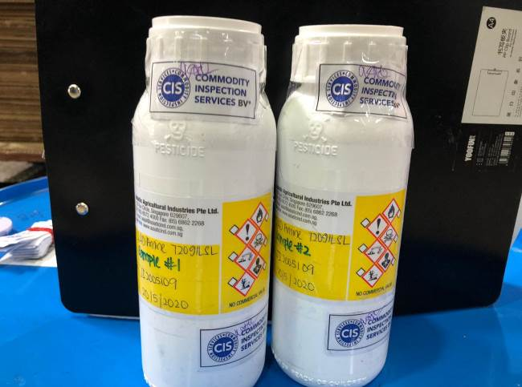 | 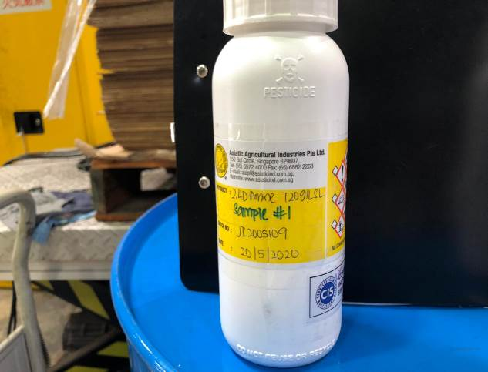
Samples Sealed– for Retention and Send to Client | Sampling 1 for Retention
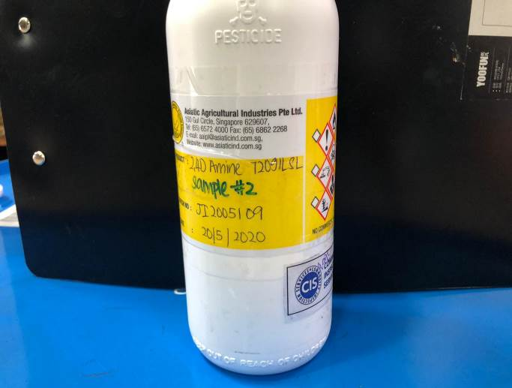 | 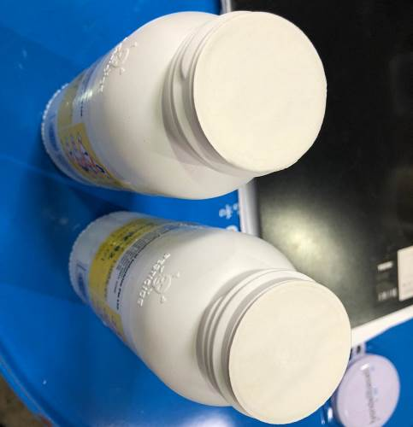
Sampling 2 to Send Client | Typical view of the samples covered seal paper
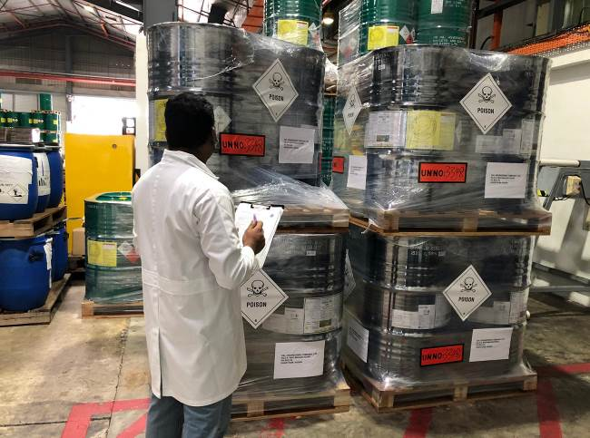 | 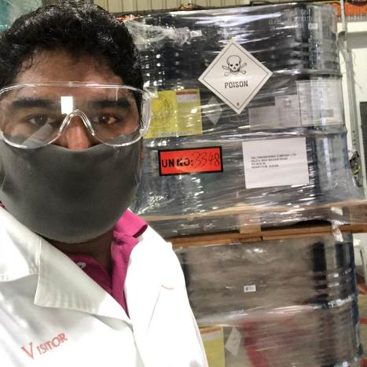
Typical View of Inspections
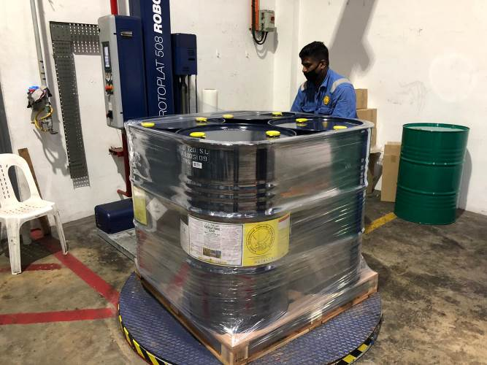 | 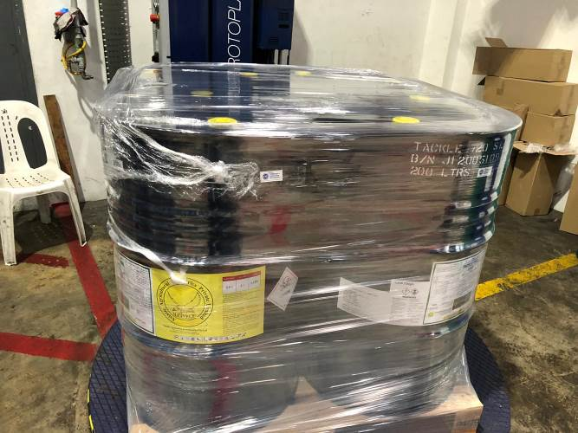
Typical view of Wrappings and Packings
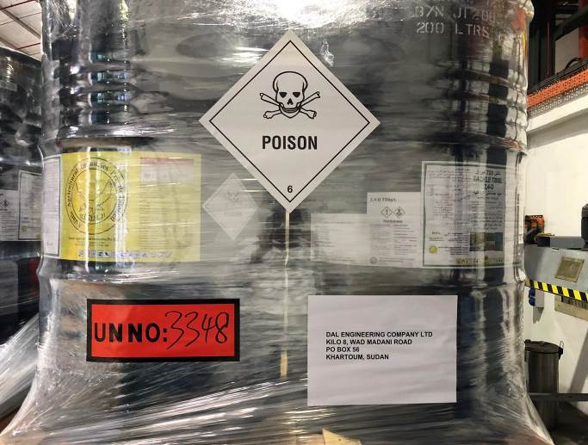 | 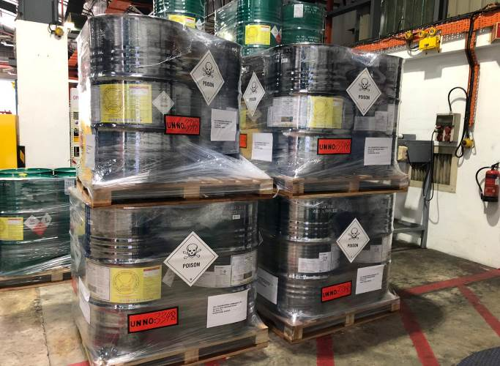
Packing with Labelling – Pre-shipment

Hemanth Kumar
Inspector's Printed Name |  | Inspector's Signature

**** End of Report *****

