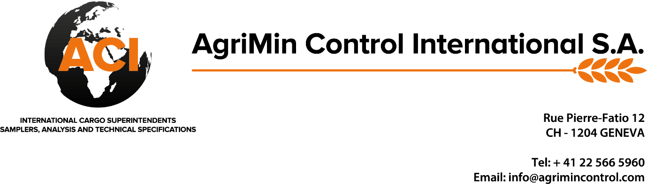

**PRE-SHIPMENT INSPECTION AND SAMPLING REPORT CH/2020/024**

|  |  |  |
| --- | --- | --- |
| SHIPPER | **:** | BIO TREASURE OVERSEAS.  478/01/01/01, BEHIND 20  INDUSTRIAL AREA,  RAU, INDORE, M.P |
| BUYER | **:** | COCFO FRANCE |
| COMMODITY | **:** | ORGANIC SOYABEAN MEAL |
| OFFERED QUANTITY | **:** | 2200 Bags (110.000 gMT) PACKED IN APPROX 50.000 KGS white PLAIN PP BAGS |
| NATURE OF WORK | **:** | PRE-SHIPMENT INSPECTION & SAMPLING |
| DATE & PLACE OF INTERVENTION | **:** | BIO TREASURE OVERSEAS., RAU, M.P DT.06.03.2020 |

|  |  |  |  |  |  |  |  |
| --- | --- | --- | --- | --- | --- | --- | --- |
| Client | Bio Treasure Overseas | | | |  | DATE : 06.03.2020 | |
| LOCATION: Rau,Indore | | | | |  |  |  |
| COMMODITY/ CARGO : Organic Soyabean Meal | | | | | | | |
| **Sr. No.** | **Weight/Bags** | **Sr. No.** | **Weight/Bags** | **Sr. No.** | **Weight/Bags** | **Sr. No.** | **Weight/Bags** |
| 1 | 50.000 | 1 | 49.900 | 1 | 50.750 | 1 | 50.000 |
| 2 | 48.350 | 2 | 50.500 | 2 | 50.000 | 2 | 50.050 |
| 3 | 49.750 | 3 | 49.650 | 3 | 50.250 | 3 | 48.300 |
| 4 | 50.350 | 4 | 49.750 | 4 | 50.000 | 4 | 49.750 |
| 5 | 50.150 | 5 | 49.950 | 5 | 52.400 | 5 | 49.950 |
| 6 | 49.800 | 6 | 50.050 | 6 | 49.950 | 6 | 50.000 |
| 7 | 50.350 | 7 | 49.750 | 7 | 49.800 | 7 | 50.000 |
| 8 | 50.450 | 8 | 50.250 | 8 | 50.000 | 8 | 50.050 |
| 9 | 49.800 | 9 | 50.000 | 9 | 50.050 | 9 | 49.950 |
| 10 | 49.950 | 10 | 48.950 | 10 | 48.950 | 10 | 49.850 |
| **Total** | **498.950** | **Total** | **498.750** | **Total** | **502.150** | **Total** | **497.900** |
|  |  |  |  |  |  |  |  |
|  |  |  |  |  |  |  |  |
|  | **Total no bags** |  | **Total weight (in Kgs)** | | **Average Wt per** | | **Min-48.300 Kgs** |
|  | 40 | | 1997.750 | | 49.944 | | **Max-52.400 Kgs** |

Geneva: 9th March 2019 AgriMin Control International S.A.