DAP_figures

sophie whikehart

2023-12-04

Table of Contents

Figure 1 3

Conduct descriptive analysis for the quantitative variables by creating a summary table for the quantitative variables [age, alcoh, hdl, insulin] 3

Figure 2 4

Histogram to show distribution of alcohol 4

Figure 3 5

Histogram to show distribution of hdl 5

Figure 4 7

Histogram to show distribution of serum insulin levels 7

Figure 5 7

Frequency distribution of categorical variables 7

Figure 6 8

Bar chart of Family History of Heart Attack 8

Figure 7 9

Bar chart on smoking status 9

Figure 8 10

Bar chart to show alcohol consumption 10

Figure 9 11

Box plot of CHD and HDL Cholestrol 11

Figure 10 12

Two sample t-test to determine if HDL cholesterol levels are associated with CHD 12

Figure 11 13

Final summary table reporting HDl cholesterol, alcohol, serum insulin, smoking status and family history of heart attack by CHD 13

Figure 12 14

Overall HDL cholesterol by CHD 14

Figure 13 15

Bar chart on categorized HDL 15

Figure 14 16

HDL cholesterol by CHD - Family History of Heart Attack = Yes 16

Figure 15 17

HDL cholesterol by CHD - Family History of Heart Attack = No 17

knitr::opts_chunk$set(echo = TRUE,  
 warning = FALSE,  
 message = FALSE,  
 comment = "")  
  
# load libraries   
library(e1071) # Needed for skewness()  
  
library(tidyverse) # Need to summarize data and for %>% function

## ── Attaching core tidyverse packages ──────────────────────── tidyverse 2.0.0 ──  
## ✔ dplyr 1.1.4 ✔ readr 2.1.4  
## ✔ forcats 1.0.0 ✔ stringr 1.5.0  
## ✔ ggplot2 3.4.3 ✔ tibble 3.2.1  
## ✔ lubridate 1.9.2 ✔ tidyr 1.3.0  
## ✔ purrr 1.0.2   
## ── Conflicts ────────────────────────────────────────── tidyverse_conflicts() ──  
## ✖ dplyr::filter() masks stats::filter()  
## ✖ dplyr::lag() masks stats::lag()  
## ℹ Use the conflicted package (<http://conflicted.r-lib.org/>) to force all conflicts to become errors

library(ggplot2) # Needed to create graphs using the ggplot2 package  
  
library(flextable) # Used to create a nice summary table in Word

##   
## Attaching package: 'flextable'  
##   
## The following object is masked from 'package:purrr':  
##   
## compose

library(gtsummary) # Used to create a nice summary table in Word

## #StandWithUkraine  
##   
## Attaching package: 'gtsummary'  
##   
## The following objects are masked from 'package:flextable':  
##   
## as_flextable, continuous_summary

#import data   
chdclass <- read.csv(file = "chd3200 (1).csv")  
  
#create factor variables   
# MI family history  
chdclass$fhha.f <- factor(chdclass$fhha, levels = c(0,1),   
 labels = c("No", "Yes"))  
  
# Coronary heart disease (CHD)  
chdclass$incchd.f <- factor(chdclass$incchd, levels = c(0,1),   
 labels = c("No", "Yes"))  
# Smoking status  
chdclass$smoke.f <- factor(chdclass$smoke, levels = c(1,2,3),   
 labels = c("Never", "Former", "Current"))

# Figure 1

## Conduct descriptive analysis for the quantitative variables by creating a summary table for the quantitative variables [age, alcoh, hdl, insulin]

chdclass %>% select(age, alcoh, hdl, insulin) %>%  
 tbl_summary(missing = "ifany",  
 type = all_continuous() ~ "continuous2",  
 statistic = all_continuous() ~ c("{mean} ({sd})",  
 "{median} ({p25}, {p75})",   
 "{min}, {max}",  
 "{skewness}"),  
 digits = list(all_continuous() ~ 1),   
 label = list(age ~ "Age (y)",  
 alcoh ~ "Alcohol consumption (drinks/wk)",  
 hdl ~ "HDL cholesterol (mg/dL)",  
 insulin ~ "Serum insulin (IU/ml)")  
 ) %>%  
 modify_header(label = "**Variable**") %>%   
 add_stat_label(label = all_continuous() ~ c("Mean (SD)",   
 "Median (IQR)",  
 "Min to Max", "Skewness"))

| **Variable** | **N = 3,200** |
| --- | --- |
| Age (y) |  |
| Mean (SD) | 71.6 (4.4) |
| Median (IQR) | 71.0 (68.0, 75.0) |
| Min to Max | 65.0, 82.0 |
| Skewness | 0.5 |
| Alcohol consumption (drinks/wk) |  |
| Mean (SD) | 2.6 (6.5) |
| Median (IQR) | 0.0 (0.0, 1.3) |
| Min to Max | 0.0, 77.0 |
| Skewness | 4.4 |
| HDL cholesterol (mg/dL) |  |
| Mean (SD) | 54.9 (15.6) |
| Median (IQR) | 53.0 (44.0, 64.0) |
| Min to Max | 15.0, 149.0 |
| Skewness | 0.9 |
| Serum insulin (IU/ml) |  |
| Mean (SD) | 16.1 (20.0) |
| Median (IQR) | 13.0 (10.0, 17.0) |
| Min to Max | 3.0, 400.0 |
| Skewness | 12.8 |

# Figure 2

# Histogram to show distribution of alcohol

ggplot(data=chdclass, aes(x=alcoh)) +  
geom_histogram(color="black", fill="blue4", binwidth=10, position="identity", alpha=0.7) +  
labs(x="Alcohol drinks",  
y="No. of subjects",  
title="Histogram of Alcohol Consumption (drinks/wk)")

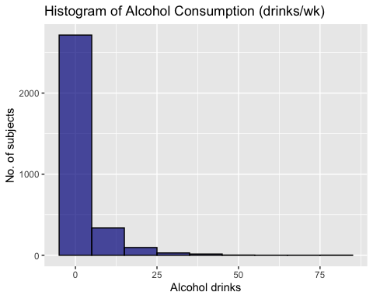

# Figure 3

# Histogram to show distribution of hdl

ggplot(data=chdclass, aes(x=hdl)) +  
geom_histogram(color="black", fill="lightblue", binwidth=10, position="identity", alpha=0.7) +  
labs(x="HDL",  
y="No. of subjects",  
title="HDL Cholesterol (mg/dL)")

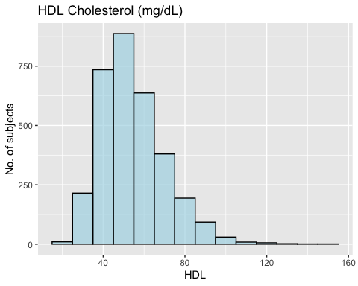

#create categories  
chdclass$alcoh <- cut(chdclass$alcoh, breaks = c(-Inf,0,7.000,Inf))  
  
#check categories  
table(chdclass$alcoh, exclude=FALSE)

(-Inf,0] (0,7] (7, Inf]   
 1537 1240 423

#create a factor variable   
chdclass$alcoh.f <- factor(chdclass$alcoh,  
 levels = c("(-Inf,0]", "(0,7]",  
 "(7, Inf]"),  
 labels = c("0", ">0 to 7", ">7"))  
#check factor variable  
table(chdclass$alcoh.f)

0 >0 to 7 >7   
 1537 1240 423

# Figure 4

## Histogram to show distribution of serum insulin levels

ggplot(data=chdclass, aes(x=hdl)) +  
geom_histogram(color="black", fill="purple4", binwidth=10, position="identity", alpha=0.7) +  
labs(x="Insulin (Serum insulin level (IU/ml))",  
y="No. of subjects",  
title="Histogram of Insulin")

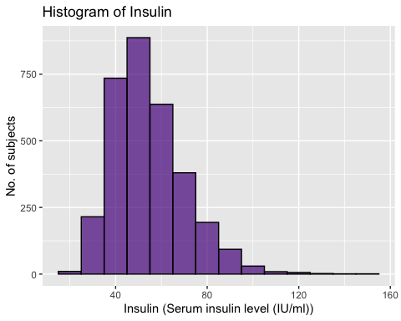

# Figure 5

## Frequency distribution of categorical variables

theme_gtsummary_journal(journal = "jama") # Use the JAMA theme  
  
chdclass %>% select(fhha.f, incchd.f, smoke.f, alcoh.f) %>%  
 tbl_summary(missing = "ifany",  
 type = list(fhha.f ~ "categorical",  
 incchd.f ~ "categorical"),  
 digits = list(all_categorical() ~ c(0,1)),   
 label = list(fhha.f ~ "Family history MI",  
 incchd.f ~ "Coronary heart disease",  
 smoke.f ~ "Smoking status",  
 alcoh.f ~ "Average consumption of alcohol per week")  
 ) %>%  
 modify_header(label = "**Variable**")

| **Variable** | **N = 3,200** |
| --- | --- |
| Family history MI, n (%) |  |
| No | 2,216 (69.3) |
| Yes | 984 (30.8) |
| Coronary heart disease, n (%) |  |
| No | 2,769 (86.5) |
| Yes | 431 (13.5) |
| Smoking status, n (%) |  |
| Never | 1,558 (48.7) |
| Former | 1,266 (39.6) |
| Current | 376 (11.8) |
| Average consumption of alcohol per week, n (%) |  |
| 0 | 1,537 (48.0) |
| >0 to 7 | 1,240 (38.8) |
| >7 | 423 (13.2) |

# Figure 6

## Bar chart of Family History of Heart Attack

ggplot(data=chdclass, aes(x=fhha.f)) +  
geom_bar(color="black", fill="red4", binwidth=10, position="identity", alpha=0.7) +  
labs(x="Family History of Heart Attack",  
y="No. of subjects",  
title="Bar chart on Family History of Heart Attack")

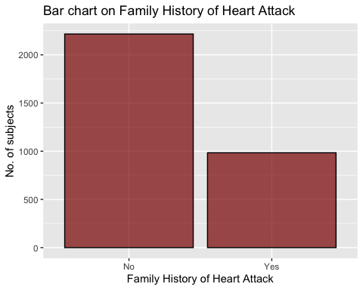

# Figure 7

## Bar chart on smoking status

ggplot(data=chdclass, aes(x=smoke.f)) +  
geom_bar(color="black", fill="black", binwidth=10, position="identity", alpha=0.7) +  
labs(x="Smoking Status",  
y="No. of subjects",  
title="Bar chart on Smoking Status")

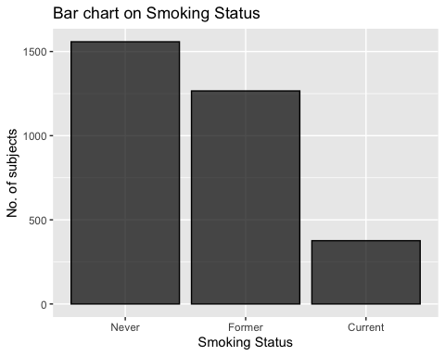

# Figure 8

## Bar chart to show alcohol consumption

ggplot(data=chdclass, aes(x=alcoh.f)) +  
geom_bar(color="black", fill="lightblue4", binwidth=10, position="identity", alpha=0.7) +  
labs(x="Alcohol drinks",  
y="No. of subjects",  
title="Bar chart on Alcohol Consumption by 0 drinks, >0 to 7 and >7 drinks per week")

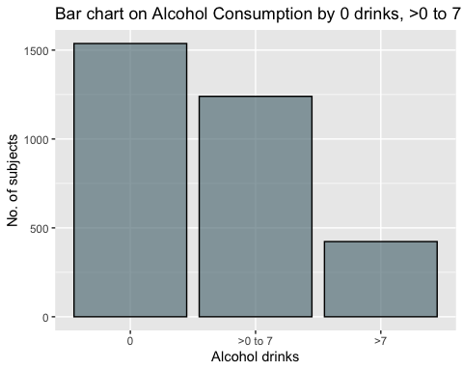

# Figure 9

## Box plot of CHD and HDL Cholestrol

ggplot(data=chdclass, aes(x=incchd.f, y=hdl, fill=incchd.f)) +  
 geom_boxplot() +  
 labs(x="CHD",  
 y="HDL cholesterol (mg/dL)",  
 title="HDL cholesterol by CHD") +   
 scale_y_continuous(limits=c(0, 140), breaks=seq(0,150,20)) +   
 theme_classic() +  
 theme(legend.position="none") +  
 theme(  
 legend.position = "none",  
 legend.title = element_text(colour="black", size=10,   
 face="bold"),  
 legend.text = element_text(colour="black", size=10,   
 face="bold"),  
 axis.title.x = element_text(face="bold", size=12),  
 axis.text.x = element_text(face="bold", size=11),  
 axis.title.y = element_text(face="bold", size=12),  
 axis.text.y = element_text(face="bold", size=11)) +  
 scale_fill_manual(values=c("orange","lightblue"))

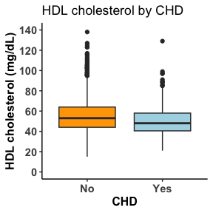

# Figure 10

## Two sample t-test to determine if HDL cholesterol levels are associated with CHD

# t.test   
t.test(hdl ~ incchd.f, conf.level=0.95, var.equal = FALSE, data=chdclass, alternative= "two.sided")

Welch Two Sample t-test  
  
data: hdl by incchd.f  
t = 6.1893, df = 600.74, p-value = 1.119e-09  
alternative hypothesis: true difference in means between group No and group Yes is not equal to 0  
95 percent confidence interval:  
 3.190391 6.156090  
sample estimates:  
 mean in group No mean in group Yes   
 55.54099 50.86775

# Figure 11

## Final summary table reporting HDl cholesterol, alcohol, serum insulin, smoking status and family history of heart attack by CHD

theme_gtsummary_journal(journal = "jama") # Use the JAMA theme  
  
chdclass %>% select(incchd.f, age, alcoh.f, hdl, insulin, smoke.f, fhha.f) %>%  
 tbl_summary(by = incchd.f,  
 missing = "ifany",  
 statistic = list(age ~ c("{median} ({p25}, {p75})"),  
 hdl ~ c("{mean} ({sd})"),  
 insulin ~ c("{median} ({p25}, {p75})")  
 ),  
 percent = "row",  
 type = list(fhha.f ~ "categorical",  
 alcoh.f ~ "categorical"),  
 digits = list(all_categorical() ~ c(0,1)),   
 label = list(hdl ~ "HDL cholesterol (mg/dL)",  
 insulin ~ "Serum insulin (IU/ml)",  
 smoke.f ~ "Smoking status",  
 age ~ "Age (years)",  
 alcoh.f ~ "Average number of alcoholic drinks per week",  
 fhha.f ~ "Family history of heart attack")  
 ) %>%  
 add_overall() %>%  
 modify_header(label = "**Variable**") %>%  
 modify_spanning_header(stat_1 ~ "Coronary Heart Disease",  
 stat_2 ~ "Coronary Heart Disease") %>%   
 add_p()

|  | | Coronary Heart Disease | |  |
| --- | --- | --- | --- | --- |
| **Variable** | **Overall**, N = 3,200 | **No**, N = 2,769 | **Yes**, N = 431 | **p-value**1 |
| Age (years), Median (IQR) | 71 (68, 75) | 71 (68, 75) | 72 (69, 77) | <0.001 |
| Average number of alcoholic drinks per week, n (%) |  |  |  | 0.046 |
| 0 | 1,537 (100.0) | 1,311 (85.3) | 226 (14.7) |  |
| >0 to 7 | 1,240 (100.0) | 1,078 (86.9) | 162 (13.1) |  |
| >7 | 423 (100.0) | 380 (89.8) | 43 (10.2) |  |
| HDL cholesterol (mg/dL), Mean (SD) | 55 (16) | 56 (16) | 51 (14) | <0.001 |
| Serum insulin (IU/ml), Median (IQR) | 13 (10, 17) | 12 (9, 17) | 13 (10, 19) | 0.002 |
| Smoking status, n (%) |  |  |  | 0.005 |
| Never | 1,558 (100.0) | 1,376 (88.3) | 182 (11.7) |  |
| Former | 1,266 (100.0) | 1,065 (84.1) | 201 (15.9) |  |
| Current | 376 (100.0) | 328 (87.2) | 48 (12.8) |  |
| Family history of heart attack, n (%) |  |  |  | <0.001 |
| No | 2,216 (100.0) | 1,947 (87.9) | 269 (12.1) |  |
| Yes | 984 (100.0) | 822 (83.5) | 162 (16.5) |  |
| 1Wilcoxon rank sum test; Pearson's Chi-squared test | | | | |

# Figure 12

## Overall HDL cholesterol by CHD

#Categorizing HDL cholesterol  
chdclass$hdlcat <- cut(chdclass$hdl, breaks = c(-Inf,40,Inf))  
  
table(chdclass$hdlcat, exclude = FALSE)

(-Inf,40] (40, Inf]   
 550 2650

# Create a factor variable  
chdclass$hdlcat.f <- factor(chdclass$hdlcat,   
 levels = c("(-Inf,40]", "(40, Inf]"),   
 labels = c("<40", ">=40"))  
  
# Check factor variable  
table(chdclass$hdlcat.f)

<40 >=40   
 550 2650

#Create cross-tab for overall HDL cholesterol and CHD incidence  
chdclass |>   
 select(incchd.f, hdlcat.f) |>  
 tbl_summary(by = incchd.f,  
 missing = "no",  
 percent = "row",  
 statistic = all_categorical() ~ "{n} ({p}%)",  
 label = list(incchd.f ~ "Incidence of CHD",  
 hdlcat.f ~ "HDL cholesterol")) %>%  
 modify_spanning_header(stat_1 ~ "Overall HDL and CHD")

|  | Overall HDL and CHD |  |
| --- | --- | --- |
| **Characteristic** | **No**, N = 2,769 | **Yes**, N = 431 |
| HDL cholesterol, n (%) |  |  |
| <40 | 442 (80%) | 108 (20%) |
| >=40 | 2,327 (88%) | 323 (12%) |

# Figure 13

## Bar chart on categorized HDL

ggplot(data=chdclass, aes(x=hdlcat.f)) +  
geom_bar(color="black", fill="pink4", binwidth=10, position="identity", alpha=0.7) +  
labs(x="HDL",  
y="No. of subjects",  
title="Bar chart on HDL <40 and >=40")

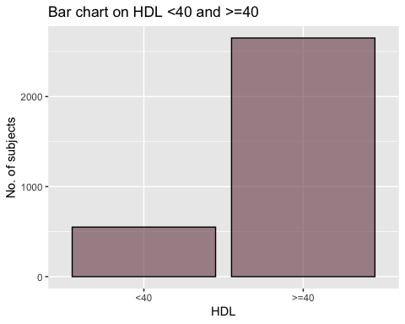

# Figure 14

## HDL cholesterol by CHD - Family History of Heart Attack = Yes

#Categorizing HDL cholesterol  
chdclass$hdlcat <- cut(chdclass$hdl, breaks = c(-Inf,40,Inf))  
  
table(chdclass$hdlcat, exclude = FALSE)

(-Inf,40] (40, Inf]   
 550 2650

# Create a factor variable  
chdclass$hdlcat.f <- factor(chdclass$hdlcat,   
 levels = c("(-Inf,40]", "(40, Inf]"),   
 labels = c("<40", ">=40"))  
  
# Check factor variable  
table(chdclass$hdlcat.f)

<40 >=40   
 550 2650

#Create cross-tab for FFHA = YES by HDL cholesterol and CHD incidence  
chdclass %>%   
 filter(fhha.f == "Yes") %>%  
 select(incchd.f, hdlcat.f) %>%  
 tbl_summary(by = incchd.f,  
 missing = "no",  
 percent = "row",  
 statistic = all_categorical() ~ "{n} ({p}%)",  
 label = list(incchd.f ~ "Incidence of CHD",  
 hdlcat.f ~ "HDL cholesterol (mg/dL)")) %>%  
modify_header(label = "**Variable**") %>%  
 modify_spanning_header(stat_1 ~ "Family History of Heart Attack = Yes to CHD")

|  | Family History of Heart Attack = Yes to CHD |  |
| --- | --- | --- |
| **Variable** | **No**, N = 822 | **Yes**, N = 162 |
| HDL cholesterol (mg/dL), n (%) |  |  |
| <40 | 135 (75%) | 44 (25%) |
| >=40 | 687 (85%) | 118 (15%) |

# Figure 15

## HDL cholesterol by CHD - Family History of Heart Attack = No

#Categorizing HDL cholesterol  
chdclass$hdlcat <- cut(chdclass$hdl, breaks = c(-Inf,40,Inf))  
  
table(chdclass$hdlcat, exclude = FALSE)

(-Inf,40] (40, Inf]   
 550 2650

# Create a factor variable  
chdclass$hdlcat.f <- factor(chdclass$hdlcat,   
 levels = c("(-Inf,40]", "(40, Inf]"),   
 labels = c("<40", ">=40"))  
  
# Check factor variable  
table(chdclass$hdlcat.f)

<40 >=40   
 550 2650

#Create cross-tab for FFHA = NO by HDL cholesterol and CHD incidence  
chdclass %>%   
 filter(fhha.f == "No") %>%  
 select(incchd.f, hdlcat.f) %>%  
 tbl_summary(by = incchd.f,  
 missing = "no",  
 percent = "row",  
 statistic = all_categorical() ~ "{n} ({p}%)",  
 label = list(incchd.f ~ "Incidence of CHD",  
 hdlcat.f ~ "HDL cholesterol (mg/dL)")) %>%  
modify_header(label = "**Variable**") %>%  
 modify_spanning_header(stat_1 ~ "Family History of Heart Attack = No to CHD")

|  | Family History of Heart Attack = No to CHD |  |
| --- | --- | --- |
| **Variable** | **No**, N = 1,947 | **Yes**, N = 269 |
| HDL cholesterol (mg/dL), n (%) |  |  |
| <40 | 307 (83%) | 64 (17%) |
| >=40 | 1,640 (89%) | 205 (11%) |