**[Terraform Scripts](https://www.geeksforgeeks.org/what-is-terraform/" \t "_blank)**

Terraform is an **infrastructure-as-code (IaC)** tool that allows you to automate the provisioning and management of infrastructure resources. It uses configuration files written in the **HashiCorp Configuration Language (HCL)** to define the desired state of your infrastructure. Terraform supports multiple cloud providers, such as AWS, Azure, and Google Cloud Platform, as well as on-premises environments.

**Terraform Architecture:**

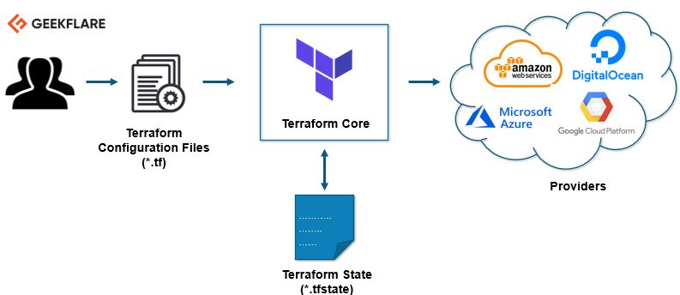

**Configuration Files**

Terraform configuration files contain the definition of the infrastructure resources that Terraform will manage. These files are written in HCL and can include input and output variables, modules, and resource definition.

**State File**

The state file stores the current state of the infrastructure resources managed by Terraform. It is used to track the resources that have been created, modified, or destroyed, ensuring that the infrastructure matches the desired state defined in the configuration files.

**Core:**

Terraform core is a piece of software installed on a host machine. It uses two input sources: a user-configured Terraform configuration and the current state of the infrastructure. The core compares these inputs to create a plan, determining what needs to be created, updated, or deleted to achieve the desired infrastructure setup.

**Providers**

Providers are plugins that enable Terraform to communicate with various infrastructure platforms. They define the resource types and data sources that Terraform can manage for a specific platform[1](https://www.geeksforgeeks.org/what-is-terraform/).

**Modules**

Modules are containers for a set of related resources that are used together to perform a specific task. They allow users to organize and reuse their infrastructure code, making it easier to manage complex deployments[1](https://www.geeksforgeeks.org/what-is-terraform/).

**Terraform Workflow**

**1. Initialization (Init):**

* Sets up a working directory for Terraform.
* Downloads necessary provider plugins.
* Prepares the environment for subsequent operations.

**2. Validation (Validate):**

* Checks Terraform configuration files for syntactic correctness.
* Verifies internal consistency within the configuration.
* Ensures the configuration is ready for the next phase.

**3. Planning (Plan):**

* Analyzes the current state of infrastructure compared to the desired state defined in the configuration.
* Generates an execution plan, outlining the necessary actions to reach the desired state.
* Provides a preview of changes before they are applied.

**4. Application (Apply):**

* Executes the plan generated in the previous phase.
* Creates, modifies, or deletes resources to match the desired state.
* Provides feedback on the progress of the application process.

**5. Destruction (Destroy):**

* Removes the infrastructure managed by Terraform.
* Prompts for confirmation before proceeding to avoid accidental deletion.
* Cleans up all resources created by Terraform.

**Example: Provisioning an AWS EC2 Instance**

Here is a simple example of a Terraform script to launch an AWS EC2 instance:

provider "aws" {

access\_key = "YOUR\_ACCESS\_KEY"

secret\_key = "YOUR\_SECRET\_KEY"

region = "us-west-2"

}

resource "aws\_instance" "example" {

ami = "ami-0a634ae95e11c6f91"

instance\_type = "t2.micro"

}

**Steps to Execute**

1. **Initialize Terraform**: terraform init
2. **Create an Execution Plan**: terraform plan
3. **Apply the Plan**: terraform apply
4. **Destroy the Resources** (if needed): terraform destroy

**Advantages and Disadvantages**

**Advantages**

* **Declarative Configuration**: Users define the desired state of their infrastructure, making it easier to manage complex deployments[1](https://www.geeksforgeeks.org/what-is-terraform/).
* **Multi-Cloud Support**: Terraform supports multiple cloud providers, allowing users to manage resources across different environments[1](https://www.geeksforgeeks.org/what-is-terraform/).
* **Reusable Code**: Infrastructure resources can be defined in a reusable and modular way using features like modules and variables[1](https://www.geeksforgeeks.org/what-is-terraform/).

**Disadvantages**

* **Complexity**: Terraform can be complex to learn and use, especially for beginners[1](https://www.geeksforgeeks.org/what-is-terraform/).
* **State Management**: Issues can arise if the state file becomes out of sync with the actual infrastructure[1](https://www.geeksforgeeks.org/what-is-terraform/).
* **Performance**: Terraform can be slower than some other IaC tools, especially when managing large deployments[1](https://www.geeksforgeeks.org/what-is-terraform/).

Terraform is a powerful tool that enables users to define and manage infrastructure resources in a reusable and automated way. It is widely used in various industries and scenarios, including cloud infrastructure, data centers, and hybrid environments