

|  |
| --- |
| **DEP301 Project Proposal** |

|  |  |  |  |
| --- | --- | --- | --- |
|  | | |  |
| **Mzimela** | **S.T.** | **MR.** | |
| **Arduino Six Way Traffic Light Project** | | | |
| Type of project:  Design | Programme enrolled for:  Engineering: Computer Systems | | |
| Student declaration:  I understand what plagiarism is and that I have to complete my project on my own. | __S.T. MZIMELA 14/03/2018  Student signature Date | | |

|  |  |
| --- | --- |
| Declaration by language editor (proof-reader) |  |
| I have been allowed adequate time to read this document carefully and to make corrections where necessary (date received indicated below).  To the best of my knowledge, correct formatting, spelling and grammar are used throughout the document. |  |
|  | |
| _______________________________  Example: D. Williams (language editor) | |

|  |  |  |  |
| --- | --- | --- | --- |
| Declaration and recommendation by study leader |  | | |
| 1. Have you (the supervisor) been allowed adequate time to read and comment on the Project Proposal? | | | Yes |
| 2. Is the Project Proposal a correct, complete, clear and unambiguous description of what is required of the student? | | Correct: | Yes |
| Complete: | Yes |
| Clear: | Yes |
| Unambiguous: | Yes |
| 3. Recommendation: Do you recommend that the Project Proposal be approved? | | | Yes |
|  | | |  |
| ________________________________  Example: Mr. K.E.Moorgas (Supervisor) | | | ___________  Date |

PLAGIARISM DECLARATION

1. I know and understand that plagiarism is using another person’s work and pretending it is one’s own, which is wrong.

2. This essay/report/project is my own work.

3. I have appropriately referenced the work of other people I have used.

4. I have not allowed, **and will not allow**, anyone to copy my work with the intention of passing it off as his/her own work.

____Mzimela S.T____ 21200262________

Surname and Initials Student Number

________mzimela s.t_________ ________14/03/2018__________

Signature Date

Table of Contents

PLAGIARISM DECLARATION 2

Table of Contents 3

1. PROBLEM STATEMENT 1

2. USER REQUIREMENT STATEMENT 3

2.1.1Task breakdown 3

2.1.2 mission requirements of the product 3

2.2 INVESTIGATIVE PART OF THE PROJECT 5

3. FUNCTIONAL ANALYSIS 7

4. SYSTEM SPECIFICATIONS 11

4.1 MISSION-CRITICAL SYSTEM SPECIFICATIONS 11

4.2 FUNCTIONAL UNIT SPECIFICATIONS 11

5.1 DESIGN AND INVESTIGATIVE COMPONENTS 13

5.2 TECHNICAL DELIVERABLES 13

5.3 ADDITIONAL PROJECT REQUIREMENTS 13

5.4 DEMONSTRATION AT THE EXAMINATION 13

6. PROJECT PLAN 14

7.REFERENCES 15

# PROBLEM STATEMENT

The problem addressed in this report is how to efficiently free our roads from high traffic caused by the outdated technology of traffic lights as the number of cars and people increase everyday especially in Cities, Airports and in all high populated areas in the world we live in.

To eliminate our current problem we face in this country, creating control programs for traffic lights for more sophisticated roads than we already have in South Africa can do, of cause such roads have to be implemented first. The time spent in the traffic especially in the morning between 7:00 to 8:30 and afternoon 15:00 to 17:30 can be reduced drastically, this is when the workers and students are most active in the roads. Usually we have 1-4 way streets which quickly reach the limits and insufficient for road users in SA. Presenting the traffic control lights for newly Implemented 6 way streets in South Africa might change the time we spend on traffic forever.

The typical operation of a present traffic light we have, taking a T-junction street for example the approximate number of polls we can have is five with two facing west, two east and one facing south. The possible movement of the cars will of cause be from south to west, south to east, west to south, east to south, east to west and viseverse. People may want to cross in all three directions, so the lights to cater for them will be taken in account also.

When the Traffic lights Turns Green to which ever direction facing that particular traffic will start moving, and when Amber the cars are to slow down or pass fast if already in the interception. For the Red light all cars must stop moving in that direction.

When the Pedestrian pole button, software search that at least eight seconds have gone by since the last lapse the lights were changed thus allowing smooth flow of traffic, if specified 8 seconds has passed, the code is executed that changes the lights from green to amber then read .then pedestrian lights go green. After 10 seconds the red pedestrian light will flash for 10 seconds warning pedestrians to hurry as the lights are about to change back to green for cars. Then the pedestrian light changes back to red and the cars lights go from red to green and the traffic can resume.

The technical challenge the one has to contend with in this project is to write an algorithm that will not exceed the memory space allocated to Arduino Uno. Therefore the data type need to be selected for every variable has to be checked very carefully as it can take up unnecessary memory if chosen poorly. The number of ports available in the Arduino Uno is limited to the flexibility that the one wish to have. Which makes it a challenge because now the ways to rearrange and group components has to be done? The one is limited by the engineering designs, a sensory that can be used to simulate for cars when they pull up at the intersection. Such small sensor cannot be found except a push button can be used to represent such sensory that will interrupt the normal program and allow cars to automatically be granted a pass in abnormal cases e.g. Ambulance siren, Police Siren, abnormal weather or late night situation

# USER REQUIREMENT STATEMENT

# 2.1.1Task breakdown

The tasks to be completed in the project are to thoroughly investigate on how the traffic lights works and how it can be improved using Arduino code.

* A research on how traffic lights really work had to be done starting all the way from the 1900s.
* A complete design for a modern traffic light had to be done.
* A commented code written in Arduino
* Compiling and Testing the code
* Building the roads in the breadboard.
* Implementing the design into the bread board and integrating it with Arduino

## mission requirements of the product

The electronic components to be used are listed below. And the circuit diagram for the four way street is provided as it will be used as component to add one diagonal road on it’s as shown in Figure8 (The picture of a six way street).

Breadboard

Leds x30

Resistors x30 10kohms

Arduino Uno

Wires

USB cable

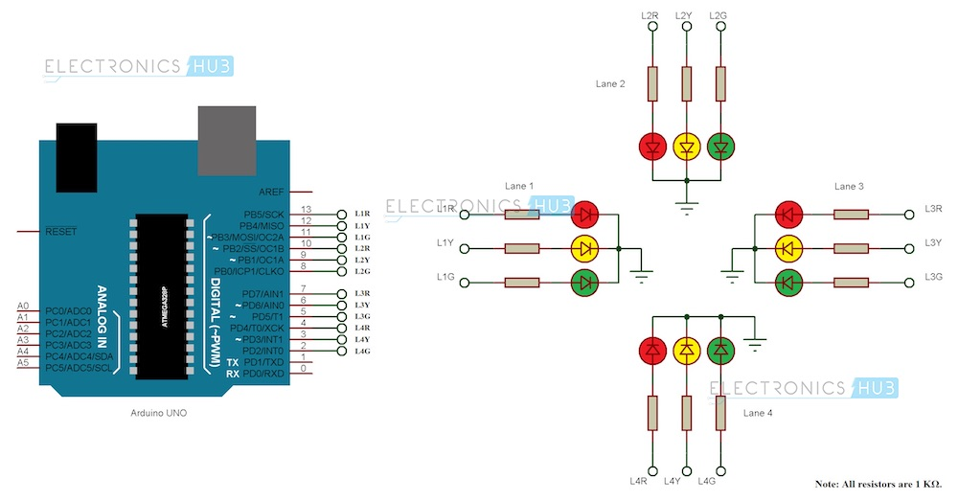

**Figure 7.**Administrator, 8 October, *Aurduino Traffic Light Controller, image*, viewed 14 march 2018 **, <**[**https://www.electronicshub.org/arduino-traffic-light-controller/**](https://www.electronicshub.org/arduino-traffic-light-controller/)**>.**

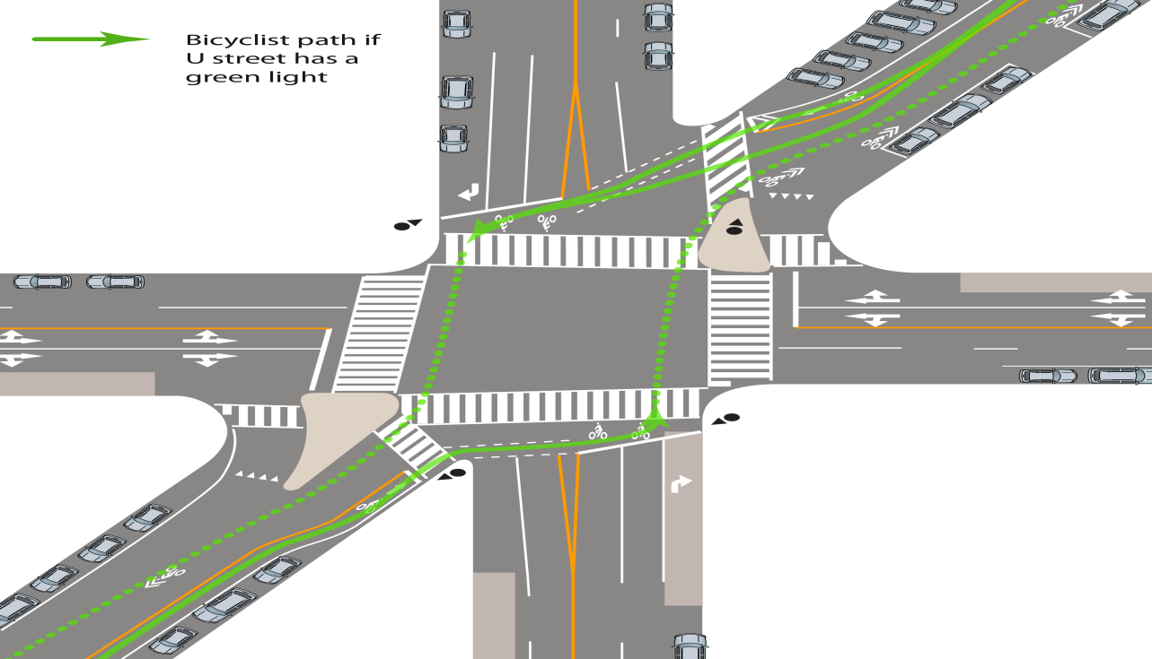

**Figure 8.** Allen,6 January 2013, *The 6-Way Washington DC*, image, viewed March 14 <<https://www.iamtraffic.org/evaluation/the-six-way/>.>

# 2.2 INVESTIGATIVE PART OF THE PROJECT

Back in a day when technology was young and cars just been introduced, meanwhile in the world of electronics and computer science there was not much progress to accommodate this radical history changer invention. For cars to fit the real world and put people’s minds at ease knowing that it is safe to embrace this new change and even own one of them auto mobiles so proper roads were built but still there was something missing as there were increasing number of people being victimized by this so called auto-mobiles.

The speed they moved at was nothing like what they were used too, now long ago precautions were taken for similarly case which could cater for wagons in the early 1800s first traffic light was invented [1] for peoples safety and smooth flow of traffic. The first traffic light invented was using a gas which caused a lot of accidents as the gas blew from time to time. In the 1900s a Police man named Charles Lester designed a first known electric traffic light which was controlled manually, it had only two colours: Red and Green [1]. Now as exciting as it was this tech had too much disadvantages as it required manual labour to carry out day to day operations.

For the advancement of Mr Lester invention in 1920 a three colour traffic light was made which had Red , Yellow and Orange [1] which was a great improvement and now this traffic light was used in a four way street, description of course were used in the same fashion as today where Red: was for stopping cars as it was regarded as a colour that represent danger as it is today while, Green: used to signal that it safe to proceed and Orange: use to alert drivers that the colour Red is about to come next so the driver has to be cautious as they approach the lights.

To create an auto responsive traffic light thus cutting down on manual labour seemed to be the greatest new improvement needed, It was not long before first sensing traffic light [1] was created which was controlled by timers, a microphone was installed at the poll where the traffic lights were installed the car had to hoot as t pulled up to the lights for traffic. While this seemed like a great improvement it had flaws, causing people in the surrounding areas where traffic lights were installed to file complaints because of the noise that was unbearable.

Finally the computers were invented in the 1960s presenting a unique opportunity to overcome this many foes which the traffic lights had faced over the years. Since the computers the sky became the limit ever since the robots now use the software written in a computer language such as C or VHDL to complete the daily tasks. And more sophisticated sensors are now used, the fa-mouse one is an **Inductive Coil**  [1] the traffic lights today have also the signals for the pedestrians in some states even a countdown, notifying how long the light will change back to Red is available.

# FUNCTIONAL ANALYSIS

The sequence of events that should unfold as the ardiuno board is powered up are automatically initiated since the idea of a modern traffic light is trying to read of manual labor along with human errors embracing this “auto-bot” i like to call it.

In reality traffic lights are aught to work in precise order that foresee events before they even arise with the use of sensors this makes it able to accomplish some of the most important tasks, such as manipulating the traffic lights to suits emergency situations should an ambulance or police vehicle comes ringing the alarm from a distance. Of cause the failure of auto response is anticipated that why admin ruling is required for intervening Whenever an operation fails, the signals could be controlled remotely from admin panel for demonstration in an ardiuno board this requires an Ethernet Shield then a web page can be created, all the signals can be viewed and manipulated anywhere in the world as long as long as Internet connection is available.

The functional units below portray the visual change of light emitting diodes as the program runs that controls the traffic. Only one end of the intersection is shown as the other end mirrors exactly what is displayed in the opposite end.

We assume by default the lights that are controlling east and west direction traffic will first have the right of way as shown in Figure1 below by FU1a and FU1b the other traffic will remain still for exactly one minute and 20 seconds.

Then the caution light (Yellow) on FU1a and FU1b turns on for 10s same time as green turns off. Mean while all other lights are Red. Now as soon as FU1a and FU1b turns Red , the traffic on North and South shown in Figure2 starts moving in their respective directions as the lights in FU4a and FU4b turns green.

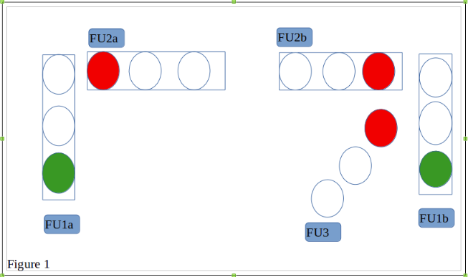

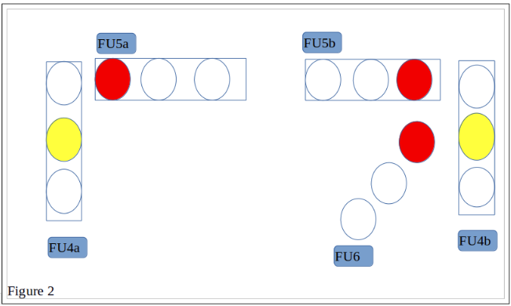

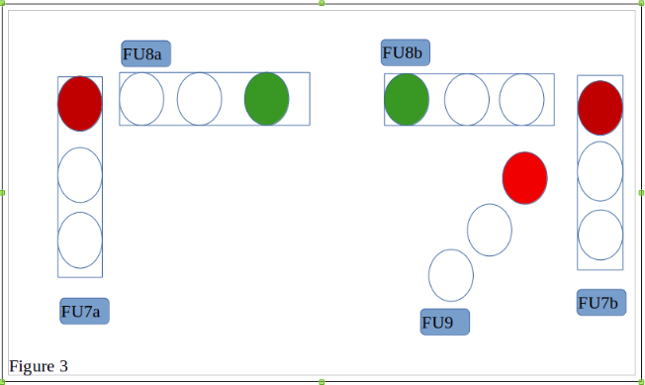

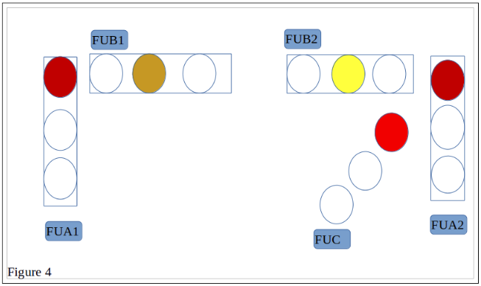

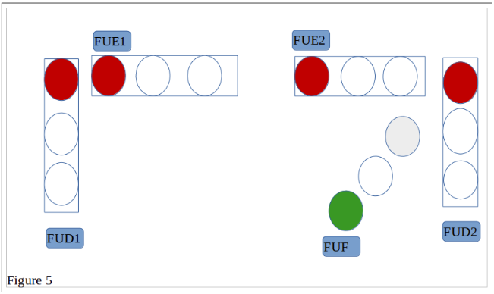

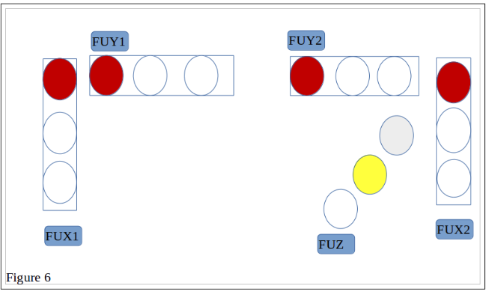

# SYSTEM SPECIFICATIONS

## 4.1 MISSION-CRITICAL SYSTEM SPECIFICATIONS

|  |  |  |
| --- | --- | --- |
| **SPECIFICATION** | **ORIGIN OR MOTIVATION** | **HOW WILL YOU CONFIRM THAT YOUR SYSTEM COMPLIES WITH THIS SPECIFICATION?** |
| The time delay should not exceed 1mininutes (m), 30 seconds(s). | This will allow proper movement of vehicles from either side of the road the extra 10s is for the caution light. | The timing will be provided by the audiuno software. |
| The pedestrian crossing should last about 20s. | The first 10s will be green for pedestrians and the red light should start flashing for the next 10s to warn the pedestrians. | The 20s is the addition of 20s from the 1m of cars movement to allow the smooth flow of traffic. |
| The data type for the variable that stores time delay should be long. | This prevents the overflow since long is a fairly storage allowance for such variable. | This will be initiated by the press of the button in the pole and the program will run to check the last time when the lights turned red for cars in that direction. |

## 4.2 FUNCTIONAL UNIT SPECIFICATIONS

|  |  |
| --- | --- |
| **SPECIFICATIONS** | **ORIGIN OR MOTIVATION** |
| FU1(a&b). The output signal in the lights should be green. | This shows that the vehicles directed to this side have the right of way but this should last for exactly 1m,30s the last 10s is the warning light. |
| FU2(a&b)&FU3. The output signal in the lights should be red. | This prevents the cars facing these directions not to move |
| FU4(a&b).The output signal in the lights is now Amber. | This serves as a warning that in 10s the lights is about to turn Red thus preventing cars from the respective direction to have the right of way. |
| FU5(a,b) and FU6.The output signal in the lights turns red. | The vehicles that are facing South and North starts to move at this instant. Whilst all else remain still. |
| FU7(a,b) and FU9.The output signal in the lights Remains Red while FU8(a,b) turns Amber. | This strictly gives warning to the cars moving at these respective directions the warning lasts about 10s. |
| FUD .Output Signal Change to green same time as FUB(a,b) turns Red. | This allows cars moving diagonally from South West to North East and vice versa. The other traffic stop. |
| FUD .Output Signal Change to Amber.. | This is a warning to the cars moving at this directions the Warning should last about precisely 10s than the cycle will start to repeat itself from FU1(a&b) |

1. DELIVERABLES

## 5.1 DESIGN AND INVESTIGATIVE COMPONENTS

## 5.2 TECHNICAL DELIVERABLES

|  |  |
| --- | --- |
| **DELIVERABLE** | **NATURE OF THE DELIVERABLE** |
| Arduino Uno board | The Arduino Uno board is off-the-shelf. |
| Arduino code for the six way street traffic lights. | All software will be developed from first principles. |
| Six way street circuit connected on the breadboard and thus connected with the Arduino board to download the code. | All the hardware will be developed from first principles, and will be implemented on a PC board developed from first principles. |

## 5.3 ADDITIONAL PROJECT REQUIREMENTS

There are no additional requirements for this project.

## 5.4 DEMONSTRATION AT THE EXAMINATION

1. Connect the Arduino UNO board to the power supply (+12V or USB cable).
2. The code will then run automatically showcasing the accuracy of timing as the traffic runs smoothly.
3. The function for pedestrians will run showcasing that pedestrians can also cross smoothly without hindrance.

# PROJECT PLAN

|  |  |  |  |  |
| --- | --- | --- | --- | --- |
| **Tasks** | Start Date | End Date | Progress | Submissions |
| Proposal :   * Research the topic | 09/02/2018 | 12/02/2018 | finished |  |
| * Problem Statement Draft | 12/02/2018 | 12/02/2018 | finished |  |
| * User Requirement Statement | 12/02/2018 | 12/02/2018 | finished |  |
| * Task breakdown | 12/02/2018 | 12/02/2018 | finished |  |
| * Mission requirements of the product | 12/02/2018 | 12/02/2018 | finished |  |
| * Functional Analysis | 13/02/2018 | 16/02/2018 | finished |  |
| * System Specifications | 16/02/2018 | 16/02/2018 | finished |  |
| * Mission-Critical System | 16/02/2018 | 16/02/2018 | finished |  |
| * Specification | 16/02/2018 | 16/02/2018 | finished |  |
| * Design And Investigative | - | - |  |  |
| * Components | 16/02/2018 | 16/02/2018 | finished |  |
| * Functional Unit Specification | 16/02/2018 | 16/02/2018 | finished |  |
| * Technical Deliverable | - | - |  |  |
| * Additional Project Requirements | - | - |  |  |
| * Demonstration At The Examination | - | - |  |  |
| **Construction Progress** |  |  |  |  |
| * Pseudo Code for Test Code * Flow Diagram * Test Code * Test Components |  |  |  |  |

# 7.REFERENCES

[1] Science ABC by Ashwin, available at :

<https://www.scienceabc.com/innovation/ready-steady-go-the-evolution-of-traffic-lights.html> [accessed 02 March 2018]

[2] Michael McRoberts, Beginning Arduino, 2nd Edition, Springer Science + Business Media New York, 2013

[3] I am Traffic, available at:

<http://iamtraffic.org/evaluation/the-six-way/> [accessed 28 March 2018]