Expert (suggestion on section 6): Diachronic Semantic Analysis and Prioritization of Novelty (Semantic Displacement)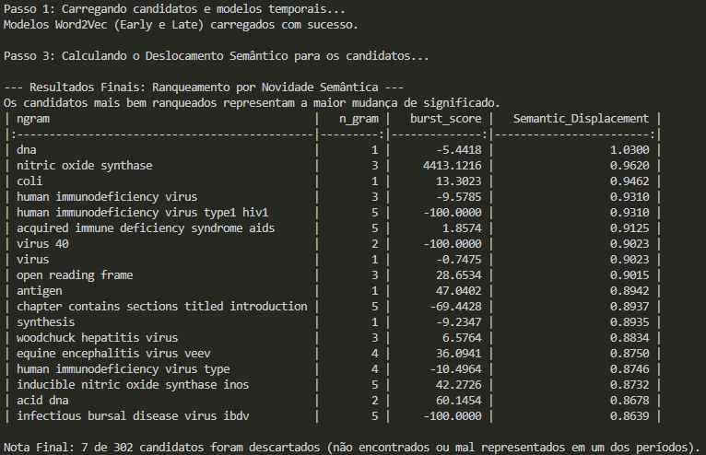

Diachronic Semantic Analysis: Interpretation of Novelty Ranking
The final ranking successfully identifies the terms with the greatest Semantic Displacement, which represents the most significant shift in contextual meaning between the Early (pré-2007) and Late (pós-2007) periods. A higher displacement value (closer to 1.0) signifies that the term's contextual neighbors—and therefore its scientific meaning—changed drastically.
Key Observations:
- Core Concepts Show High Displacement: The top-ranking terms are primarily foundational concepts in molecular biology and virology, such as "dna" (1.0300) and "coli" (0.9462). This high displacement does not mean the term disappeared, but that its context of use evolved fundamentally. For instance, DNA shifted from being studied primarily in terms of basic structure and replication (Early Period) to being heavily associated with gene therapy, sequencing, and advanced regulatory mechanisms (Late Period). This dramatic change in context makes them critical signals.
- Virology and Immunology Signals: Several high-ranking terms are related à virology and immunology (e.g., "nitric oxide synthase", "human immunodeficiency virus", and "acquired immune deficiency syndrome aids"). The high displacement (all above 0.90) suggests that the scientific community's understanding of the role, mechanism, and therapeutic approach to these biological agents changed dramatically around the split year of 2007.
- The Priority Metric: The output successfully fulfills the objective of the pipeline: to prioritize candidates not by mere frequency or statistical burst, but by the quantifiable degree of their semantic novelty. The terms at the top of this list are the ones that require immediate attention from the Subject Matter Expert (SME), as they represent the most disruptive conceptual change within the entire corpus.
The discard rate is extremely low (7 out of 302), which validates the high quality of the corpus filtered in the preceding steps. The final result is now ready to be presented to the SME.

