4.1. The Critical Difference: Volume vs. Relevance
The analysis of the term "messenger rna expression" using both absolute and normalized frequencies perfectly illustrates the fundamental problem in weak signal detection: volume must be separated from relevance.
By plotting the two trajectories (Figure 1), we can see that they tell two fundamentally different stories about the term's lifecycle.
Figure 1 – Plot A and Plot B: looks same but “don´t”
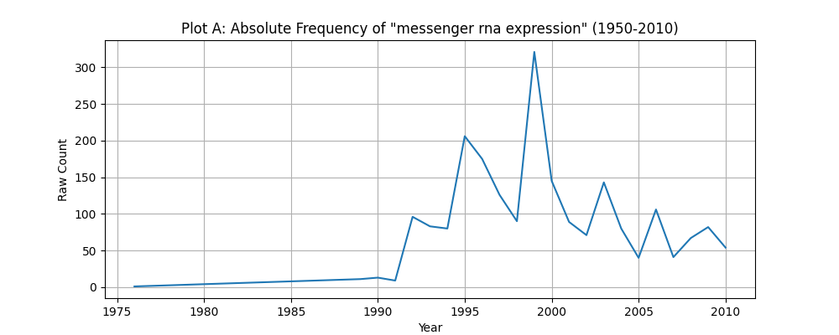
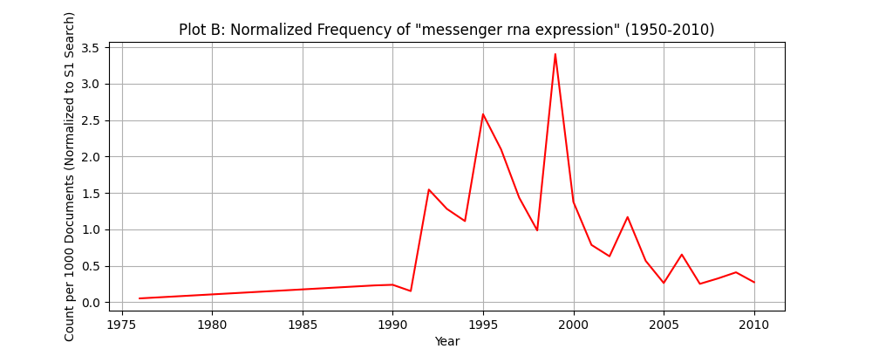
Source: Script 4.1.

Plot A: The Illusion of Constant Importance (Absolute Frequency)
The Absolute Frequency (Raw Count) trajectory (Plot A) measures the raw volume of publications.
- Interpretation: The curve shows a steep rise in the 1990s, culminating in a significant peak around 1999 (over 300 occurrences). Crucially, even after the 1999 peak, the volume of articles using the term stabilizes at a high baseline (between 50 and 150 counts per year).
- The Flaw: If we only analyzed this plot, we might conclude that while the explosive growth phase ended, the term maintained high, stable importance throughout the 2000s. This pattern is heavily biased by the exponential growth of the S1 research field itself.
Plot B: The Reality of Declining Relevance (Normalized Frequency)
The Normalized Frequency (Count per 1000 Documents) trajectory (Plot B) is the term's count divided by the total publications in the S1 search area, thus measuring relative relevance.
- Interpretation: This curve confirms the acute peak in strategic importance around 1999 (reaching a normalized value of approximately 3.4). However, immediately after this burst, the curve falls sharply and does not recover. In the post-2005 period, the normalized relevance fluctuates at a much lower floor (below 0.5).
- The Revelation: Normalization reveals that while the absolute volume remained high (Plot A), the term's importance relative to the rest of the growing mRNA field rapidly declined. Other concepts and terms were capturing the attention and funding of the scientific community, rendering "messenger rna expression" less strategically relevant.

