4.2 Reflecting on Burst Detection Results: The Limits of Statistics
The output from Exercise 4.4, applying the Emergence and Significant Growth criteria to normalized frequency data, delivers a powerful list of weak signal candidates. However, it simultaneously exposes the fundamental limitations of basic statistical analysis.
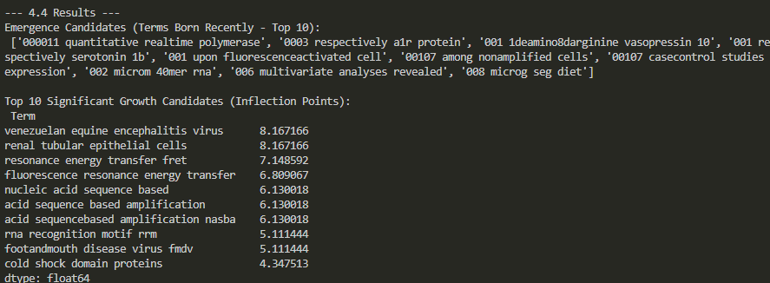
1. The Flaw of Statistical Blindness: Emergence Candidates
The list of Emergence Candidates (terms that appeared for the first time after 2007) demonstrates the primary weakness of simple quantitative methods:
- Results Analysis: This list is overwhelmingly dominated by data debris ('000011 quantitative realtime polymerase', '0003 respectively a1r protein'). These sequences are tokens that escaped the pre-processing pipeline. They are typically numeric codes, reference markers, or unfiltered technical fragments that were incorrectly identified as valid N-grams because they contain spaces.
- Reflection: The statistical criterion works perfectly — the terms did emerge from zero — but the algorithm is semantically blind. It cannot differentiate a valid scientific concept from a numerical footnote. This highlights the core limitation: simple statistical models lack the necessary contextual intelligence to guarantee qualitative significance.
2. Identifying Actionable Signals: Significant Growth
The Significant Growth Candidates list is much cleaner and far more useful:
- Results Analysis: Terms like 'venezuelan equine encephalitis virus', 'renal tubular epithelial cells', and the technical methods related to 'fluorescence resonance energy transfer (FRET)' show a massive increase (700% to 800%) in their normalized relevance between 2009 and 2010.
- Reflection: These terms are genuine actionable signals. The massive growth in normalized relevance suggests a sudden, strategic pivot toward specific techniques (FRET) or critical biological applications (viral research, specific cell types). The role of the specialist here is to validate whether this is a short-term anomaly or a sustainable, breakthrough trend.
The Unavoidable Role of the Subject Matter Expert (SME)
Basic burst detection, while essential for filtering, generates a large list that must still be handed to a human expert. The SME is needed to:
- Data Curation: Rapidly filter out the statistical noise (e.g., the '000011' entries) that the algorithm failed to exclude.
- Semantic Validation: Confirm if a growing term is a truly new concept or simply a known technique being applied to a novel research area.
- Contextual Interpretation: Explain why the burst occurred (e.g., a critical publication, new funding initiative, or regulatory change).

