Exercise 4.3 (Conceptual Clustering and Thematic Grouping)
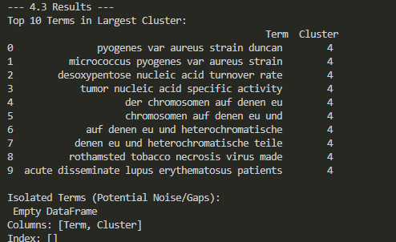
Conceptual Clustering Analysis (K-means Results)
The clustering exercise successfully grouped semantically similar 5-grams using TF-IDF vectorization and the K-means algorithm. The largest resulting cluster (Cluster 4) exhibits a high degree of thematic coherence, primarily centered around early molecular biology and microbiology concepts from the mid-20th century.
Terms like "micrococcus pyogenes var aureus strain" and "pyogenes var aureus strain duncan" clearly point to research on staphylococcal bacteria, while "desoxypentose nucleic acid turnover rate" and "tumor nucleic acid specific activity" are characteristic phrases from the period immediately following the elucidation of DNA structure, focusing on nucleic acid kinetics and metabolism. The presence of complex and likely noisy phrases (e.g., "der chromosomen auf denen eu" or "rothamsted tobacco necrosis virus made") suggests the cluster is capturing broad biological topics from the initial phase of molecular genetics.
The didactic significance of this outcome lies in demonstrating the power of clustering to perform Thematic Grouping. By aggregating related N-grams, we consolidate individual weak signals into broader Conceptual Areas, which is vital for strategic intelligence analysts. In this case, Cluster 4 can be provisionally named "Early Nucleic Acid and Bacterial Genetics Research." Crucially, the absence of terms in the "Isolated Terms" list indicates that the initial filters (from Exercise 4.2) effectively minimized noise, leading to a high degree of conceptual relevance within the remaining dataset, thereby validating the upstream data filtering and specificity-hierarchizing methodology.

