UNIVERSITY PERFORMANCE ONE PAGE DASHBOARD

User Story
As a University Administrator or Faculty Manager, I want a single, multi-page University Performance Dashboard that clearly visualizes key metrics (like student satisfaction, research publications, budget correlation, and attendance rates) so that I can monitor institutional performance, identify trends, and make data-driven decisions across strategic, analytical, operational, and tactical levels of management.

Goals
- High-Level Monitoring (Main Overview): Quickly grasp the overall health of the university across all key dimensions in one consolidated view.
- Strategic Insight: Understand long-term trends and institutional health (e.g., satisfaction and publication growth).
- Analytical Exploration: Investigate relationships and correlations between budget, enrollment, and output (e.g., budget vs. publications).
- Operational Tracking: Monitor short-term, immediate performance metrics (e.g., current attendance rates).
- Tactical Assessment: Evaluate mid-term performance differences across individual faculties (e.g., satisfaction distribution).

Tasks
- Load Data: Ensure the 'UC1-typesOfDashboards_universityDataSet.csv' file is loaded correctly, regardless of the delimiter (semicolon or comma).
- Set Up Environment: Configure the Streamlit app's title and wide layout.
- Create Navigation: Implement a sidebar radio button for easy switching between the five dashboard views.
- Define Visualizations: Create reusable Python functions for each type of chart (Strategic, Analytical, Operational, Tactical) using Plotly Express.
- Display Views: Based on the sidebar selection, render the corresponding charts and relevant text for each dashboard view.

Graphs
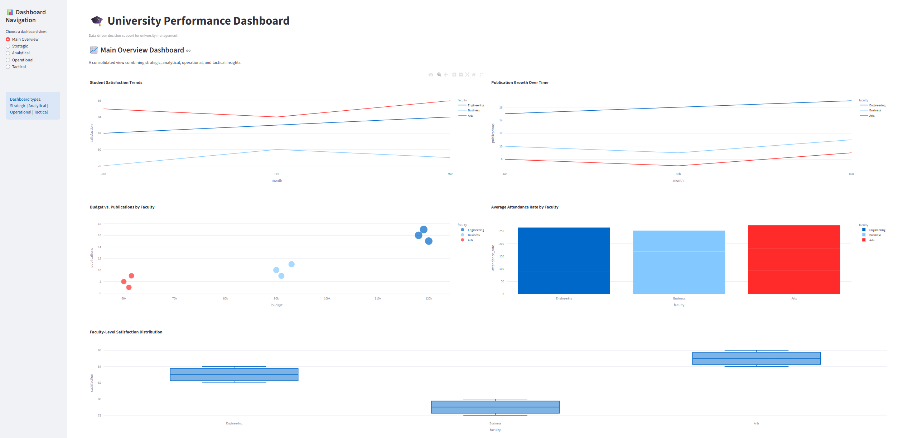

Strategic Dashboard Charts

Student Satisfaction Trends:
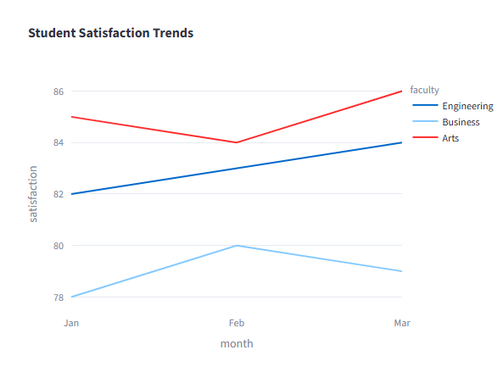
Purpose: Visualizes how student satisfaction levels change over time (month). It uses color="faculty" to show separate trends for each academic faculty.
  - Interpretation: Administrators look for overall rising trends (success) or sudden dips (critical issues needing long-term strategy adjustments) across all faculties. The comparison between faculties helps prioritize institutional efforts.

Publication Growth Over Time
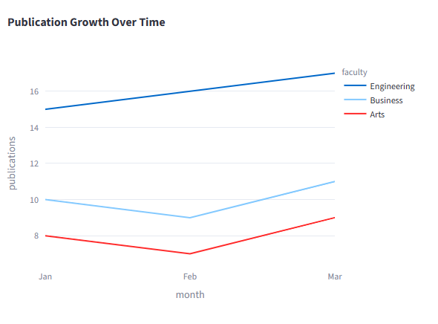
Purpose: Tracks the university's research output (number of publications) over time (month). It uses color="faculty" to compare research success by faculty.
  - Interpretation: This is a key measure of institutional reputation and research strategy effectiveness. A steady upward slope indicates a successful research policy. Lagging faculties may require strategic investment or resource allocation.

Analytical Dashboard Chart

Budget vs. Publications by Faculty
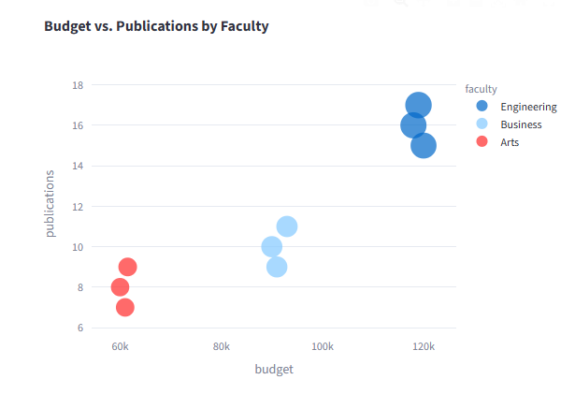
Purpose: Examines the relationship between budget (investment) and publications (output). The size="students" makes the size of the data point relative to student enrollment, and color="faculty" categorizes the results.
  - Interpretation: The goal is to see if higher budgets correlate with higher publication counts (efficiency). Points far from the main cluster (outliers) are important:

High Budget, Low Publications: Signals potential budget inefficiency or mismanagement within that specific faculty.
Low Budget, High Publications: Signals extreme efficiency or resourcefulness.

Operational Dashboard Chart
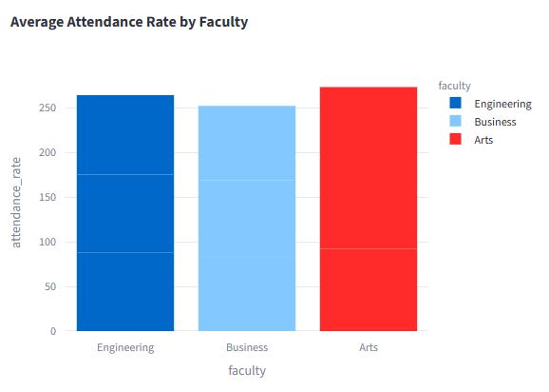
Average Attendance Rate by Faculty
  - Purpose: Provides a quick visual comparison of the average attendance_rate across all faculties using a bar chart.
  - Interpretation: This is an immediate, actionable metric. Low attendance rates may indicate current issues like poor scheduling, poor course engagement, or student welfare problems that need immediate, day-to-day intervention (e.g., contacting students, reviewing class times).

Tactical Dashboard Chart

Faculty-Level Satisfaction Distribution
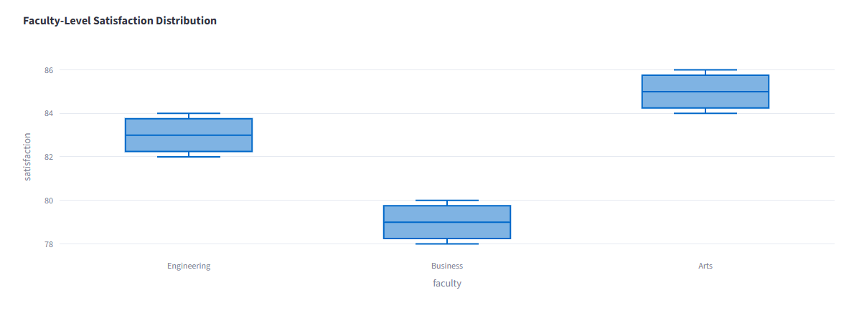
  - Purpose: Uses a box plot to show the distribution (median, spread, and outliers) of satisfaction scores for each faculty.
  - Interpretation: Unlike the strategic line chart that shows the average trend, this plot reveals the consistency of satisfaction.
A short box: Indicates consistent satisfaction scores (low variance).
A long box: Indicates wide variance in satisfaction (some students are very happy, others are very unhappy).
Position of the median line (middle line): Indicates the typical satisfaction score. This helps managers assess faculty performance relative to peers over a mid-term period.

