Predicting Valorant Esports Map Outcomes Using Machine Learning
DS 4400 Machine Learning and Data Mining I, Spring 2026
Rohil Singh and Sean Tian
Link to code: https://github.com/sn-tn/vlr-matchup-predictor

Problem Description
In this project we study a binary classification problem in esports analytics. The goal is to predict whether Team 1 wins a single Valorant map. This framing returns to the predictive formulation in our original proposal, which aimed to predict a given team outcome using statistics from previous matches rather than describing what happened inside the same map. Valorant is one of the fastest growing esports titles and publicly available match prediction work remains more limited than in traditional sports. Our motivation is to build a model that can support broadcast analysts, coaching staff, and data driven discussion of competitive success while also identifying the features that most strongly separate winning and losing teams.
Our milestone submission used same map combat and economy features. That baseline was useful but the very high accuracy suggested the problem was too easy because many same map variables were closely tied to the final result. The milestone feedback from our TA specifically encouraged us to examine previous matches and to study whether a minimal subset of variables could still predict well. We reframed the main project around two related tasks. Task A remained as a same map baseline. Task B became the main project and used only information available before the map started. This made the prediction problem harder, more realistic, and more closely aligned with both the original proposal and the course emphasis on thoughtful feature engineering and model comparison.
We reviewed several related references before finalizing the project. Makarov and colleagues studied win prediction in Dota 2 and Counter Strike Global Offensive and showed that structured game statistics can support strong prediction models. Wang and colleagues applied machine learning methods to Dota 2 outcome prediction and highlighted the value of carefully designed predictive features. Hodge and colleagues later examined live professional esports prediction and showed that the professional setting introduces practical challenges but also meaningful opportunities for predictive analytics. We also referenced Breiman on Random Forests and a community dataset description from VLR.gg to understand the feature semantics of our data source. Together, this prior work motivated us to treat Valorant as a serious prediction problem while keeping our methods within the scope of the class.

Dataset
We used a publicly available VLR.gg match dataset focused on professional and semi professional Valorant competition. After cleaning, the final corpus contained 127,804 map level records. Task A contained 40 columns including the target, while Task B contained 44 columns including the target. We used a temporal split so that all maps from 2020 through 2023 formed the training set and all maps from 2024 formed the test set. This produced 108,358 training rows and 19,446 test rows. The target variable was Team1 Win and the overall positive class proportion was 0.5789, which shows a moderate class imbalance but not an extreme one.
Each row represents one team matchup on one map within a series. The raw data included combat statistics such as Rating, ACS, Kills, Deaths, KAST, ADR, headshot rate, economy features such as ecos and full buys, round outcomes, map name, and odds information. For Task A we retained same map features but removed the most direct leakage variables such as final rounds, attack and defense round splits, and delta summary columns that nearly encoded the answer. For Task B we created a past only dataset that intentionally excluded same map performance fields from the map being predicted.
Task B contained the most important feature engineering work in the project. We computed Elo ratings in chronological order using only the outcomes of previously observed matches to produce each pre match strength estimate. We created rolling last three match averages for recent win rate, rating, ACS, KAST, ADR, kills, and deaths, using the shift and rolling operations in pandas so that the current map was never included in its own feature. We added overall prior win rate, map specific prior win rate, and head to head prior win rate, each built from cumulative counts minus the current row. We also included difference features such as Elo Diff, Recent Rating 3 Diff, Prior WinRate Diff, and Map Prior WinRate Diff. These engineered variables allowed us to move from a descriptive same map setup to an honest pre map prediction setup without any future information leakage.
Missingness was handled differently across the two tasks. In Task A, missing values primarily appeared in economy features and were imputed during model fitting. In Task B, missing values were expected for early observations because some teams had no prior maps, no prior head to head history, or no prior map specific history. This was a natural consequence of using only prior information and was handled with median imputation for numeric features and most frequent imputation for the categorical map feature.

Exploratory Data Analysis
We began by examining the class balance and the yearly distribution of maps, shown in Figure 1. The class balance plot showed that Team 1 wins slightly more often than Team 2, which justified the use of metrics beyond raw accuracy. The maps by year plot showed substantial growth from 2020 into 2021 and 2022, with a large 2024 holdout set that supported reliable temporal evaluation.
Figure 1, class balance of Team1 Win and yearly match count distribution.
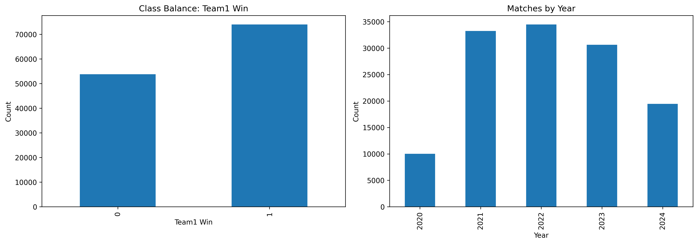
We also examined feature correlation patterns for Task B, shown in Figure 2. The correlation structure was weaker and more interpretable than the same map setting, because these features reflect team history rather than direct map outcomes. The strongest within block correlations appear between paired team level summaries, for example Team1 Recent Rating 3 and Team2 Recent Rating 3 each correlate with their corresponding difference feature. No single Task B feature showed a dominant correlation with the target, which was an early indicator that the prediction problem was genuinely harder than the Task A baseline.
Figure 2, Task B correlation heatmap for the first 15 numeric features.
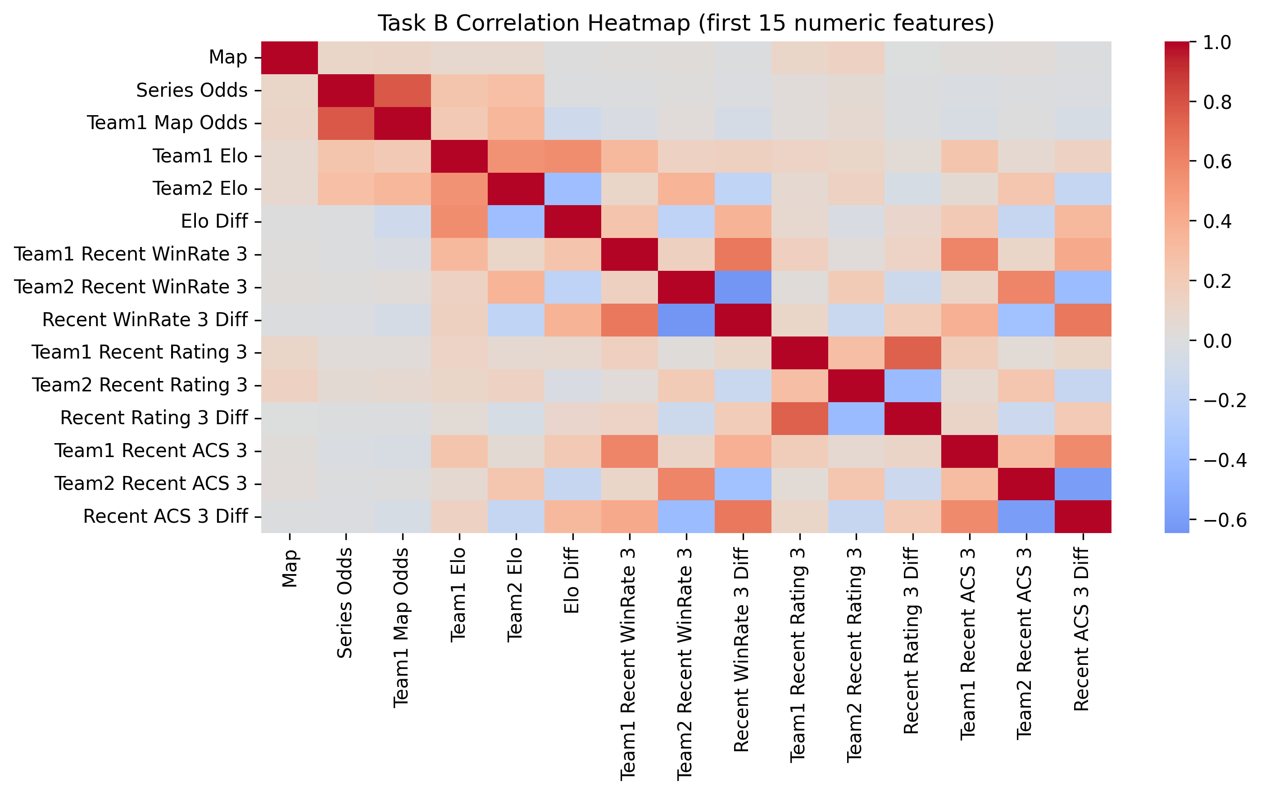
Finally, we reviewed missingness in the historical features. The largest gaps occurred in head to head and map specific prior win rate fields because many early matchups had little or no shared history. Rather than treating this as a flaw, we treated it as an expected property of a true pre map prediction problem, since a model should not know a matchup history that does not yet exist.

Approach and Methodology
Our general approach followed a standard supervised machine learning workflow from the course. We cleaned the raw data, constructed a binary response variable, selected features, normalized numeric variables, encoded the categorical map feature, trained several models, and compared them with multiple evaluation metrics. Throughout the project we kept modeling choices tied to topics covered in class. In particular, our Random Forest feature analysis maps directly to the variable importance material from the course lecture on bagging and Random Forests, which frames importance as a feature selection tool.
For feature selection we took two complementary approaches. First, we manually removed features that were obviously leaky or duplicated the response. This was especially important in Task A. Second, we used the feedback from the proposal and milestone to motivate a more systematic feature importance analysis in Task B. The final preprocessing pipeline used median imputation for numeric variables, most frequent imputation for the map variable, one hot encoding for the map variable, and standard scaling for the numeric columns. These steps mirror the course notebooks that use scikit learn pipelines and column transformers.
We trained five models overall. The classical models were Logistic Regression, K Nearest Neighbors, SVM, and Random Forest. We then added a feedforward neural network so the project included a neural model as emphasized in the course. Logistic Regression used up to 1500 iterations and the scikit learn default regularization. K Nearest Neighbors used k equal to 21. SVM used LinearSVC with C equal to 1.0 and dual equal to False, which gave a scalable linear margin classifier that could be trained on our full dataset in Colab. Random Forest used 150 trees, maximum depth 20, and minimum samples per leaf 2. For Task A and for the slower models on Task B, we used a random training subsample of 30,000 to 40,000 rows for computational feasibility while evaluating on the complete test set, so the reported test numbers are not affected by subsampling.
The feedforward neural network was implemented in TensorFlow and Keras. We initially planned to implement the neural network in PyTorch, but we later decided that it would make more sense to use TensorFlow as we could use the notebook from the class Canvas as groundwork. It used an input layer sized to the preprocessed feature dimension, a Dense layer of 128 units with ReLU activation, a Dropout layer with rate 0.25, a Dense layer of 64 units with ReLU activation, a Dropout layer with rate 0.20, and a single unit sigmoid output. It was trained with the Adam optimizer, binary crossentropy loss, batch size 256, and up to 20 epochs, with an early stopping callback that monitored validation loss with patience 3 and restored the best weights.
Evaluation used six metrics, Accuracy, Precision, Recall, F1, ROC AUC, and Brier score, with Brier reported only for models that produced calibrated probability outputs. We used the same temporal test split across models within each task. Task A used the same map baseline dataset. Task B used the past only historical dataset. This side by side design allowed us to compare not only models but also problem formulations. In addition, for Task B we compared the learned models against a market baseline built from the decimal betting odds supplied in the raw data, restricted to the subset of 5,341 test maps where a valid odds quote was available, and we ran a minimal subset analysis that retrained a Random Forest using only the top ranked features identified by permutation importance. For our best Task B model we also produced the confusion matrix and per class classification report that mirror the diagnostic outputs used in the course Logistic Regression notebook.

Model Results
Task A produced extremely strong results across all five models. Logistic Regression performed best overall with accuracy 0.9963, F1 0.9968, ROC AUC 0.9997, and Brier score 0.0024. The feedforward neural network and SVM were nearly identical, while Random Forest and KNN were somewhat lower but still very strong. Inspecting the training data showed that per map combat statistics correlate very strongly with who won the map, for example Team1 ACS and Team1 KAST each correlate with Team1 Win above 0.70 in magnitude. Task A therefore behaves much more like a reconstruction of the known outcome than a real prediction problem, which is exactly the concern that motivated Task B.
Task B produced much more realistic and more informative performance. The feedforward neural network was the best overall model with accuracy 0.6863, precision 0.6976, recall 0.8022, F1 0.7462, ROC AUC 0.7471, and Brier score 0.2001. Random Forest ranked second with accuracy 0.6780 and F1 0.7328. Logistic Regression, KNN, and SVM clustered closely behind it, with F1 values around 0.725. The top four model families finished within roughly one point of F1, which suggests we are approaching the predictive ceiling that the pre map features can support rather than a gap between model classes. The much lower Task B scores relative to Task A were expected and actually strengthen the project, because they show the difference between a same map reconstruction problem and a true pre map prediction problem.
The corrected odds based baseline was evaluated only on the 5,341 test maps with valid decimal odds, using implied probability 1 divided by odds. It reached accuracy 0.6141, F1 0.6681, ROC AUC 0.6592, and Brier score 0.2326. All five learned Task B models clearly exceeded this market baseline, with the feedforward neural network roughly 7 points of accuracy and 9 points of AUC above it. This is a more credible margin than a raw comparison against a 50 percent coin flip, since the market baseline already internalizes basic team strength.
Figure 3, Task B F1 comparison across all models and the corrected odds baseline.
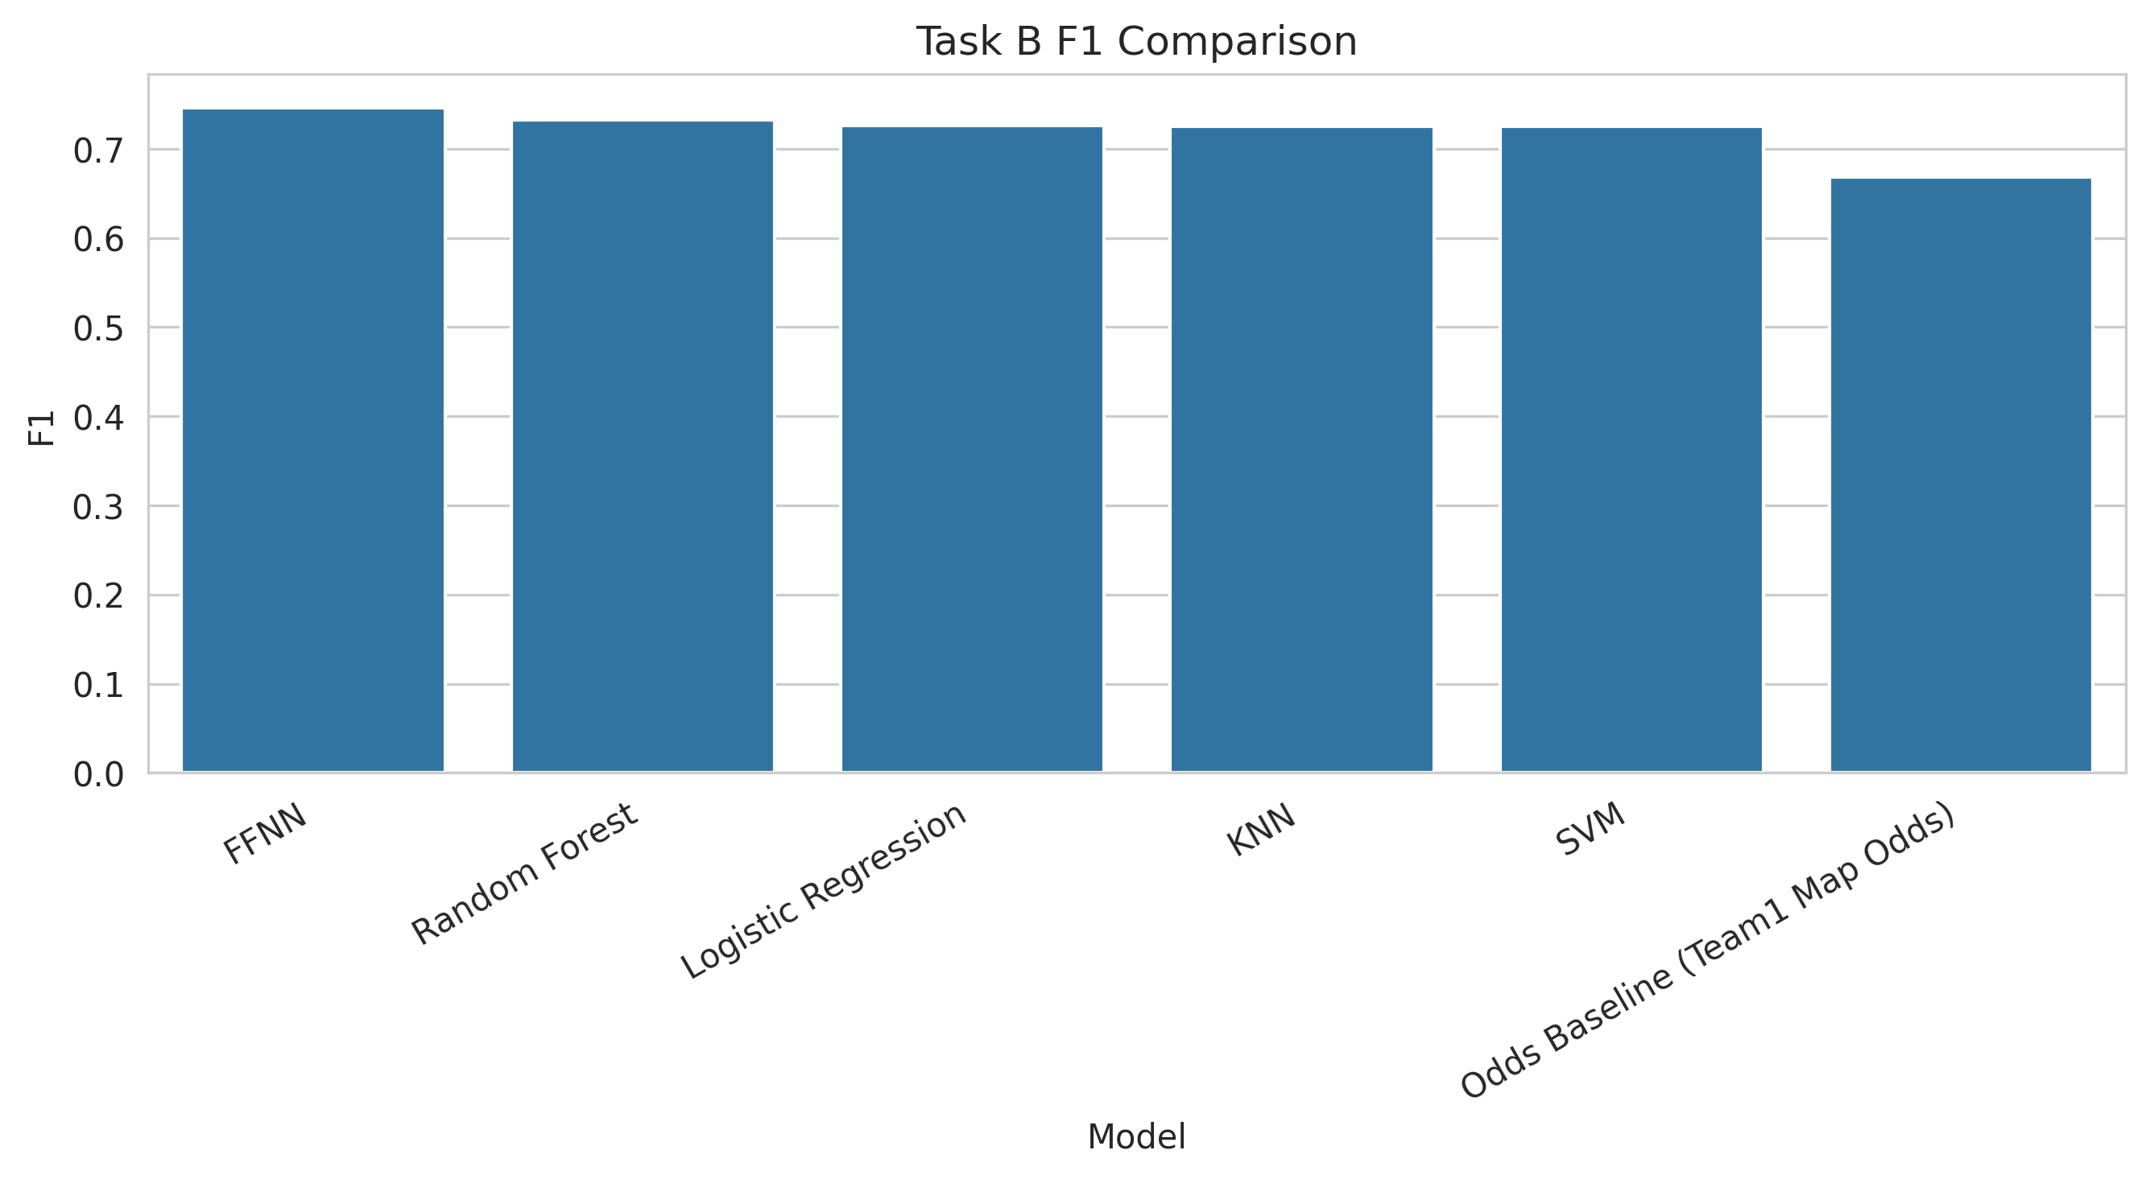
Figure 4, Task B ROC curves for the four classical models and the feedforward neural network.
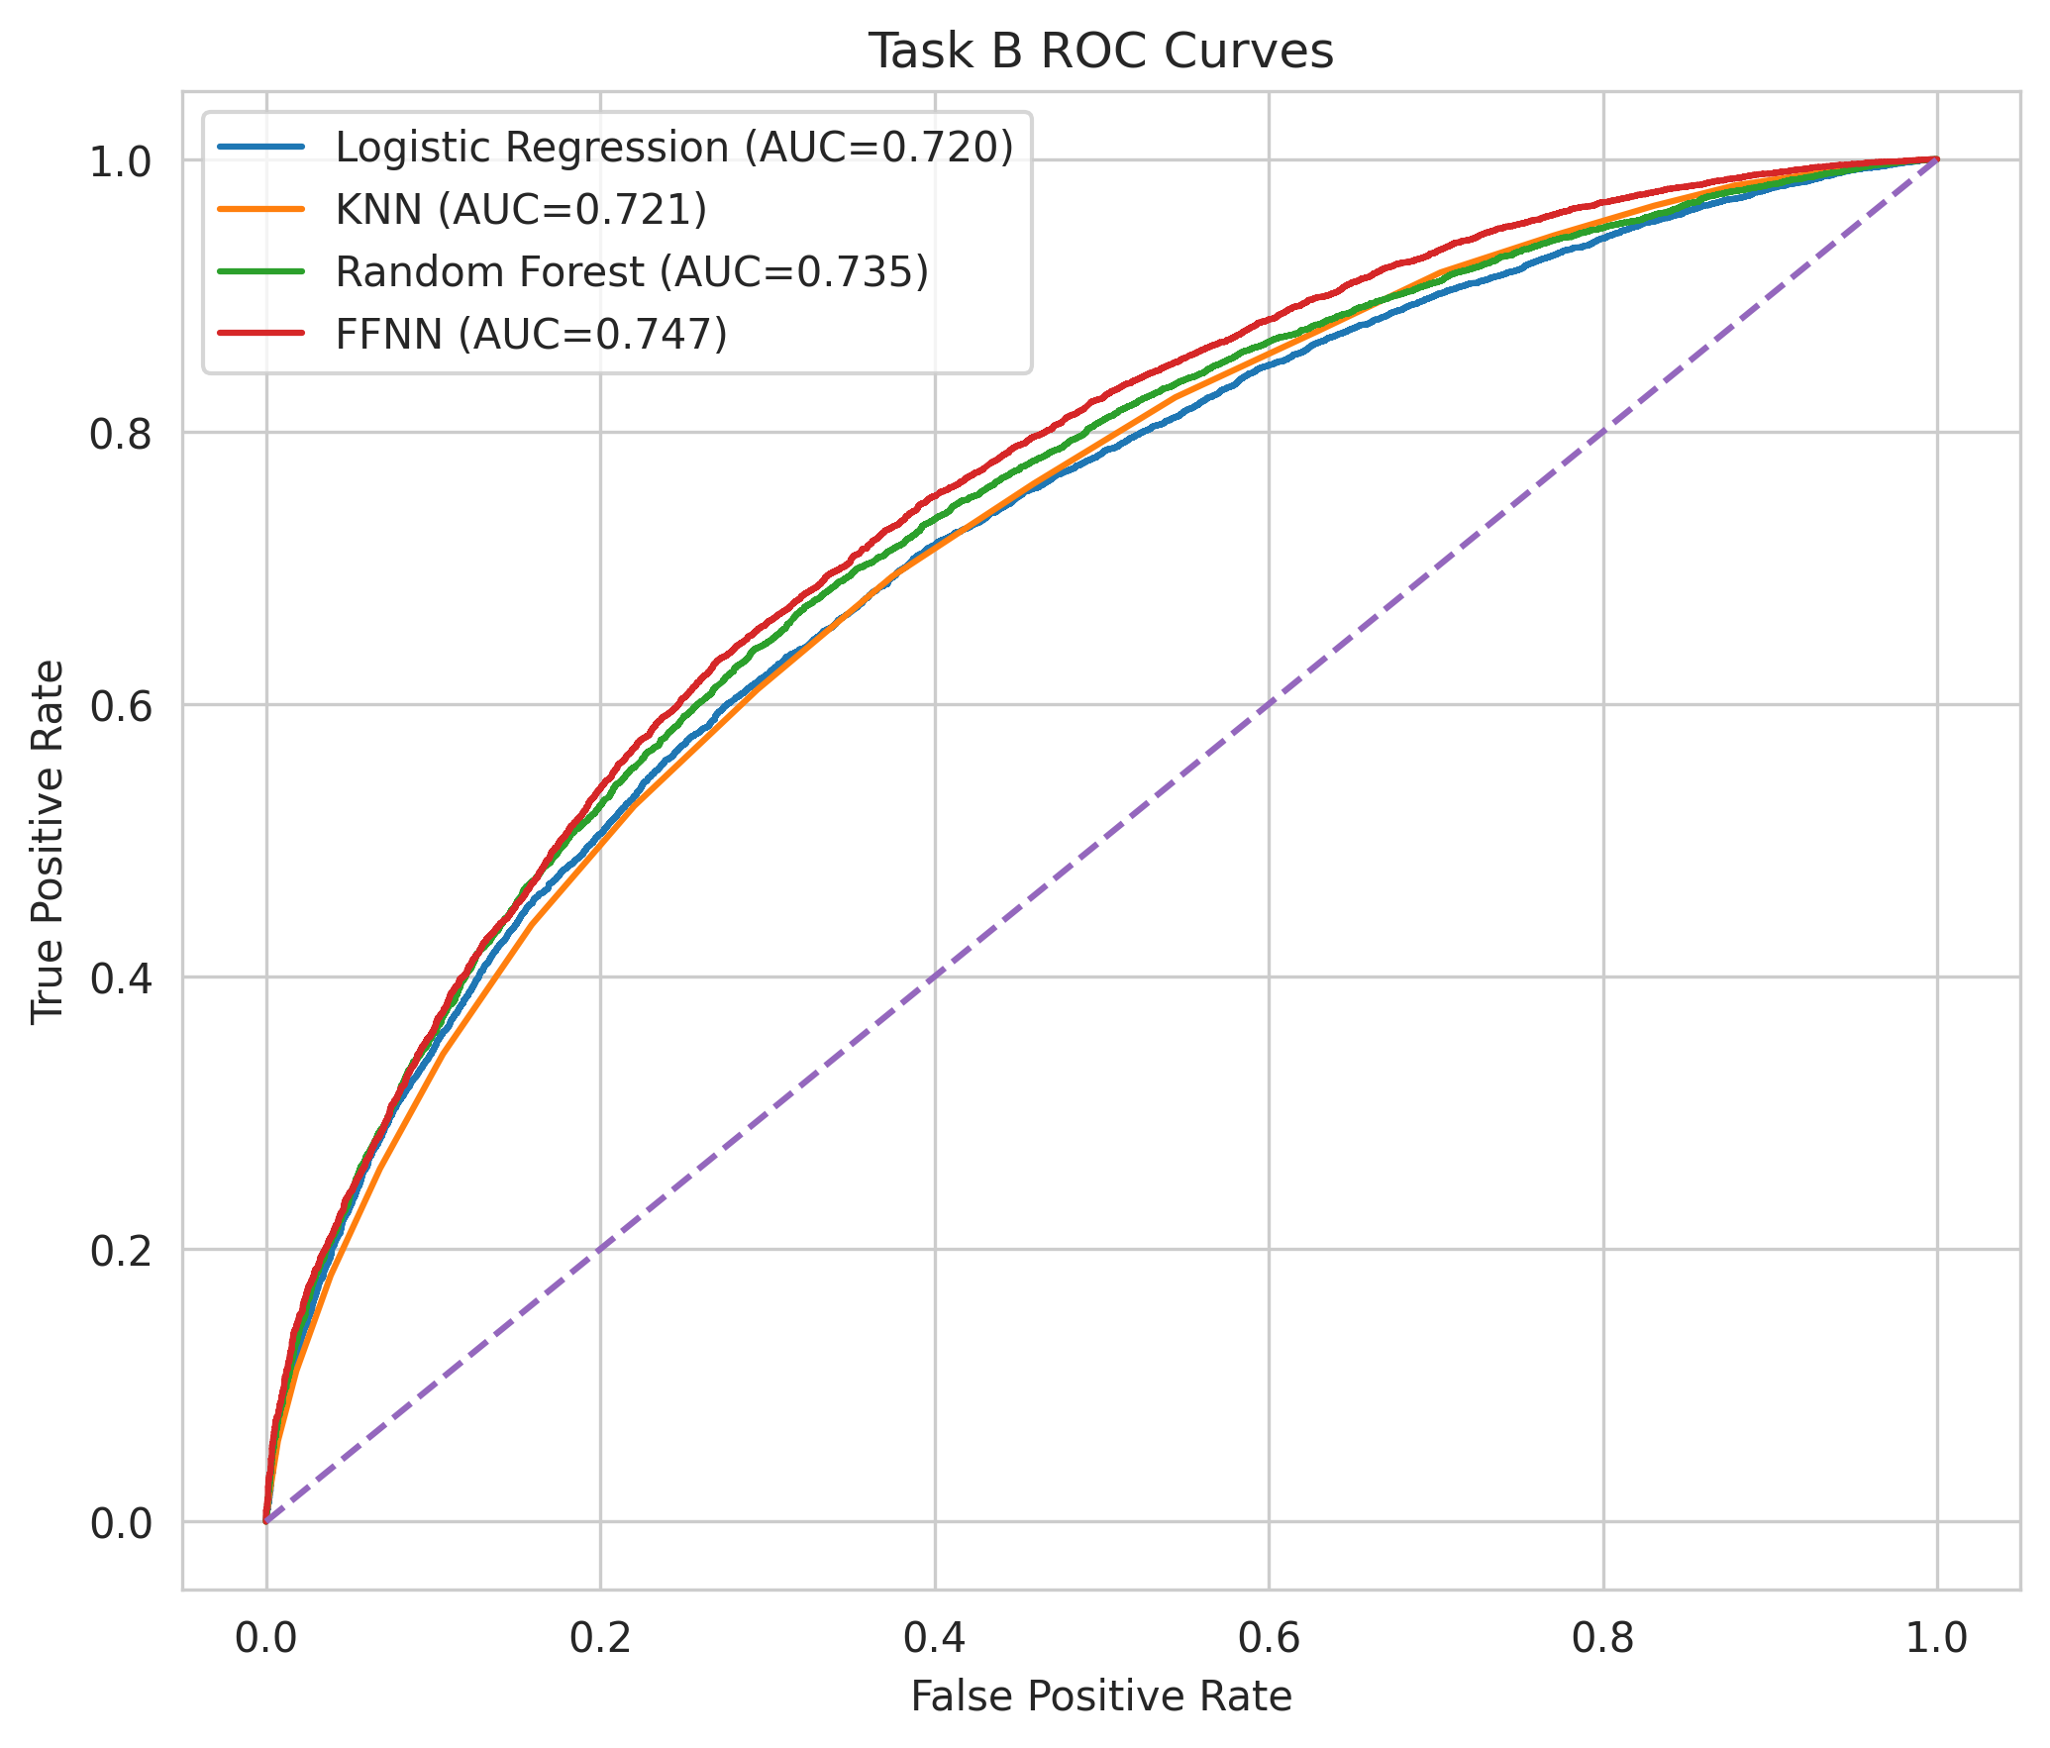

Discussion of Results and Insights
The most important insight in this project is that problem framing matters as much as model choice. In Task A, all models achieved very high performance because they were effectively reconstructing the winner from same map outcomes. That baseline still has value because it shows that same map combat and economy statistics are highly informative. However, it is not the best representation of a true predictive problem.
Task B is the more meaningful contribution. By restricting the model to prior information only, we created a setting that better matches real world pre map analysis. Under this harder setup, the feedforward neural network achieved the best balance across metrics, with Random Forest close behind. The gap between Task A and Task B tells a clear story. Very high accuracy in esports can be misleading when features are too close to the final result. Modest accuracy on a truly pre match problem is a stronger and more honest outcome.
The feature importance results also produced useful insight. The three most important Task B features were Elo Diff, Series Odds, and Team1 Map Odds. Recent Rating 3 Diff, Recent Deaths 3 Diff, Recent ADR 3 Diff, and Prior WinRate Diff also ranked highly. This suggests that strength ratings, recent form, and map aware context all matter. Importantly, no single feature dominated the task in the same way that same map combat statistics did in Task A. The model needed several complementary signals.
Figure 5, Task B permutation importance from Random Forest, top twelve features.
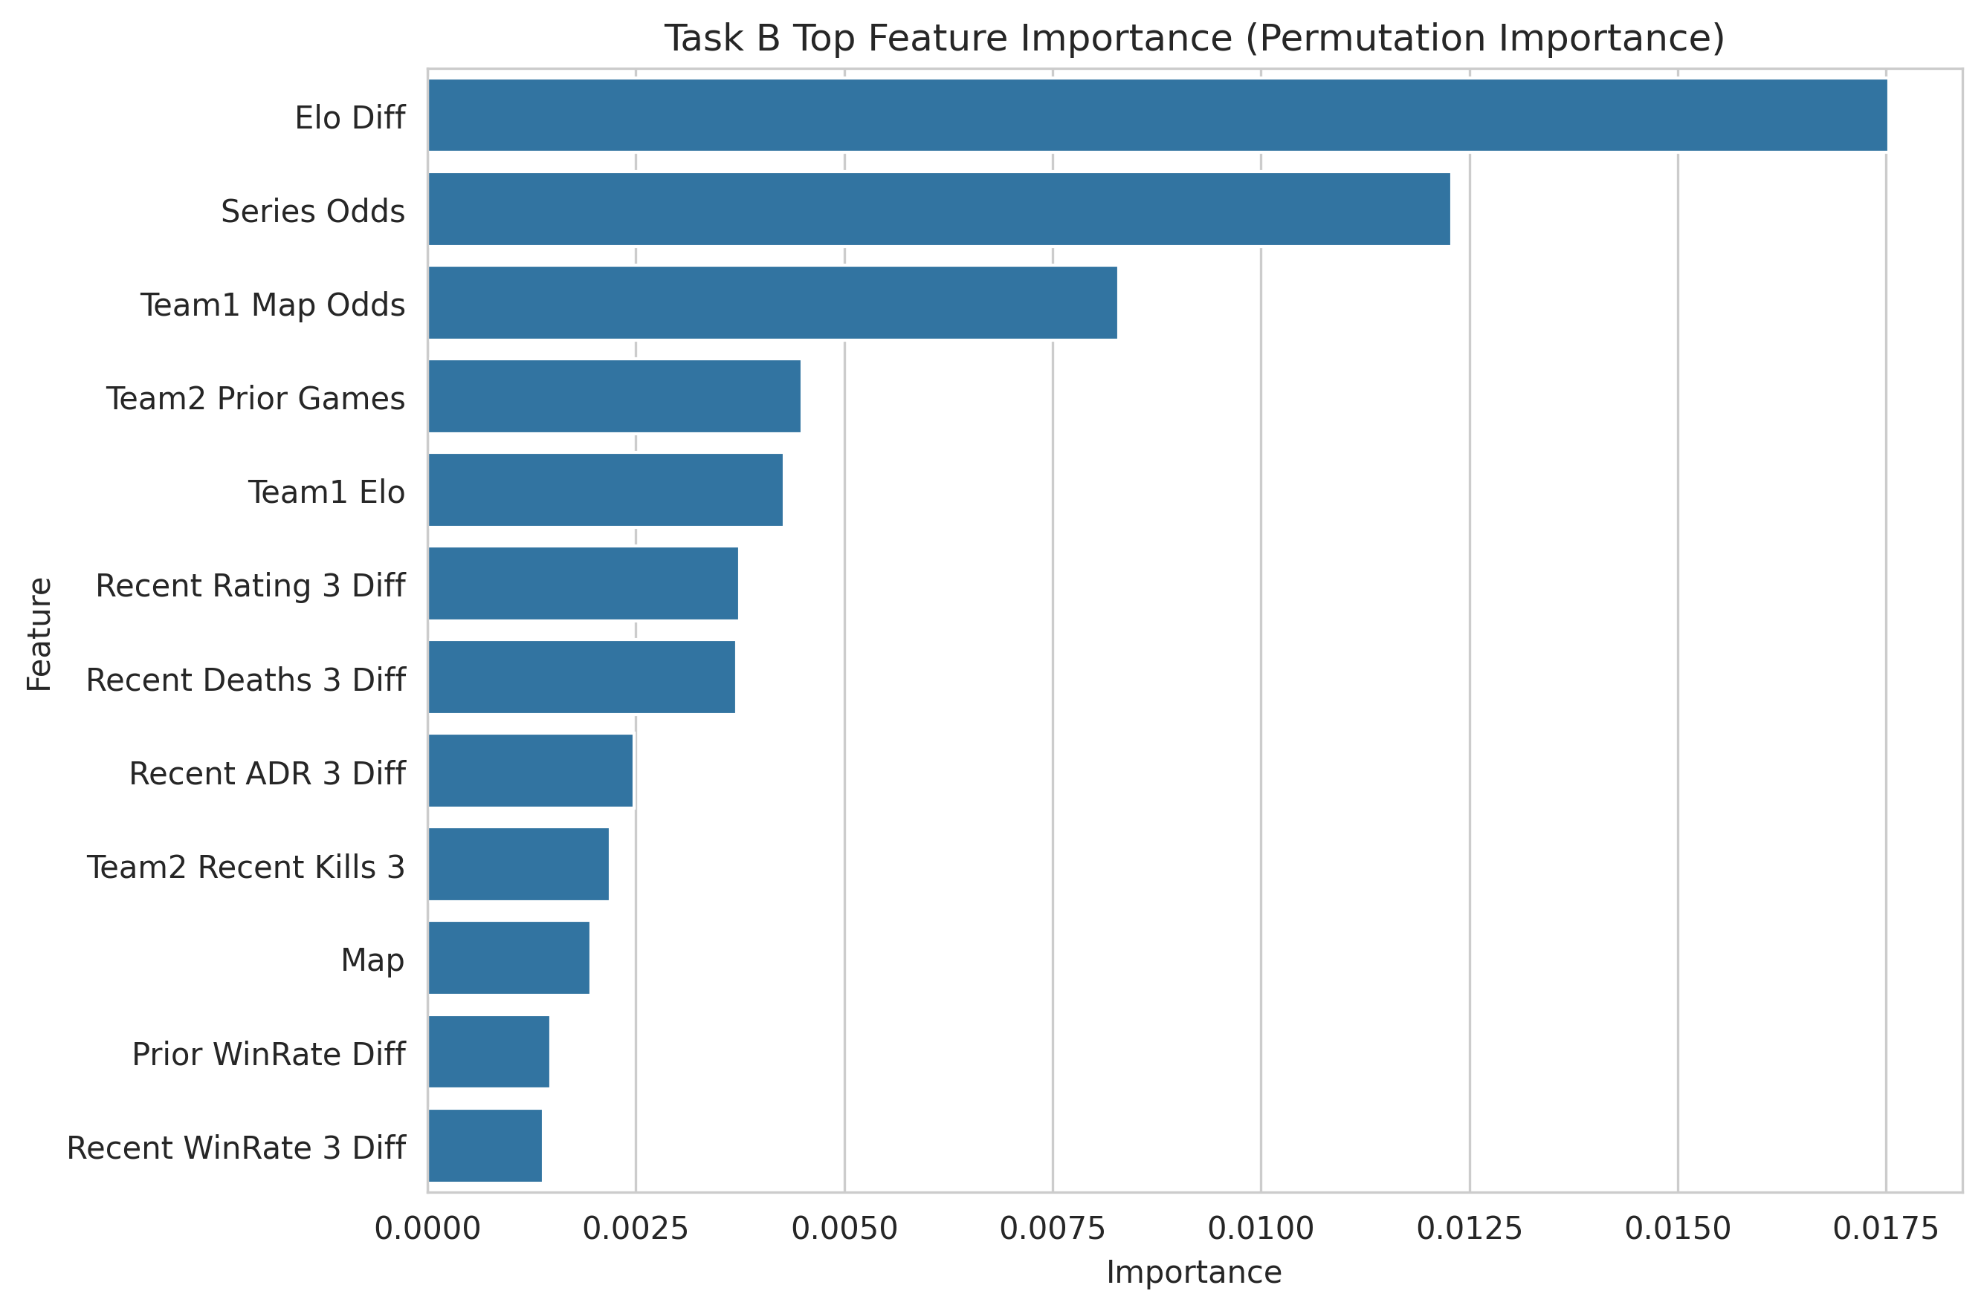
The minimal subset experiment directly addressed the milestone feedback. Using only the top three features produced an F1 score of 0.7544 and an accuracy of 0.6977. Using the top ten features produced an accuracy of 0.7022 and a ROC AUC of 0.7542. These values were competitive with the full model results. This suggests that a compact subset of historical features captures much of the useful signal in the problem and supports the idea that pruning the feature space can improve interpretability without sacrificing much predictive power.
Figure 6, Task B minimal subset F1 across top three, five, ten, and fifteen features.
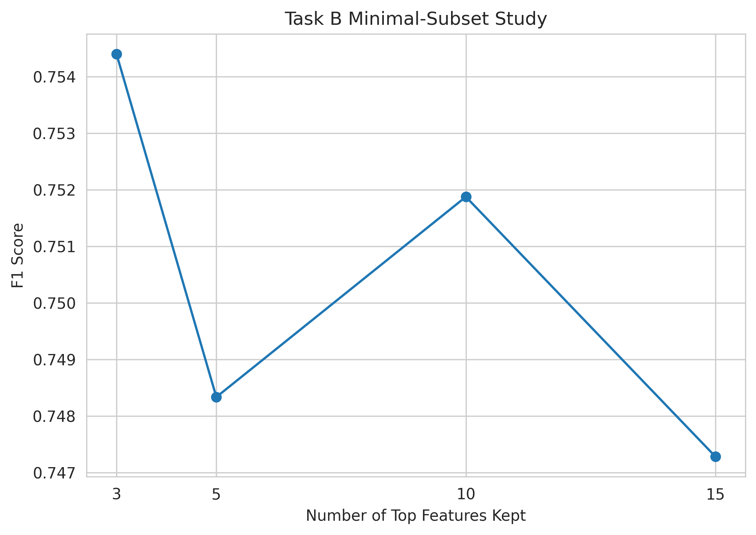
The Brier scores also provided a useful calibration lens. A naive model that always predicts the base rate would give a Brier score of approximately 0.245 on this test set. The feedforward neural network Brier score of 0.2001 sits comfortably below that, and the corrected odds baseline Brier of 0.2326 is closer to the naive value, suggesting that the learned probability outputs are better calibrated than market implied probabilities on this slice of the data.
The neural network loss curves in Figure 7 and Figure 8 were also informative. In Task A the loss dropped rapidly and stabilized early, which is consistent with an easy classification problem. In Task B the loss improved gradually and showed a modest but controlled train and validation gap, which is consistent with a harder problem where the model must learn broader statistical tendencies rather than direct signatures of the outcome.
Figure 7, Task A feedforward neural network training and validation loss.
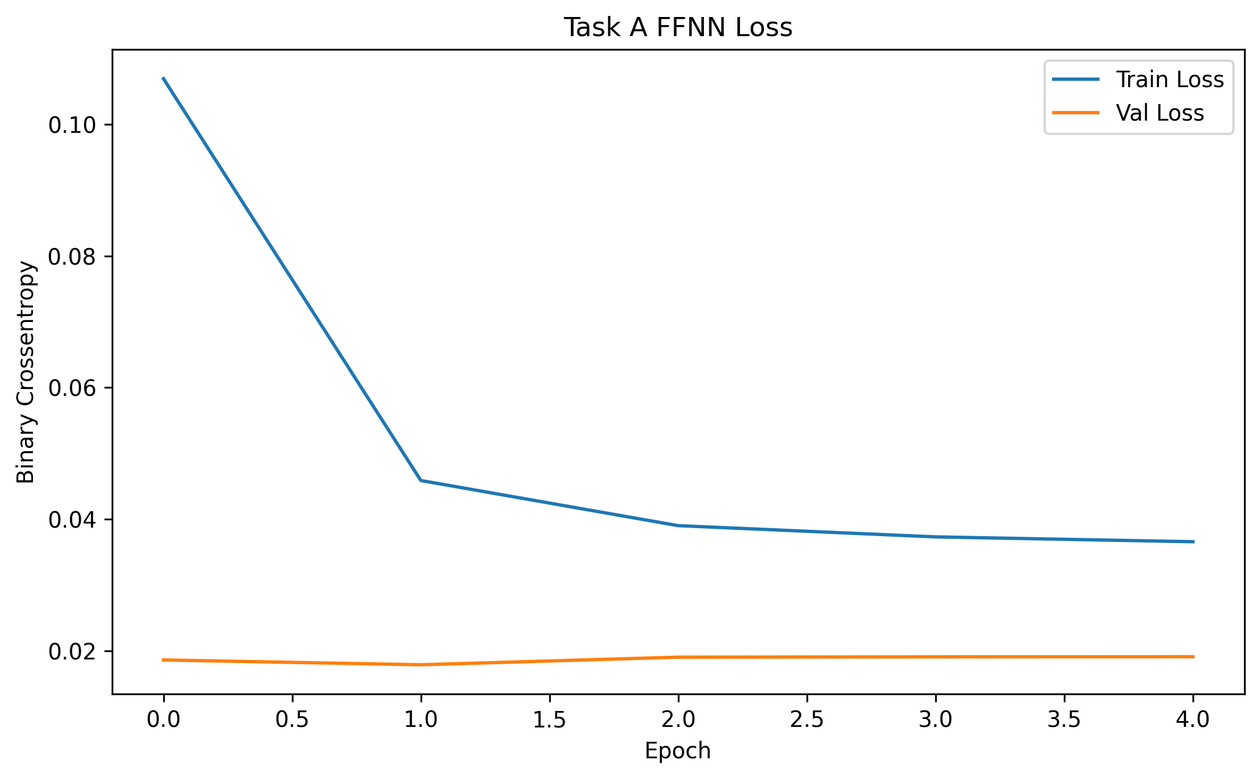
Figure 8, Task B feedforward neural network training and validation loss.
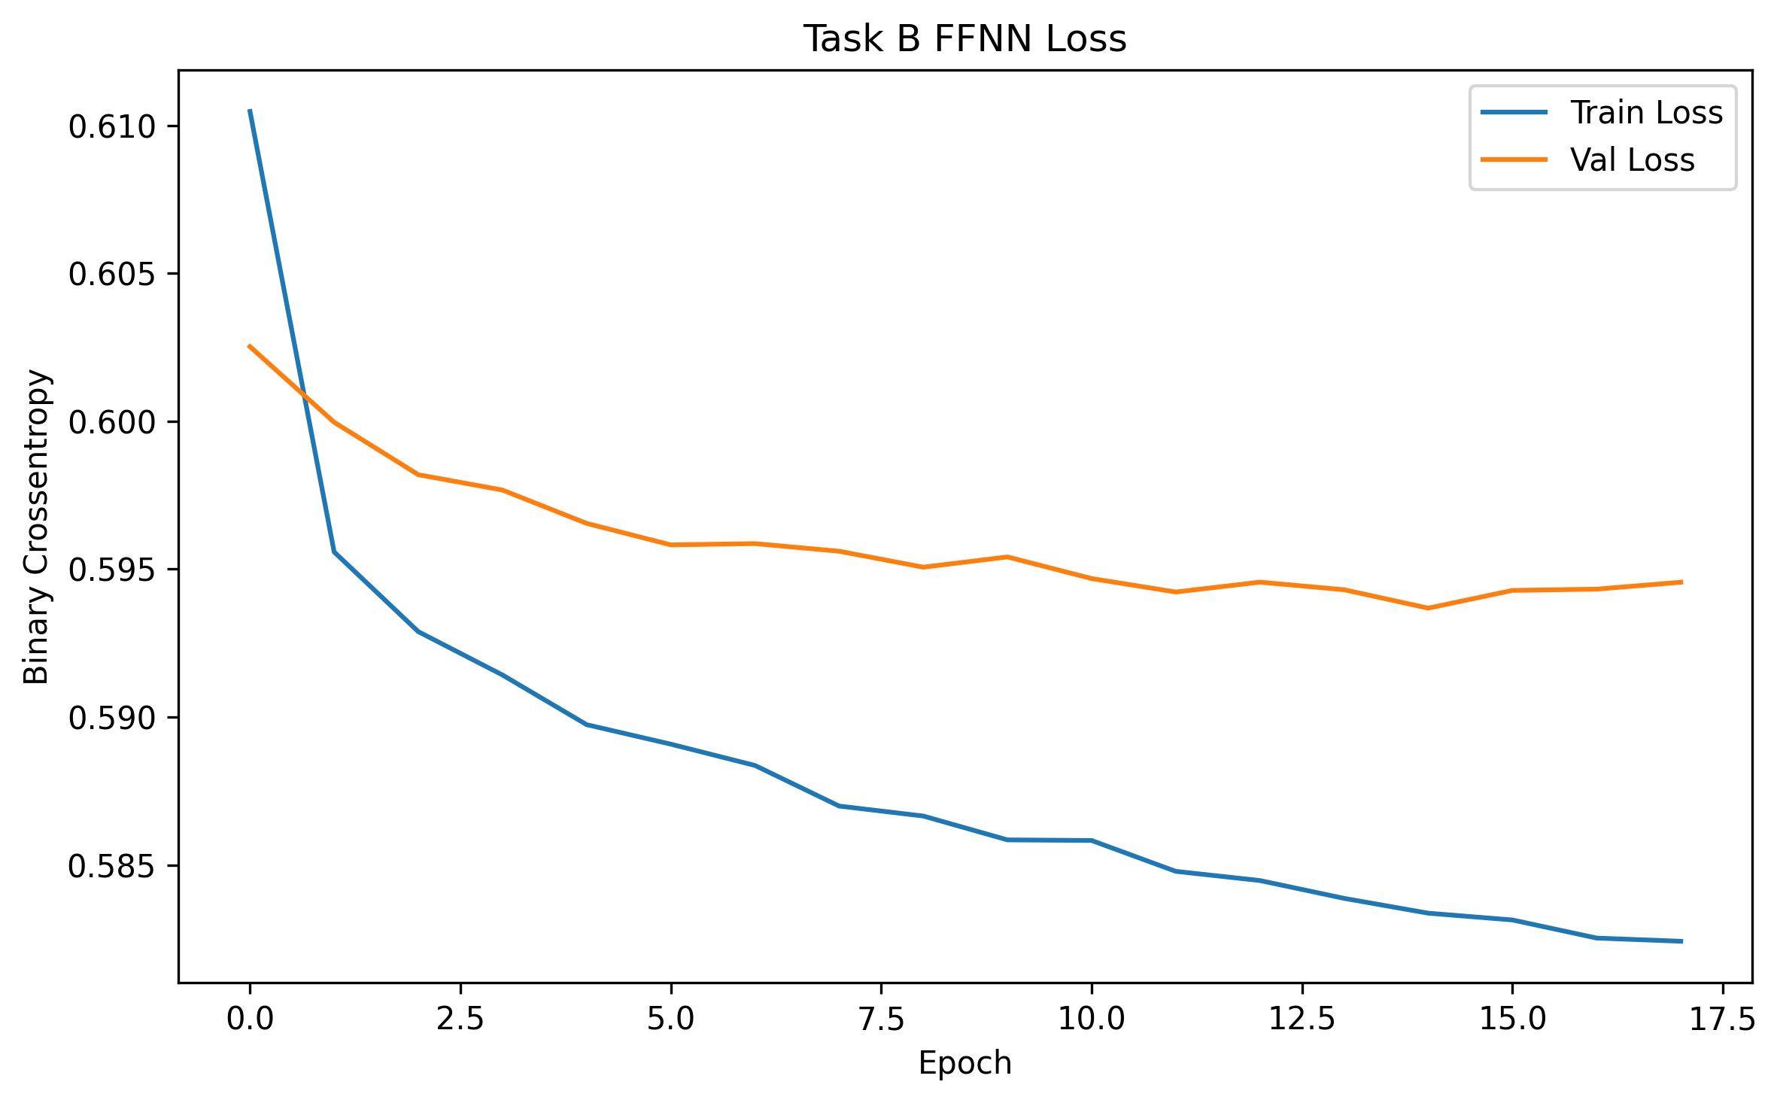
To provide a class style diagnostic view of the best Task B model, Figure 9 shows the confusion matrix for the feedforward neural network on the 2024 test set. The model recovers 8,970 true positive Team 1 wins out of 11,182, which matches the recall of approximately 0.80 reported in Table 2. It misclassifies 3,889 maps where Team 2 actually won as Team 1 wins, which reflects the model preference for predicting the majority class when historical signals are roughly balanced. The pattern is consistent with the per class precision and recall values in the classification report that accompanies this figure.
Figure 9, confusion matrix for the Task B feedforward neural network.
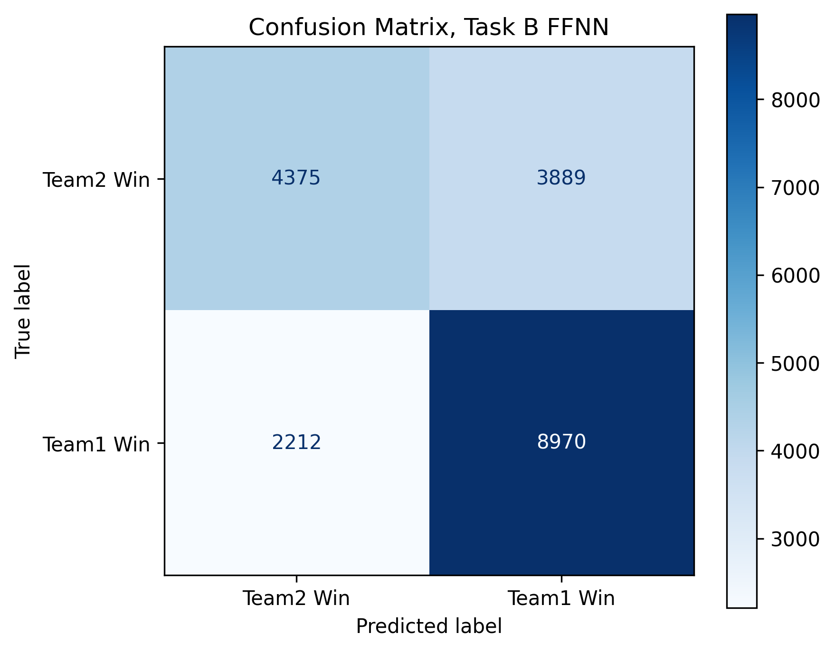

Novel Contributions
Our primary novel contribution is a new engineered feature set built directly from the raw VLR data, which supports the rubric category of defining new features. Starting only from raw match level rows, we constructed chronologically safe pre match features that include an Elo style strength rating, rolling last three match averages for key combat metrics, overall and map specific prior win rates, head to head prior win rate, and a family of difference features between the two teams. None of these features were present in the raw file in their final predictive form. Each was derived with explicit leakage protection so that no value used as input for a given map could depend on the outcome of that same map.
Our second novel contribution is the two task experimental design, which directly responds to the milestone feedback that encouraged us to move from same map descriptive signals to prior match predictive signals. Holding the same data, pipeline, and model families constant across Task A and Task B produced a controlled comparison between a descriptive same map setup and an honest pre map setup. The gap between the two is one of the most informative results in the project.
Our third novel contribution is the minimal subset study. This component responds directly to the specific milestone suggestion to check whether a smaller set of variables could still predict well. We used Random Forest permutation importance, which connects to the course treatment of variable importance in the bagging and Random Forests lecture, and then retrained a Random Forest on only the top three, five, ten, and fifteen features. The small subsets preserved most of the predictive performance of the full model. We interpret these importances as predictive rather than causal, which is more appropriate for the observational data we used.

Team Member Contribution
Rohil Singh focused on the problem framing, preprocessing workflow, classical model implementation, evaluation pipeline, and interpretation of the comparative results. This included work on Logistic Regression, K Nearest Neighbors, SVM, dataset construction checks, and the final report writeup.
Sean Tian focused on feature engineering, exploratory data analysis, neural network implementation, figure generation, and support for model comparison and presentation preparation. This included work on the feedforward neural network, performance plots, and interpretation of the Task B feature engineering results.
Both team members contributed to model comparison, debugging, interpretation of the final outputs, and revision of the final report so that the narrative remained aligned with the proposal, the milestone feedback, and the course rubric.

References
1. Makarov I, Savostyanov D, Litvyakov B, Ignatov DI. Predicting Winning Team and Probabilistic Ratings in Dota 2 and Counter Strike Global Offensive Video Games. In Analysis of Images, Social Networks and Texts, 2017.
2. Wang N, Li L, Xiao L, Yang G, Zhou Y. Outcome Prediction of DOTA2 Using Machine Learning Methods. Proceedings of the 2018 International Conference on Mathematics and Artificial Intelligence, 2018, pages 61 to 67.
3. Hodge VJ, Devlin S, Sephton N, Block F, Cowling PI, Drachen A. Win Prediction in Multiplayer Esports Live Professional Match Prediction. IEEE Transactions on Games, 2019, volume 13, number 4, pages 368 to 379.
4. Breiman L. Random Forests. Machine Learning, 2001, volume 45, number 1, pages 5 to 32.
5. VLR.gg public match data. Professional Valorant match history and statistics. Accessed spring 2026 via the public VLR dataset distribution used in this project.

Appendix A, Results Tables
Table 1, Task A model performance.
Model | Accuracy | Precision | Recall | F1 | ROC AUC | Brier
Logistic Regression | 0.9963 | 0.9949 | 0.9987 | 0.9968 | 0.9997 | 0.0024
FFNN | 0.9956 | 0.9933 | 0.9991 | 0.9962 | 0.9997 | 0.0029
SVM | 0.9956 | 0.9940 | 0.9983 | 0.9962 | 0.9996 | NA
Random Forest | 0.9685 | 0.9705 | 0.9749 | 0.9727 | 0.9969 | 0.0233
KNN | 0.9570 | 0.9564 | 0.9694 | 0.9629 | 0.9941 | 0.0355

Table 2, Task B model performance.
Model | Accuracy | Precision | Recall | F1 | ROC AUC | Brier
FFNN | 0.6863 | 0.6976 | 0.8022 | 0.7462 | 0.7471 | 0.2001
Random Forest | 0.6780 | 0.7008 | 0.7678 | 0.7328 | 0.7345 | 0.2052
Logistic Regression | 0.6641 | 0.6841 | 0.7729 | 0.7258 | 0.7202 | 0.2097
KNN | 0.6678 | 0.6917 | 0.7619 | 0.7251 | 0.7213 | 0.2090
SVM | 0.6604 | 0.6783 | 0.7788 | 0.7251 | 0.7165 | NA

Table 3, corrected odds based baseline on the valid odds subset of the test set.
Model | N Rows | Accuracy | Precision | Recall | F1 | ROC AUC | Brier
Odds Baseline, Team1 Map Odds | 5341 | 0.6141 | 0.5972 | 0.7580 | 0.6681 | 0.6592 | 0.2326

Table 4, top ten Task B features by permutation importance.
Feature | Importance
Elo Diff | 0.0175
Series Odds | 0.0123
Team1 Map Odds | 0.0083
Team2 Prior Games | 0.0045
Team1 Elo | 0.0043
Recent Rating 3 Diff | 0.0037
Recent Deaths 3 Diff | 0.0037
Recent ADR 3 Diff | 0.0025
Team2 Recent Kills 3 | 0.0022
Map | 0.0020

Table 5, minimal subset results for Task B.
Top K Features | Accuracy | Precision | Recall | F1 | ROC AUC
3 | 0.6977 | 0.7079 | 0.8075 | 0.7544 | 0.7510
5 | 0.6986 | 0.7197 | 0.7793 | 0.7483 | 0.7498
10 | 0.7022 | 0.7217 | 0.7847 | 0.7519 | 0.7542
15 | 0.6973 | 0.7186 | 0.7784 | 0.7473 | 0.7493

