for_loop_and_more

sn0wfree

11/24/2016

Table of Contents

# Quantitative Research Methods Term 1

this chapter aim at the for loop for r language.

**if you totally understand the for loop from ang another language, you may ignore this chapter**

## for loop

for (i in 1:10){print(c(i,i^.5))}

## [1] 1 1  
## [1] 2.000000 1.414214  
## [1] 3.000000 1.732051  
## [1] 4 2  
## [1] 5.000000 2.236068  
## [1] 6.00000 2.44949  
## [1] 7.000000 2.645751  
## [1] 8.000000 2.828427  
## [1] 9 3  
## [1] 10.000000 3.162278

x=0  
for (i in 1:10){x[i]=i^.5}  
y=0  
for (i in 10:2){x[i]=i^.5   
print(x[i])}

## [1] 3.162278  
## [1] 3  
## [1] 2.828427  
## [1] 2.645751  
## [1] 2.44949  
## [1] 2.236068  
## [1] 2  
## [1] 1.732051  
## [1] 1.414214

#for loop to add each previous number  
#function#1  
for(i in 1:10){x=x+i   
print(x)}

## [1] 2.000000 2.414214 2.732051 3.000000 3.236068 3.449490 3.645751  
## [8] 3.828427 4.000000 4.162278  
## [1] 4.000000 4.414214 4.732051 5.000000 5.236068 5.449490 5.645751  
## [8] 5.828427 6.000000 6.162278  
## [1] 7.000000 7.414214 7.732051 8.000000 8.236068 8.449490 8.645751  
## [8] 8.828427 9.000000 9.162278  
## [1] 11.00000 11.41421 11.73205 12.00000 12.23607 12.44949 12.64575  
## [8] 12.82843 13.00000 13.16228  
## [1] 16.00000 16.41421 16.73205 17.00000 17.23607 17.44949 17.64575  
## [8] 17.82843 18.00000 18.16228  
## [1] 22.00000 22.41421 22.73205 23.00000 23.23607 23.44949 23.64575  
## [8] 23.82843 24.00000 24.16228  
## [1] 29.00000 29.41421 29.73205 30.00000 30.23607 30.44949 30.64575  
## [8] 30.82843 31.00000 31.16228  
## [1] 37.00000 37.41421 37.73205 38.00000 38.23607 38.44949 38.64575  
## [8] 38.82843 39.00000 39.16228  
## [1] 46.00000 46.41421 46.73205 47.00000 47.23607 47.44949 47.64575  
## [8] 47.82843 48.00000 48.16228  
## [1] 56.00000 56.41421 56.73205 57.00000 57.23607 57.44949 57.64575  
## [8] 57.82843 58.00000 58.16228

#function#2  
for(i in 1:10){y[i+1]=y[i]+i;print (y[i+1])}

## [1] 1  
## [1] 3  
## [1] 6  
## [1] 10  
## [1] 15  
## [1] 21  
## [1] 28  
## [1] 36  
## [1] 45  
## [1] 55

## random number

sample the random based on different distributions

#uniform to sample data  
runif(10,1,10)

## [1] 3.005334 5.120513 3.138117 7.656886 5.899508 8.597863 6.973004  
## [8] 9.052011 1.352925 8.947608

#interge digital  
trunc(runif(5,1,7))

## [1] 2 6 2 1 5

round(runif(5,1,7),2)

## [1] 5.20 4.35 4.91 6.99 2.69

signif(10)

## [1] 10

#normally sample  
rnorm(5,mean =0 ,sd =1 )

## [1] -1.7857372 -0.9512411 -1.0615286 -0.9316470 -1.0611147

round(rnorm(5,mean =0 ,sd =1 ),2)

## [1] 1.84 -0.92 -0.19 -0.26 0.22

for(i in 1:10){print(rnorm(5,-2,3))}

## [1] -3.8719278 -2.0014496 0.6910715 -1.6701953 0.8146190  
## [1] -0.4167129 -3.1040656 -3.0078709 -6.7940653 -0.2787538  
## [1] -1.928602 -3.235502 2.304812 -1.852831 -1.172625  
## [1] -0.06589035 2.98326110 -5.29331076 -1.75485729 0.92368215  
## [1] -1.957385 2.731265 1.749595 -2.988016 -3.057454  
## [1] -1.689029 5.666594 5.526829 -2.427665 -5.026397  
## [1] -4.434267 -2.854016 -5.811910 -1.240785 -4.194622  
## [1] -4.1321942 -4.2684991 -0.8626291 -1.4476791 -6.8405775  
## [1] 1.685872 -5.482771 -5.128390 -4.209707 -4.880324  
## [1] 2.700087 -3.829946 -1.805734 2.891029 -5.639923

#take sample  
sample(x=1:10,replace=TRUE)

## [1] 1 1 2 1 10 6 3 8 1 6

sample(x=1:10,size=2,replace=TRUE)

## [1] 2 4

sample(x=1:10,size=1,replace=0)

## [1] 7

x=rnorm(10,-.5,2)  
t.test(x,mu=0,alternative = "less")

##   
## One Sample t-test  
##   
## data: x  
## t = 0.055129, df = 9, p-value = 0.5214  
## alternative hypothesis: true mean is less than 0  
## 95 percent confidence interval:  
## -Inf 1.029121  
## sample estimates:  
## mean of x   
## 0.03004638

## bootstrap-1

x=rnorm(20,-.5,1)  
y=sample(1:20,replace = 1)  
  
leaveit=x  
mean(leaveit)

## [1] -0.5046186

m=0  
#for(i in 1:10000){print(mean(leaveit[sample(1:20,replace = 1)]))}  
for(i in 1:10000){m[i]=mean(leaveit[sample(1:20,replace = 1)])}  
mean(m)

## [1] -0.5045206

sd(m)

## [1] 0.2538457

t.test(m,mu=-0.5)

##   
## One Sample t-test  
##   
## data: m  
## t = -1.7808, df = 9999, p-value = 0.07497  
## alternative hypothesis: true mean is not equal to -0.5  
## 95 percent confidence interval:  
## -0.5094965 -0.4995447  
## sample estimates:  
## mean of x   
## -0.5045206

boxplot(m)

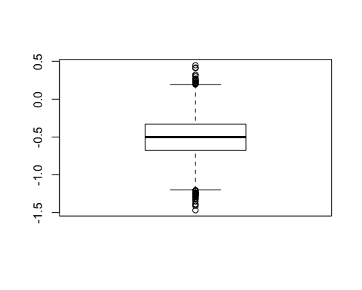

qqnorm(m)

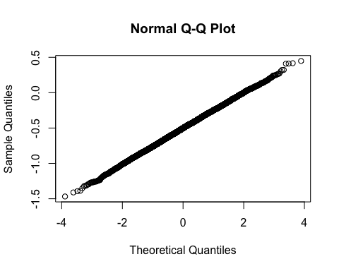 ## bootstrap-2

for(i in 1:10000){  
 m[i]=mean(leaveit[sample(1:20,replace = 1)])}  
pos=0  
  
for (i in 1:10000){  
 if (m[i] > 0){  
 pos=pos+1  
 }  
}  
pos

## [1] 203

leaveit[21]=10  
for(i in 1:10000){  
 m[i]=mean(leaveit[sample(1:21,replace = 1)])}  
pos=0  
boxplot(m)

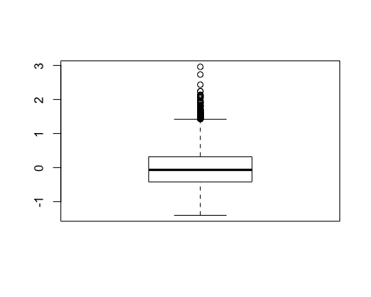

for (i in 1:10000){  
 if (m[i] > 0){  
 pos=pos+1  
 }  
}  
pos

## [1] 4513