**Problem 6-2.**

The given data of this problem is as follows.

|  |  |  |  |  |
| --- | --- | --- | --- | --- |
| **Participant** | **No Distraction** | **Call Answering** | **Test Messaging** | **Group** |
| P1 | 10 | 10 | 17 | G1 |
| P2 | 14 | 11 | 13 | G1 |
| P3 | 11 | 9 | 14 | G1 |
| P4 | 9 | 13 | 11 | G1 |
| P5 | 13 | 14 | 10 | G2 |
| P6 | 11 | 8 | 18 | G2 |
| P7 | 14 | 9 | 14 | G2 |
| P8 | 9 | 11 | 16 | G2 |
| P9 | 7 | 14 | 15 | G3 |
| P10 | 9 | 11 | 17 | G3 |
| P11 | 10 | 9 | 11 | G3 |
| P12 | 12 | 14 | 15 | G3 |

This problem tested if there is an effect of distraction type on driving error. The null hypothesis is that there is no significant effect in those distraction type.

**Table summarizing the data**

|  |  |  |  |
| --- | --- | --- | --- |
|  | No Distraction | Call Answering | Test Messaging |
| G1 | 11 | 10.75 | 13.75 |
| G2 | 11.75 | 10.5 | 14.5 |
| G3 | 9.5 | 12 | 14.5 |

**The statistical method what I used :** ANOVA

Why : For.

The result by using a tool of chi-square test is as follows.

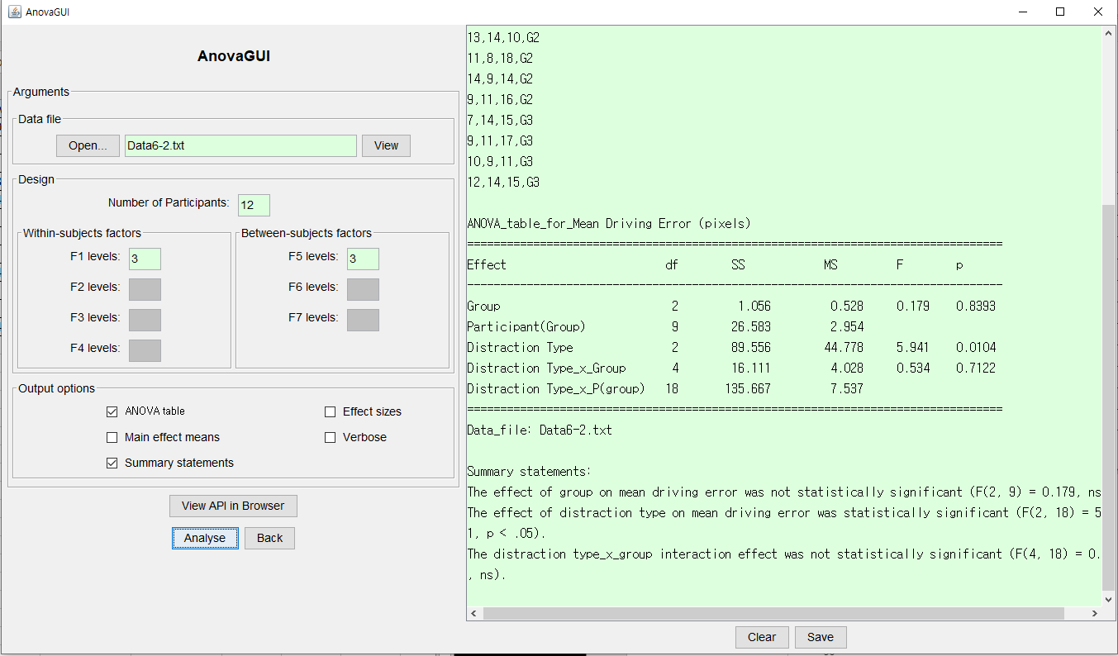

**My own description :**

The

** Include post hoc result **

**Problem 6-3.**

The given data of this problem is as follows.

|  |  |  |  |  |  |  |
| --- | --- | --- | --- | --- | --- | --- |
| **Participant** | **T1** | **T2** | **T3** | **T4** | **T5** | **Background** |
| P1 | 23 | 21 | 16 | 17 | 15 | Non-gamer |
| P2 | 24 | 21 | 20 | 17 | 14 | Non-gamer |
| P3 | 24 | 20 | 21 | 15 | 13 | Non-gamer |
| P4 | 26 | 21 | 20 | 17 | 16 | Non-gamer |
| P5 | 17 | 18 | 20 | 15 | 14 | Non-gamer |
| P6 | 19 | 16 | 15 | 14 | 15 | Gamer |
| P7 | 20 | 16 | 15 | 13 | 14 | Gamer |
| P8 | 16 | 16 | 14 | 13 | 11 | Gamer |
| P9 | 15 | 15 | 12 | 14 | 12 | Gamer |
| P10 | 17 | 16 | 13 | 14 | 12 | Gamer |

This problem tested if there is an effect of participant background on task completion time. The null hypothesis is that there is no significant effect in participants background

**Table summarizing the data**

|  |  |  |  |  |  |
| --- | --- | --- | --- | --- | --- |
| Background | T1 | T2 | T3 | T4 | T5 |
| Non-gamer | 22.8 | 20.2 | 19.4 | 16.2 | 14.4 |
| Gamer | 17.4 | 15.8 | 13.8 | 13.6 | 12.8 |

**The statistical method what I used :** ANOVA

Why :.

The result by using a tool of ANOVA test is as follows.

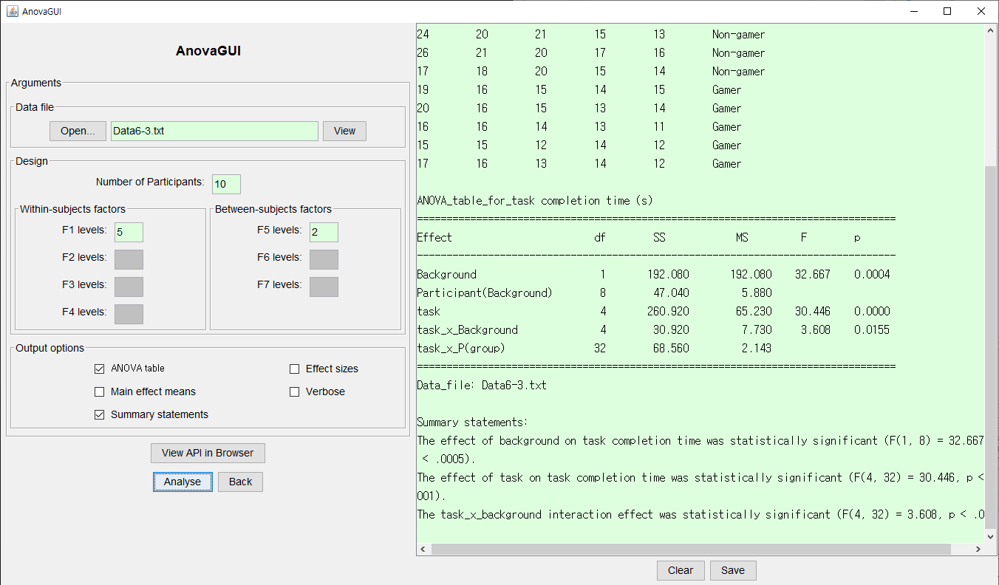

**My own description :**

The

**Question >** Investigate whether learning occurred over the five tasks and whether the progress in learning was the same for both groups of participants.

**Problem 6-4**

The given data of this problem is as follows.

|  |  |  |  |  |  |
| --- | --- | --- | --- | --- | --- |
| **Participant** | **One-handed** | | **Two-handed** | | **Group** |
| **Drag-only** | **Drag+flick** | **Drag-only** | **Drag+flick** |
| P1 | 12 | 11 | 7 | 6 | G1 |
| P2 | 11 | 7 | 6 | 8 | G1 |
| P3 | 9 | 8 | 8 | 7 | G1 |
| P4 | 9 | 9 | 7 | 6 | G1 |
| P5 | 13 | 5 | 6 | 5 | G1 |
| P6 | 6 | 6 | 5 | 9 | G1 |
| P7 | 7 | 7 | 8 | 8 | G2 |
| P8 | 9 | 8 | 9 | 5 | G2 |
| P9 | 8 | 8 | 9 | 7 | G2 |
| P10 | 7 | 8 | 9 | 5 | G2 |
| P11 | 11 | 10 | 8 | 11 | G2 |
| P12 | 12 | 8 | 8 | 11 | G2 |

This problem tested if there is an effect of hand use or interaction method on task completion time. The null hypothesis is that there is no difference effect in the hand use or interaction method.

**Table summarizing the data**

|  |  |  |  |
| --- | --- | --- | --- |
|  | **One-handed** | **Two-handed** | **Mean** |
| **Drag-only** | 9.5 | 7.5 | 8.5 |
| **Drag+flick** | 7.92 | 7.34 | 7.63 |
| **Mean** | 8.71 | 7.42 | 8.065 |

**The statistical method what I used :** ANOVA

Why : 이 데이터는 data completion time을 나타낸 데이터이다. Completion time의 경우 interval data로 parametric data이다. 따라서 ANOVA test를 사용하여야 한다.

The result by using a tool of chi-square test is as follows.

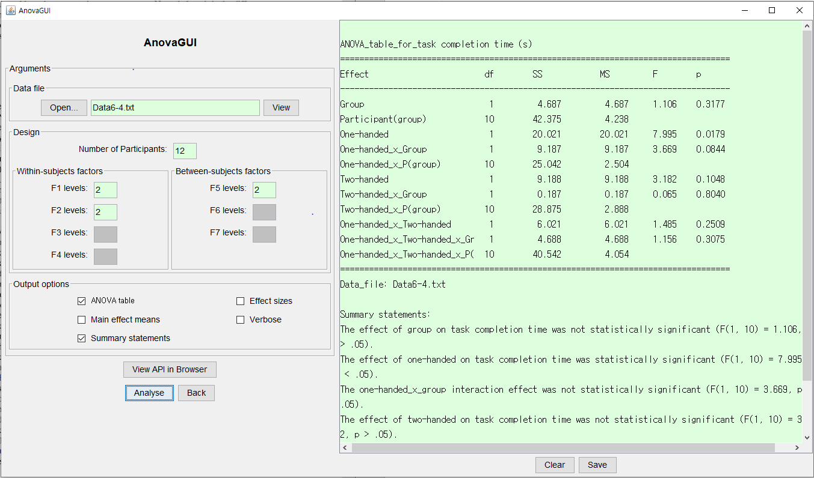

My own description :

The grand mean for task completion time was 8.065 seconds. The mean completion time of the two-handed group was 7.42 seconds, while the mean time of the one-handed group was 8.71seconds. Thus, the two-handed users are more faster than one handed group. The main effect of hand uses on task completion time was

**Problem 6-8.**

|  |  |  |  |
| --- | --- | --- | --- |
| System | Wallpaper Habit | | |
| None | Wallpaper Static | Wallpaper Dynamic |
| Mac | 13 | 8 | 25 |
| PC | 25 | 21 | 18 |

The given data of this problem is as follows.

This problem tested if there is a difference in their wallpaper habits between Mac and PC users. The null hypothesis is that there is no difference in the habits between two user groups.

**Table summarizing the data**

|  |  |  |  |  |
| --- | --- | --- | --- | --- |
| System | Wallpaper Habit | | | total |
| None | Wallpaper Static | Wallpaper Dynamic |
| Mac | 13 | 8 | 25 | 46 |
| PC | 25 | 21 | 18 | 64 |
| total | 38 | 29 | 43 | 110 |

**The statistical method what I used :** Chi-Square test

**Why :** For each users, it is noted whether they are Mac users or PC users and whether they did not used wallpaper, used static changing personalized wallpaper, or used dynamical changing personalized wallpaper. The categories are Main system (Mac, PC) and wallpaper habits (none, static, dynamic). Since the data are between categorical and nominal data, chi-square test was used to analyze.

The result by using a tool of chi-square test is as follows.

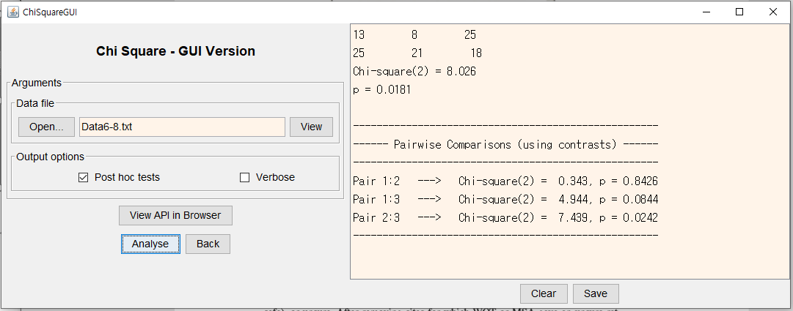

**My own description :**

The chi-square test is a comparison between the observed data and the expected data and the result is shown in above figure. In this problem, the degrees of freedom are 2. According to the significance threshold table in book, the threshold value with degree of freedom is two and p-value is less than 0.05 is 5.99. Since the value of chi-square is 8.026 and it exceeds critical value, the difference between two main system user groups is statistically significant( X2 =8.026, p<0.05).

|  |  |
| --- | --- |
| **Females** | **Males** |
| 25 | 18 |
| 25 | 14 |
| 19 | 13 |
| 21 | 15 |
| 22 | 17 |
| 19 | 19 |
| 15 | 18 |
| 18 | 20 |

**Problem 6-10.**

The given data of this problem is as follows.

This problem tested if there is a difference in the ratings of the texting interface between females and males. The null hypothesis is that there is no difference in the ratings between genders.

**Table summarizing the data**

|  |  |  |
| --- | --- | --- |
|  | **Females** | **Males** |
| **Mean** | 20.5 | 16.75 |
| **SD** | 3.47 | 2.5 |

**The statistical method what I used :** Mann-Whitney U test

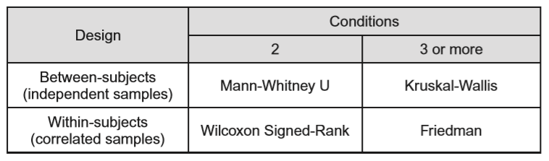**Why :** This data presented rate the texting interface on a 25-point. Although the rate data are potentially interval scale, the intervals between acceptable interfaces are not equal. Also, since the data indicate the level of the acceptable degree, and it is ordinal data, the non-parametric test was used. For the non-parametric test, there are four different methods according to the number of conditions and the experiment design. In this data, the number of conditions is two and the experiment design is between subjects. Therefore, the Mann-Whitney U test was used according to following table.

By using the tool of Mann-Whitney U test, the result is shown as follows.

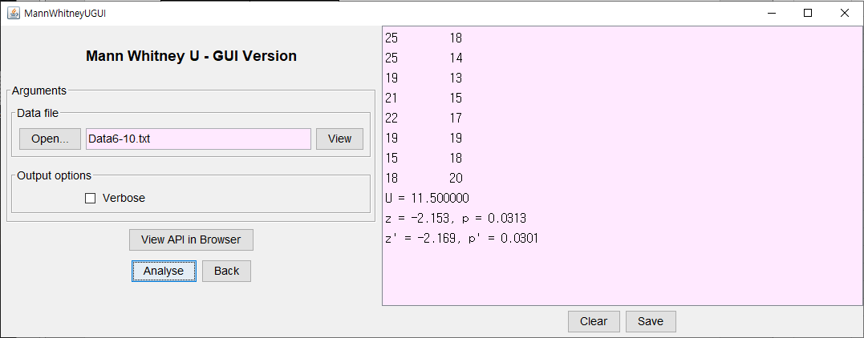

**My own description :**

The mean score for the female is 20.5 and for the male 16.75. Evidently, the female are more statistically significant( U = 11.5, P<0.05 )

**Problem 6-12.**

|  |  |  |
| --- | --- | --- |
| **Participant** | **Waggy** | **Scratchy** |
| 1 | 189 | 75 |
| 2 | 189 | 130 |
| 3 | 222 | 135 |
| 4 | 178 | 143 |
| 5 | 205 | 98 |
| 6 | 278 | 125 |
| 7 | 231 | 156 |
| 8 | 177 | 213 |

The given data of this problem is as follows.

**Table summarizing the data**

|  |  |  |
| --- | --- | --- |
|  | **The number of words** | |
|  | **Mean** | **SD** |
| **Waggy** | 208.625 | 134.375 |
| **Scratchy** | 34.26 | 40.85 |

**The statistical method what I used :** Wilcoxon Signed-Rank

**Why :** This data represents the number of words spoken by each children while playing with the each dog. This numbers indicates the level of engagement. It means that the fewer words are used, the lower the engagement level. Thus, this data is ordinal data. Therefore, the non-parametric test should be used. In this problem, the number of condition is 2 and the assignment is within-subjects, therefore the appropriate test is **Wilcoxon Signed-Rank test**.

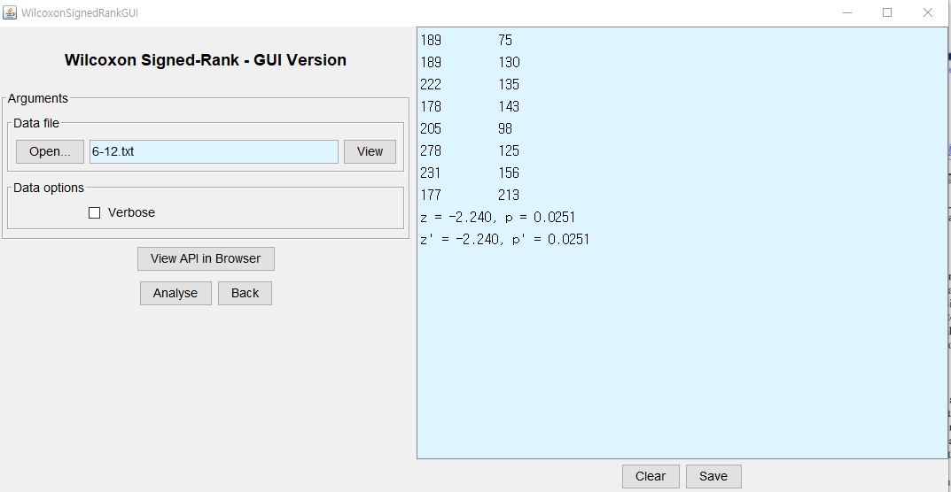By using the tool of Wilcoxon Signed-Rank test, the result is shown as follows.

In addition to this non-parametric test, since the data is ratio data, parametric test was also tried. Hence, the result of the ANOVA tool is shown as follows. This data is one way with one within subject factors.

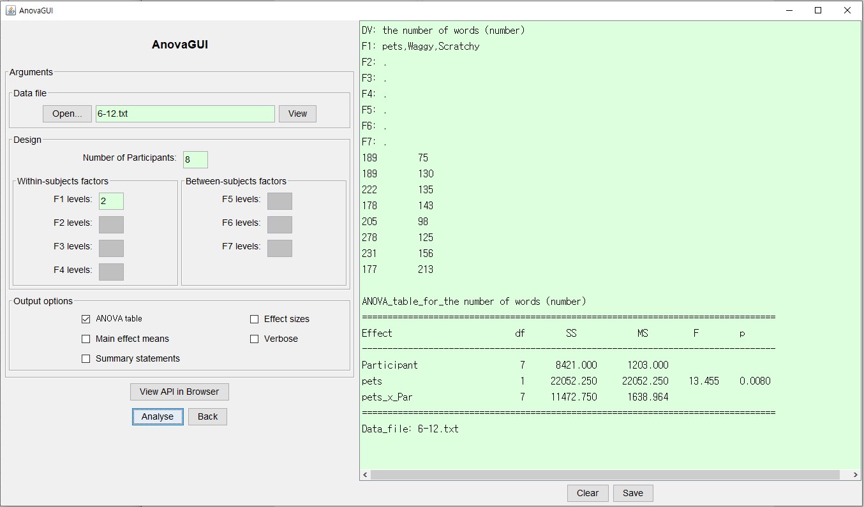

**My own description :**

The difference is statistically significant. Waggy has more high level of the engagement than scratchy(z=-2.240, p<0.05).

The mean number of words for waggy was 208.625. This was 55.2% more than the mean number of 134.375 observed for scratchy. The difference was statistically significant (F1,7 = 13.455, P<0.01)