**Tutorial-1**

Date: 16/06/2024

**Question 1:** The pyroxene end members are Enstatite (En, Mg₂Si₂O₆), Ferrosilite (Fs, Fe₂Si₂O₆), and Wollastonite (Wo, Ca₂Si₂O₆). Plot the compositions of these pyroxene end members on the ternary diagram provided below.

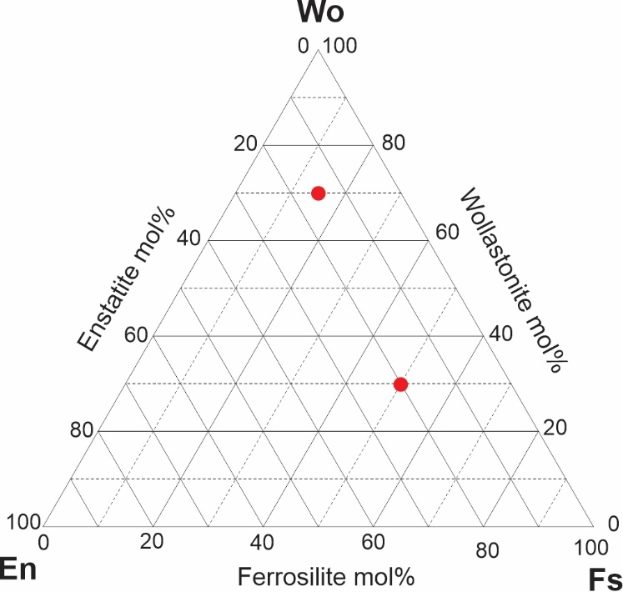

1. En42Fs8Wo50
2. En40Fs25Wo35
3. En15Fs75Wo10
4. En60Fs15Wo25
5. En10Fs25Wo65
6. En37Fs63Wo0

Also identify the composition of En, Fs, and Wo which are plotted in the figure

**Question 2:**

1. Ca3Al2 Si3O12 🡪 Mg3Al2Si3O12
2. Ca3Al2 Si3O12 🡪 (Ca, Fe, Mg) Al2Si3O12
3. Ca2Mg5Si8O22(OH)2 🡪 Ca2Mg4Al2Si7O22(OH)2
4. Ca2Mg5Si8O22(OH)2 🡪 NaCa2Mg5AlSi7O22(OH)2

Identify the substitutions and write the nature of the substitutions.