https://www.youtube.com/watch?v=FPR7VVSg76o&list=PL_OVypi7ED9Et7fRYH8YBbybS65sBj2UE&index=41
Dependency injection is a design pattern used to increase the maintainability and testability of applications by reducing the coupling between components
Instead of instantiating objects within a class, those objects are passed in as parameters to the class like passing it to the Constructor of the method instead.
asp.net core provides a built-in DI container that can be used to manage the dependencies of an application.
The DI container is responsible for creating and managing instances of services which are registered with the container when the application starts
Doesn't use Dependency Injection  - creating the instance using the new operator within the class  - instantiating objects within a class, those objects are passed in as parameters to the class like passing it to the Constructor of the method instead. | Using Dependency Injection  -Instead of creating the instance within the class  - Instead of instantiating objects within a class  - inject the interface IMyService in the program.cs file.  - register your class as services in program.cs file or startup.cs file.  Services.AddScoped<IMyService, MyService>();  -DI manages object creation and lifetimes
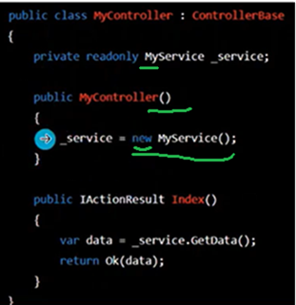 | 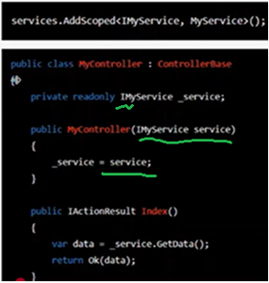

So MyService has been injected inside the application.
Inside the controller or any controller that we want to use this MyService, we can easily inject the service as a parameter to the controller or a parameter to the method.
Public MyController (IMyService service)
{
_service = service;
}
And then we can use this service, _service, throughout the application for example in this index action method.
This is a good practice, and it also satisfies the D in solid
By doing that we can easily change the implementation of MyService to say MyService2 which is another implementation and we can easily change the implementation in the program.cs file
Just at one place and then later on all the controllers can easily implement the new implementation which is now provided and managed by the application.
----------------------
After this we want to inject our DB context class so I will use the Builder object.
Builder.Services.AddDbContext<DB context class that we want to inject the type of DB context >
we will use this method and then provide the detail of the DB context class that we want to inject.
The type of DB context that we want to inject is the NZWalksDbContext. This come from NZWalks.API.Data; folder. So, I have to impose it. (using NZWalks.API.Data;)
Builder.Services.AddDbContext<NZWalksDbContext>()
after that it needs a DBContextOptions which is you know handled by the OptionBuilder

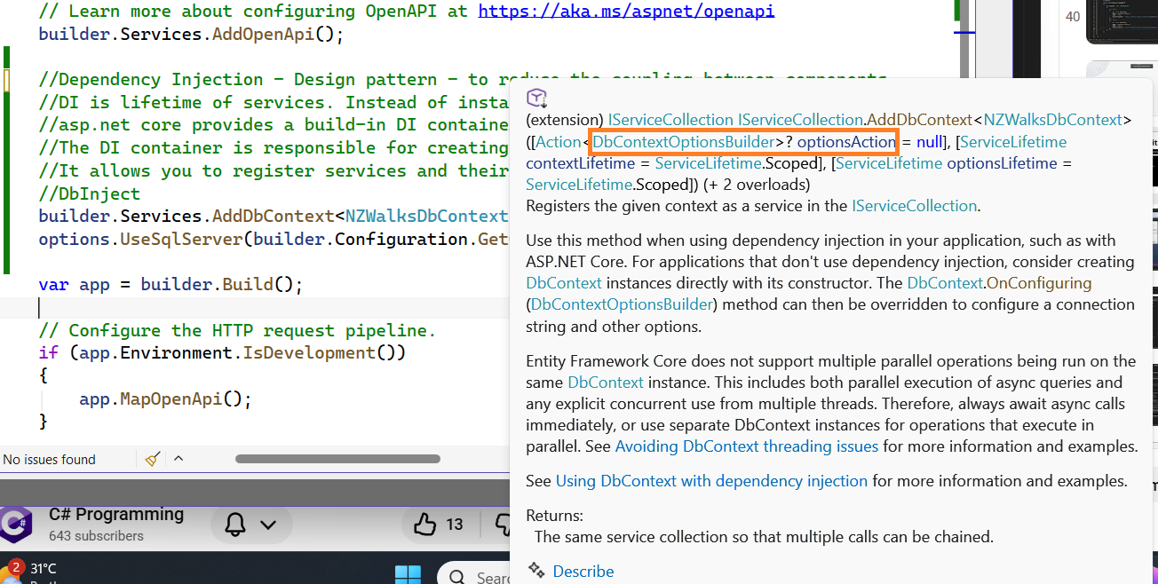

And this is the same thing as we did inside here, NZWalksDbContext.cs, by using the Options Builder in the program.cs file.
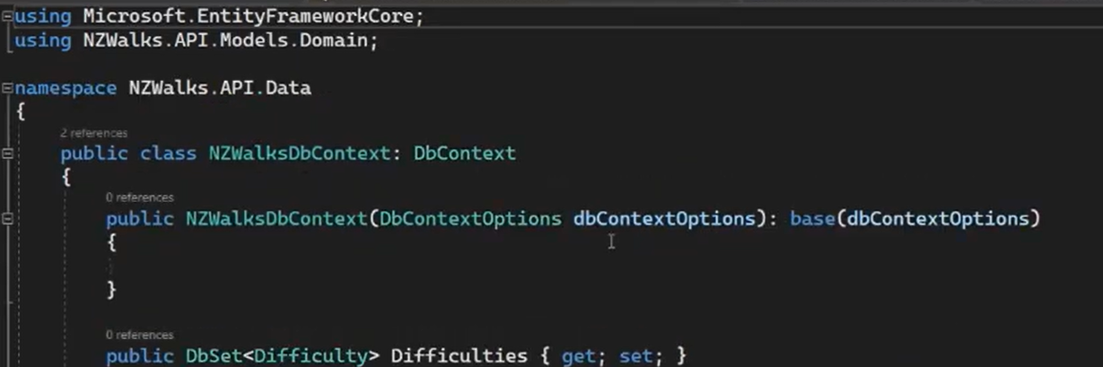
we are basically passing the Options to the base class over here and to this DBContext class as well.
Options base DbContext
So let's come back and start with our options such that …..
builder.Services.AddDbContext<NZWalksDbContext>(options =>
options.UseSqlServer(builder.Configuration.GetConnectionString("NZWalksConnectionString")));
By using this we have injected our DBContext class and we have also provided the connection string to this DB context class and the application will manage
all the instances of this DB context class whenever we call it inside controllers or repositories
so we have
used dependency injection inside asp.net core to inject a class which we can later on use uh and you know use it in
different places inside our application
so now we have injected the DB context class in the next lecture we
will go on and uh run Entity framework core migrations so that we can create a
new database inside the SQL Server that we have

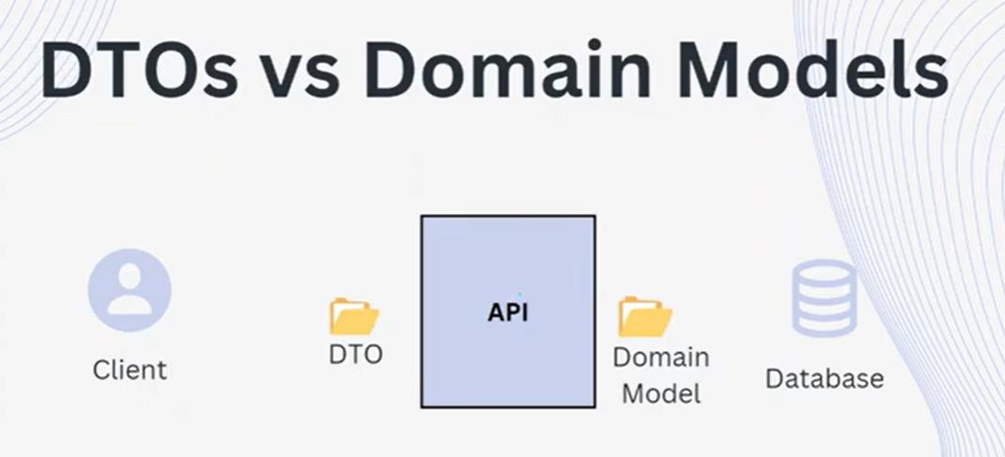

Versioning
it can be versioned independently allowing you to update the API without breaking the existing clients
if you want to make a change to a Domain Model which was exposed to the client directly, it wasn't possible because the client wouldn't be able to send the information because you now have breaking changes
but now we can change the domain model but can keep the DTO the same so that we are not breaking the contract between the client and the API but we can still play around with the domain models within our application

