Guide to create the point cloud.

1. First you will encounter the below screen.

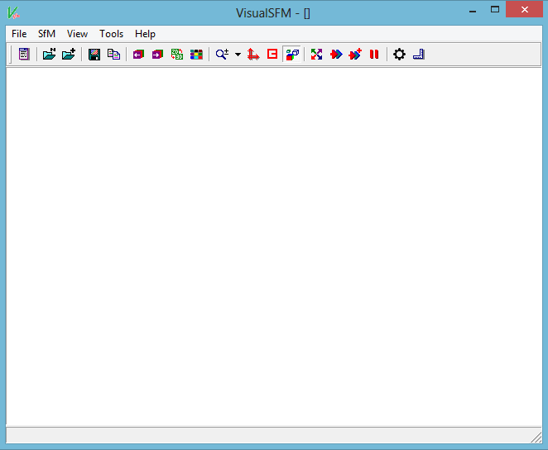

1. Select the option to choose your set of images.
2. Then select the option “SfM” and its further option as shown below.

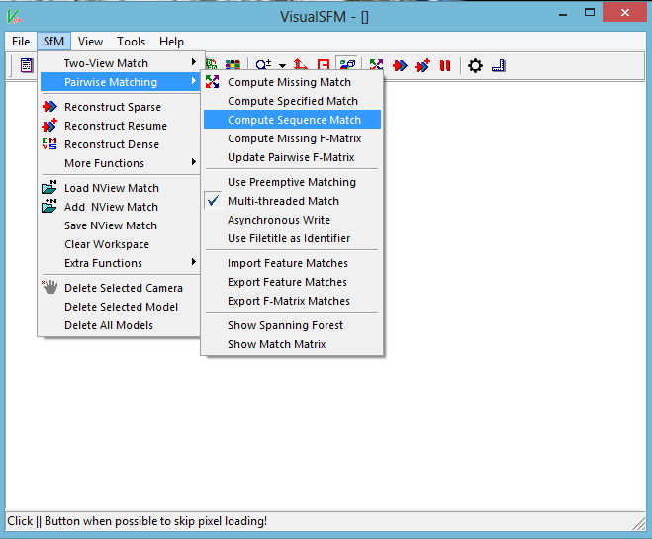

1. Then enter the frames you want to select , preferably enter 2 or 4.

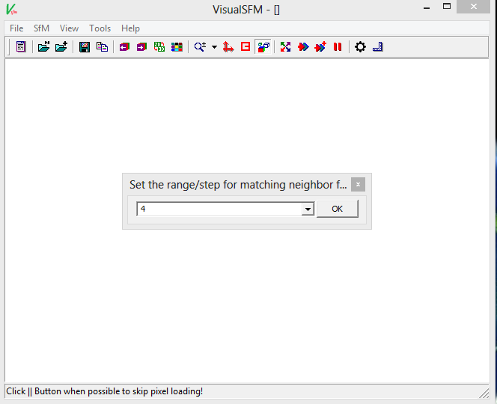

1. Then choose the below shown option.



1. Then to navigate and rotate the point cloud in 3 dimensions using the right mouse button accordingly.

--