Hird and colleagues (2010) showed that along the contact zone of the subspecies *Tamias ruficaudus ruficaudus* and *Tamias ruficaudus simulans* in Idaho there is discrepancy between inter-specific introgression of mitochondrial DNA (mtDNA) and nuclear DNA. This discrepancy appears to be due to biased mtDNA introgression from *T r. ruficaudus* into *T. r. simulans*. This bias may be driven by either neutral gene flow or selection. For example, neutral demographic processes can drive introgression. Rare alleles can become common along a range expansion front (Klopstein et al 2006). As mitochondria are uniparentally inherited and have an effective population size of ¼ that of autosomes, the same demographic process can actually drive discordance between nuclear and cytogenetic histories of the same population. Alternatively, selection for the introgressed *T. r. ruficaudus* mtDNA in *T. r. simulans* may be driving the observed imbalance.

We are using geographically explicit simulations to parameterize genomic expectations for patterns of introgressions between these taxa. We will model these processes using the geographically explicit software DimSum (Brown et al. 2010) and the coalescent-based splatche2 (Currat et al. 2004). This will allow us to leverage both the spatial data we have about these species’ ranges and dispersal distributions using DimSum and explore complex linkage and recombination scenarios using splatche2. Comparing the genomic data generated in this project to these expectations will determine whether observed patterns are consistent with neutral introgression, or selection for inter-specific mtDNA. Understanding the processes that have lead to the patterns we see in the *T. r. ruficadus/simulans* pair will provide insight into how speciation and reproductive isolation occurs in the face of gene flow. We will then extend our simulations from the well-characterized *T. r. ruficadus/simulans* hybrid zone to examine patterns of nuclear and mitochondrial divergence and introgression across all sampled *Tamias* taxon pairs, which will allow us to assess whether these same processes are driving patterns of introgression across a range of divergence times.

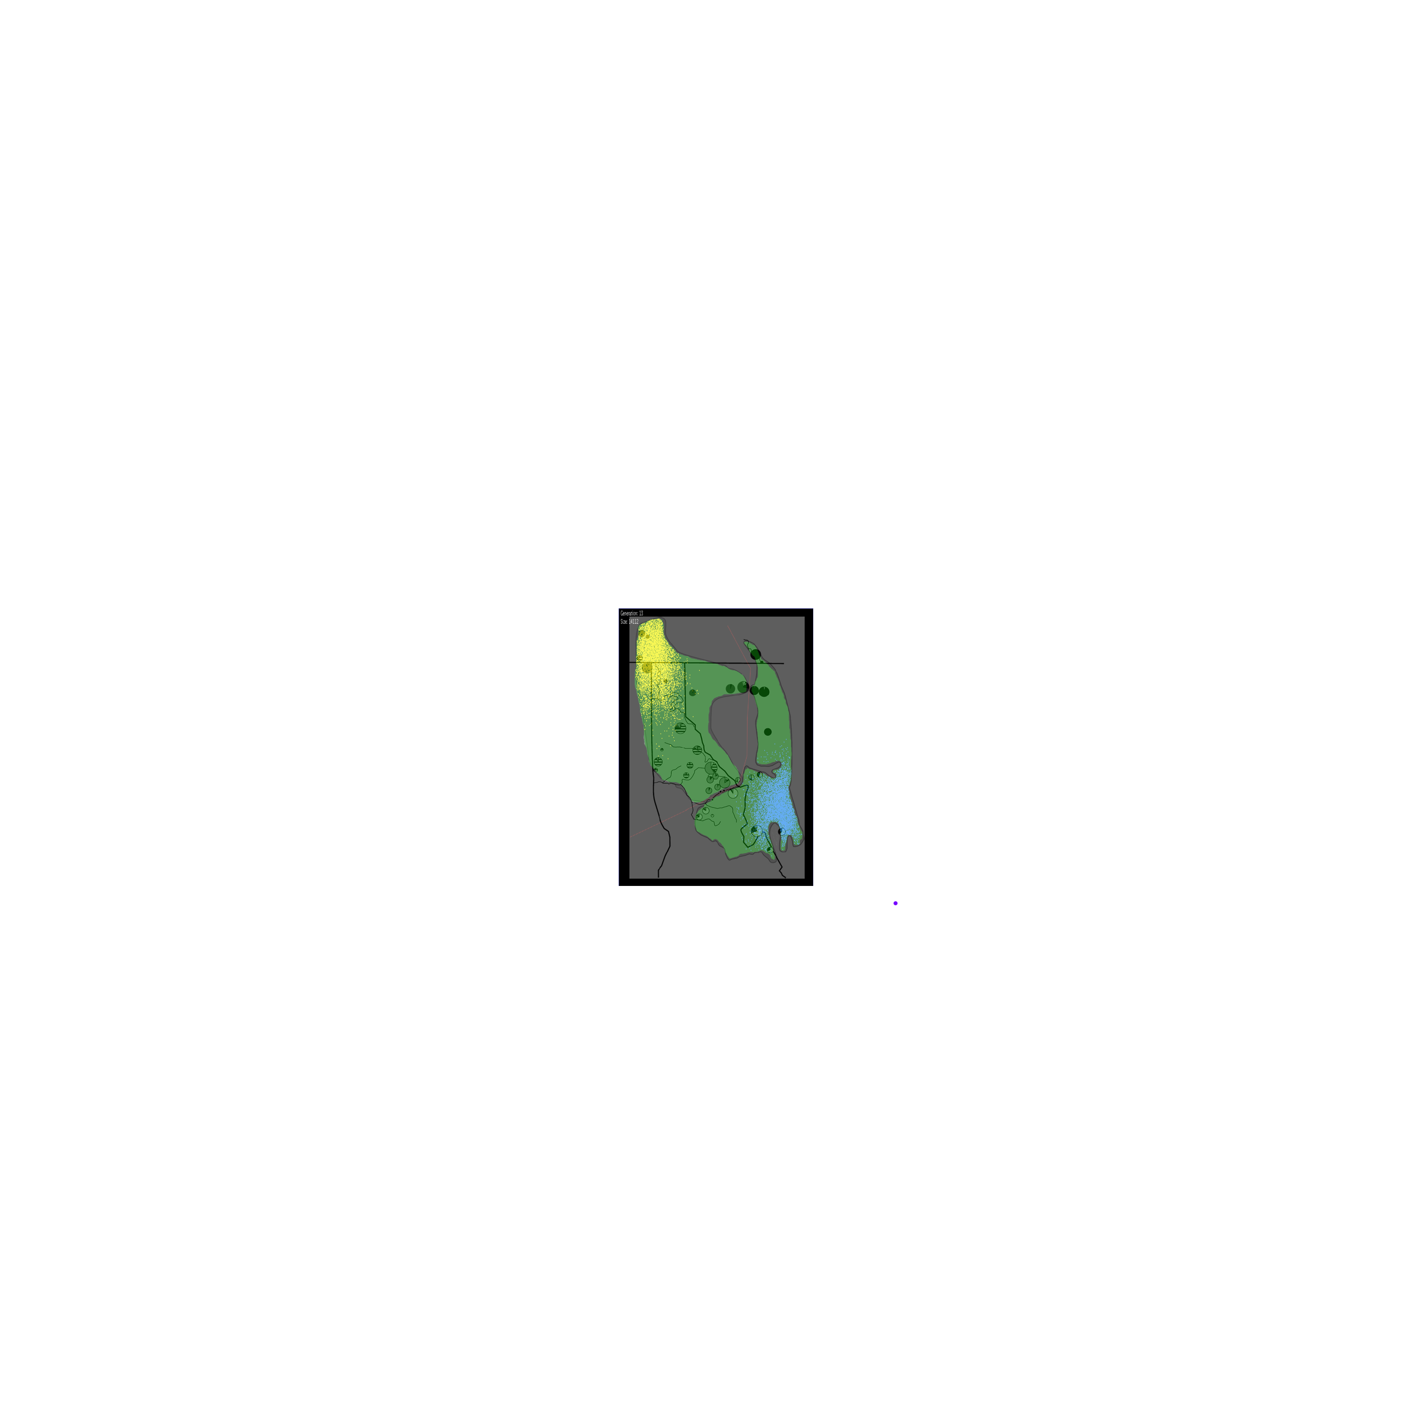

Figure 1. Modified from Hird et al 2010 Mapped coancestry coefficients. Pie charts represent the proportion of coancestry to the five demes. Dots represent indivdual locations simulated using DimSum. Yellow - *T.r. simulans,* Blue - *T. r. ruficaudus*

Brown, J, K. Savidge, and E. J. McTavish, 2010. DIM SUM: Demography and Individual Migration Simulated Using a Markov chain. Molecular Ecology Resources 11:358-363

Currat, M, N. Ray and L. Excoffier, 2004. splatche: a program to simulate genetic diversity taking into account environmental heterogeneity. Molecular Ecology Notes 4:139-142

Hird S, N. Reid, J. Demboski, and J. Sullivan, 2010. Introgression at differentially aged hybrid zones in red-tailed chipmunks. Genetica 138:869-883

Klopfstein S, M. Currat, and L. Excoffier, 2006. The fate of mutations surfing on the wave of a range expansion. Molecular Biology and Evolution 23:482-490