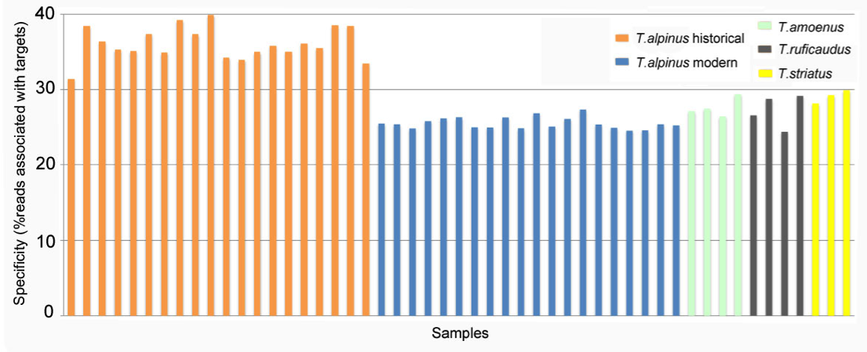

**% of reads mapped to *T.alpinus* target regions**

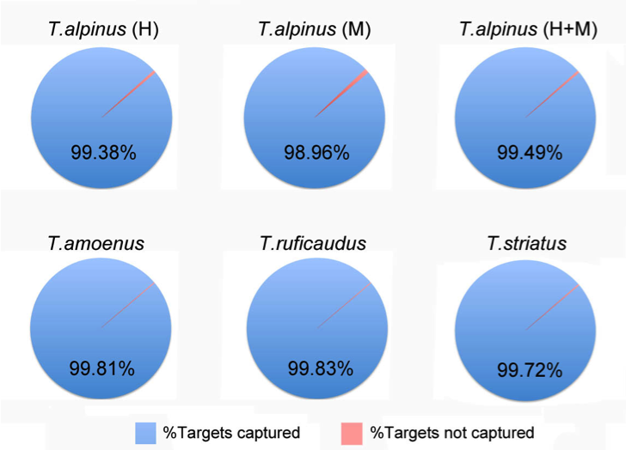

**% of *T.alpinus* targets captured**

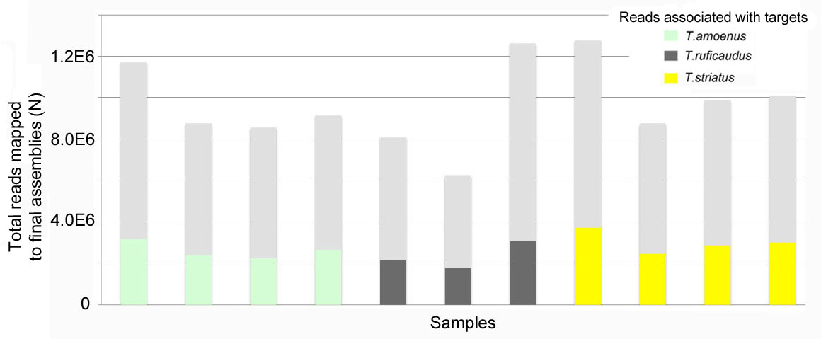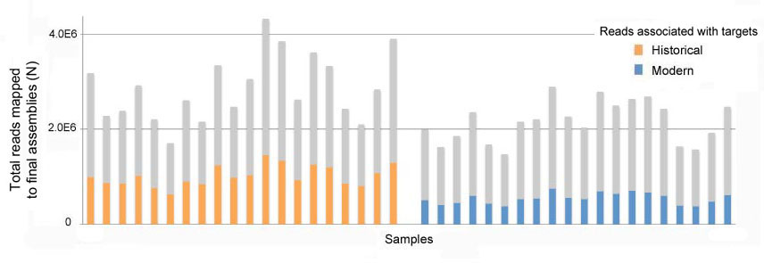

**Number of reads mapped to *T.alpinus* target regions**

**Number of sequence reads of *T. alpinus* samples (modern) associated with captured *T.alpinus* target regions vs. reads overlapped with exons**

**(reads that overlap with exons with at least 1bp)**

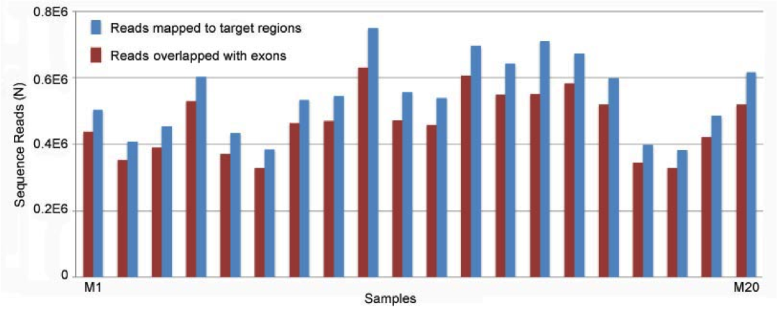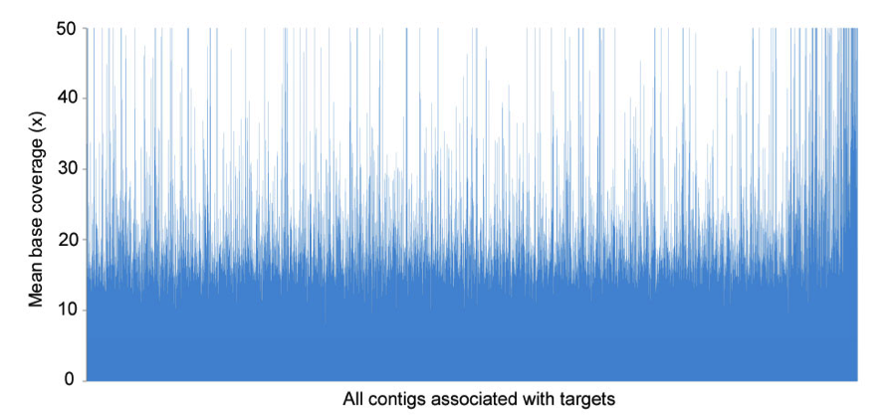

**Mean base coverage across captured targets of 20 *T.alpinus* historical samples (by contigs) (avg. cov. 15x)**

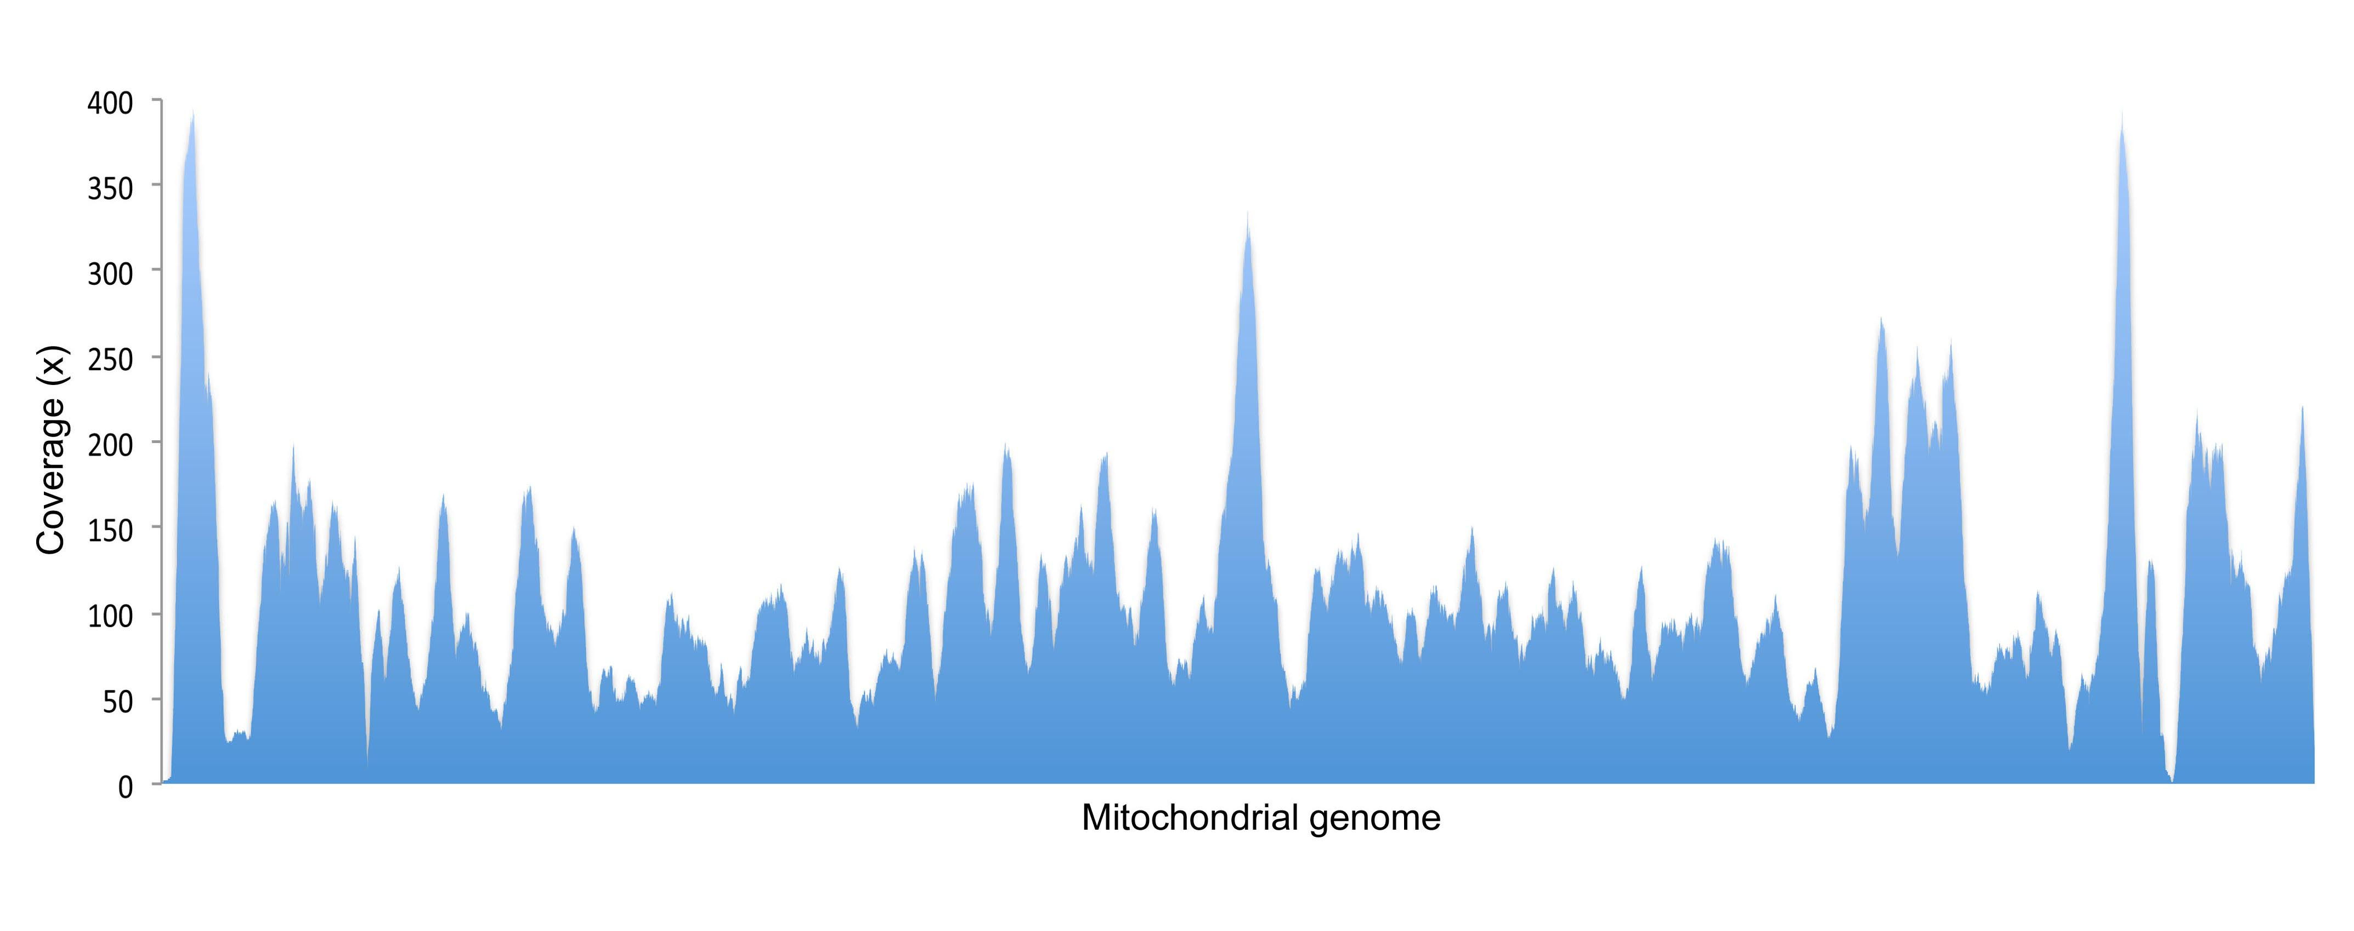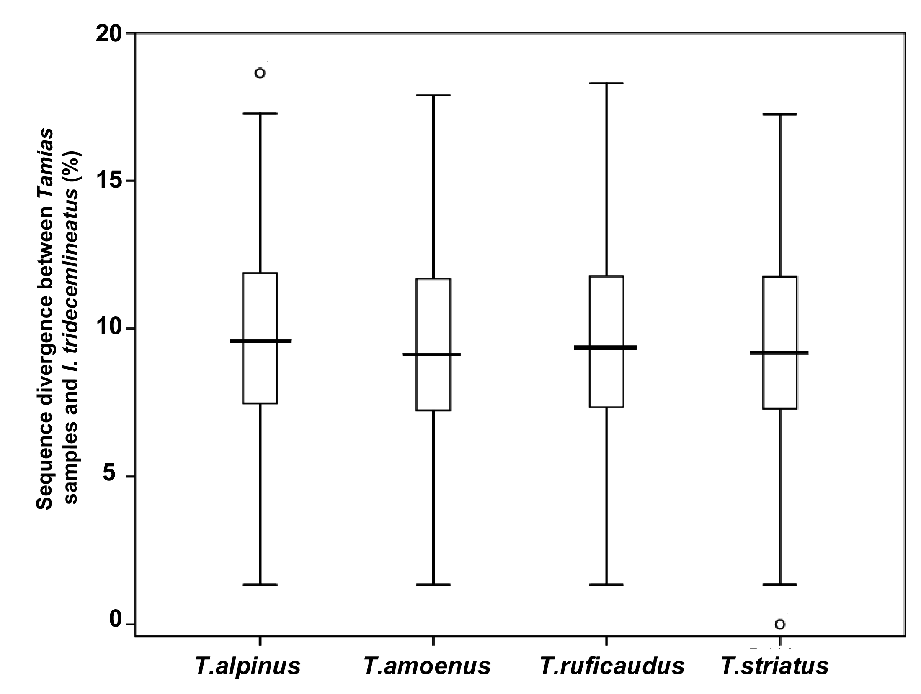

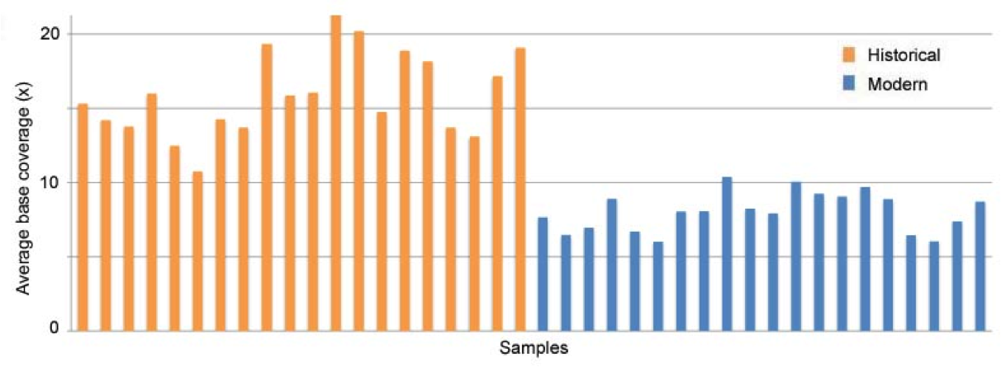

**Mean base coverage of captured targets of of all *T.alpinus* samples (by samples)**

**Base coverage of complete mtGenome (avg. cov. 109x)**

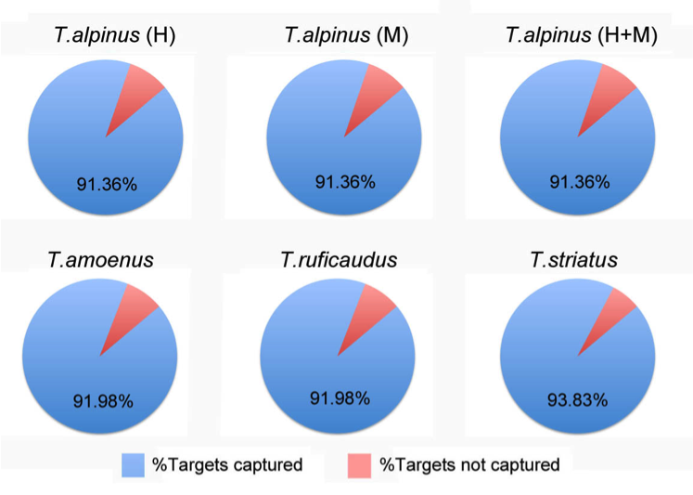

**% of *I. tridecemlineatus* genomic regions captured**

**Sequence divergence of ~150 orthologous pairs (*Tamias* vs. *I. tridecemlineatus*)**

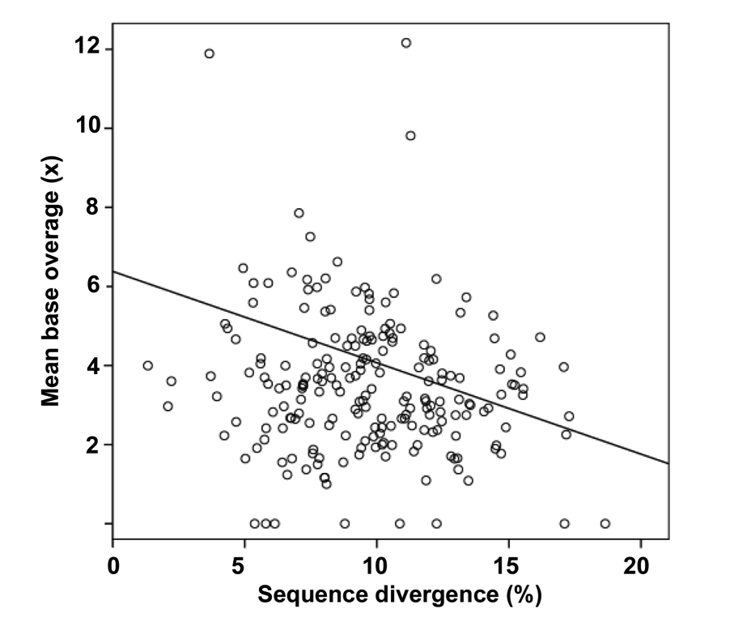

**Sequence divergence of ~150 *T.alpinus* – *I. tridecemlineatus* orthologous pairs vs. mean base coverage of *T.alpinus* contigs associated with *I. tridecemlineatus* genomictargets**

Average base coverage for *T. alpinus* exons associated contigs (modern): 7.65x

Average base coverage for *I. tridecemlineatus*associated contigs (modern): 4.20x

We see drop in capture efficiency with increase of divergence. 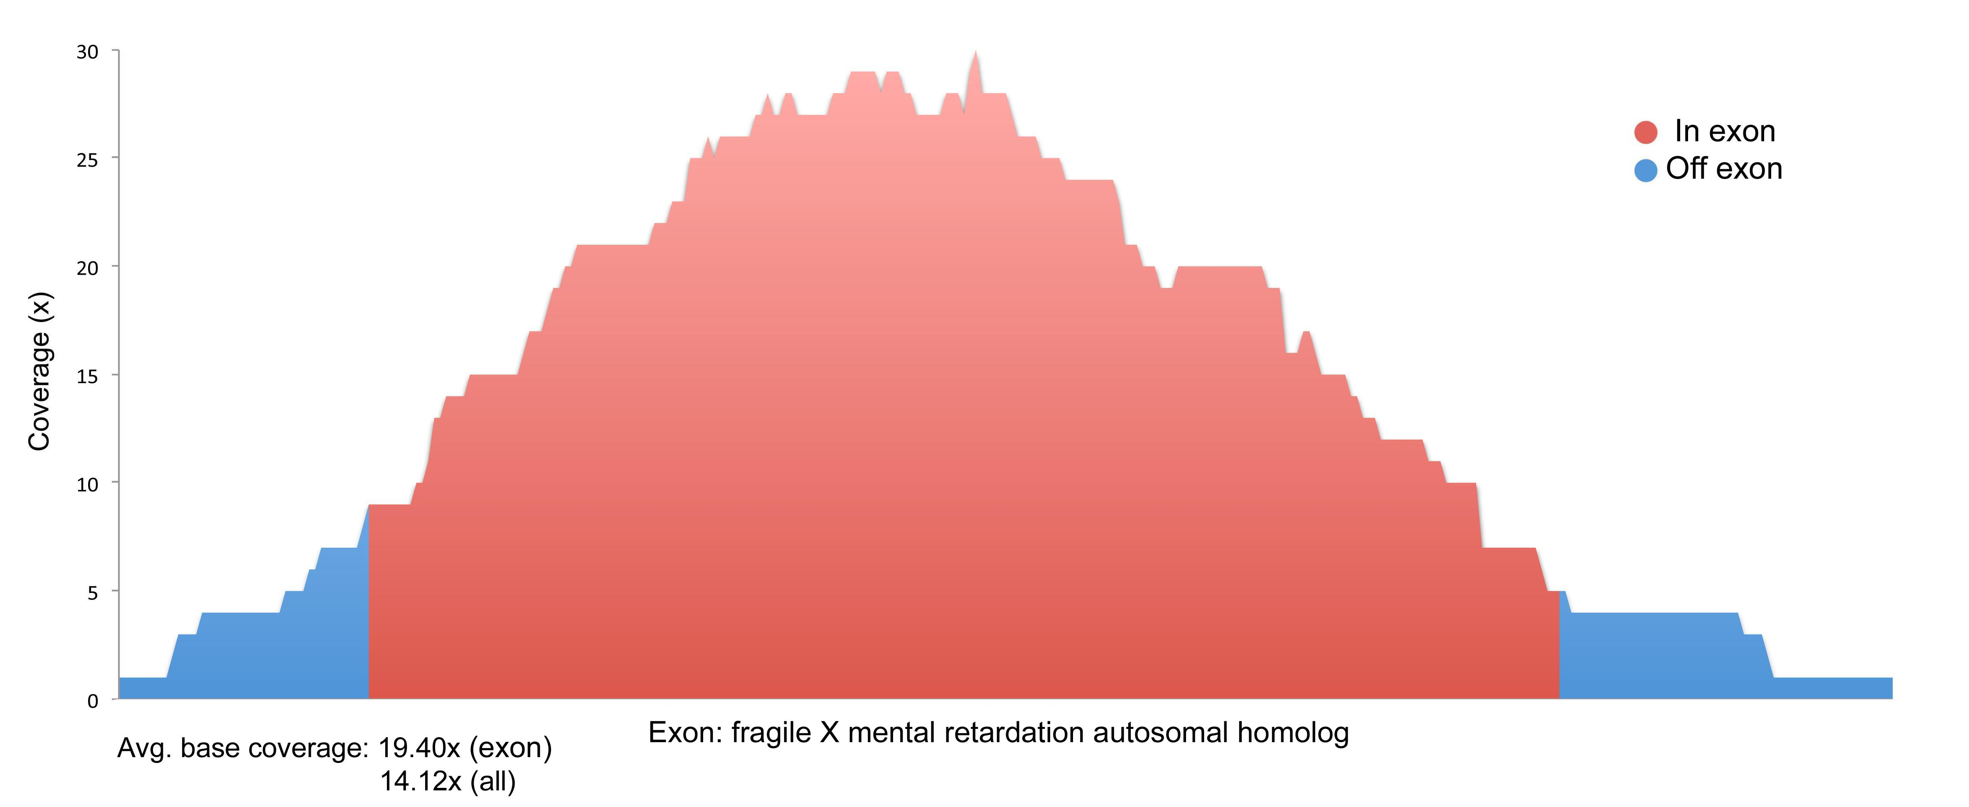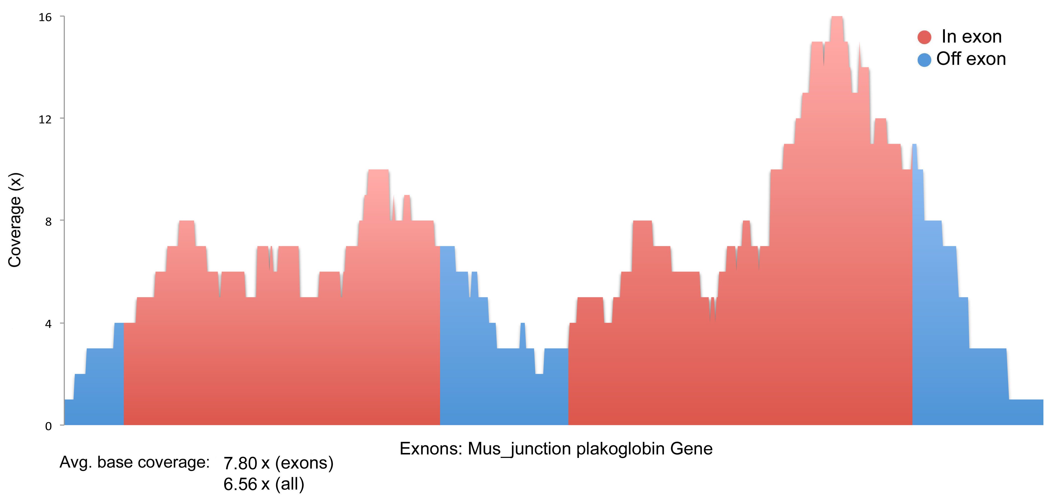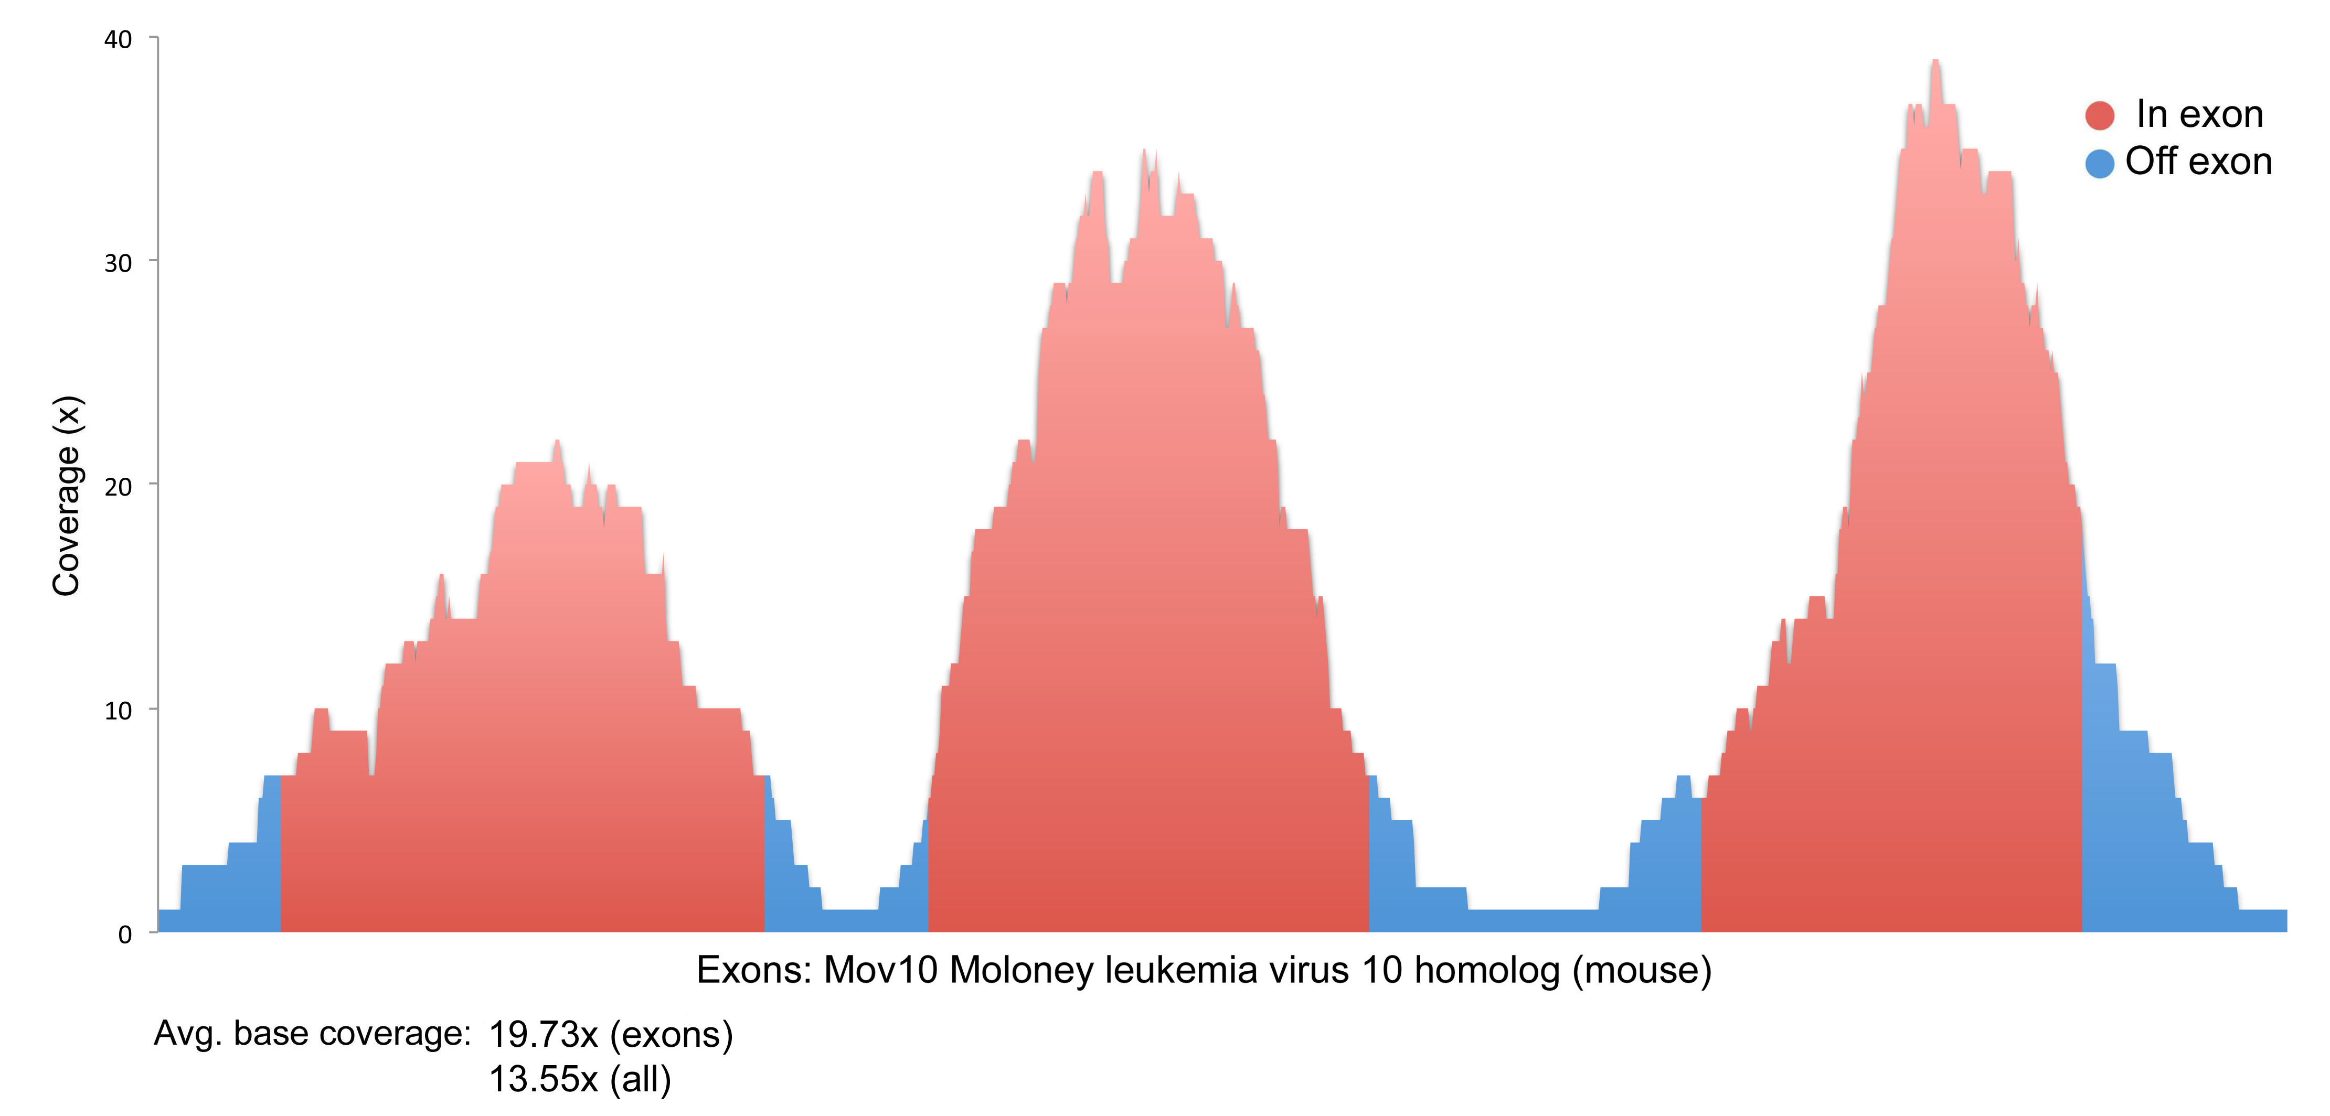

Examples of assembled contigs associated target regions

**Evaluation of final assemblies**

|  |  |  |  |  |  |
| --- | --- | --- | --- | --- | --- |
|  | **mean** | **median** | **n50** | **totContigs** | **totLength(bp)** |
| T.alpinus exons (targets) | 332 | 245 | 308 | 11975 | 3985839 |
| T.alpinus_Histroical(KB001_index6~25) | 599 | 507 | 585 | 10600 | 6347511 |
| T.alpinus_Modern(KB002_index6~25) | 703 | 587 | 719 | 10445 | 7351579 |
| T.alpinus_Histroical+Modern | 726 | 609 | 736 | 10470 | 7609972 |
| T.amoenus (JG01_index1, 3~5) | 690 | 585 | 694 | 10580 | 7299990 |
| T.ruficaudutus(JG01_index6~9) | 710 | 596 | 719 | 10562 | 7508917 |
| T.striatus(JG01_index10~12) | 692 | 591 | 694 | 10535 | 7293068 |