CS 870 – Numerical Algorithms and Image Processing

Fall 2010

Assignment

Karim Ali
Part a
Figures 1-3 show the curve evolution of the circle at grid sizes m=20, 40, and 80 respectively. Table 1 shows the error for each grid size m.

To re-generate those plots, you can run the following Matlab function:
evolveCurve('circle', F, tMax, m)

where: F = speed (here it's always = 1),
tMax = maximum value for time t (here it's always = 0.25)
m = grid size (=20, 40, 80)

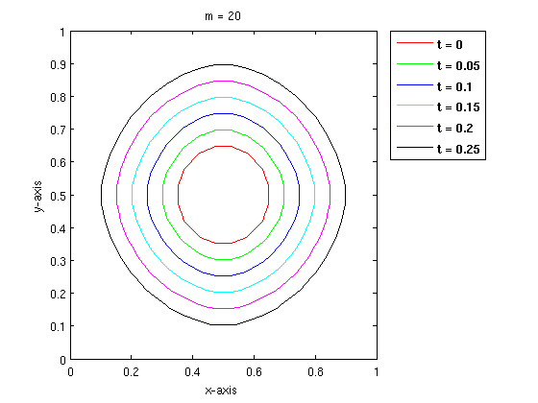Figure 1

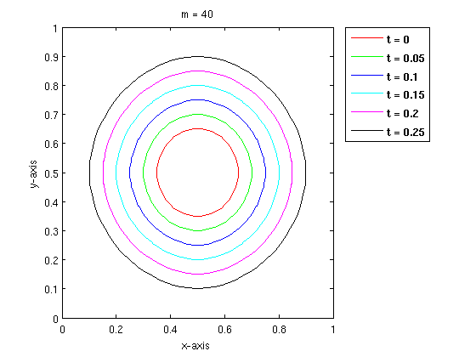Figure 2

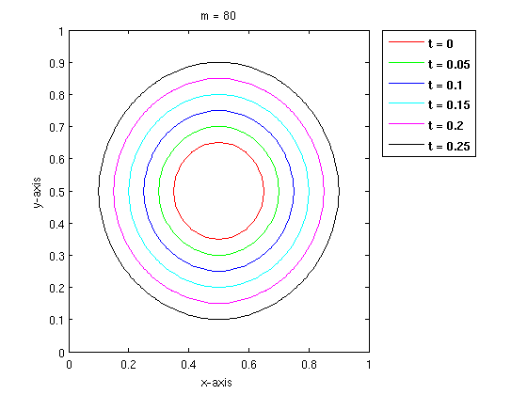Figure 3

Table 1 shows the error (A_{exact} – A_{ф}) for each grid size m.
Grid Size (m) | Error (A_{exact} – A_{ф})
20 | -0.0955004
40 | -0.0403150
80 | -0.0258936
Table 1
Figure 4 shows a plot for the error versus grid size m.

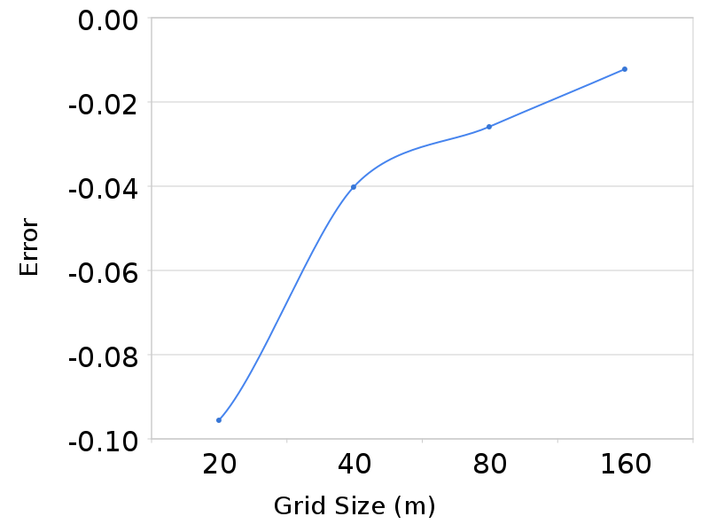Figure 4

Part b
Figure 5 shows the curve evolution of the dumbbell at grid size m=80 . The evolution shows that the dumbbell will split around t = 0.1.

To re-generate the plot, you can run the following Matlab function:
evolveCurve('dumbbell', -1, 0.25, 80)

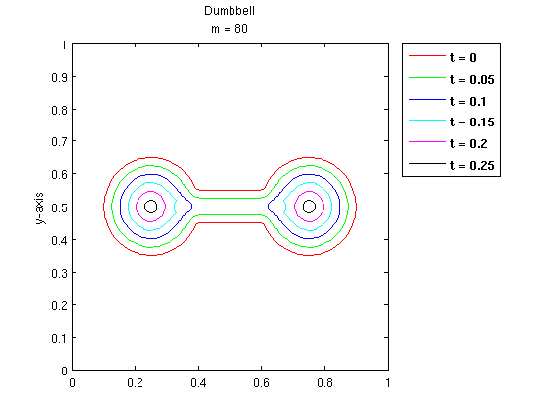Figure 5

