Homework-6

**Out date:** March 12, 2021

**Due date:** March 23, 2021



Team#: **12**

Team Member-1:____ **Elizabeth Garcia**_________Member’s Contribution (in %) _**50%**

Team Member-2:____**Sara Nafaryeh** __________ Member’s Contribution (in %) _**50%**



**Submission**

1. Answer the following questions.
2. Rename this word file “HW6-YourTeam#” (e.g., HW6-Team1.docx).
3. Upload the file to the blackboard system.



**Problem-1 [50 points]**

Consider the following visualization. It shows the monthly unemployment rate change in Spain. It may be effective in presenting abstract information such as southeast suffers more from the unemployment problem than that of northwest and west.

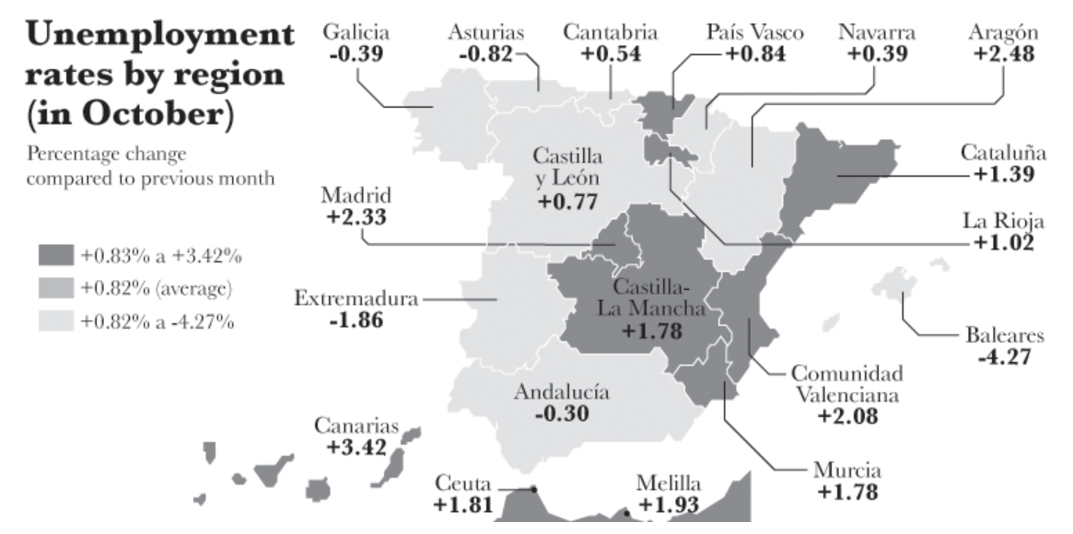

Yet, the visualization is not very effective in answering the questions such as the following:

1. Which state has unemployment grown the most?
2. Which state has it dropped the most?
3. Has the unemployment change been bigger in Madrid, La Rioja, or Canarias?
4. Has unemployment dropped more in Extremadura, Andalucía, or Baleares?

**Sketch a most appropriate visualization that can effectively answer the questions such as listed above.**

The most appropriate visualization that can effectively answer the question for this data is a loli-pop graph

1. The state that has grown the most in unemployment is Canarias at 3.420%.
2. The state that has dropped the most in unemployment is Baleares.
3. The unemployment rate has been bigger in Baleares than the others.
4. Unemployment has dropped the most in Baleares at -4.270%

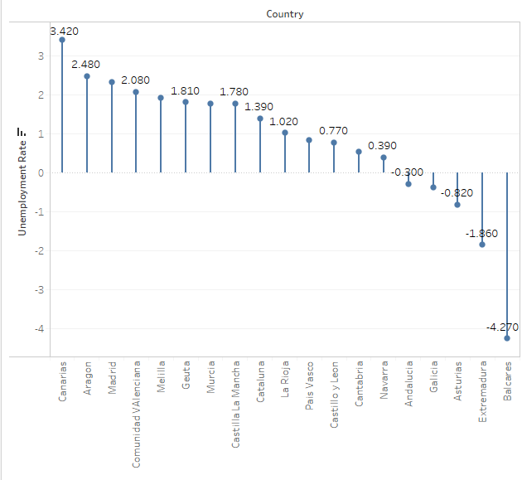

**Problem-2 [50 points]**

The following table shows the percentage of people holding BA degrees (or higher) per state, and the percentage of people who are obese. How would you encode the data so readers can see the relationship, or lack thereof, between your two variables?

**In particular, sketch two most appropriate visualizations that show the relationship between the two variables for every state.**

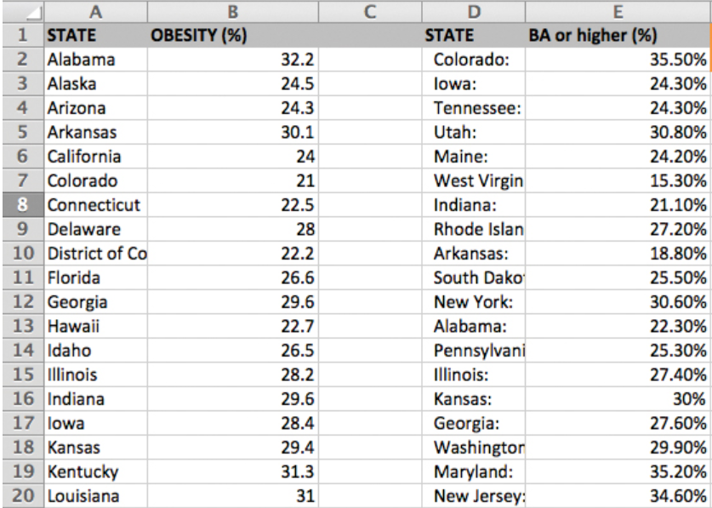

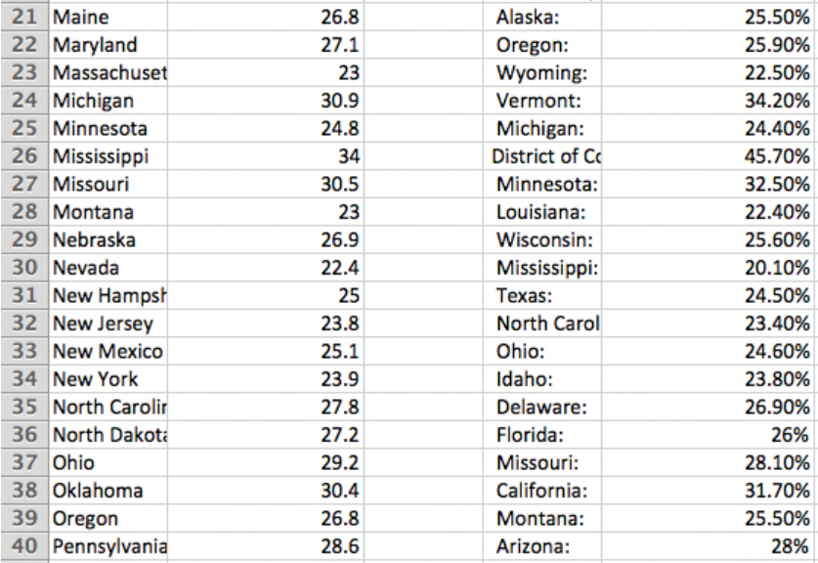

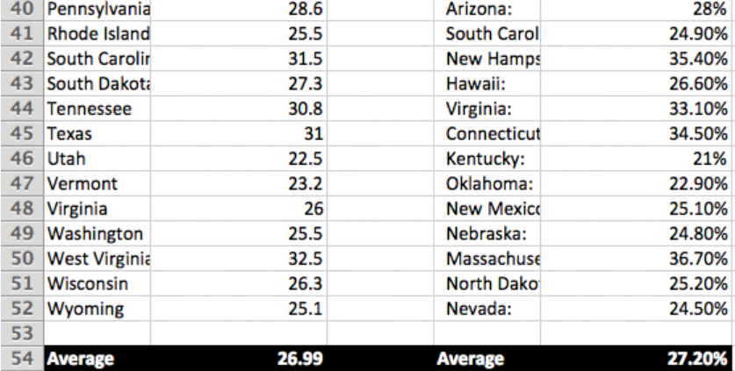

The two graphs that fit for this data is a side-by-side bar graph and a correlation graph of the two variables.

The side-by-side bar graph helps compare the two variables: Obesity and College degrees for each state to determine a relationship between the variables, while the correlation graph helps show if there is a relationship of the variables based on states.

