BankingBot

In this project we are using Artificial Intelligence and Machine Learning techniques to trained BankingBot and if asked question available in training model then bot will answer otherwise it say sorry message. So to build such application we need all possible questions and answers as dataset and then by using that dataset we can train BOT.

To train this BOT I am using below dataset but I request you to increase dataset size as per your requirements and this dataset saved inside ‘Dataset’ folder

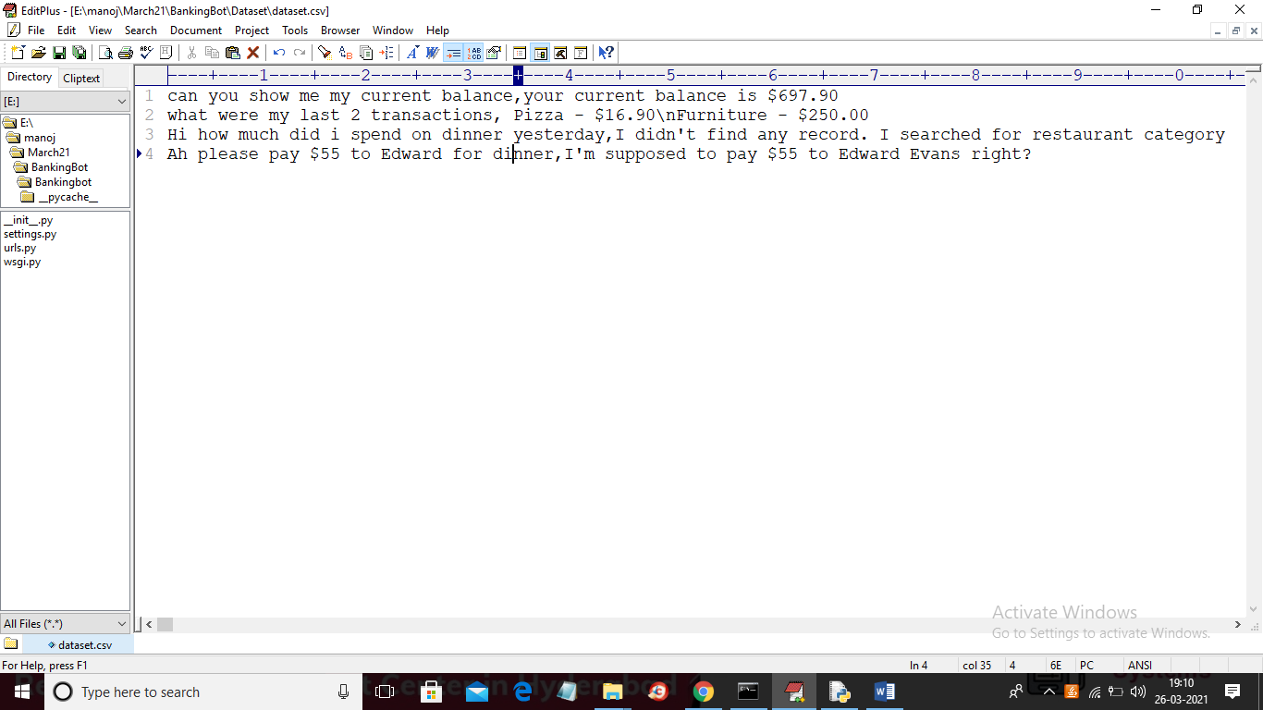

In above screen I have added 4 lines to train BOT but you can increase size and you can write each question and answer in same line separated by comma symbol, in the same way as I did for above 4 lines dataset. Once you increase dataset then restart application and then application will trained BOT with updated dataset.

SCREENSHOT

To run project install PYTHON, MYSQL and DJANGO package and then deploy code in DJANGO server and then open browser and enter URL as ‘http://127.0.0.1:8000/index.html’ to get below home page

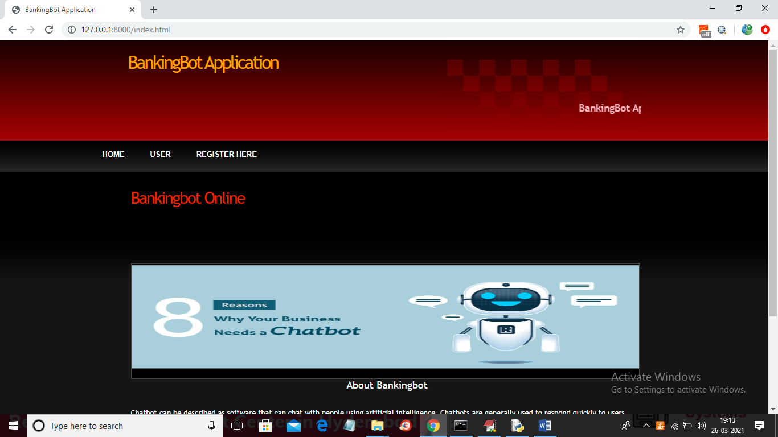

In above screen click on ‘Register Here’ link to get below registration page

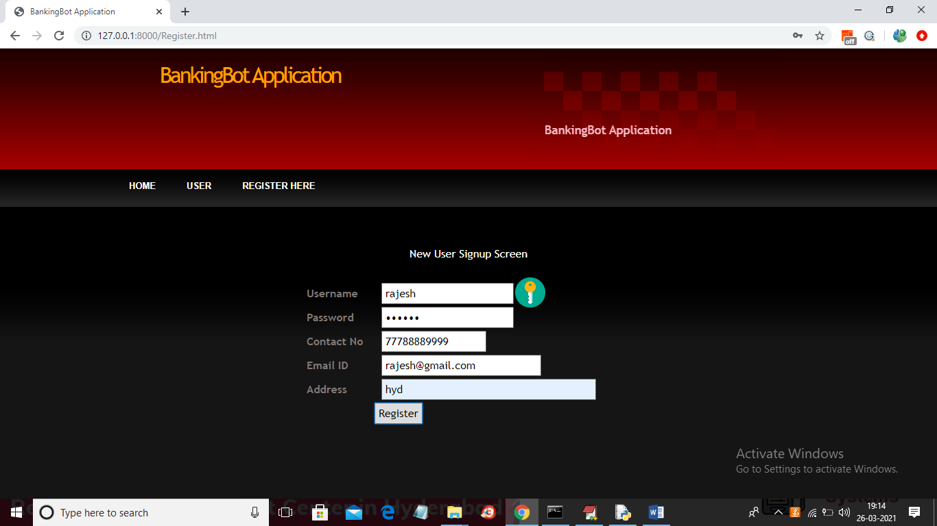

In above screen user is getting register and after pressing ‘Register’ button will get below screen

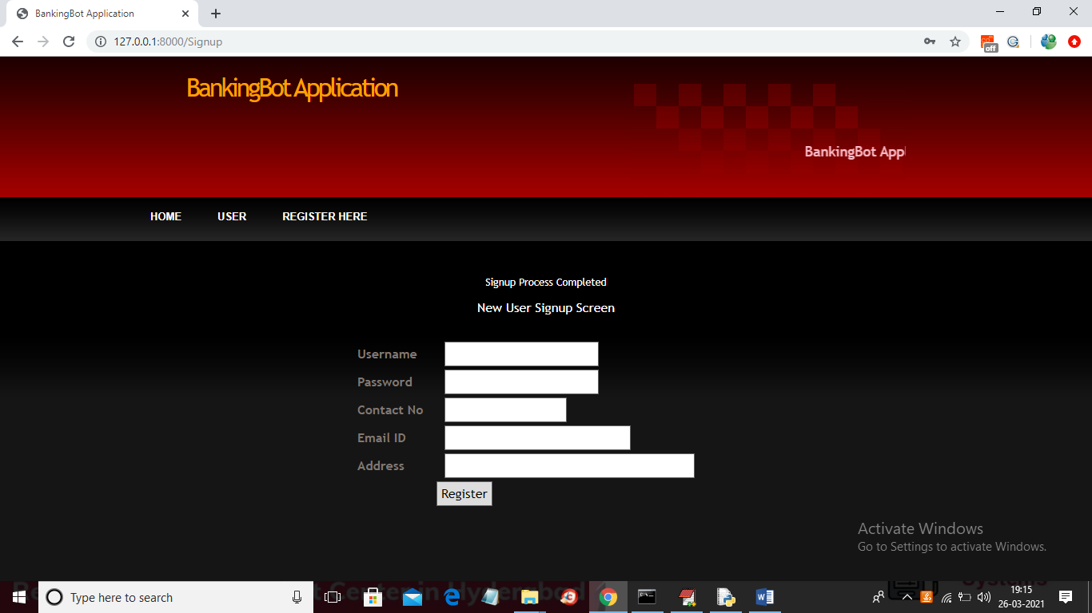

In above screen user signup process completed and now click on ‘User’ link to get below login page

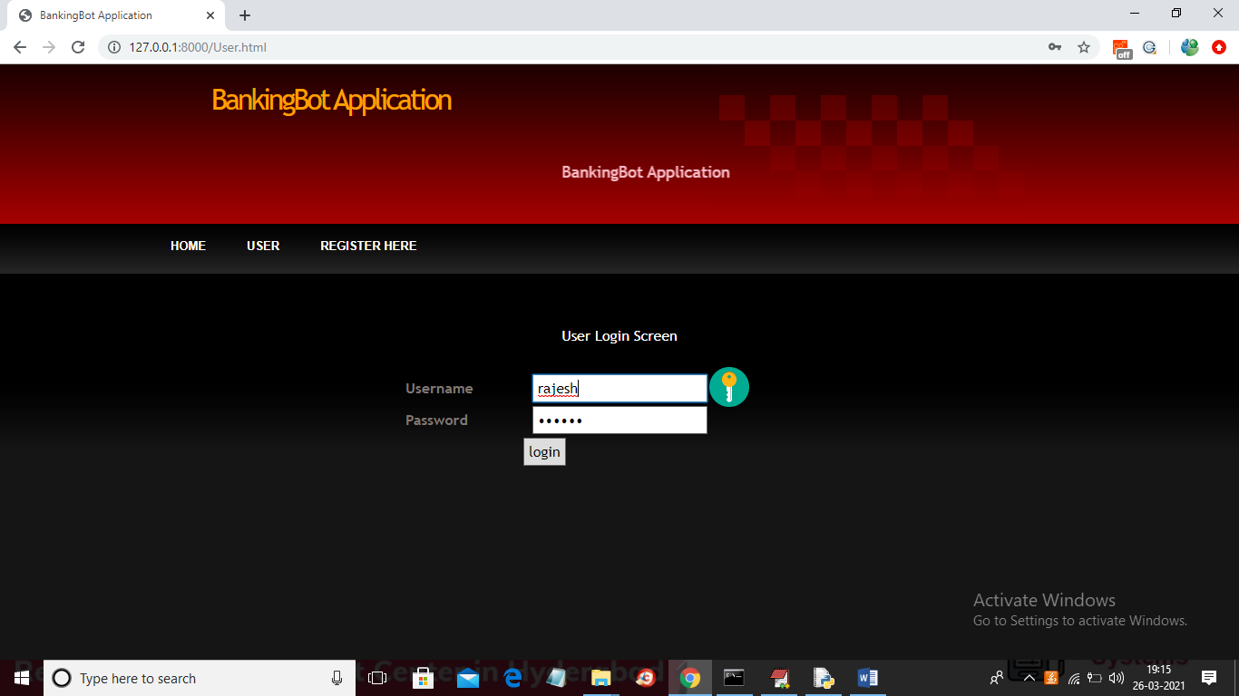

In above screen user is login and after login will get below page

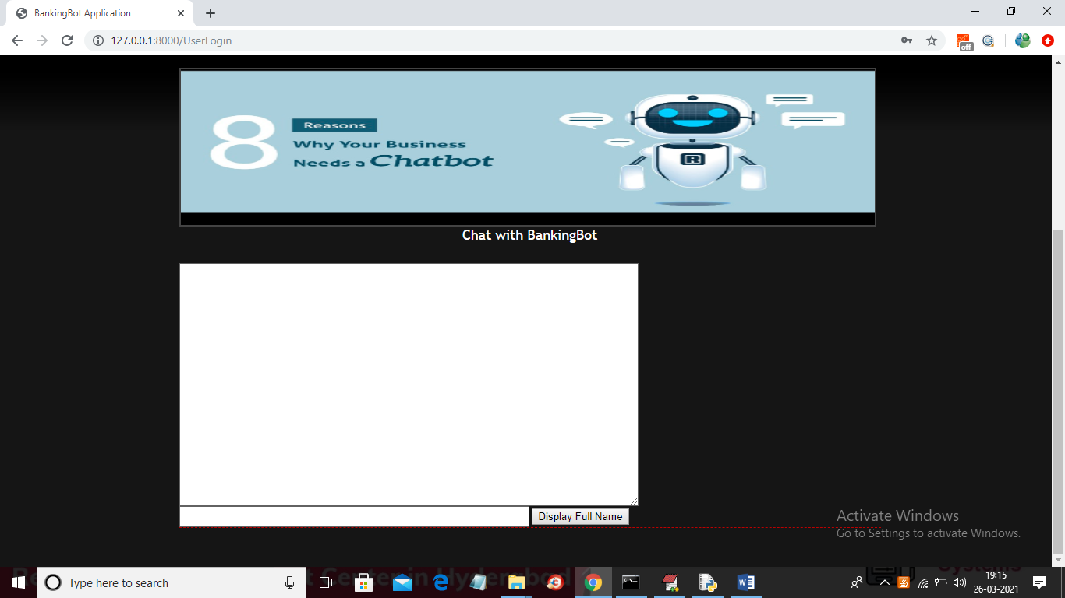

In above screen user will get BankingBot chat page and then user can type complete question or partial question to get below response

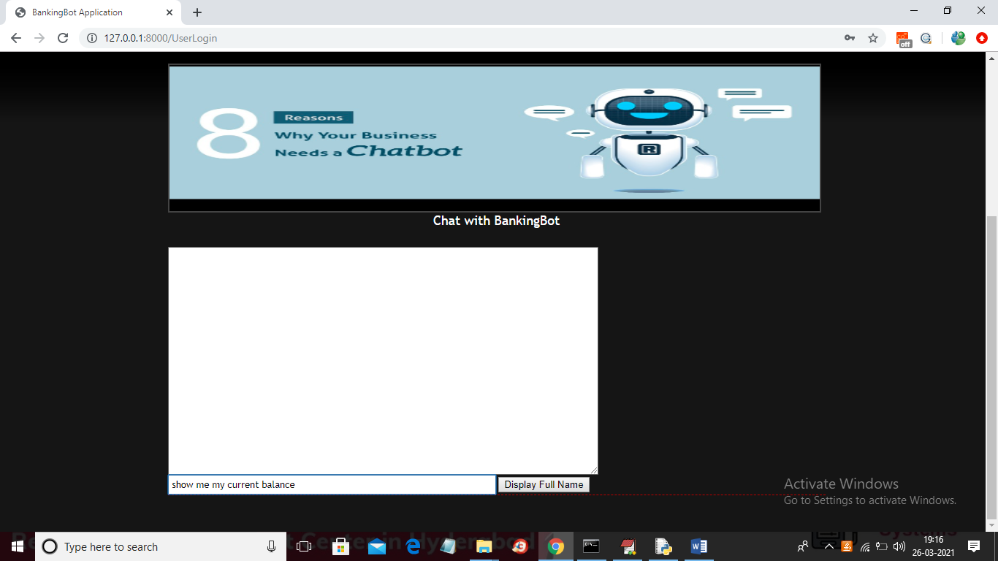

In above screen I entered some message and then click on button to get below result

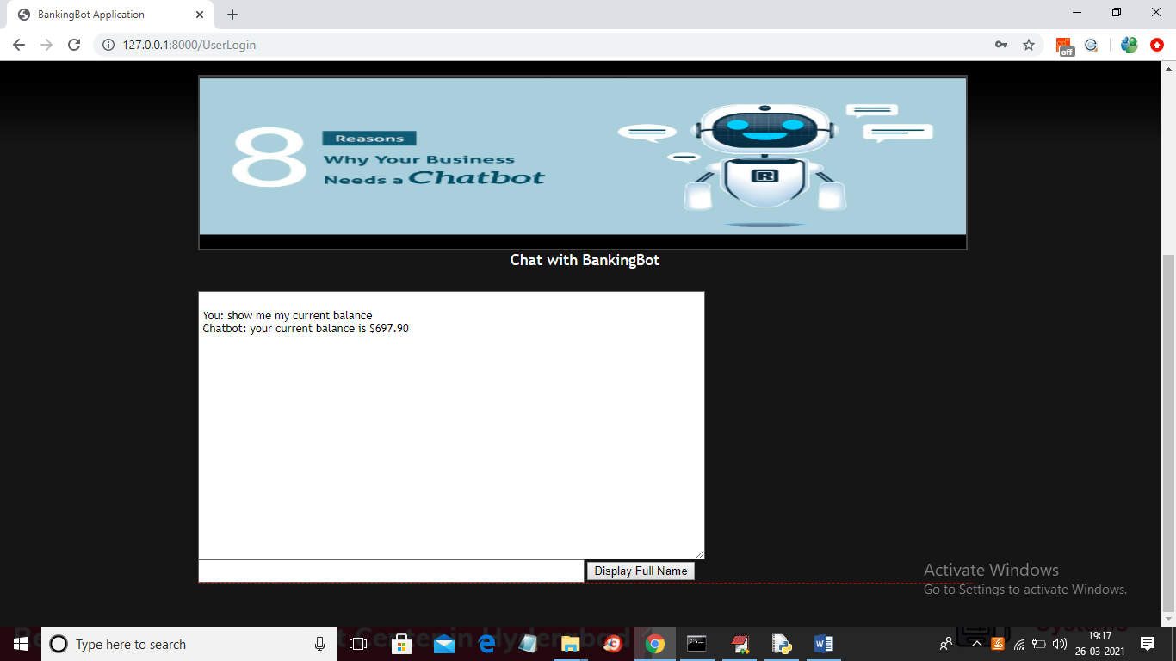

In above screen BOT replied for asked question and similarly you can ask any question available in dataset

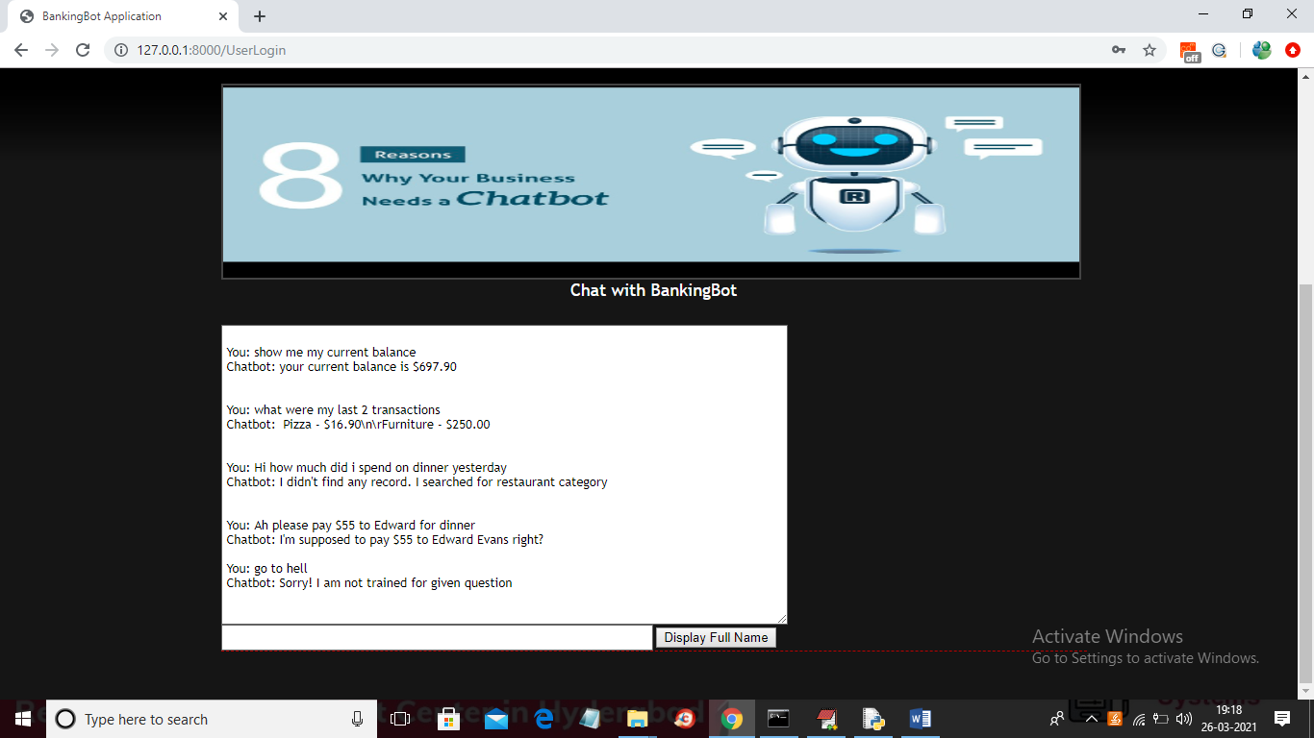

In above screen BOT answer for all questions given in dataset and when we gave unknown question then BOT will reply ‘Sorry! I am not trained’. Similarly you can signup any number of users and then ask any question but before that add some questions based on your requirements