Content

1. Introduction to FindingPrimo
2. environment setup
3. creating 2 SQS.
4. creating EC-2 instances
5. installing nginx in webserver
6. installing go, git in 2 app servers
7. starting processPrime server
8. starting prime server
9. accessing the application
10. stoping the primeserver
11. starting the primeserver

Introduction to FindingPrimo

- Finding Primo application basically uses aws SQS to identify primes.
- system basically has 2 sqs, one to hold all natural number[processPrimeQueue] and one to hold all evaluated primes[primeQueue].
- system has 3 ec2 instances.
  - 1 webserver[nginx]
  - 2 ec2 instances for following purpose.
    - ec2 - processPrimeServer basically performs 2 actions.
      - receives natural numbers from user to evaluate prime.
      - 2. stores the received no in sqs[processPrimeQueue]
      - 3. provides list of no in queue processPrimeQueue
    - ec2 - primeServer performs 2 actions.
      - runs a concurrent job, which reads natural numbers from queue processPrimeQueue and check for prime and stores the same queue primeQueue if it is a prime.
      - provides a list of primes nos from queue [primeQueue]
- even if the ec2 - instance primeServer goes down. system still stays intact. i.e. all nos to be evaluated for prime are still intact.
- when the system primeServer comes back up. still start performing as usual.
- Git repo: https://github.com/snagurum/findingPrimo_goSqs.git

Architecure diagram
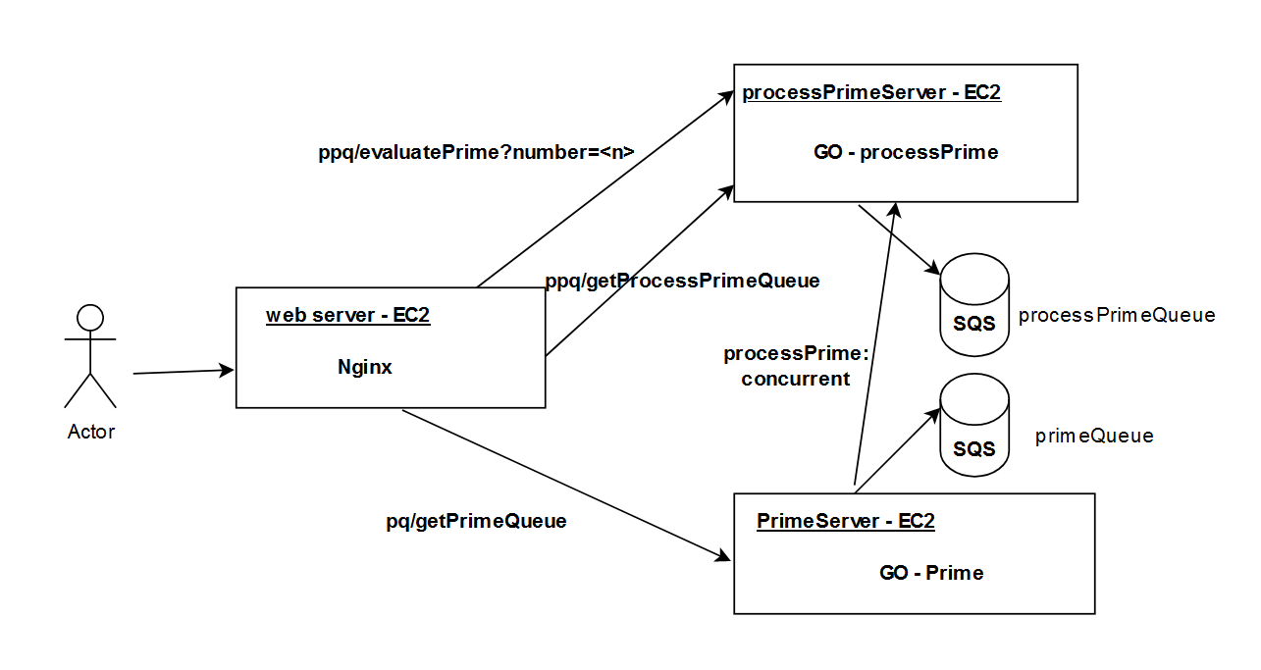

creating 2 SQS.
Creation of 2 SQS [standard queue]
- processPrimeQueue [queue to hold numbers that are to be evaluated for prime]
- primeQueue [queue to hold prime numbers]

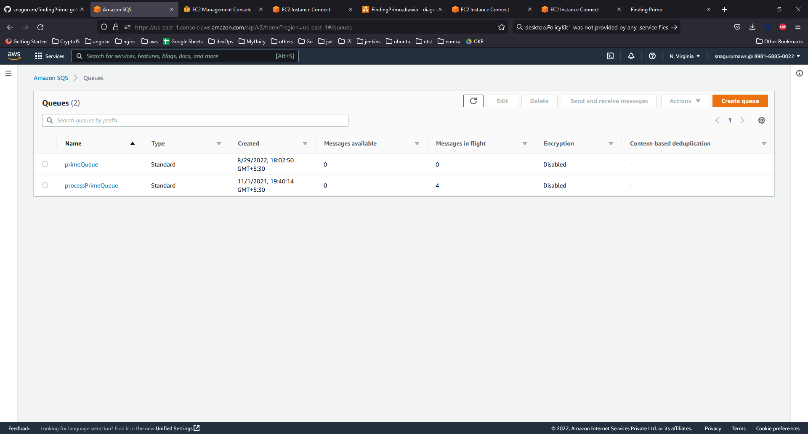
creating three EC-2 instances

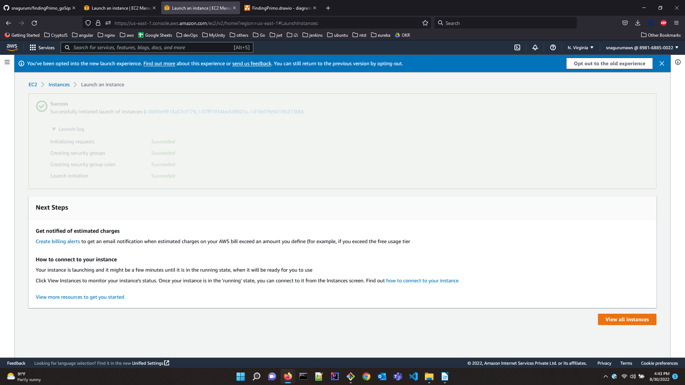
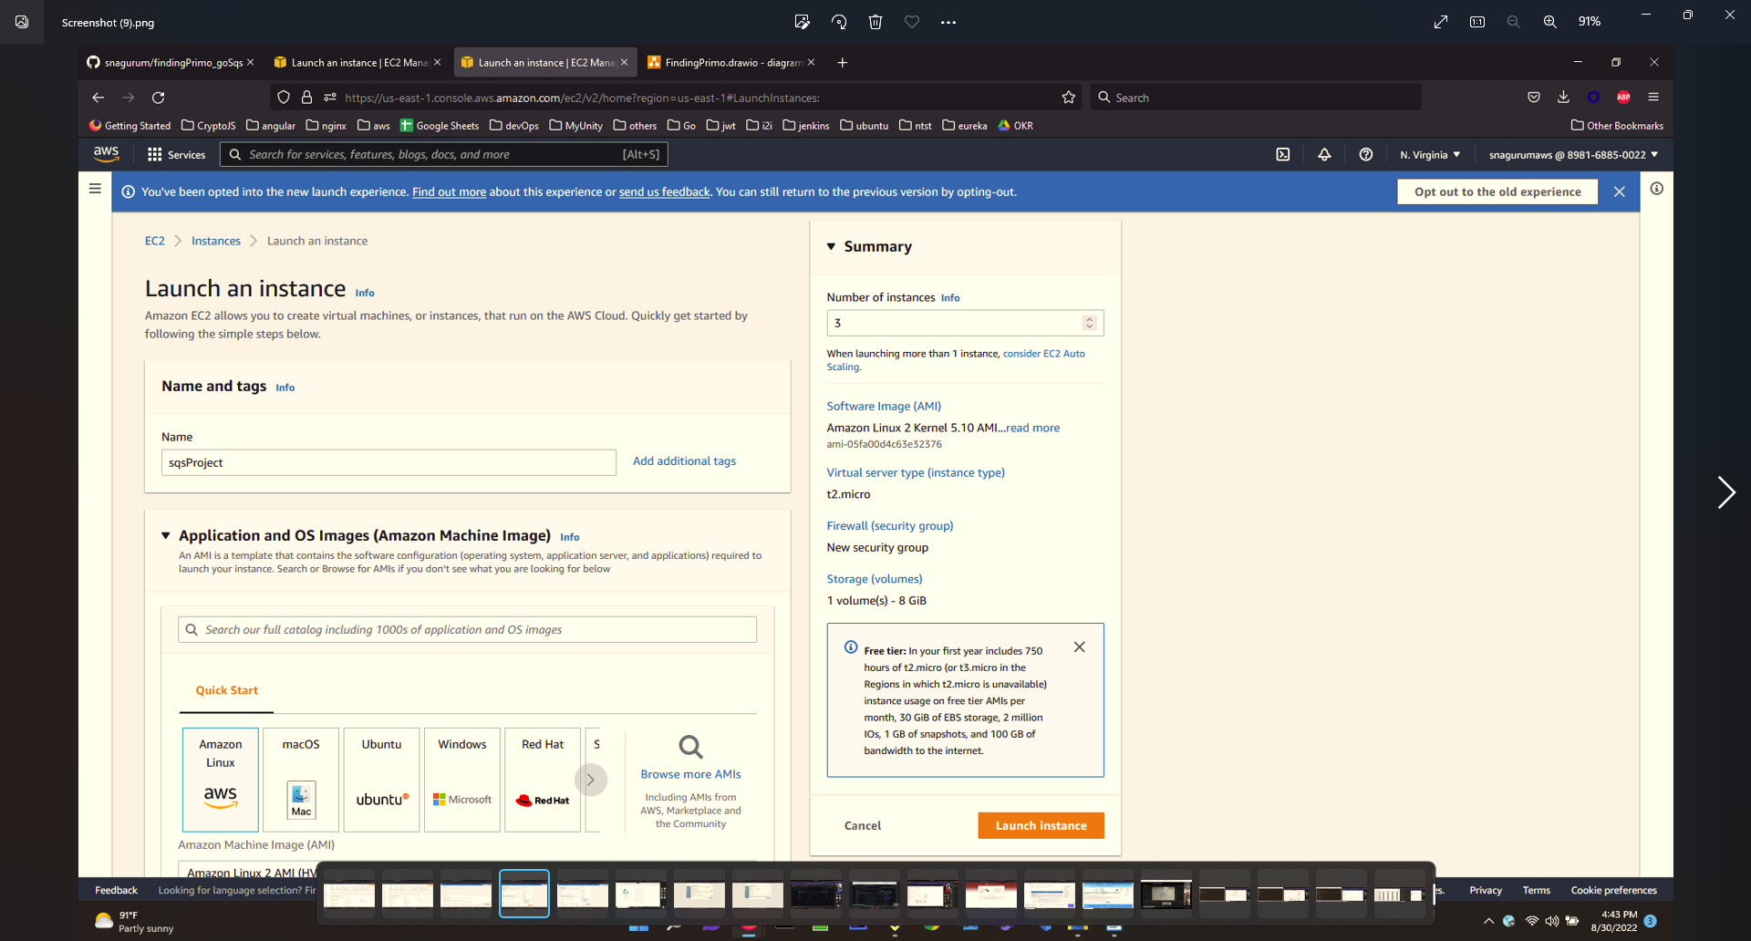
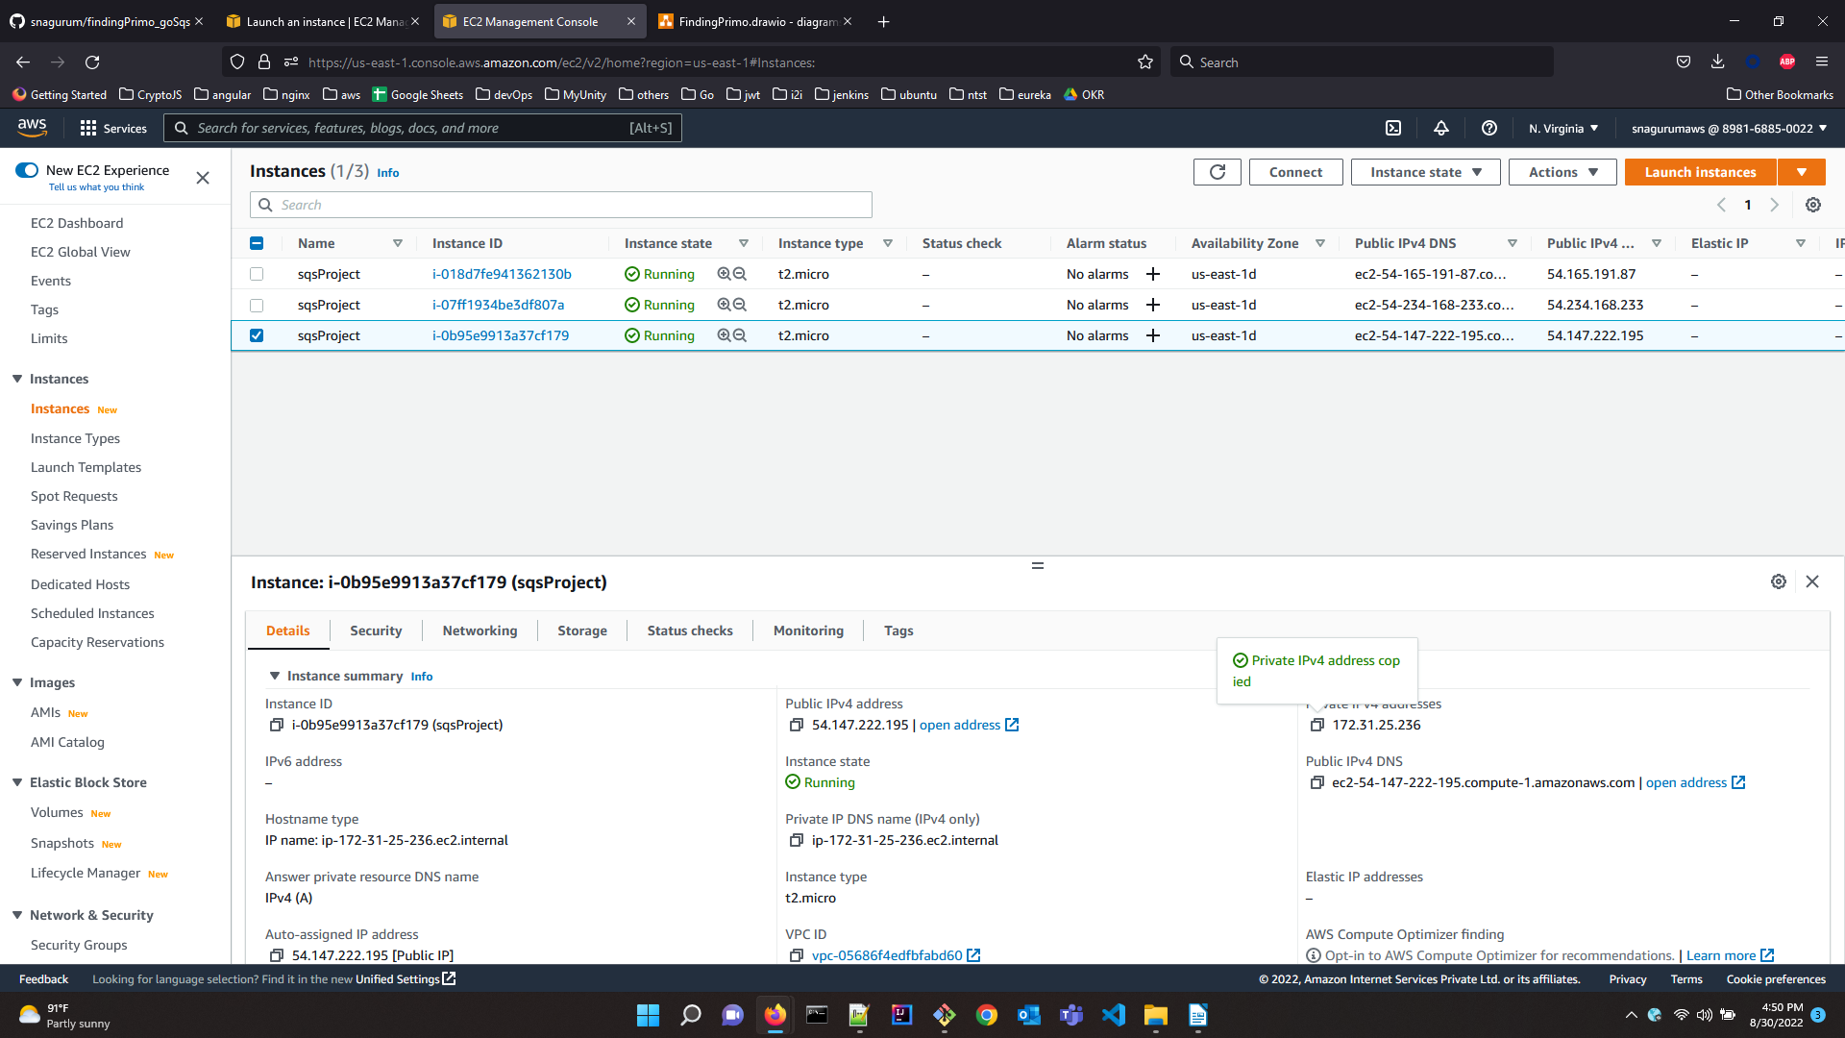

instance-id | public IPv4 address | Internal-ip | external-ip
i-018d7fe941362130b | ec2-54-165-191-87.compute-1.amazonaws.com | 172.31.17.174 | 54-165-191-87
i-07ff1934be3df807a | ec2-54-234-168-233.compute-1.amazonaws.com | 172.31.26.196 | 54-234-168-233
i-0b95e9913a37cf179 | ec2-54-147-222-195.compute-1.amazonaws.com | 172.31.25.236 | 54-147-222-195

installing nginx in webserver

server: 54-165-191-87, ec2-54-165-191-87.compute-1.amazonaws.com will be the nginx/webserver.
Running commands.
sudo yum update
sudo amazon-linux-extras install nginx1
sudo service nginx status

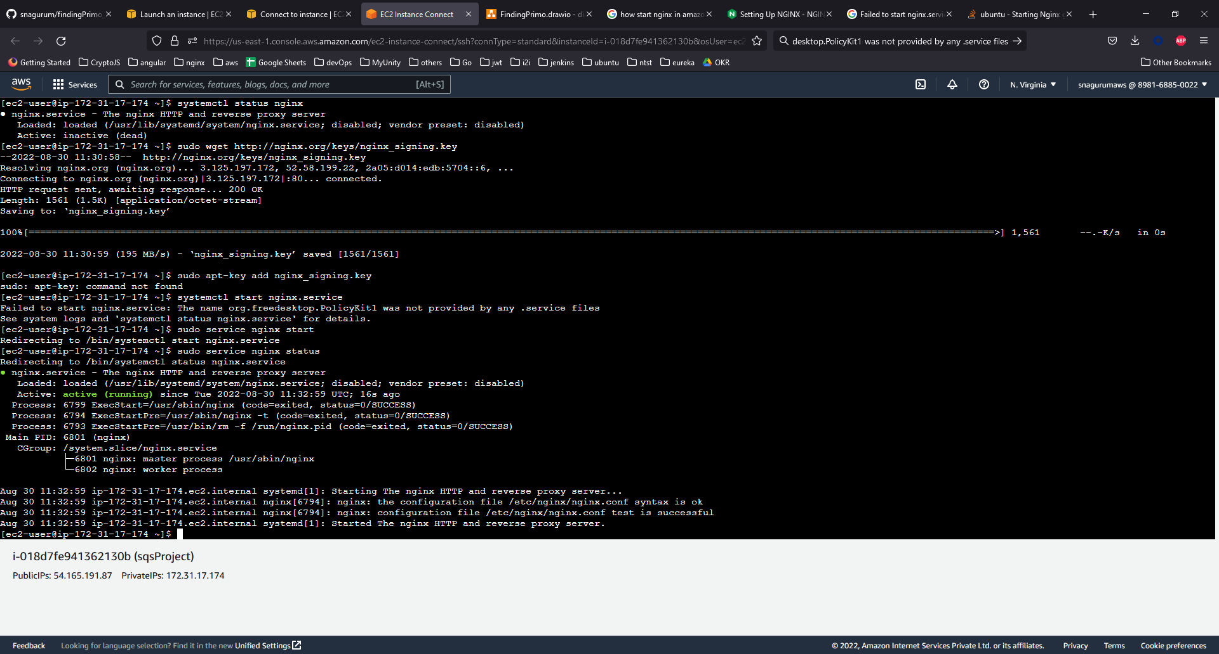
Adding configuration for routing in nginx.conf

location / {
root html;
index index.html index.htm;
}
location /ppq/ {
proxy_redirect off;
proxy_set_header Host $host;
proxy_pass http://172.31.26.196:8081;
proxy_http_version 1.1;
}
location /pq/ {
proxy_redirect off;
proxy_set_header Host $host;
proxy_pass http://172.31.25.236:8082;
proxy_http_version 1.1;
}

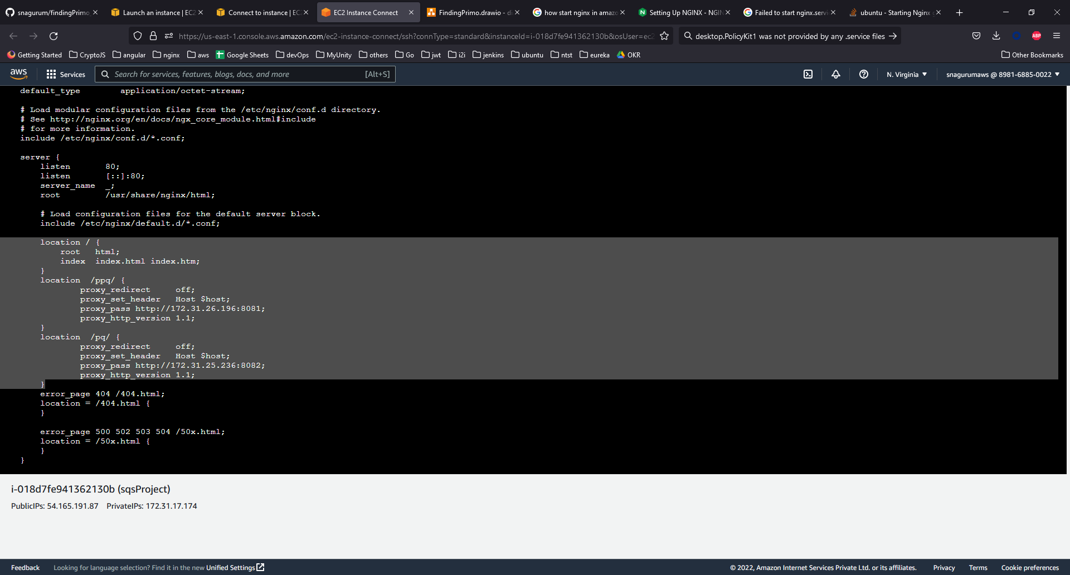
Adding security rule for http access on port 80
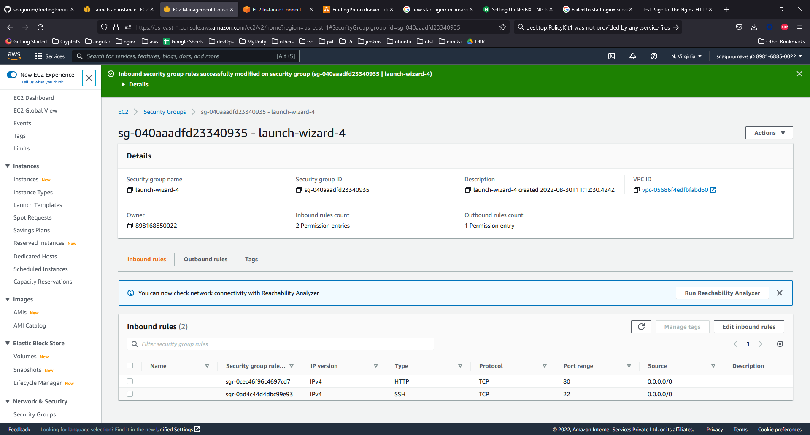
testing the landing page.
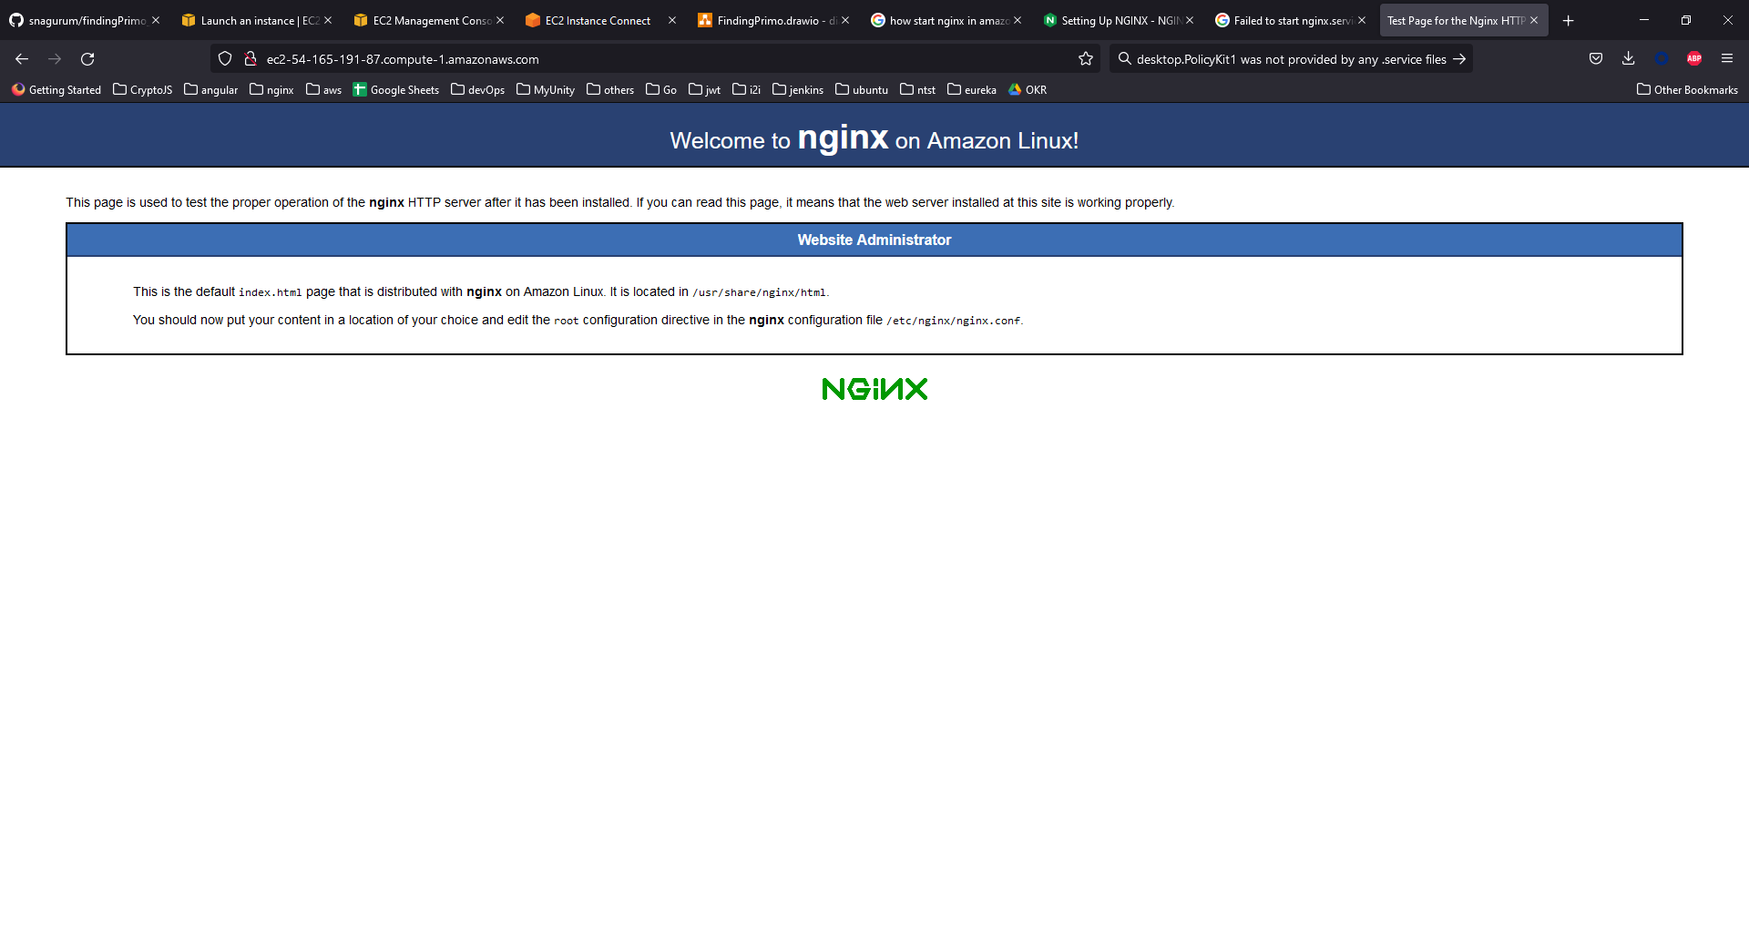
copying index.html file to /usr/share/nginx/html
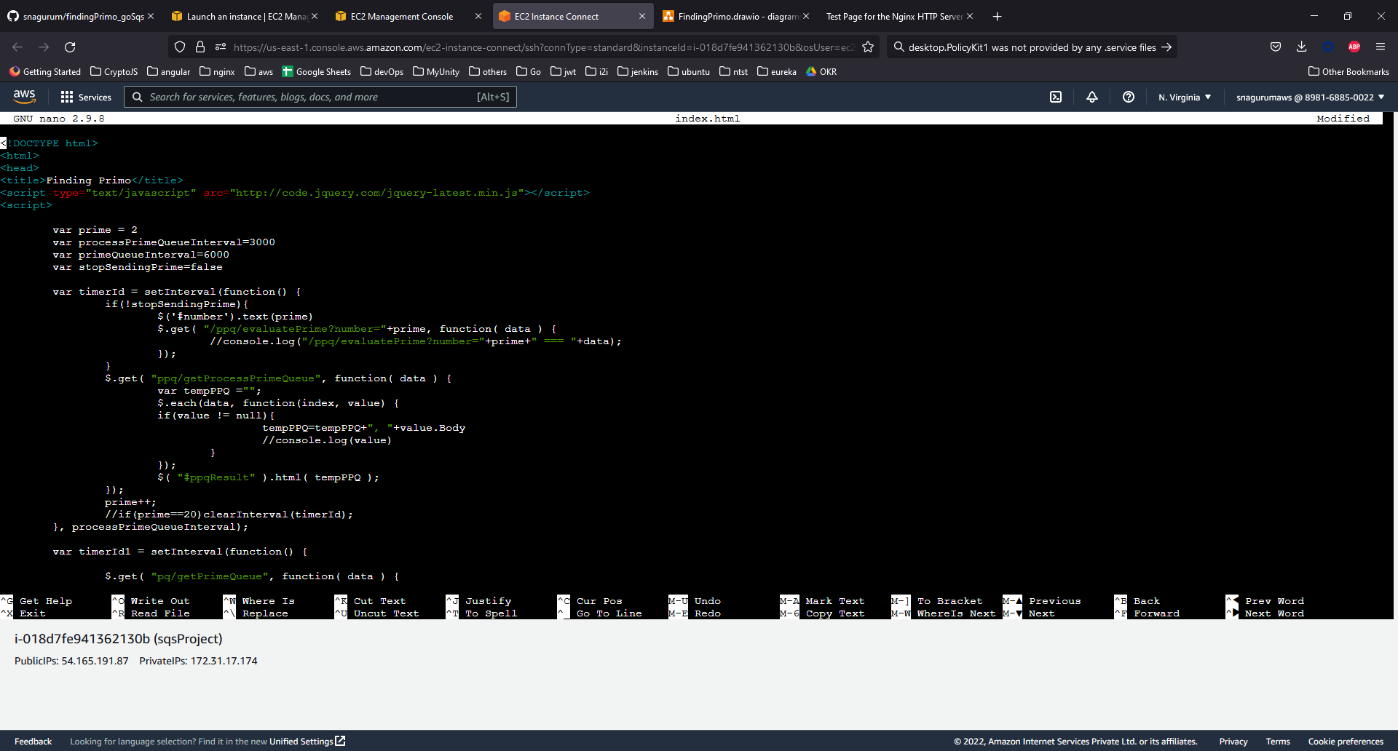
testing the landing page.
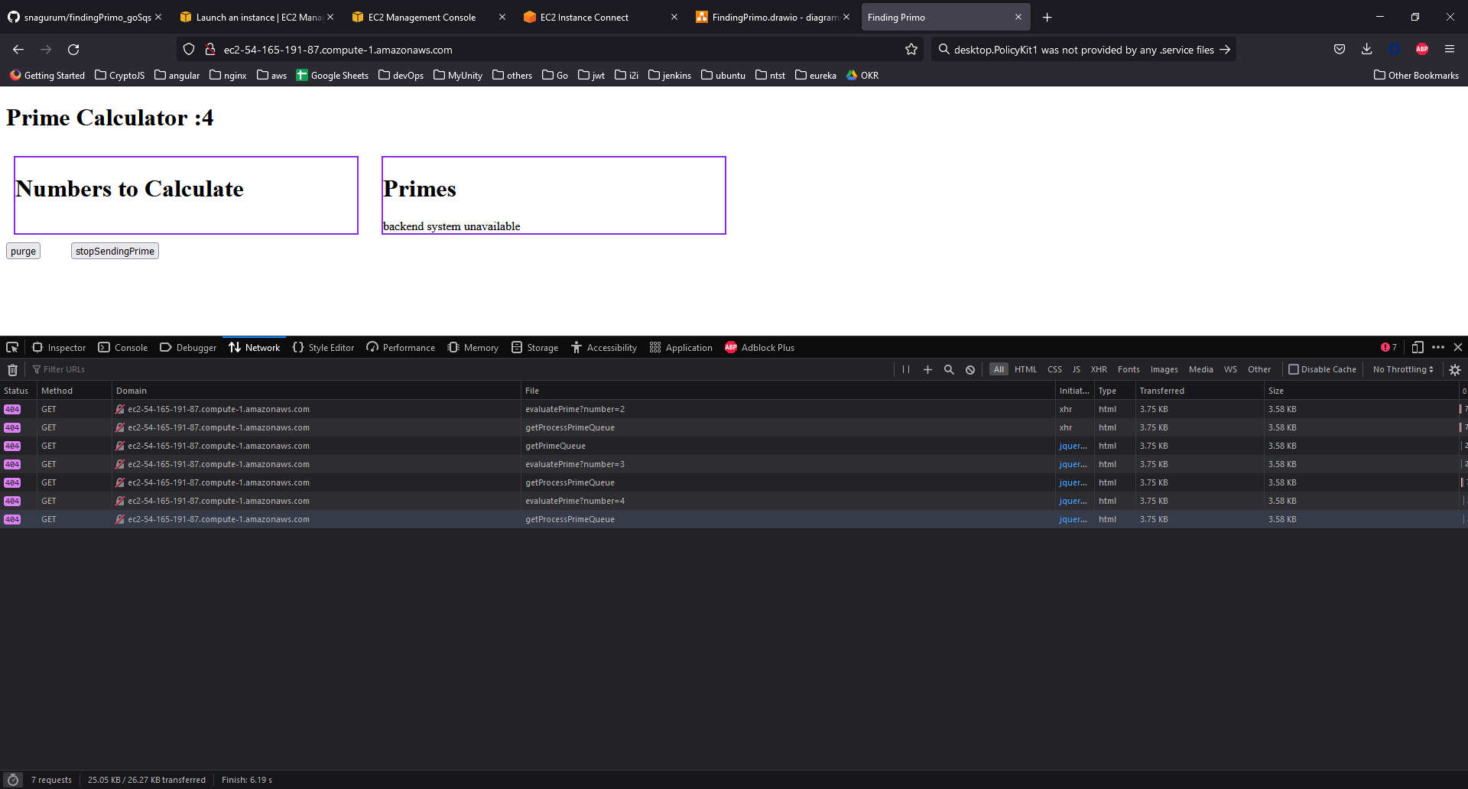
installing go, git in 2 app servers
sudo yum update
sudo yum install git
sudo yum install go
creating ~/.aws/config & ~/.aws/credentials file
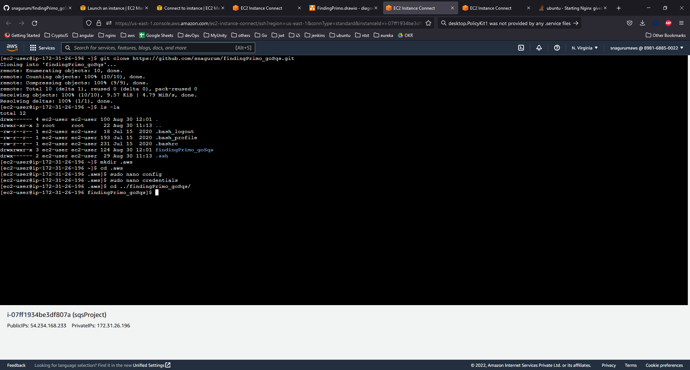

starting processPrime server
git clone https://github.com/snagurum/findingPrimo_goSqs.git
go run main.go -opType=processPrimeQueue
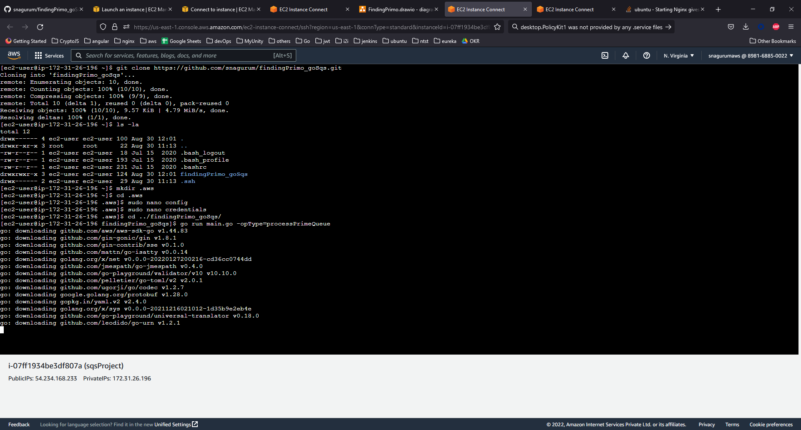
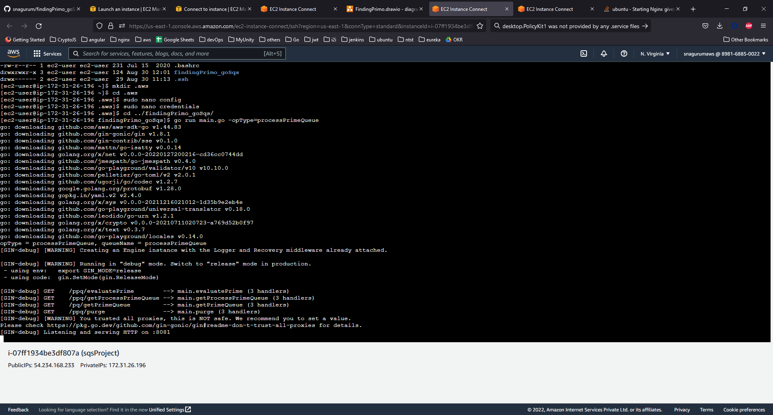
starting prime server
git clone https://github.com/snagurum/findingPrimo_goSqs.git
go run main.go -opType=primeQueue

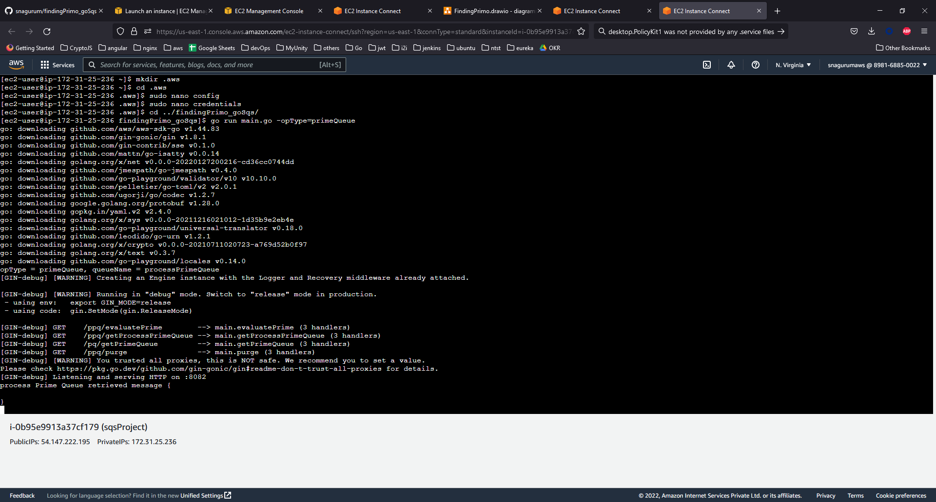

accessing the application

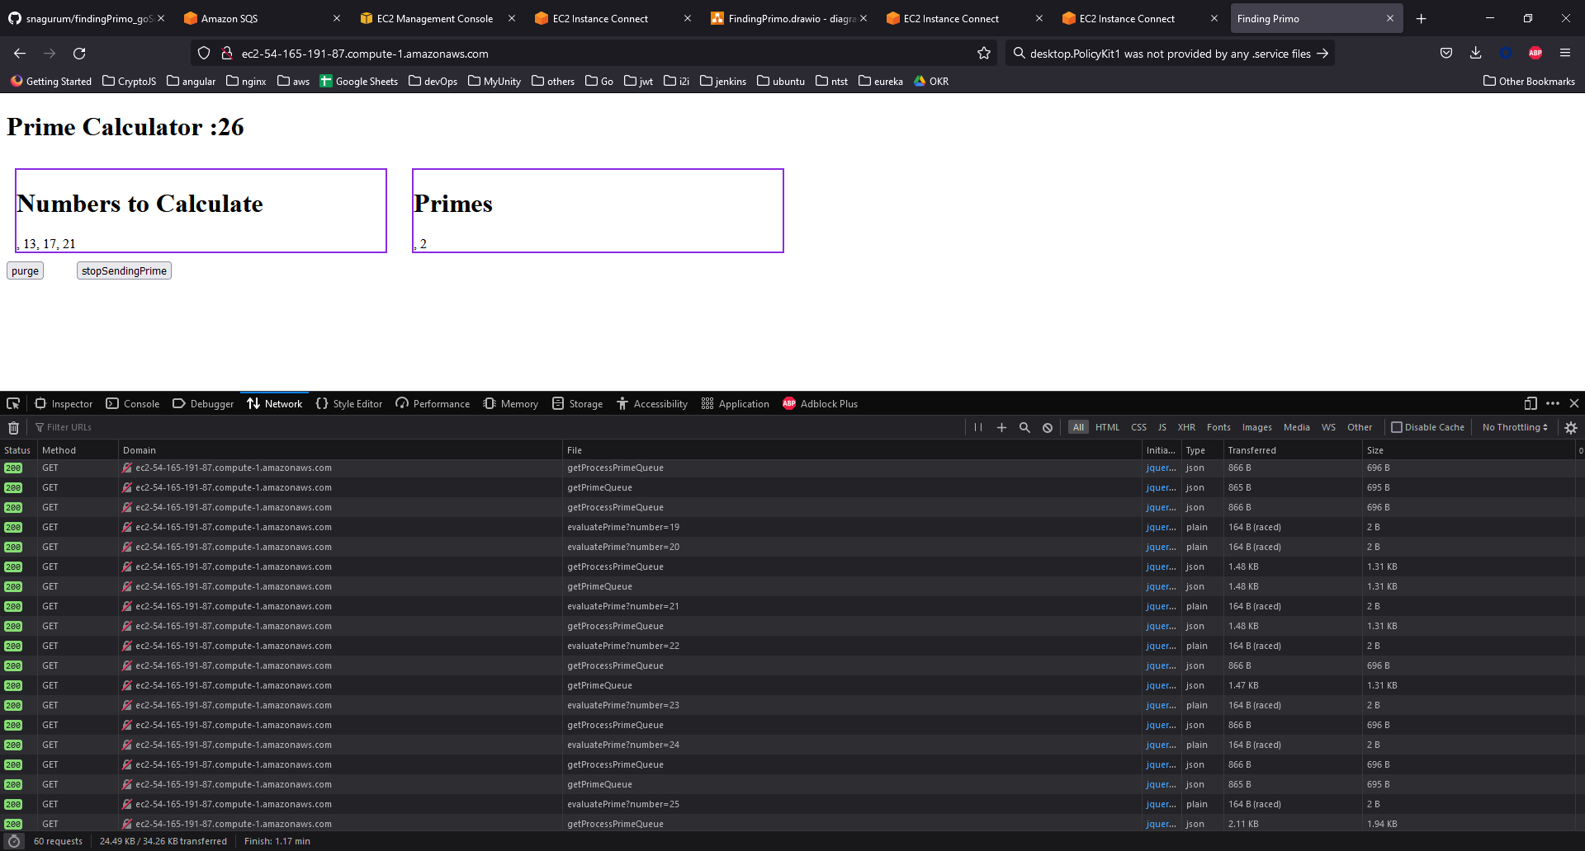

stoping the primeserver
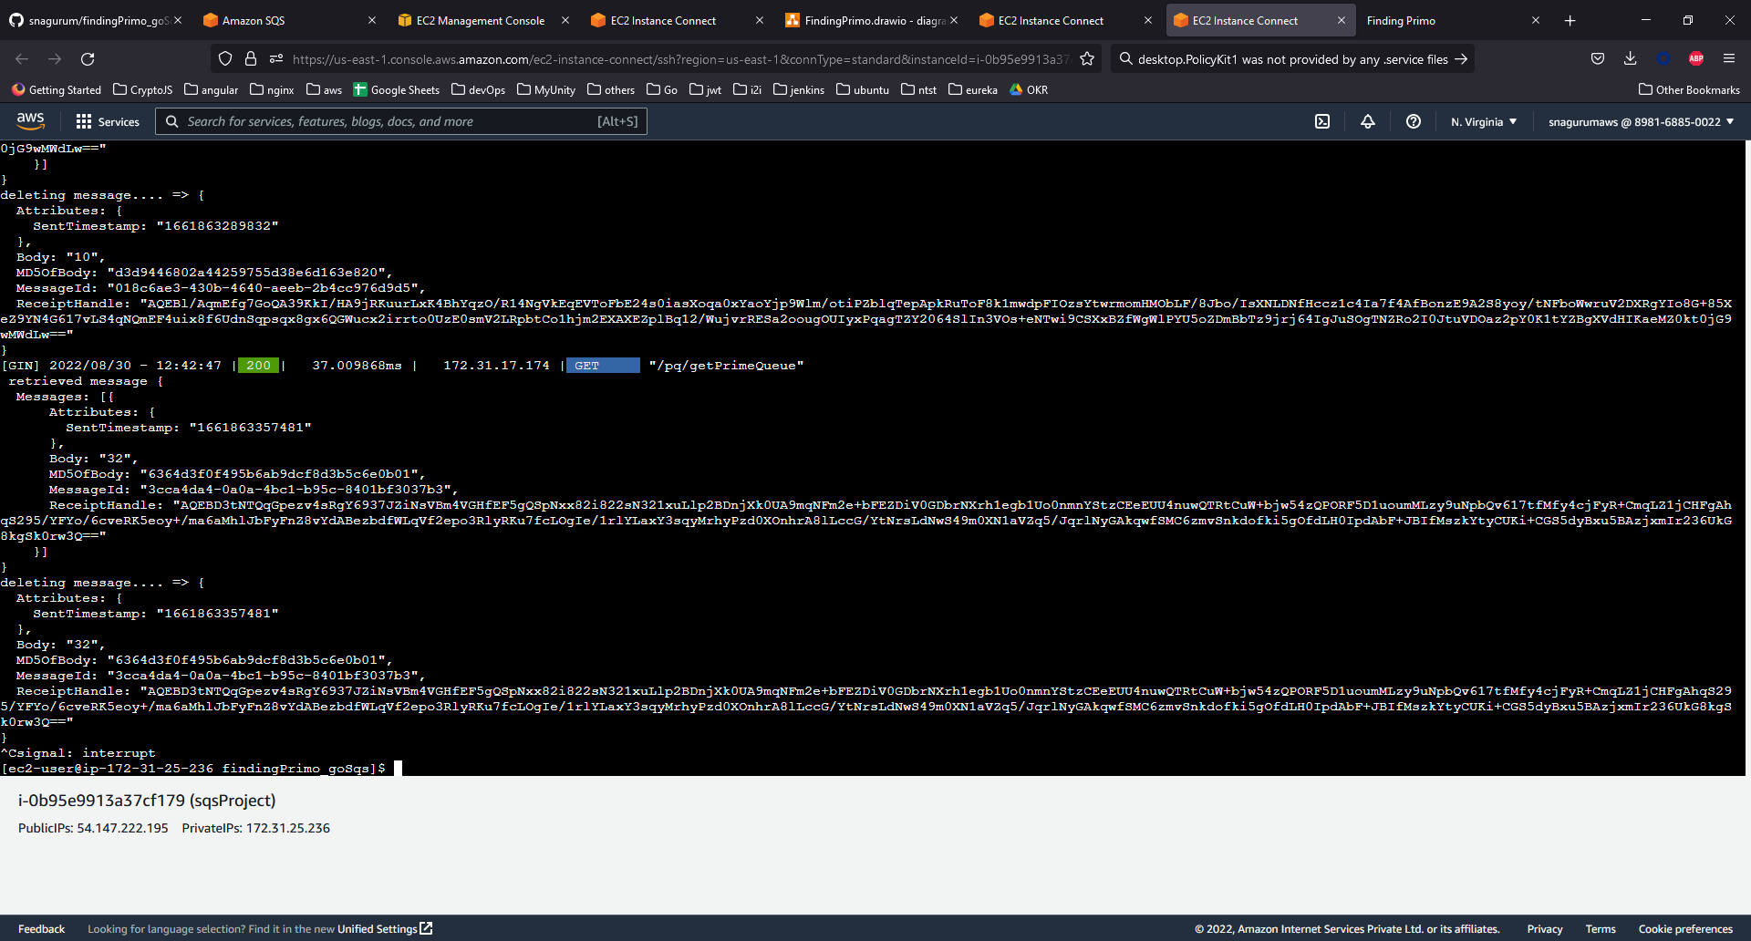
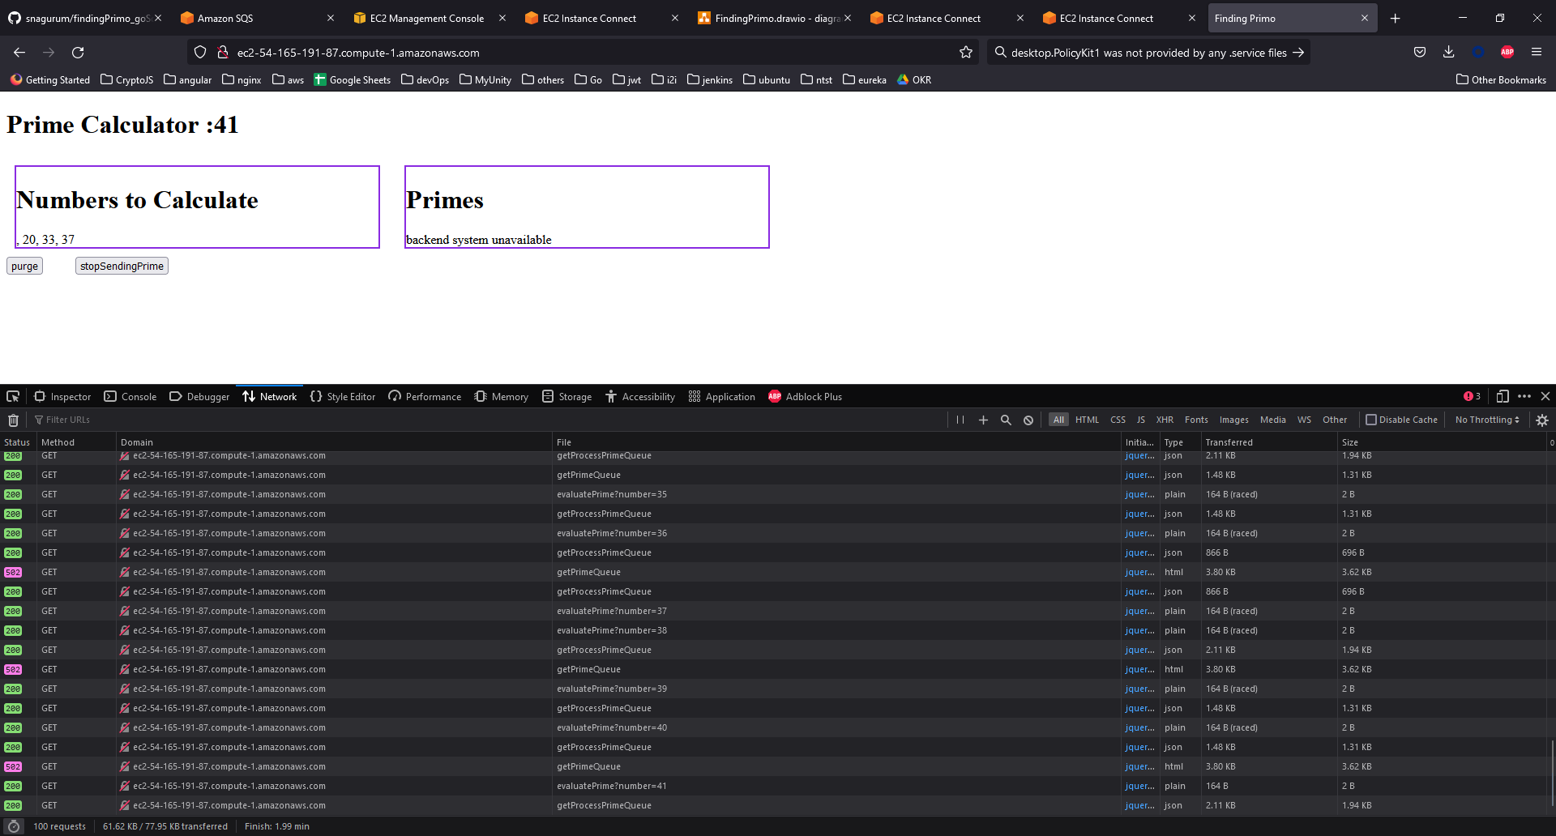
as it can be seen the back-end system prime-Server is stopped and ui is reflecting the same

starting the primeserver

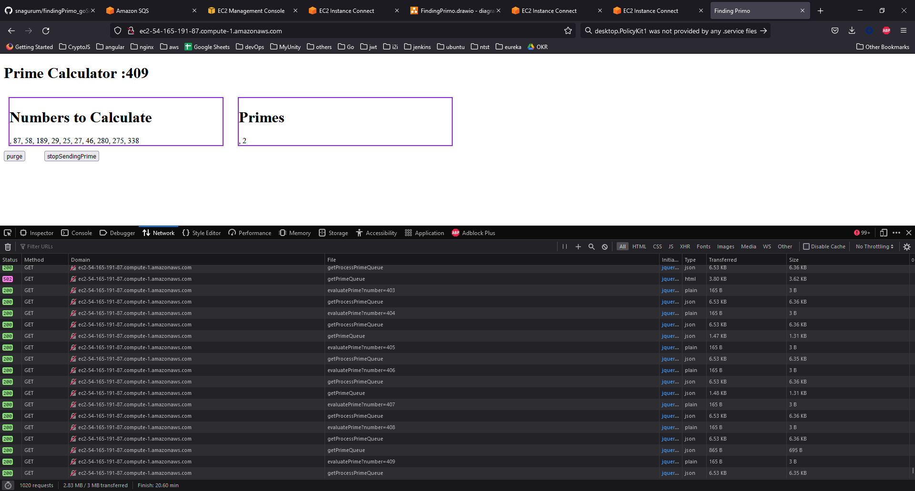

console log shows , even when the primeserver went down and came back up. The system is still working fine.

