 | American International University- Bangladesh (AIUB) Faculty of Engineering
Course Name: | Computer Aided Design & Drafting | Course Code: | BAE 2101
Semester: | Spring-25-26 | Term: | Mid
Total Marks: | 30 | Submission Date: | 06-04-2026 [12PM]
Faculty Name: | Mahamudul Hassan | Assignment: | 01

Course Outcome Mapping with Questions
Item | COs | POIs | K | P | A | Marks | Obtained Marks
Q1 | CO2 | P.e.1.C6 | K6 | P1, P4, P5 |  | 30
Total: |  |  |  |  |  | 30

Marking Rubrics (to be filled by Faculty):
Problem # | Excellent [15] | Proficient [12] | Good [10] | Acceptable [07] | Unacceptable [05] | No Response [0] | Marks
 | Detailed unique response explaining the concept properly and answer is correct with all  works clearly shown. | Response with no apparent errors and the answer is correct, but explanation is not adequate/unique. | Response shows understanding of the problem, but the final answer may not be correct | Partial problem is solved; response indicates part of the problem was not understood clearly. | Unable to clarify the understanding of the problem and method of the problem solving was not correct | No Response/(Copi ed/identical submissions will be graded as 0 for all parties concerned)
1
2
Comments |  |  |  |  |  | Total marks (30)

Instructions:

- This is an individual assignment not a group assignment.
- Please submit the .dwg file in the created channel “CADD_Assignment_Midterm_Spring-25-26_sec-Y” in Microsoft Teams.
- The deadline of the submission is on or before 6th April, 2026 [12:00 PM]
- If you miss the deadline of the submission, you will get penalty.
- Draw both circuits in one cad file.
- File name must be your ID.

- Draw the following circuit diagram.
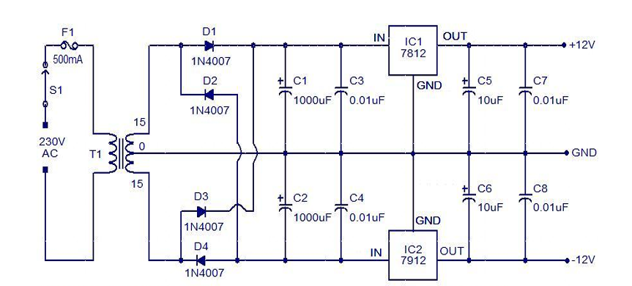
- Draw the following circuit diagram.



