sum=0;
for i=1:1:100;
sum=sum+i;
end
sum

jc=1;
for i=1:1:100;
jc=jc.*i;
end
jc

y=[3,5,7,9,11,16]
rem (y,3)

A=[2,4,6,8,10];
B=[4,9,6,7,4];
he=0;
for i=1:1:5;
he=he+A(i)*B(5-i+1);
end
he

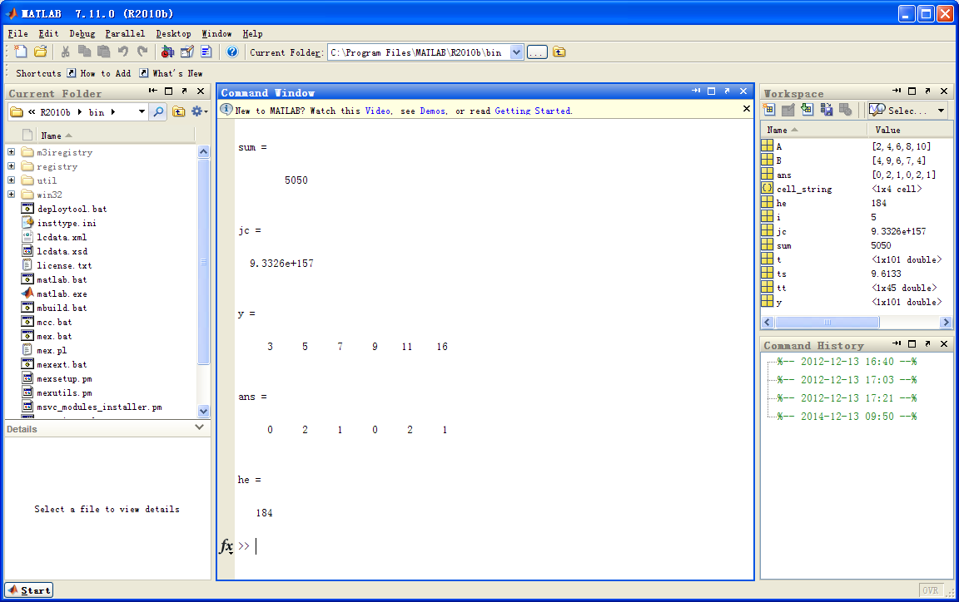

clf;t=6*pi*(0:100)/100;y=1-exp(-0.3*t).*cos(0.7*t);
tt=t(find(abs(y-1)>0.05));ts=max(tt);
plot(t,y,'r-','LineWidth',3)
axis([-inf,6*pi,0.6,inf])
set(gca,'Xtick',[2*pi,4*pi,6*pi],'Ytick',[0.95,1,1.05,max(y)])
grid on
title('\it y = 1 - e^{ -\alphat}cos{\omegat}')
text(13.5,1.2,'\fontsize{12}{\alpha}=0.3')
text(13.5,1.1,'\fontsize{12}{\omega}=0.7')
hold on;plot(ts,0.95,'bo','MarkerSize',10);hold off
cell_string{1}='\fontsize{12}\uparrow';
cell_string{2}='\fontsize{16} \fontname{Á¥Êé}Õò¶¨Ê±¼ä';
cell_string{3}='\fontsize{6} ';
cell_string{4}=['\fontsize{14}\rmt_{s} = ' num2str(ts)];
text(ts,0.85,cell_string)
xlabel('\fontsize{14} \bft \rightarrow')
ylabel('\fontsize{14} \bfy \rightarrow')

