# Callable接口源码阅读

# 1.总览

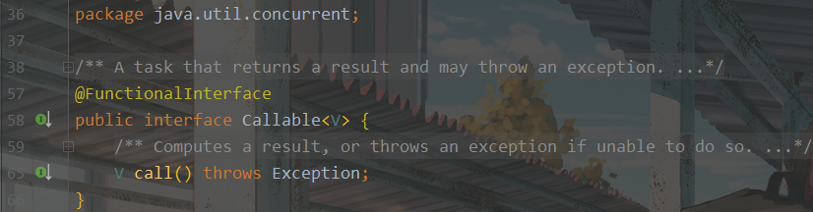

在查看任何详细注释前，粗看Callable接口，能够获取到以下信息：

1. Callable接口是一个泛型接口。
2. Callable接口是一个函数式接口，所以可以使用lambda表达式。

# 2.细看

## 2.1接口说明

### 2.1.1泛型参数说明

Interface Callable<V>

V - the result type of method call

### 2.1.2接口功能说明

A task that returns a result and may throw an exception. Implementors define a single method with no arguments called call.

The Callable interface is similar to Runnable, in that both are designed for classes whose instances are potentially executed by another thread. A Runnable, however, does not return a result and cannot throw a checked exception.

（Callable接口与Runnable相似，两者均适用于其实例可能由另一个线程执行的类。但是，Runnable不会返回结果，也不能引发已检查的异常。）

The Executors class contains utility methods to convert from other common forms to Callable classes.

## 2.2方法说明

