Future接口源码阅读

# 官方文档

<https://docs.oracle.com/javase/8/docs/api/java/util/concurrent/Future.html>

# Future接口概览

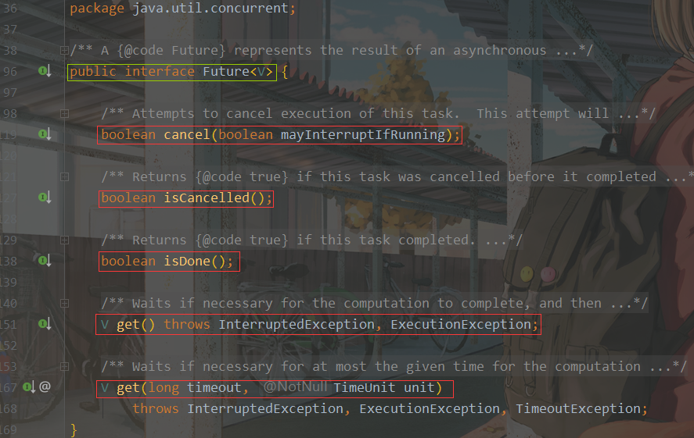

# Future接口阅读

## 接口Future<V>

V - The result type returned by this Future's get method

## 接口功能说明

1）A Future represents the result of an asynchronous computation. （Future代表异步计算的结果）

2）Methods are provided to check if the computation is complete, to wait for its completion, and to retrieve the result of the computation.（提供了一些方法来检查计算是否完成，等待其完成以及检索计算结果。）

3） The result can only be retrieved using method get when the computation has completed, blocking if necessary until it is ready. （只有在计算完成后才可以使用get方法检索结果，必要时将其阻塞，直到准备就绪为止。）

4） Cancellation is performed by the cancel method.（通过cancel方法执行取消操作）

5）Additional methods are provided to determine if the task completed normally or was cancelled. （提供了一些方法来确定任务是正常完成还是被取消。）

6）Once a computation has completed, the computation cannot be cancelled. （计算一旦完成，就不能取消。）

7） If you would like to use a Future for the sake of cancellability but not provide a usable result, you can declare types of the form Future<?> and return null as a result of the underlying task.( 如果出于可取消性的目的而使用Future而不提供可用的结果，则可以声明Future <？>形式的类型，并作为基础任务的结果返回null。)

## 内存一致性影响（Memory consistency effects）

Actions taken by the asynchronous computation [*happen-before*](https://docs.oracle.com/javase/8/docs/api/java/util/concurrent/package-summary.html#MemoryVisibility) actions following the corresponding Future.get() in another thread.（异步计算采取的操作发生在另一个线程中相应的Future.get（）之后的操作之前。）

## 方法

|  |  |
| --- | --- |
| **Modifier and Type** | **Method and Description** |
| **boolean** | [**cancel**](https://docs.oracle.com/javase/8/docs/api/java/util/concurrent/Future.html#cancel-boolean-)**(boolean mayInterruptIfRunning)**  Attempts to cancel execution of this task.（尝试取消执行此任务。） |
| [**V**](https://docs.oracle.com/javase/8/docs/api/java/util/concurrent/Future.html) | [**get**](https://docs.oracle.com/javase/8/docs/api/java/util/concurrent/Future.html#get--)**()**  Waits if necessary for the computation to complete, and then retrieves its result.（必要时等待计算完成，然后检索其结果。） |
| [**V**](https://docs.oracle.com/javase/8/docs/api/java/util/concurrent/Future.html) | [**get**](https://docs.oracle.com/javase/8/docs/api/java/util/concurrent/Future.html#get-long-java.util.concurrent.TimeUnit-)(long timeout, **[TimeUnit](https://docs.oracle.com/javase/8/docs/api/java/util/concurrent/TimeUnit.html" \o "enum in java.util.concurrent)** unit)  Waits if necessary for at most the given time for the computation to complete, and then retrieves its result, if available.（必要时最多等待给定时间以完成计算，然后检索其结果（如果有）。） |
| boolean | [**isCancelled**](https://docs.oracle.com/javase/8/docs/api/java/util/concurrent/Future.html#isCancelled--)()  Returns true if this task was cancelled before it completed normally. |
| boolean | [**isDone**](https://docs.oracle.com/javase/8/docs/api/java/util/concurrent/Future.html#isDone--)()  Returns true if this task completed. |