Assignment 1
Course Code: | MWD2A (UIUX)
Course Name: | UI/UX Design
Assignment: | Assignment 1
Textbook: | N/A
Software: | Microsoft Word
Materials and Resources
Assignment Description
This week, you learned the basics of the UI/UX design process. In this assignment, you will choose a fictitious client, identify their needs, and create a Lo-Fi prototype of a website UI.
Assignment Steps
Activity Steps
- Think of a fictitious client from an industry of your choice. This client and industry will be used for all assignments in this course. Use your imagination and draw inspiration from friends, family members, places you have worked before, online websites, AI suggestions, and so on. Name your client and describe them (including their industry) in a short paragraph under the Assignment Documentation section at the end of this Word document.
- Next, establish a set of five fictitious client needs (or tasks) regarding a website for which you will create a UX design. Try to avoid overly complex needs for the purposes of learning UX design, but also ensure that the needs are not too simple. For example, a website that is only used for information seeking is not a good choice, because information seeking is only a single type of task. Also ensure that these needs can be easily translated to a mobile app in the future. List your five client needs under the Assignment Documentation section at the end of this Word document (1-2 sentences per need, adding space in the document as necessary).
- Create an initial Lo-Fi prototype sketch of the website UI on paper that includes at least six screens. When finished, take a clear picture of your sketch with your smartphone and paste it under the Lo-Fi Prototype Sketch section at the end of this Word document. If necessary, paste several pictures if your sketch will not fit clearly in one picture.
- Rename this completed Word document to YourName-Assignment1.
- Access Brightspace and this Word document to the Assignment 1 section for this course.

Rubric
Criteria | Level 4  Exemplary | Level 3  Proficient | Level 2  Basic | Level 1  Unsatisfactory
Client Definition | 5 Marks | 3-4 Marks | 1-2 Marks | 0 Marks
Client Definition | Client name supplied and associated industry described in adequate detail for design purposes. | Client name supplied but the associated industry is not described in adequate detail for design purposes. | Client name supplied but the associated industry is not described. | Client name not supplied.
Client Needs | 12-15 Marks | 8-11 Marks | 5-8 Marks | 0-4 Marks
Client Needs | Five relevant client needs are supplied and described appropriately. | Five client needs are supplied, but one or two are either not relevant or described appropriately. | Five client needs are supplied, but three or more are not relevant or described appropriately. | Less than five client needs are supplied.
Lo-Fi Prototype Sketch | 5 Marks | 3-4 Marks | 1-2 Marks | 0 Marks
Lo-Fi Prototype Sketch | Lo-Fi prototype sketch submitted with an appropriate layout for a website design. | Lo-Fi prototype sketch submitted, but does not contain an appropriate layout for a website design. | Lo-Fi prototype sketch submitted, but does not contain layout components. | Lo-Fi prototype sketch not submitted.
Total: / 25

Assignment Documentation:

Client Description

Client Name: GreenThumb Community Gardens

Industry: Urban Agriculture & Community Development
GreenThumb Community Gardens is a non-profit organization that manages a network of 15 community garden plots across the city. They connect urban residents with available garden spaces, provide educational resources on sustainable gardening practices, and facilitate a community of gardeners who share knowledge, seeds, and surplus produce. The organization currently relies on phone calls, emails, and a basic Facebook page to manage plot applications, event registrations, and community engagement, but they need a comprehensive digital platform to streamline their operations and better serve their growing membership of over 500 active gardeners.

Five Client Needs

Need 1: Plot Availability and Application Management
Community members need to easily browse available garden plots by location, size, and amenities (water access, sun exposure, accessibility features), and submit applications online with automatic waitlist management for popular locations.
Need 2: Event Registration and Community Calendar
Members need to discover and register for upcoming workshops, volunteer days, seed swaps, and seasonal celebrations, with automated reminders and the ability to add events to their personal calendars.

Need 3: Resource Library and Growing Guides
Gardeners need access to a searchable library of seasonal planting guides, pest management tips, composting tutorials, and video demonstrations tailored to the local climate and organized by skill level (beginner, intermediate, advanced).
Need 4: Community Marketplace and Sharing
Members need a platform to offer surplus produce, exchange seeds, share gardening tools, and post requests for specific plants or resources, fostering a culture of sharing and reducing waste within the community.
Need 5: Member Dashboard and Plot Management
Active plot holders need a personalized dashboard to view their plot assignment details, track their annual membership status, log volunteer hours (required for membership), submit maintenance requests, and communicate with their plot neighbors.

Lo-Fi Prototype Sketch:

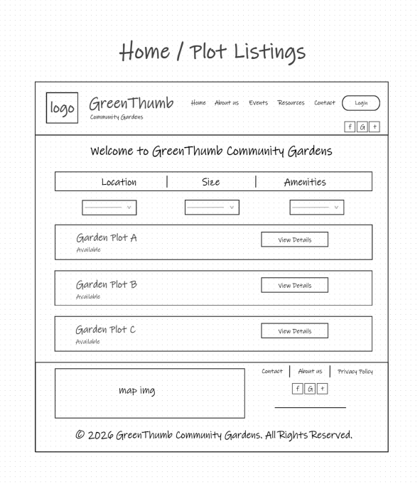 | 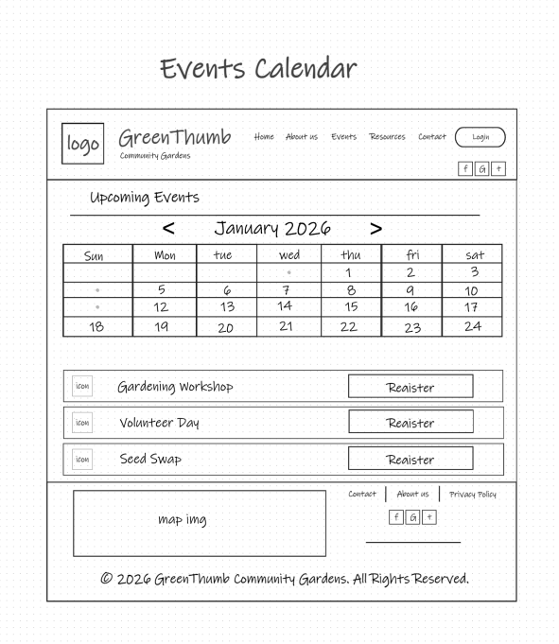
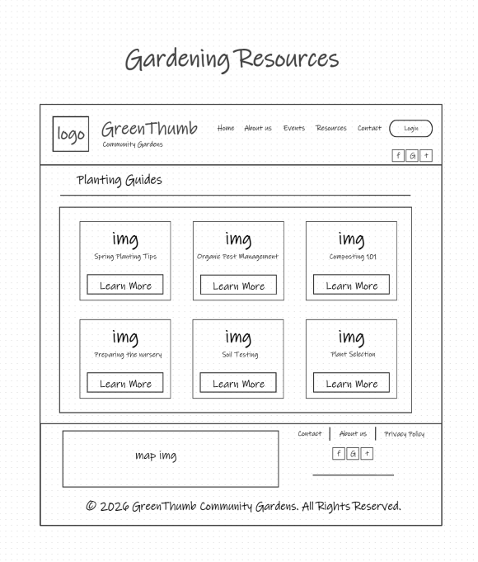 | 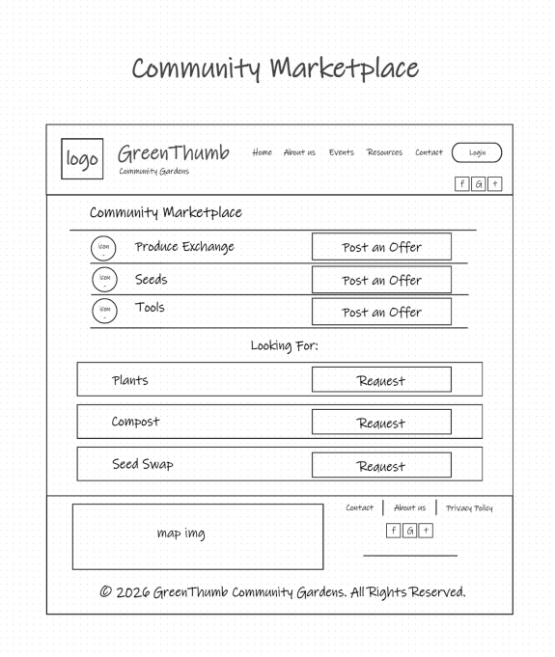
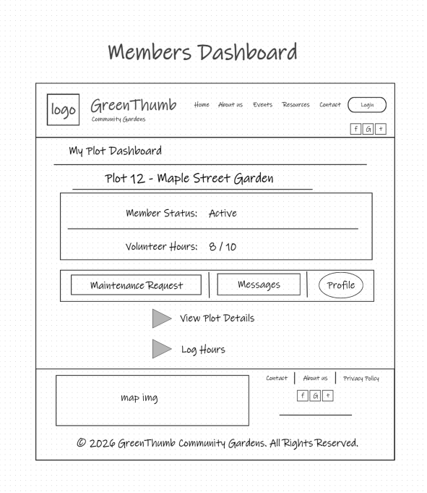 | 