REINFORCEMENT LEARNING FOR PHYSICS INFORMED NEURAL NETWORKS

ABSTRACT
Physics-Informed Neural Networks (PINNs) have emerged as a powerful framework for solving partial differential equations (PDEs) by embedding physical laws into neural network training. However, traditional PINNs with uniform sampling often suffer from inefficiencies in convergence and accuracy. In this study, we propose a reinforcement learning (RL) based adaptive sampling strategy to guide sample selection during training. By dynamically focusing on regions with high residuals, expecting that RL enhanced PINNs achieve improved solution accuracy and faster convergence.

CHAPTER 1: INTRODUCTION

  - Problem Statement
Physics informed neural networks (PINNs) is used for solving partial differential equations (PDEs). Physics informed neural networks has various limitations, one such limitation is its inefficient sampling strategy. PINNs uniformly samples collocation points due to which regions which are harder to learn won’t get enough training. Therefore, I am bringing up an RL based adaptive strategy to uniformly sample collocation points. Here I am considering a 1D heat equation (PDE) to solve this problem.

1.2. Motivation and Significance
PINNs results are very much influenced by how the points are sampled. Traditional static or uniform sampling often wastes computation time as well as doesn’t give optimal solutions for regions that are harder to learn. RL based PINNs solves this issue by efficiently sampling the points and thereby reducing waste of sampling points instead of focusing on already learned regions.

  - Project Objectives
The project objective is to analyze and compare the analytical solutions for both PINNs using uniform sampling and PINNs incorporating RL based adaptive strategy. Comparing the L2 error, final error and computations time.

1.4. Scope and Limitations
Scope: Showcase how RL based adaptive sampling strategy using UCB method can enhance training efficiency for solving the 1D heat equation.

Limitations: It is limited to single PDE, that is the UCB method in our case is a simple algorithm which is able to show slight improvements in all the metrices with respect to normal PINNs. It won’t be suitable for a system of PDEs or for solving multidimensional problems.

1.5. Report Structure
- Chapter 1 provides an introduction, problem statement, motivation, objectives, scope, and limitations.
- Chapter 2 gives the literature review; research works and comparison.
- Chapter 3 explains the methodology, algorithm used
- Chapter 4 gives implementation.
- Chapter 5 provides the results and discussion.
- Chapter 6 provides conclusion and future work.

CHAPTER 2: LITERATURE REVIEW

2.1. Existing Systems and Solutions
There are very few research papers related to using RL for solving PINNs. One such research article is RL-PINNs: Reinforcement learning-driven adaptive sampling for efficient training of pins. Here they have used Markov decision Process (MDP) for sampling process and Deep Q Network (DQN) to learn optimal policy for collocation point selection.

2.2. Theoretical Background
Physics-Informed Neural Networks (PINNs) are neural networks that solve Partial differential equation (PDE) problems by using physical laws into their loss function. Their performance depends on how collocation points are sampled. Uniform sampling is inefficient because it ignores regions with high error.
To overcome this, Reinforcement learning can be used to adaptively focus sampling on difficult regions, improving accuracy and convergence. The Upper Confidence Bound (UCB) method is used to guide sampling for the 1D heat equation, balancing exploration and exploitation.

2.3. Technology Review
- Programming Language: Python
- Framework: PyTorch for PINN model implementation
- RL Implementation: UCB algorithm in Python
- Visualization: Matplotlib, Seaborn, NumPy

2.4. Research Gap / Justification for Chosen Approach
The combination of PINNs and UCB based adaptive sampling strategy is a simple yet effective solution for solving one of the core limitations of PINNs.

CHAPTER 3: METHODOLOGY

3.1. Proposed method
The proposed method is to integrate Reinforcement learning in PINNs. The main idea is to replace the traditional uniform sampling in PINNs with an adaptive sampling approach that uses UCB algorithm for selecting the number of collocation points for sampling by focusing on regions with lesser rewards that is regions with higher residuals. This helps the model learn harder regions better and improves the overall accuracy of the model.

3.2. Problem Formulation
The 1D heat equation is selected as the PDE for implementing this proposed approach.
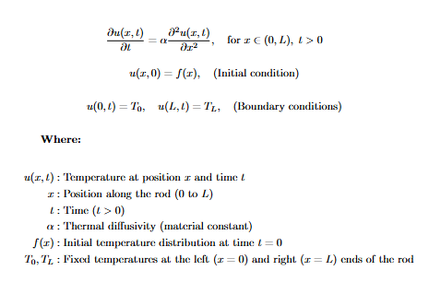
The goal is to approximate the solution using a neural network trained with physics-informed loss.

3.3. PINN architecture and Loss Function
The PINN consists of a fully connected feedforward neural network that takes (x, t) as inputs and outputs the predicted temperature u (x, t). The loss function is a combination of PDE residual loss, initial condition loss, and boundary condition loss. These components ensure that the model respects both the data and the underlying physical laws during training.

3.4. Adaptive Sampling Using RL
To overcome the inefficiency of uniform sampling, RL is introduced to guide the selection of collocation points. The state represents the current distribution of residual errors, the action corresponds to selecting regions of the domain for new collocation points, and the reward reflects the reduction in error after training on the selected region. This adaptive mechanism allows the model to focus more on difficult regions over time.

3.5. UCB algorithm
The UCB method is applied to balance exploration and exploitation in selecting sampling regions. Regions with high error receive higher UCB values, making them more likely to be sampled, while less-explored areas are occasionally chosen to ensure coverage. This simple and lightweight strategy efficiently integrates with the PINN training loop to enhance learning efficiency.

3.6. Training Setup
The training consists of two main setups:
- PINN with uniform random sampling of collocation points.
- PINN with RL-based UCB adaptive sampling.
Both models are trained under the same network architecture and hyperparameter settings. The UCB algorithm is invoked at each iteration to select the next batch of collocation points based on the current residual distribution.

3.7. Evaluation Metrics
The performance of both methods is evaluated using L2 error, final error, and computational time. Convergence behavior and error distribution are also analyzed through visualizations to understand the effect of adaptive sampling. These metrics provide a clear comparison between traditional PINN training and the proposed RL-based approach.

Chapter 4: Implementation
Following are the steps followed during implementation part:
- Dividing the domain into n number of grids.
- Allocating collocation points.
- Training the model.
- The agent learns to adaptively sample collocation points.
- Model learns to satisfy the physics equation and predict the solution.

Chapter 5: Results and discussion

Table: Quantitative Summary of Uniform vs UCB-Adaptive PINNs

Method | Final L2 Error | Training Time (s) | Epochs to L2 < 1e-3 | Final Loss | Average Residual
Uniform Sampling | 0.033735 ± 0.000000 | 70.54 ± 0.00 | 3000 ± 0 | 0.000884 ± 0.000000 | 0.014815 ± 0.000000
UCB-Adaptive | 0.024194 ± 0.000000 | 70.48 ± 0.00 | 3000 ± 0 | 0.000434 ± 0.000000 | 0.010954 ± 0.000000

UCB based adaptive achieves 28.28% improvement in L2 error compared to Uniform Sampling, while maintaining similar training time and convergence epochs.
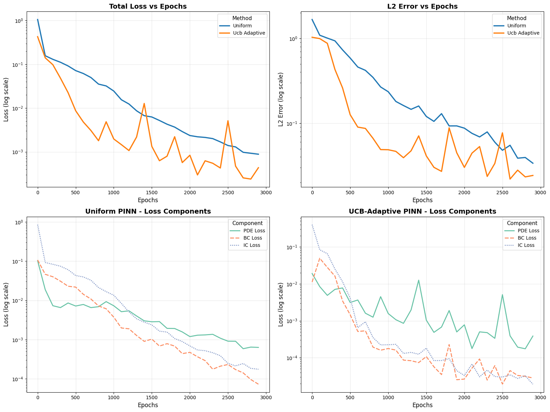

Figure 1. shows training dynamics of uniform and UCB based adaptive PINNs

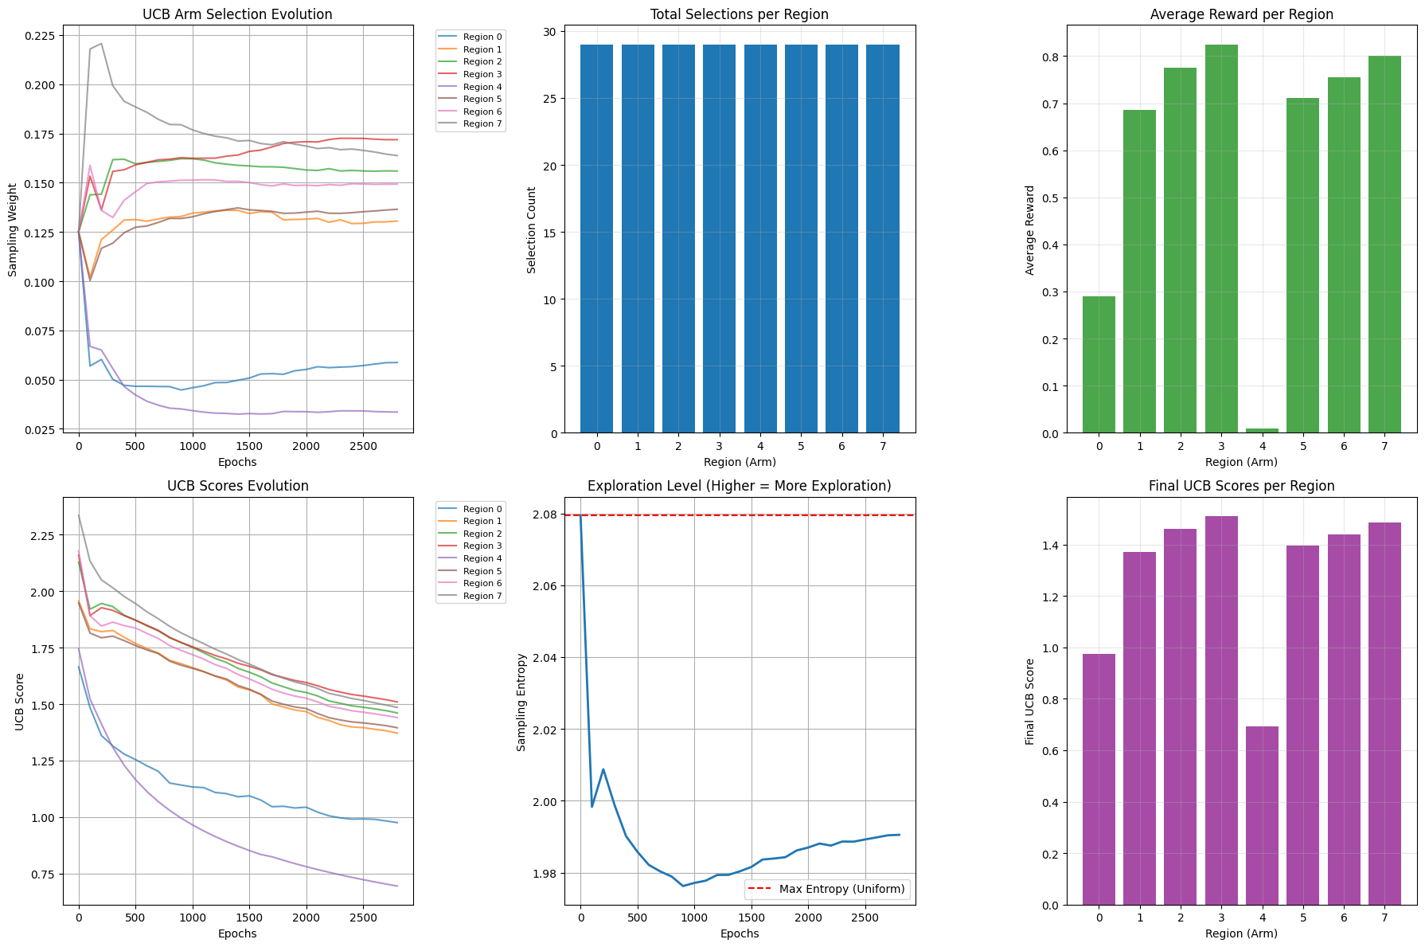

Figure 2. shows the UCB arm selection behavior, highlighting how the agent adaptively focuses on high-error regions to improve sampling efficiency.

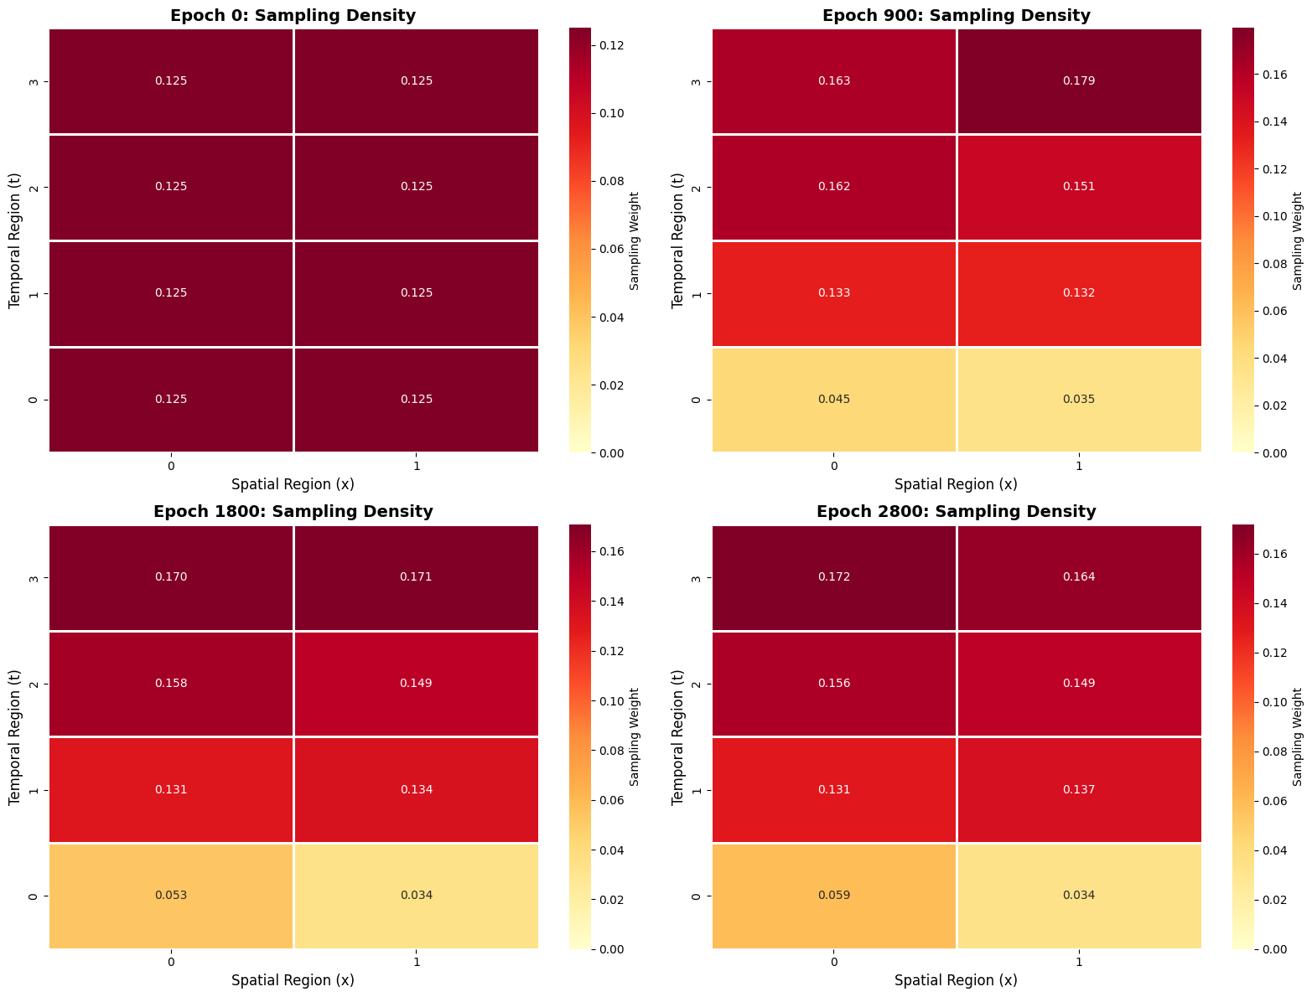

Figure 3. shows the sampling density in RL PINNs with respect to epoch

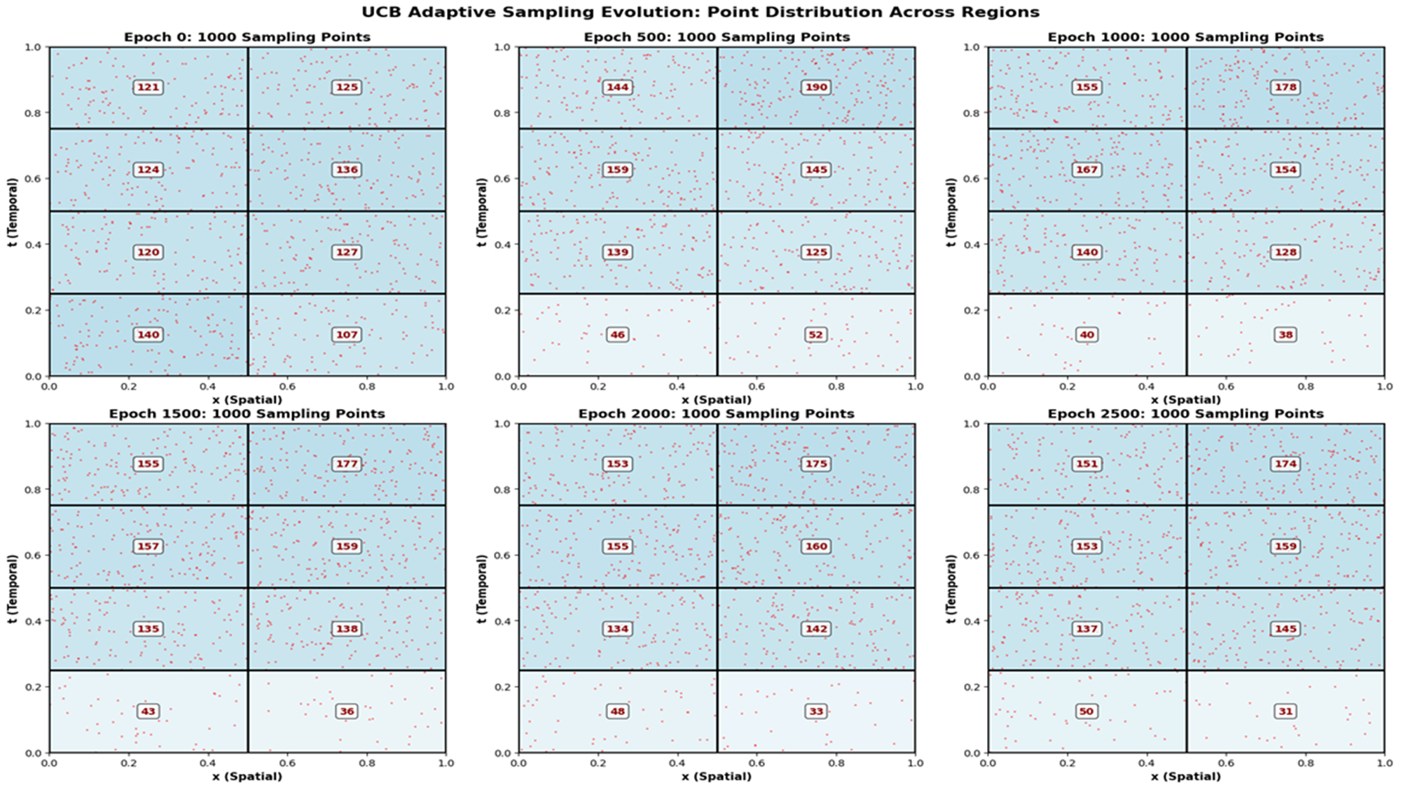

Figure 4. shows the distribution of collocation points in RL PINNs at different epochs

These results indicate that RL PINNs outperforms normal PINNs in all aspects.

Chapter 6: Conclusion and Future Work

6.1. Learning Outcomes and Achievements
- Understand and formulate the 1D heat equation as a partial differential equation (PDE) with appropriate initial and boundary conditions.
- Explain the limitations of traditional PINNs when using uniform sampling for training.
- Apply Reinforcement Learning (RL) techniques such as Multi-Armed Bandits or Epsilon-Greedy strategies to adaptively guide the sampling process in PINNs.
- Develop and implement a hybrid RL-PINN framework to solve the 1D heat equation more efficiently.
- Analyze and compare the performance of standard PINNs and RL-enhanced PINNs using metrics such as solution accuracy, loss convergence, sampling efficiency, and error distribution.

6.2. Conclusion
This work shows how integrating reinforcement learning with Physics-Informed Neural Networks through a UCB-based adaptive sampling strategy significantly improves training efficiency and accuracy. By focusing on regions with higher errors, the RL agent effectively reduces the L2 error by 28.28% compared to uniform sampling, without increasing training time.

6.3. Future Enhancements
The results highlight that adaptive sampling accelerates convergence, enhances loss reduction, and makes better use of collocation points. While this study focuses on a single PDE (1D heat equation), the approach establishes a strong foundation for extending adaptive strategies to more complex and higher-dimensional problems in future research.

