Quick Start Guide

February 2009

Table of Contents
About the SLAMD Distributed Load Generation Engine 3
Installing and Configuring the SLAMD Server Software 5
Installation Prerequisites 5
Installing with the Provided Tomcat Container 5
Installing in an Existing Web Container 7
Accessing the SLAMD Administrative Interface 7
Installing and Configuring the SLAMD Client Software 8
Installing and Configuring the SLAMD Resource Monitor Client Software 10
Scheduling and Running Jobs 12
SLAMD License 16

About the SLAMD Distributed Load Generation Engine

The SLAMD Distributed Load Generation Engine (SLAMD) is a Java-based application designed for stress testing and performance analysis of network-based applications. It was originally developed for benchmarking LDAP directory servers, but it is a very extensible framework that may be easily used for other forms of communications, including HTTP, SMTP, POP, IMAP, and TFTP. It is provided with several default workloads (called jobs), but new kinds of jobs can be developed using a simple but powerful Java API. SLAMD also has its own built-in scripting engine that may be used to create workloads using a custom scripting language, and support for new scripting languages may be added via the Bean Scripting Framework.

SLAMD offers a number of key features that makes it ideal for large-scale testing for network applications. Some of these features include:

- Distributed Load Generation. SLAMD was designed from the ground up to be able to harness the collective processing capabilities of multiple systems in order to ensure that client-side limitations do not artificially limit the amount of load that may be generated against the server.

- Cross-Platform Compatibility. SLAMD is a pure-Java application, capable of running on any system for which a Java 1.4 or higher runtime environment is available. It is known to work on many platforms, including Solaris, Linux, HP-UX, AIX, Mac OS X, and Windows.

- Simple HTML-Based and Command-Line Interfaces. The SLAMD server runs as a Web application and therefore may be accessed from any browser capable of rendering HTML 4.01. Access to the administrative interface does not require any client-side processing (e.g., JavaScript, applets, etc.), and it works well even with text-based browsers like Lynx. In addition, SLAMD provides command-line utilities for performing many tasks like scheduling jobs and obtaining results.

- Easily Accessible Job Data. The data collected in the course of running a job will be transmitted back to the SLAMD server and will be available both numerically and graphically in the administrative interface. The information may also be exported as tab-delimited text for easy import into other applications, and a report generation mechanism can be used to create user-friendly representations of the results in a number of formats.

- Self-Optimizing Jobs. The SLAMD server can run the same workload with varying amounts of client load in an attempt to automatically identify the combination that yields the best performance. In addition, it is possible to include additional constraints (e.g., based on response time or CPU utilization), as well as to define custom optimization algorithms to better determine what the "best" performance is.

- Resource Monitoring. In addition to providing a mechanism for collecting statistics specific to the workload being processed (e.g., the number of operations performed and the time required to process them), it is also possible to monitor system resources like CPU utilization, disk and network I/O, and memory consumption.

More information about the SLAMD Distributed Load Generation Engine may be found on its primary site located at http://www.SLAMD.com/, or on the java.net site at http://SLAMD2.dev.java.net/.

Installing and Configuring the SLAMD Server Software

The SLAMD server provides a centralized point of access for the SLAMD environment. It is used to schedule jobs for processing, to access the results, and to coordinate the activities of the various kinds of client software. It is a Web application, and may be used either with the provided Tomcat Servlet engine or in any existing Web container.

Installation Prerequisites
The SLAMD server software has the following requirements:

- A Java 5.0 or higher runtime environment must be installed on the target system. SLAMD has been tested and verified to work properly on Java 5.0 and 6.0 releases.

- If the SLAMD server is to be run in an existing Web container, then that container should provide support for the Java Servlet API version 2.2 or higher.

- A Web browser capable of rendering HTML 4.01 for interaction with the SLAMD administrative interface. The browser software does not need to be installed on the SLAMD server system itself, but should be installed on any system that needs to access the administrative interface.

- Software capable of extracting ZIP compressed archives.

Installing with the Provided Tomcat Container
The slamd-{buildid}.zip file contains the SLAMD server software embedded within an Apache Tomcat Servlet engine. Using this archive is the easiest and fastest way to get the SLAMD server running, and it also includes the client software and a number of tools that can assist in various aspects of benchmarking and performance analysis of LDAP directory servers and other applications. This is the recommended method of running the SLAMD server and is the most thoroughly-tested configuration. In order to install the SLAMD server software, simply extract the slamd-{buildid}.zip archive in the desired location on the server system.

Running on a UNIX-Based System

To start the SLAMD server on a UNIX-based system, execute the bin/startup.sh shell script. In many cases (in particular, if the JAVA_HOME environment variable is set or an appropriate java command is in the path), no further configuration is required. If an error occurs while running the startup script, then you may explicitly specify which Java runtime environment to use in one of the following ways:

- Update the PATH environment variable so that it includes the directory with a suitable java command.

- Set the value of the JAVA_HOME environment variable to the root of the Java runtime environment installation.

- Edit the tools/set-java-home.sh script so that the JAVA_HOME environment variable is set automatically when the script is invoked.

Running on a Windows System

To start the SLAMD server on a Windows system, execute the bin\startup.bat batch file. This will be all that is necessary if the JAVA_HOME variable is defined in the environment (it is not sufficient to have the java.exe command in the path). If an error occurs, you may specify which Java runtime environment to use in one of the following ways:

- Set the value of the JAVA_HOME environment variable to the root of the Java runtime environment installation.

- Edit the tools\set-java-home.bat script so that the JAVA_HOME environment variable is set automatically when the script is invoked.

Installing in an Existing Web Container
The slamd-{buildid}.war file contains the SLAMD server software in a standard Web archive format that may be installed in any Java EE Web container supporting at least the Servlet 2.2 API. The mechanism for deploying a Web application varies, so consult the documentation for the Web container to determine how to install a WAR file in your environment.

Note that installing in this manner will not include the client software, so that will need to be downloaded separately. It will also not include the additional tools that are provided with the full version of the SLAMD server embedded within Tomcat, so if they are needed then the full SLAMD server archive (contained in the slamd-{buildid}.zip file) should still be downloaded.

Accessing the SLAMD Administrative Interface
Once the SLAMD server software has been deployed and the associated Web container is running, then the administrative interface may be accessed using the "/slamd/" URI in that Web container. For example, if the server has been installed using the provided Tomcat engine and you will be using a browser on the same system as the server software, then you may access the administrative interface using a URL of http://127.0.0.1:8080/slamd/.

The first time the SLAMD administrative interface is accessed, it will be necessary to initialize the database used to store the configuration and job data. This may be accomplished by clicking the "Create Database" button as may be seen below:

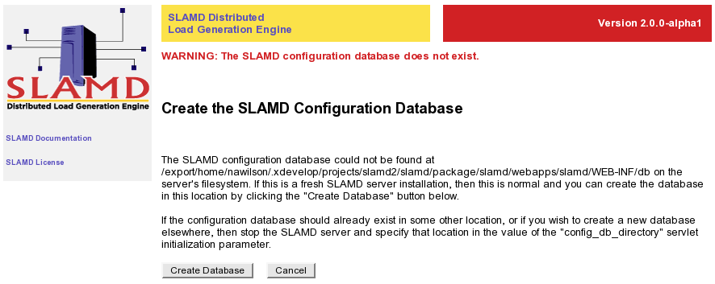

Once the database has been created, then the SLAMD server should be fully functional. See the Scheduling and Running Jobs section for information about performing common tasks in the administrative interface.

Installing and Configuring the SLAMD Client Software

Because SLAMD is a distributed application, the server does not actually generate the load against the target application. Rather, this work is done by the clients. Multiple client systems may process a job concurrently to increase the total amount of load that can be generated.

The SLAMD client software contains two primary components: the standard SLAMD client, and the SLAMD client manager. The standard client is the component that actually generates load against the target application, and there may be multiple instances of this client running on a single system. The client manager is an application that can be used to create and destroy client instances. The primary benefit of the client manager software is that it can automatically reconnect to the SLAMD server if the connection is lost for some reason (e.g., the SLAMD server is restarted). If the client manager is used, then it is recommended that it be used to create and destroy clients rather than starting the clients individually outside of the client manager.

The SLAMD client software is included in the slamd_client-{buildid}.zip archive. This file is included in the full SLAMD server package (the slamd-{buildid}.zip archive), or it may be downloaded separately. To install the client software, simply extract the contents of the SLAMD client archive into the desired location on the client system(s).

Before the client may be used, it must be configured. This may be done by editing the slamd_client.conf configuration file. In most cases, the default values supplied will be sufficient, but you will need to specify at least the address of the SLAMD server. The properties most likely to be customized include:

- SLAMD_ADDRESS -- Specifies the address of the SLAMD server system.

- ENABLE_REAL_TIME_STATS -- Indicates whether the client should report in-progress statistical information while the job is running.

- ENABLE_STAT_PERSISTENCE -- Indicates whether the client should periodically save information collected by long-running jobs locally so that at least partial data will be available in the event that communication between the client and the server is lost.

- AGGREGATE_CLIENT_THREADS -- Indicates whether the client should aggregate the information from all threads used to run a job before sending the results to the SLAMD server. This will conserve space and memory on the SLAMD server system, but it will not be possible to obtain information about the performance of each individual client thread (this information is not important in most cases).

- RESTRICTED_MODE -- Indicates whether the client will operate in restricted mode, in which case it will only be used to run jobs for which it has been explicitly requested.

- AUTO_START_CLIENTS -- Specifies the number of client instances that the client manager should automatically create when it establishes a connection to the SLAMD server.

- MAX_CLIENTS -- Specifies the maximum number of concurrent client instances that a SLAMD client manager should allow at any given time.

- VERBOSE_MODE -- Indicates whether the client will operate in verbose mode, providing additional information that may be useful for debugging problems but may have a small impact on the performance of the client.

When the slamd_client.conf file has been edited, the client may be started using the start_client.sh script on UNIX systems or start_client.bat batch file on Windows. Starting the client with no arguments will be sufficient in most cases, although any arguments provided on the command line will override those defined in the configuration file (e.g., invoking "./start_client.sh -v" will start the client in verbose mode even if the VERBOSE_MODE option is disabled in the configuration file). Use the "-H" argument to obtain a list of all of the command-line arguments that may be provided.

If the SLAMD client cannot find an appropriate Java environment to use, then you may either set the JAVA_HOME environment variable or edit the tools/set-java-home.sh script (or tools\set-java-home.bat on Windows) to provide the path to the Java installation to use.

In order to start the client manager software on UNIX systems, use the start_client_manager.sh script. The client manager software is currently not available on Windows systems because of a platform limitation (Windows does not provide the equivalent of the UNIX exec command that can run a separate command in the same process as the original command). This restriction will be removed in the near future, as the client manager software will be redesigned to work around the problem.

Once the SLAMD client or client manager has been started, then the "SLAMD Server Status" page in the administrative interface may be used to view information about those clients. In the case of the client managers, it is possible to request that client instances be created or destroyed through this interface, and individual load generation client instances may be disconnected as desired.

Installing and Configuring the SLAMD Resource Monitor Client Software

The SLAMD resource monitor client may be used to capture information about the environment in which jobs are being run. It can measure system resources like CPU utilization, disk and network I/O rates, and memory consumption, not only for the server(s) being tested, but also for the clients generating the load and any other systems that might be involved in some way. It can also be used to collect information about the application under load from an external standpoint (e.g., for the Sun Java System Directory Server, it may be used to monitor cache utilization, operations processed, and replication latency).

The SLAMD resource monitor client software is contained in the slamd_monitor_client-{buildid}.zip archive, which is included in the full SLAMD server archive or may be downloaded separately. To install the resource monitor client, simply extract the contents of this archive onto a system to be monitored in the desired location. Then edit the slamd_monitor_client.conf configuration file to define the settings to use to communicate with the SLAMD server. The settings are most likely to be customized include:

- SLAMD_ADDRESS -- Specifies the address of the SLAMD server system.

- ENABLE_REAL_TIME_STATS -- Indicates whether the client should report in-progress statistical information while the job is running.

- ENABLE_STAT_PERSISTENCE -- Indicates whether the client should periodically save information collected by long-running jobs locally so that at least partial data will be available in the event that communication between the client and the server is lost.

- AUTO_RECONNECT -- Indicates whether the client should automatically reconnect to the SLAMD server if the connection is lost.

- VERBOSE_MODE -- Indicates whether the client will operate in verbose mode, providing additional information that may be useful for debugging problems but may have a small impact on the performance of the client.

In addition to the settings in the slamd_monitor_client.conf file, each type of resource monitor should have its own configuration file, located in the config subdirectory. The properties in each of these configuration files is dependent upon the type of resource monitor described by that configuration. See the SLAMD Administration and Usage Guide for information about the configuration properties for each resource monitor.

In order to start the resource monitor client, use the start_monitor_client.sh command on UNIX-based systems or the start_monitor_client.bat command on Windows. In most cases, no command-line arguments are required, but they may be given if necessary to override the values from the configuration file. Use the "-H" argument to see complete usage information for the resource monitor client.

If the resource monitor client cannot find an appropriate Java environment to use, then you may either set the JAVA_HOME environment variable or edit the tools/set-java-home.sh script (or tools\set-java-home.bat on Windows) to provide the path to the Java installation to use.

Scheduling and Running Jobs

With the SLAMD server running and the various types of clients connected, it is possible to schedule jobs for processing. The easiest way to accomplish this is through the administrative interface. Follow the "Schedule a Job" link under the "Manage Jobs" heading of the navigation sidebar, and a list of the jobs available for use will be displayed, organized alphabetically by category and job name. Select the type of job to schedule and a form will be displayed that may be used to supply the necessary for use in running the job:

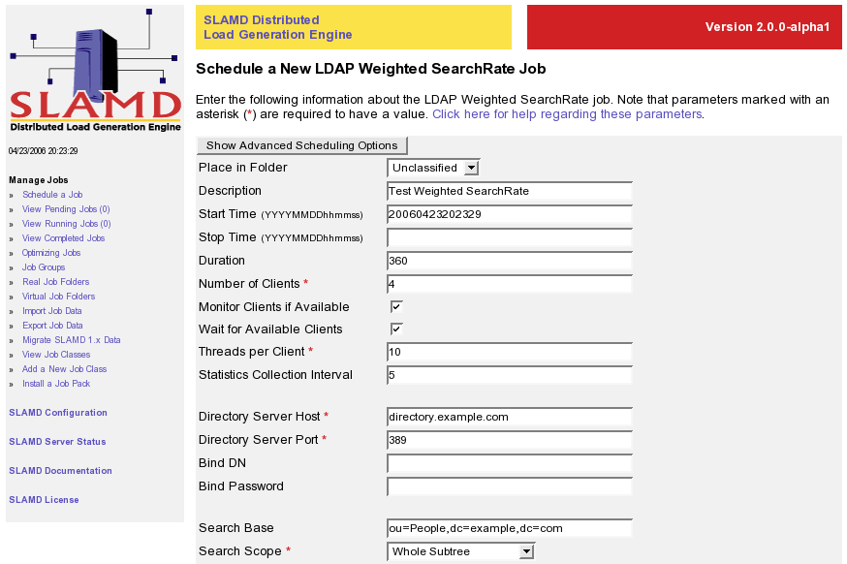

In most cases, a job will define a number of parameters that will need to be supplied in order to perform the associated workload (e.g., the address and port to use to communicate with the application that you want to test). Consult the SLAMD Job Reference Guide for information about the types of parameters that are available for each of these jobs. However, there is also a standard set of parameters that will always be displayed when scheduling a job. These standard parameters include:

- Place in Folder -- This specifies the folder into which the job should be placed when it is scheduled. By default, only the "Unclassified" folder exists, but additional folders may be created to help organize the job information.

- Description -- This provides a brief description of the job, which may be used to distinguish it from other jobs in the same folder.

- Start Time -- This specifies the time that the job should start running. It should be in the form "YYYYMMDDhhmmss" (for example, if the job should start running at 12:30 p.m. on May 1, 2006, then the value should be "20060501123000"). If the provided start time is equal to the current time or if it is in the past, then the job will be eligible to start running immediately.

- Stop Time -- This specifies the time that the job should stop running, if it has not already stopped for some other reason. This is an optional parameter, and if it is not provided then the job will run until it has stopped on its own or until it has run for the maximum allowed duration (if defined). The format is the same as for the start time.

- Duration -- This specifies the maximum length of time in seconds that the job should be allowed to run. This is an optional parameter, and if it is not provided then the job will run until it has stopped on its own or until the stop time (if defined) is reached.

- Number of Clients -- This specifies the number of clients that should be used to run the job. This is a required parameter, but it may be hard-coded by the job in which case it will not be displayed.

- Monitor Clients if Available -- This indicates whether to automatically make use of a resource monitor client running on the client system(s) if one is available. This can be used to help ensure that the client(s) are not overloaded while generating load against the target application.

- Wait for Available Clients -- This indicates whether the SLAMD server should wait for the specified number of clients to become available. If this is not selected, then when the start time arrives the job will fail with an error if there are not enough clients available.

- Threads per Client -- This specifies the number of threads per client to use to generate load against the target application. This is a required parameter.

- Statistics Collection Interval -- This specifies the statistics collection interval in seconds to use when running the job. This controls the number of data points that will be available for the job after it has completed (e.g., the frequency of data points available when viewing a graph of the results). This is a required parameter, and it must be less than the total duration for the job (in many cases, a good value to choose would be a length of time that is one or two percent of the total job duration).

There are additional parameters that may be available by clicking the "Show Advanced Scheduling Options" button. More detailed information about all of these parameters may be obtained by following the link at the top of the page, or in the SLAMD Administration and Usage Guide.

Once all of the parameters have been provided, the "Schedule Job" button may be used to schedule the job for execution. It will be placed in the pending jobs queue so that it will be sent to the clients to begin processing when the start time arrives. When this happens, it will be placed in the list of running jobs. If a stop time or maximum duration was provided, then the estimated time remaining will be displayed when viewing that job until it has completed.

For many jobs, there may also be a "Test Job Parameters" option that can be used to help determine whether the provided parameters are acceptable. The specific tests performed by this option may vary between jobs, but in many cases it will attempt to ensure that the target application may be accessed using the provided information. Note that this test will be performed by the SLAMD server and not by the clients, so under certain conditions (e.g., if the server and clients are on different networks) then the test may not be successful even if the clients would be able to perform the requested processing.

When the job has completed running, then the results may be viewed through the administrative interface. The information will be displayed numerically in tables by default, but it may also be seen graphically by clicking the "Graph" button at the top of the page or the "Graph Statistics" option below the data. The data may also be exported to tab-delimited text by clicking the "Save Statistics" button so that it can be used in another application.

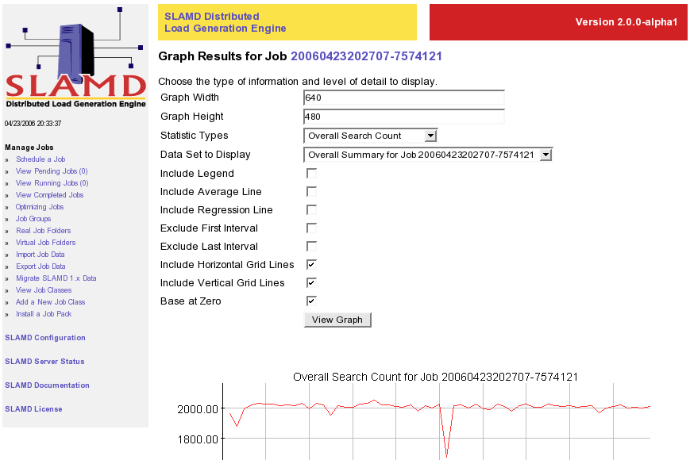

The completed job may also be cloned to easily re-schedule a job with the same or slightly altered parameters. The "Optimize Results" button may also be used to schedule the same workload as an optimizing job, which re-runs the same job repeatedly with varying numbers of threads per client in order to automatically find the amount of load that yields the best possible performance.

SLAMD License

The SLAMD Distributed Load Generation Engine (SLAMD) is distributed under the Sun Public License Version 1.0. This is an OSI-approved Open Source license, and more information about such licenses may be found at http://www.opensource.org/. The full text of the Sun Public License Version 1.0 is provided below for reference.

SUN PUBLIC LICENSE Version 1.0

1. Definitions.

1.0.1. "Commercial Use" means distribution or otherwise making the
Covered Code available to a third party.

1.1. "Contributor" means each entity that creates or contributes to
the creation of Modifications.

1.2. "Contributor Version" means the combination of the Original Code,
prior Modifications used by a Contributor, and the Modifications made
by that particular Contributor.

1.3. "Covered Code" means the Original Code or Modifications or the
combination of the Original Code and Modifications, in each case
including portions thereof and corresponding documentation released
with the source code.

1.4. "Electronic Distribution Mechanism" means a mechanism generally
accepted in the software development community for the electronic
transfer of data.

1.5. "Executable" means Covered Code in any form other than Source
Code.

1.6. "Initial Developer" means the individual or entity identified as
the Initial Developer in the Source Code notice required by Exhibit A.

1.7. "Larger Work" means a work which combines Covered Code or
portions thereof with code not governed by the terms of this License.

1.8. "License" means this document.

1.8.1. "Licensable" means having the right to grant, to the maximum
extent possible, whether at the time of the initial grant or
subsequently acquired, any and all of the rights conveyed herein.

1.9. "Modifications" means any addition to or deletion from the
substance or structure of either the Original Code or any previous
Modifications. When Covered Code is released as a series of files, a
Modification is:

A. Any addition to or deletion from the contents of a file containing
Original Code or previous Modifications.

B. Any new file that contains any part of the Original Code or
previous Modifications.

1.10. "Original Code" means Source Code of computer software code
which is described in the Source Code notice required by Exhibit A as
Original Code, and which, at the time of its release under this
License is not already Covered Code governed by this License.

1.10.1. "Patent Claims" means any patent claim(s), now owned or
hereafter acquired, including without limitation, method, process, and
apparatus claims, in any patent Licensable by grantor.

1.11. "Source Code" means the preferred form of the Covered Code for
making modifications to it, including all modules it contains, plus
any associated documentation, interface definition files, scripts used
to control compilation and installation of an Executable, or source
code differential comparisons against either the Original Code or
another well known, available Covered Code of the Contributor's
choice. The Source Code can be in a compressed or archival form,
provided the appropriate decompression or de-archiving software is
widely available for no charge.

1.12. "You" (or "Your") means an individual or a legal entity
exercising rights under, and complying with all of the terms of, this
License or a future version of this License issued under Section 6.1.
For legal entities, "You" includes any entity which controls, is
controlled by, or is under common control with You. For purposes of
this definition, "control" means (a) the power, direct or indirect, to
cause the direction or management of such entity, whether by contract
or otherwise, or (b) ownership of more than fifty percent (50%) of the
outstanding shares or beneficial ownership of such entity.

2. Source Code License.

2.1 The Initial Developer Grant.

The Initial Developer hereby grants You a world-wide, royalty-free,
non-exclusive license, subject to third party intellectual property
claims:

(a) under intellectual property rights (other than patent or
trademark) Licensable by Initial Developer to use, reproduce, modify,
display, perform, sublicense and distribute the Original Code (or
portions thereof) with or without Modifications, and/or as part of a
Larger Work; and

(b) under Patent Claims infringed by the making, using or selling of
Original Code, to make, have made, use, practice, sell, and offer for
sale, and/or otherwise dispose of the Original Code (or portions
thereof).

(c) the licenses granted in this Section 2.1(a) and (b) are effective
on the date Initial Developer first distributes Original Code under
the terms of this License.

(d) Notwithstanding Section 2.1(b) above, no patent license is
granted: 1) for code that You delete from the Original Code; 2)
separate from the Original Code; or 3) for infringements caused by:
i) the modification of the Original Code or ii) the combination of the
Original Code with other software or devices.

2.2. Contributor Grant.

Subject to third party intellectual property claims, each Contributor
hereby grants You a world-wide, royalty-free, non-exclusive license

(a) under intellectual property rights (other than patent or
trademark) Licensable by Contributor, to use, reproduce, modify,
display, perform, sublicense and distribute the Modifications created
by such Contributor (or portions thereof) either on an unmodified
basis, with other Modifications, as Covered Code and/or as part of a
Larger Work; and

(b) under Patent Claims infringed by the making, using, or selling of
Modifications made by that Contributor either alone and/or in
combination with its Contributor Version (or portions of such
combination), to make, use, sell, offer for sale, have made, and/or
otherwise dispose of: 1) Modifications made by that Contributor (or
portions thereof); and 2) the combination of Modifications made by
that Contributor with its Contributor Version (or portions of such
combination).

(c) the licenses granted in Sections 2.2(a) and 2.2(b) are effective
on the date Contributor first makes Commercial Use of the Covered
Code.

(d) notwithstanding Section 2.2(b) above, no patent license is
granted: 1) for any code that Contributor has deleted from the
Contributor Version; 2) separate from the Contributor Version; 3) for
infringements caused by: i) third party modifications of Contributor
Version or ii) the combination of Modifications made by that
Contributor with other software (except as part of the Contributor
Version) or other devices; or 4) under Patent Claims infringed by
Covered Code in the absence of Modifications made by that Contributor.

3. Distribution Obligations.

3.1. Application of License.

The Modifications which You create or to which You contribute are
governed by the terms of this License, including without limitation
Section 2.2. The Source Code version of Covered Code may be
distributed only under the terms of this License or a future version
of this License released under Section 6.1, and You must include a
copy of this License with every copy of the Source Code You
distribute. You may not offer or impose any terms on any Source Code
version that alters or restricts the applicable version of this
License or the recipients' rights hereunder. However, You may include
an additional document offering the additional rights described in
Section 3.5.

3.2. Availability of Source Code.

Any Modification which You create or to which You contribute must be
made available in Source Code form under the terms of this License
either on the same media as an Executable version or via an accepted
Electronic Distribution Mechanism to anyone to whom you made an
Executable version available; and if made available via Electronic
Distribution Mechanism, must remain available for at least twelve (12)
months after the date it initially became available, or at least six
(6) months after a subsequent version of that particular Modification
has been made available to such recipients. You are responsible for
ensuring that the Source Code version remains available even if the
Electronic Distribution Mechanism is maintained by a third party.

3.3. Description of Modifications.

You must cause all Covered Code to which You contribute to contain a
file documenting the changes You made to create that Covered Code and
the date of any change. You must include a prominent statement that
the Modification is derived, directly or indirectly, from Original
Code provided by the Initial Developer and including the name of the
Initial Developer in (a) the Source Code, and (b) in any notice in an
Executable version or related documentation in which You describe the
origin or ownership of the Covered Code.

3.4. Intellectual Property Matters.

(a) Third Party Claims.

If Contributor has knowledge that a license under a third party's
intellectual property rights is required to exercise the rights
granted by such Contributor under Sections 2.1 or 2.2, Contributor
must include a text file with the Source Code distribution titled
"LEGAL'' which describes the claim and the party making the claim in
sufficient detail that a recipient will know whom to contact. If
Contributor obtains such knowledge after the Modification is made
available as described in Section 3.2, Contributor shall promptly
modify the LEGAL file in all copies Contributor makes available
thereafter and shall take other steps (such as notifying appropriate
mailing lists or newsgroups) reasonably calculated to inform those who
received the Covered Code that new knowledge has been obtained.

(b) Contributor APIs.

If Contributor's Modifications include an application programming
interface ("API") and Contributor has knowledge of patent licenses
which are reasonably necessary to implement that API, Contributor must
also include this information in the LEGAL file.

(c) Representations.

Contributor represents that, except as disclosed pursuant to Section
3.4(a) above, Contributor believes that Contributor's Modifications
are Contributor's original creation(s) and/or Contributor has
sufficient rights to grant the rights conveyed by this License.

3.5. Required Notices.

You must duplicate the notice in Exhibit A in each file of the Source
Code. If it is not possible to put such notice in a particular Source
Code file due to its structure, then You must include such notice in a
location (such as a relevant directory) where a user would be likely
to look for such a notice. If You created one or more Modification(s)
You may add your name as a Contributor to the notice described in
Exhibit A. You must also duplicate this License in any documentation
for the Source Code where You describe recipients' rights or ownership
rights relating to Covered Code. You may choose to offer, and to
charge a fee for, warranty, support, indemnity or liability
obligations to one or more recipients of Covered Code. However, You
may do so only on Your own behalf, and not on behalf of the Initial
Developer or any Contributor. You must make it absolutely clear than
any such warranty, support, indemnity or liability obligation is
offered by You alone, and You hereby agree to indemnify the Initial
Developer and every Contributor for any liability incurred by the
Initial Developer or such Contributor as a result of warranty,
support, indemnity or liability terms You offer.

3.6. Distribution of Executable Versions.

You may distribute Covered Code in Executable form only if the
requirements of Section 3.1-3.5 have been met for that Covered Code,
and if You include a notice stating that the Source Code version of
the Covered Code is available under the terms of this License,
including a description of how and where You have fulfilled the
obligations of Section 3.2. The notice must be conspicuously included
in any notice in an Executable version, related documentation or
collateral in which You describe recipients' rights relating to the
Covered Code. You may distribute the Executable version of Covered
Code or ownership rights under a license of Your choice, which may
contain terms different from this License, provided that You are in
compliance with the terms of this License and that the license for the
Executable version does not attempt to limit or alter the recipient's
rights in the Source Code version from the rights set forth in this
License. If You distribute the Executable version under a different
license You must make it absolutely clear that any terms which differ
from this License are offered by You alone, not by the Initial
Developer or any Contributor. You hereby agree to indemnify the
Initial Developer and every Contributor for any liability incurred by
the Initial Developer or such Contributor as a result of any such
terms You offer.

3.7. Larger Works.

You may create a Larger Work by combining Covered Code with other code
not governed by the terms of this License and distribute the Larger
Work as a single product. In such a case, You must make sure the
requirements of this License are fulfilled for the Covered Code.

4. Inability to Comply Due to Statute or Regulation.

If it is impossible for You to comply with any of the terms of this
License with respect to some or all of the Covered Code due to
statute, judicial order, or regulation then You must: (a) comply with
the terms of this License to the maximum extent possible; and (b)
describe the limitations and the code they affect. Such description
must be included in the LEGAL file described in Section 3.4 and must
be included with all distributions of the Source Code. Except to the
extent prohibited by statute or regulation, such description must be
sufficiently detailed for a recipient of ordinary skill to be able to
understand it.

5. Application of this License.

This License applies to code to which the Initial Developer has
attached the notice in Exhibit A and to related Covered Code.

6. Versions of the License.

6.1. New Versions.

Sun Microsystems, Inc. ("Sun") may publish revised and/or new versions
of the License from time to time. Each version will be given a
distinguishing version number.

6.2. Effect of New Versions.

Once Covered Code has been published under a particular version of the
License, You may always continue to use it under the terms of that
version. You may also choose to use such Covered Code under the terms
of any subsequent version of the License published by Sun. No one
other than Sun has the right to modify the terms applicable to Covered
Code created under this License.

6.3. Derivative Works.

If You create or use a modified version of this License (which you may
only do in order to apply it to code which is not already Covered Code
governed by this License), You must: (a) rename Your license so that
the phrases "Sun," "Sun Public License," or "SPL" or any confusingly
similar phrase do not appear in your license (except to note that your
license differs from this License) and (b) otherwise make it clear
that Your version of the license contains terms which differ from the
Sun Public License. (Filling in the name of the Initial Developer,
Original Code or Contributor in the notice described in Exhibit A
shall not of themselves be deemed to be modifications of this
License.)

7. DISCLAIMER OF WARRANTY.

COVERED CODE IS PROVIDED UNDER THIS LICENSE ON AN "AS IS'' BASIS,
WITHOUT WARRANTY OF ANY KIND, EITHER EXPRESSED OR IMPLIED, INCLUDING,
WITHOUT LIMITATION, WARRANTIES THAT THE COVERED CODE IS FREE OF
DEFECTS, MERCHANTABLE, FIT FOR A PARTICULAR PURPOSE OR NON-INFRINGING.
THE ENTIRE RISK AS TO THE QUALITY AND PERFORMANCE OF THE COVERED CODE
IS WITH YOU. SHOULD ANY COVERED CODE PROVE DEFECTIVE IN ANY RESPECT,
YOU (NOT THE INITIAL DEVELOPER OR ANY OTHER CONTRIBUTOR) ASSUME THE
COST OF ANY NECESSARY SERVICING, REPAIR OR CORRECTION. THIS DISCLAIMER
OF WARRANTY CONSTITUTES AN ESSENTIAL PART OF THIS LICENSE. NO USE OF
ANY COVERED CODE IS AUTHORIZED HEREUNDER EXCEPT UNDER THIS DISCLAIMER.

8. TERMINATION.

8.1. This License and the rights granted hereunder will terminate
automatically if You fail to comply with terms herein and fail to cure
such breach within 30 days of becoming aware of the breach. All
sublicenses to the Covered Code which are properly granted shall
survive any termination of this License. Provisions which, by their
nature, must remain in effect beyond the termination of this License
shall survive.

8.2. If You initiate litigation by asserting a patent infringement
claim (excluding declaratory judgment actions) against Initial Developer
or a Contributor (the Initial Developer or Contributor against whom
You file such action is referred to as "Participant") alleging that:

(a) such Participant's Contributor Version directly or indirectly
infringes any patent, then any and all rights granted by such
Participant to You under Sections 2.1 and/or 2.2 of this License
shall, upon 60 days notice from Participant terminate prospectively,
unless if within 60 days after receipt of notice You either: (i)
agree in writing to pay Participant a mutually agreeable reasonable
royalty for Your past and future use of Modifications made by such
Participant, or (ii) withdraw Your litigation claim with respect to
the Contributor Version against such Participant. If within 60 days
of notice, a reasonable royalty and payment arrangement are not
mutually agreed upon in writing by the parties or the litigation claim
is not withdrawn, the rights granted by Participant to You under
Sections 2.1 and/or 2.2 automatically terminate at the expiration of
the 60 day notice period specified above.

(b) any software, hardware, or device, other than such Participant's
Contributor Version, directly or indirectly infringes any patent, then
any rights granted to You by such Participant under Sections 2.1(b)
and 2.2(b) are revoked effective as of the date You first made, used,
sold, distributed, or had made, Modifications made by that
Participant.

8.3. If You assert a patent infringement claim against Participant
alleging that such Participant's Contributor Version directly or
indirectly infringes any patent where such claim is resolved (such as
by license or settlement) prior to the initiation of patent
infringement litigation, then the reasonable value of the licenses
granted by such Participant under Sections 2.1 or 2.2 shall be taken
into account in determining the amount or value of any payment or
license.

8.4. In the event of termination under Sections 8.1 or 8.2 above, all
end user license agreements (excluding distributors and resellers)
which have been validly granted by You or any distributor hereunder
prior to termination shall survive termination.

9. LIMITATION OF LIABILITY.

UNDER NO CIRCUMSTANCES AND UNDER NO LEGAL THEORY, WHETHER TORT
(INCLUDING NEGLIGENCE), CONTRACT, OR OTHERWISE, SHALL YOU, THE INITIAL
DEVELOPER, ANY OTHER CONTRIBUTOR, OR ANY DISTRIBUTOR OF COVERED CODE,
OR ANY SUPPLIER OF ANY OF SUCH PARTIES, BE LIABLE TO ANY PERSON FOR
ANY INDIRECT, SPECIAL, INCIDENTAL, OR CONSEQUENTIAL DAMAGES OF ANY
CHARACTER INCLUDING, WITHOUT LIMITATION, DAMAGES FOR LOSS OF GOODWILL,
WORK STOPPAGE, COMPUTER FAILURE OR MALFUNCTION, OR ANY AND ALL OTHER
COMMERCIAL DAMAGES OR LOSSES, EVEN IF SUCH PARTY SHALL HAVE BEEN
INFORMED OF THE POSSIBILITY OF SUCH DAMAGES. THIS LIMITATION OF
LIABILITY SHALL NOT APPLY TO LIABILITY FOR DEATH OR PERSONAL INJURY
RESULTING FROM SUCH PARTY'S NEGLIGENCE TO THE EXTENT APPLICABLE LAW
PROHIBITS SUCH LIMITATION. SOME JURISDICTIONS DO NOT ALLOW THE
EXCLUSION OR LIMITATION OF INCIDENTAL OR CONSEQUENTIAL DAMAGES, SO
THIS EXCLUSION AND LIMITATION MAY NOT APPLY TO YOU.

10. U.S. GOVERNMENT END USERS.

The Covered Code is a "commercial item," as that term is defined in 48
C.F.R. 2.101 (Oct. 1995), consisting of "commercial computer software"
and "commercial computer software documentation," as such terms are
used in 48 C.F.R. 12.212 (Sept. 1995). Consistent with 48 C.F.R.
12.212 and 48 C.F.R. 227.7202-1 through 227.7202-4 (June 1995), all
U.S. Government End Users acquire Covered Code with only those rights
set forth herein.

11. MISCELLANEOUS.

This License represents the complete agreement concerning subject
matter hereof. If any provision of this License is held to be
unenforceable, such provision shall be reformed only to the extent
necessary to make it enforceable. This License shall be governed by
California law provisions (except to the extent applicable law, if
any, provides otherwise), excluding its conflict-of-law provisions.
With respect to disputes in which at least one party is a citizen of,
or an entity chartered or registered to do business in the United
States of America, any litigation relating to this License shall be
subject to the jurisdiction of the Federal Courts of the Northern
District of California, with venue lying in Santa Clara County,
California, with the losing party responsible for costs, including
without limitation, court costs and reasonable attorneys' fees and
expenses. The application of the United Nations Convention on
Contracts for the International Sale of Goods is expressly excluded.
Any law or regulation which provides that the language of a contract
shall be construed against the drafter shall not apply to this
License.

12. RESPONSIBILITY FOR CLAIMS.

As between Initial Developer and the Contributors, each party is
responsible for claims and damages arising, directly or indirectly,
out of its utilization of rights under this License and You agree to
work with Initial Developer and Contributors to distribute such
responsibility on an equitable basis. Nothing herein is intended or
shall be deemed to constitute any admission of liability.

13. MULTIPLE-LICENSED CODE.

Initial Developer may designate portions of the Covered Code as
"Multiple-Licensed". "Multiple-Licensed" means that the Initial
Developer permits you to utilize portions of the Covered Code under
Your choice of the alternative licenses, if any, specified by the
Initial Developer in the file described in Exhibit A.

Exhibit A -Sun Public License Notice.

The contents of this file are subject to the Sun Public License
Version 1.0 (the "License"); you may not use this file except in
compliance with the License. A copy of the License is available at
http://www.sun.com/

The Original Code is _________________. The Initial Developer of the
Original Code is ___________. Portions created by ______ are Copyright
(C)_________. All Rights Reserved.

Contributor(s): ______________________________________.

Alternatively, the contents of this file may be used under the terms
of the _____ license (the "[___] License"), in which case the
provisions of [______] License are applicable instead of those above.
If you wish to allow use of your version of this file only under the
terms of the [____] License and not to allow others to use your
version of this file under the SPL, indicate your decision by deleting
the provisions above and replace them with the notice and other
provisions required by the [___] License. If you do not delete the
provisions above, a recipient may use your version of this file under
either the SPL or the [___] License."

[NOTE: The text of this Exhibit A may differ slightly from the text of
the notices in the Source Code files of the Original Code. You should
use the text of this Exhibit A rather than the text found in the
Original Code Source Code for Your Modifications.]

