Recession project report

Subharati Ghosh, Subhrangshu Nandi, Susan Murphy

**1 Analysis of Safety net program participation**

Participation rates of households in different safety net programs were analyzed, to detect any significant difference in participation of households with a disabled adult. The following programs were analyzed:

*•* Supplemental Security Income (SSI)

*•* Unemployment Income (Unemp)

*•* Food stamps (FdStp)

The following control variables were included in the models:

*•* Year and month, from August 2008 - April 2013

*•* Race (asian, black, others and white) - 4 levels

*•* Household type (interaction between gender and marital status of household head) -

4 levels

The response variable (*p*) is the program participation rate of different types of household. Since 0 *≤ p ≤* 1, a binomial logistic regression model was fit, to estimate the effect of disability on the the odds ratio of program participation rates, after controlling for the demographic variables. The model is of the form

logit(*p*(*x*)) = log

( *p*(*x*) \

1 *− p*(*x*)

= *α* + *β*1*x*1 + *β*2*x*2 + *β*3*x*3

where, *p*(*x*) is the participation rate, as a function of the covariates *x*. The three program participation rates were analyzed separately and together. Below are the results.

Unemployment Income participation

adult_disb Not Disabled Disabled

0.15

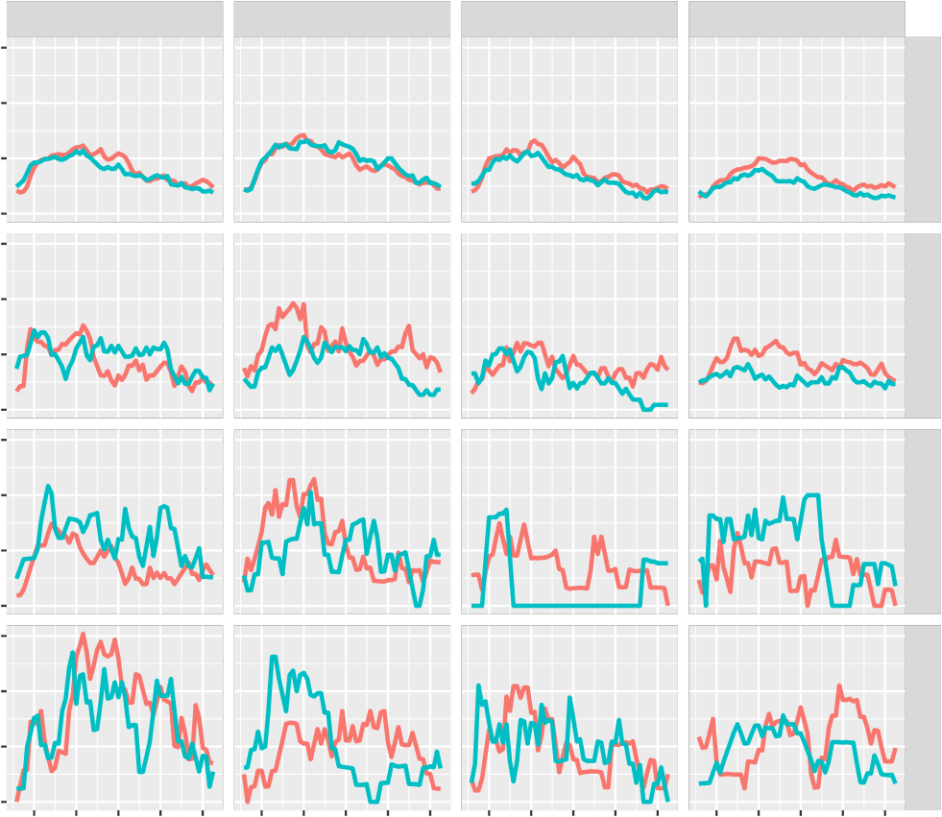

Male.Married Female.Married Male.Not married Female.Not married

0.10

White alone

0.05

0.00

0.15

0.10

Black alone

percentage of household

0.05

0.00

0.15

0.10

Asian alone

0.05

0.00

0.15

0.10

Residual

0.05

0.00

2009

2010

2011

2012

2013

2009

2010

2011

2012

2013

2009

2010

2011

2012

2013

2009

2010

2011

2012

2013

The plots above are of participation rates of different households in “unemployment income”. To incorporate the nonlinear behavior of the participation rate a quadratic term was introduced.

logit(*p*(*x*)) = log

( *p*(*x*) \

1 *− p*(*x*)

= *α*+*β*1 *·*yrmon+*β*2 *·*yrmon2 +*β*3 *·*race+*β*4 *·*hh type+*γ ·*disab

Supplemental Security Income participation

adult_disb Not Disabled Disabled

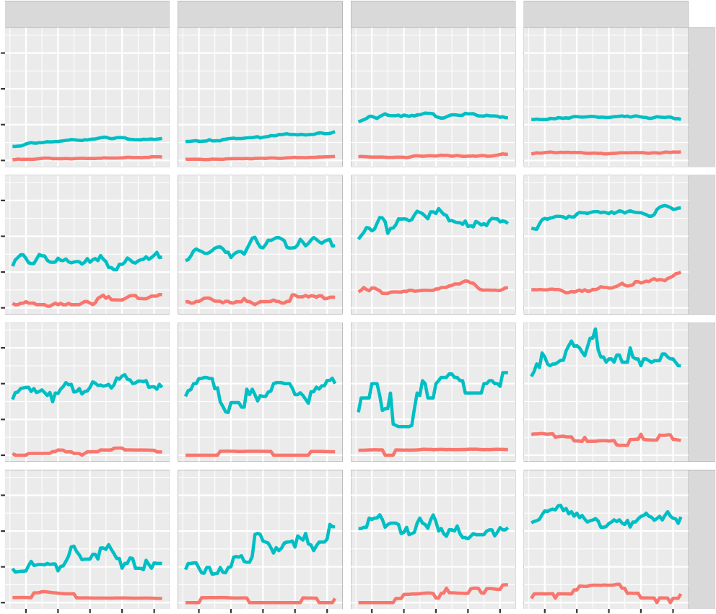

Male.Married Female.Married Male.Not married Female.Not married

0.3

White alone

0.2

0.1

0.0

0.3

Black alone

0.2

percentage of household

0.1

0.0

0.3

Asian alone

0.2

0.1

0.0

0.3

0.2

Residual

0.1

0.0

2009

2010

2011

2012

2013

2009

2010

2011

2012

2013

2009

2010

2011

2012

2013

2009

2010

2011

2012

2013

The plots above are of participation rates of different households in “supplemental security income”. The following model was fit:

logit(*p*(*x*)) = log

( *p*(*x*) \

1 *− p*(*x*)

= *α* + *β*1 *·* yrmon + *β*2 *·* race + *β*3 *·* hh type + *γ ·* disab

We are interested in *γ*ˆ, the estimate of *γ*, the contribution of disability in participation rate.

*β*ˆ S.E. z p-value Odds Ratio 2.5% 97.5%

(Intercept)

yearmon race (Black alone) race (Asian alone) race (Residual) Female.Married Male.Not married Female.Not married Disabled

-91.6394 122.7252 -0.7467 0.4552 0.0000 0.0000 Inf

0.0431 0.0610 0.7067 0.4798 1.0441 0.9264 1.1771

0.9913 0.2645 3.7481 0.0002 2.6948 1.6238 4.5989

0.8967 0.2671 3.3575 0.0008 2.4514 1.4684 4.2016

0.7257 0.2724 2.6645 0.0077 2.0662 1.2228 3.5730

0.1020 0.2653 0.3845 0.7006 1.1074 0.6581 1.8690

0.5163 0.2488 2.0755 0.0379 1.6758 1.0341 2.7506

0.7868 0.2410 3.2653 0.0011 2.1963 1.3794 3.5575

2.2330 0.2443 9.1391 0.0000 9.3279 5.9201 15.5045

**1.3 Food stamps participation**

Food stamps participation

adult_disb Not Disabled Disabled

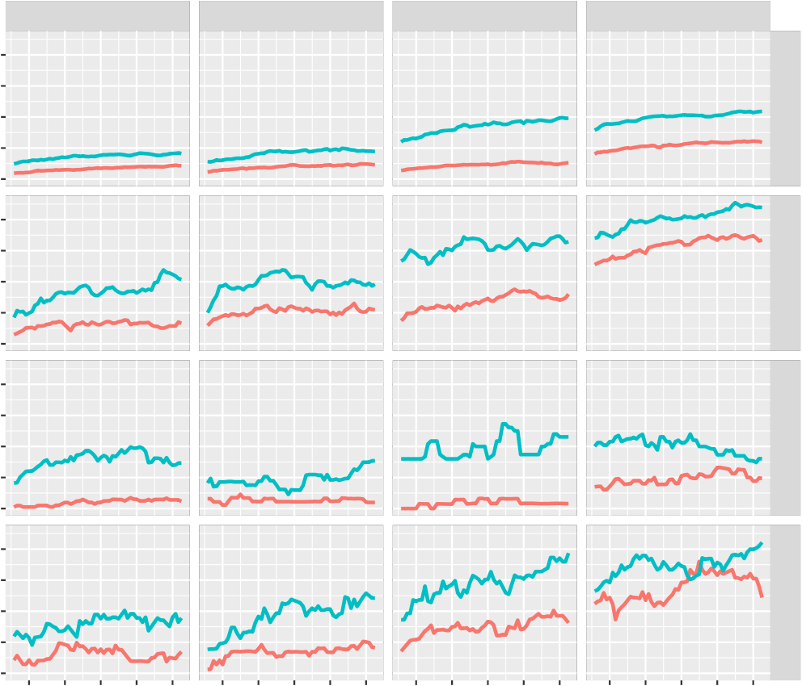

Male.Married Female.Married Male.Not married Female.Not married

0.4

0.3

White alone

0.2

0.1

0.0

0.4

0.3

Black alone

percentage of household

0.2

0.1

0.0

0.4

0.3

Asian alone

0.2

0.1

0.0

0.4

0.3

Residual

0.2

0.1

0.0

2009

2010

2011

2012

2013

2009

2010

2011

2012

2013

2009

2010

2011

2012

2013

2009

2010

2011

2012

2013

The plots above are of participation rates of different households in “Food stamp programs”. The following model was fit:

logit(*p*(*x*)) = log

( *p*(*x*) \

1 *− p*(*x*)

= *α* + *β*1 *·* yrmon + *β*2 *·* race + *β*3 *·* hh type + *γ ·* disab

We are interested in *γ*ˆ, the estimate of *γ*, the contribution of disability in participation rate. Below are the coefficients.

|  |  |  |  |  |  |  |  |
| --- | --- | --- | --- | --- | --- | --- | --- |
|  | Beta | S.E. | z | p-value | Odds Ratio | 2.5% | 97.5% |
| (Intercept) | -190.7829 | 100.8751 | -1.8913 | 0.0586 | 0.0000 | 0.0000 | 663.6447 |
| yearmon | 0.0932 | 0.0502 | 1.8576 | 0.0632 | 1.0977 | 0.9951 | 1.2115 |
| race (Black alone) | 1.0083 | 0.2030 | 4.9662 | 0.0000 | 2.7410 | 1.8528 | 4.1134 |
| race (Asian alone) | 0.0811 | 0.2284 | 0.3549 | 0.7227 | 1.0845 | 0.6928 | 1.7005 |
| race (Residual) | 0.8712 | 0.2055 | 4.2393 | 0.0000 | 2.3897 | 1.6065 | 3.6014 |
| Female.Married | 0.1015 | 0.2302 | 0.4412 | 0.6591 | 1.1069 | 0.7049 | 1.7421 |
| Male.Not married | 0.7041 | 0.2109 | 3.3387 | 0.0008 | 2.0221 | 1.3442 | 3.0786 |
| Female.Not married | 1.2347 | 0.2013 | 6.1345 | 0.0000 | 3.4374 | 2.3343 | 5.1467 |
| Disabled | 0.9047 | 0.1433 | 6.3145 | 0.0000 | 2.4712 | 1.8718 | 3.2842 |

**2 Data description**

In the original data-set there were 42,030 unique households. In the disability data-set (panel 2008, wave 6), there were 33,363 households. Only those households who have responded to the survey from wave 1 through wave 15 were analyzed. In addition, if reference person of a household changed over the duration of the survey, that household was dropped. The reference person of the households also needed to be 18 or older, at the beginning of the survey. There were a total of 22,002 unique households that satisfied all the above criteria.

**3 Methods**

The primary aim of this study was to estimate how the households with disability coped through the great recession, in terms of income poverty. We used the ratio of total monthly household income and the monthly federal poverty level to quantify income poverty. We name this income poverty ratio (IPR). Households with IPRs lower than 1 were below

100% Federal poverty levels. Data from June 2008 through May 2013 were analyzed. The baseline value of IPR (of June 2008) of each household was subtracted from the rest of that household’s responses. This helped us analyze the isolated effect of the great recession on income poverty of different socio-economic strata. A mixed effect model was fit between IPR and disability, controlling for demographic variables like race, gender and marital status of household head. Since this is a panel survey, with longitudinal observations from each household, to account for “between household” variability, we included a random effect for each household. Our conclusion is that the great recession has had a detrimental impact on IPR. Households with unmarried female adults as the head fared much worse than other types of households.