EXPLAINABLE PLANT DISEASE DETECTION VIA
CONCEPT BOTTLENECK MODELLING WITH
SWIN TRANSFORMER BACKBONE
A URE REPORT
Submitted by
ANUSHKA MAHRANIYA – 20221CSD0151
Under the guidance of,
MEENA KUMARI K S
BACHELOR OF TECHNOLOGY
IN
COMPUTER SCIENCE AND ENGINEERING
(Data Science)

PRESIDENCY UNIVERSITY
BENGALURU
APRIL 2026

PRESIDENCY SCHOOL OF COMPUTER SCIENCE AND ENGINEERING
BONAFIDE CERTIFICATE
Certified that this report "Explainable Plant Disease Detection via Concept Bottleneck Modelling with Swin Transformer Backbone" is a bonafide work of "Anushka Mahraniya (20221CSD0151)" who has successfully carried out the University Research Experience (URE) work and submitted the report in COMPUTER SCIENCE AND ENGINEERING (SPECIALIZATION DIVISION), DATA SCIENCE during 2025-26.

Meena Kumari K S  Assistant Professor  Project Guide  PSCS (Spl. Division)  Presidency University | Dr. Abirami A  Associate Professor  URE Coordinator  PSCS (Spl. Division)  Presidency University
Dr. S. Pravinthraja  Professor & Head of the Department  PSCS (Spl. Division)  Presidency University | Dr. Shakkeera L  Associate Dean  PSCS (Spl. Division)  Presidency University

PRESIDENCY SCHOOL OF COMPUTER SCIENCE AND ENGINEERING
DECLARATION
I am a student of sixth semester in COMPUTER SCIENCE AND ENGINEERING (Spl. Division) at Presidency University, Bengaluru, named Anushka Mahraniya, hereby declare that the URE work titled "Explainable Plant Disease Detection via Concept Bottleneck Modelling with Swin Transformer Backbone" has been independently carried out by me and submitted during the academic year of 2025-26. Further, the matter embodied in the work has not been submitted previously by anybody for the award of any Degree or Diploma to any other institution.

Anushka Mahraniya USN: 20221CSD0151 Signature

PLACE: BENGALURU
DATE:

ACKNOWLEDGEMENT
For completing this URE work, I have received the support and guidance from many people whom I would like to mention with deep sense of gratitude and indebtedness. I extend my gratitude to our beloved Chancellor, Pro-Vice Chancellor, and Registrar for their support and encouragement in completion of the project.
I would like to sincerely thank my internal guide, Meena Kumari K S, Assistant Professor, Presidency School of Computer Science and Engineering (Spl. Division), Presidency University, for her moral support, motivation, timely guidance and encouragement provided during the period of my project work.
I am also thankful to Dr. S. Pravinthraja, Professor, Head of the Department, Presidency School of Computer Science and Engineering (Spl. Division), Presidency University, for his mentorship and encouragement.
I express my cordial thanks to Dr. Shakkeera L, Associate Dean, Presidency School of Computer Science and Engineering (Spl. Division), Presidency University for providing the required facilities and intellectually stimulating environment that aided in the completion of my URE work.
I am grateful to my URE coordinators Dr. Abirami A, Associate Professor, PSCS (Spl. Division) and Mr. Anand Haridas, Assistant Professor, PSCS (Spl. Division) for facilitating problem statements, coordinating reviews, monitoring progress, and providing their valuable support and guidance.
ANUSHKA MAHRANIYA

Abstract
Plant diseases cause significant annual losses in agricultural yield worldwide, yet accurate and timely diagnosis remains challenging for farmers who lack access to expert agronomists. Existing deep learning systems for plant disease detection suffer from three fundamental limitations: opacity of predictions offering no human-interpretable reasoning, poor generalisation from controlled laboratory images to real field conditions, and computational heaviness that prevents deployment on edge devices. To address all three limitations simultaneously, this work proposes PlantDiseaseCBM — a Concept Bottleneck Model that couples a Swin Transformer backbone augmented with a Squeeze-and-Excitation (SE) attention block with a 12-concept intermediate representation layer before the final 38-class classifier. The 12 visual concepts — lesion_color, lesion_shape, lesion_spread, necrosis, chlorosis, wilting, spotting, blight_pattern, mold_presence, leaf_curl, vein_discoloration, and lesion_texture — are biologically grounded and learned jointly with the classification objective through a composite CBM loss combining task loss, concept supervision loss, and a diversity regularisation term. The model is trained on a merged corpus of PlantVillage (54,306 colour images, 38 classes) and PlantDoc (field-collected images across 27 disease categories), with aggressive data augmentation to bridge the domain gap. Four complementary XAI mechanisms are implemented: counterfactual concept perturbation, faithfulness evaluation via insertion-deletion AUC curves, concept intervention analysis, and concept importance ranking. On the held-out PlantVillage validation set the model achieves 99.91% accuracy, 99.78% macro F1-score, and on the combined out-of-distribution test set it achieves 99.25% accuracy and 98.27% macro F1-score. INT8 dynamic quantisation reduces model size by ~23% with negligible accuracy drop, and a FastAPI REST endpoint packaged in Docker enables production deployment. The concept bottleneck architecture is the first applied to multi-class plant disease detection at this scale and provides per-prediction explanations that are immediately actionable by agronomists without machine learning expertise.

TABLE OF CONTENTS
 | ACKNOWLEDGEMENT | iv
 | ABSTRACT | v
 | TABLE OF CONTENTS | vi
 | LIST OF FIGURES | ix
 | LIST OF TABLES | ix
 | ABBREVIATIONS | x
1. | INTRODUCTION | 1
 | 1.1 Background and Motivation | 1
 | 1.2 Problem Statement | 2
 | 1.3 Research Objectives | 2
 | 1.4 Scope and Limitations | 3
 | 1.5 Sustainable Development Goals | 3
2. | LITERATURE REVIEW | 4
 | 2.1 CNN-Based Methods | 4
 | 2.2 Transformer-Based Methods | 4
 | 2.3 Explainable AI in Plant Pathology | 5
 | 2.4 Research Gaps Identified | 6
3. | RESEARCH METHODOLOGY | 7
 | 3.1 Dataset Description | 7
 | 3.2 Proposed Framework Overview | 7
 | 3.3 Backbone and Feature Extraction | 8
 | 3.4 Concept Bottleneck Layer | 9
 | 3.5 Loss Function Design | 10
 | 3.6 XAI Components | 11
 | 3.7 Preprocessing and Augmentation Pipeline | 12
4. | IMPLEMENTATION | 13
 | 4.1 Environment and Tools | 13
 | 4.2 Data Preprocessing and Feature Construction | 13
 | 4.3 Model Architecture and Training | 14
 | 4.4 XAI Integration | 16
 | 4.5 Deployment: API and Quantisation | 17
 | 4.6 Pseudocode — Core Algorithms | 17
5. | RESULTS AND DISCUSSION | 20
 | 5.1 Classification Performance Metrics | 20
 | 5.2 Confusion Matrix Analysis | 22
 | 5.3 XAI Analysis | 23
 | 5.4 Concept Intervention Results | 24
 | 5.5 Comparative Analysis with State-of-the-Art | 26
 | 5.6 Live Web Application Demo (Hugging Face Space) | 28
6. | CONCLUSION AND FUTURE WORK | 29
 | 6.1 Summary of Contributions | 27
 | 6.2 Limitations of the Study | 28
 | 6.3 Directions for Future Research | 28
 | REFERENCES | 30
 | APPENDIX-A (Turnitin Similarity Report) | 31
 | APPENDIX-B (Turnitin AI Writing Detection Report) | 32
 | APPENDIX-C (Publication) | 33

LIST OF FIGURES
Sl. No. | Figure Name | Caption
1 | Figure 3.1 | PlantDiseaseCBM Architecture: Swin Transformer + SE Block + Concept Bottleneck pipeline
2 | Figure 5.1 | Confusion matrix on PlantVillage validation set (38 classes, 8,145 images)
3 | Figure 5.2 | Per-class precision, recall, and F1-score bar chart across all 38 disease categories
4 | Figure 5.3 | Training and validation accuracy/loss curves over 100 epochs
5 | Figure 5.4 | XAI counterfactual explanations: diseased concept profiles vs. healthy counterfactuals
6 | Figure 5.5 | Faithfulness evaluation — insertion and deletion AUC curves for the CBM
7 | Figure 5.6 | Concept intervention analysis: per-concept accuracy delta when set to 0 or 1
8 | Figure 5.7 | Concept importance ranking by mean activation across validation set
9 | Figure 5.11 | Live Web App Demo — Grape Esca (Black Measles) classified at 99.5% confidence with XAI concept chart (Hugging Face Space)

LIST OF TABLES
Sl. No. | Table Name | Caption
1 | Table 5.1 | Classification performance metrics — PlantDiseaseCBM vs. state-of-the-art methods
2 | Table 5.2 | Quantisation results: original vs. INT8 model size, speed, and accuracy

Abbreviations
Abbreviation | Full Form
AUC | Area Under the ROC Curve
CBM | Concept Bottleneck Model
CNN | Convolutional Neural Network
GELU | Gaussian Error Linear Unit
INT8 | 8-bit Integer Quantisation
IoU | Intersection over Union
ML | Machine Learning
REST | Representational State Transfer
SE | Squeeze-and-Excitation
SHAP | SHapley Additive exPlanations
Swin | Shifted Window Transformer
URE | University Research Experience
VGG | Visual Geometry Group
ViT | Vision Transformer
XAI | Explainable Artificial Intelligence

CHAPTER 1
INTRODUCTION
1.1 Background and Motivation
Agriculture accounts for approximately 25% of the global GDP and feeds more than eight billion people worldwide. Plant diseases — caused by fungi, bacteria, viruses, and parasites — are responsible for losses of up to 40% of annual crop yield, with the economic impact estimated in excess of $220 billion per year globally. Early and accurate identification of plant diseases is therefore a critical requirement for food security, and yet it remains largely inaccessible to smallholder farmers who cannot afford regular expert agronomist consultations.
The emergence of large-scale annotated datasets such as PlantVillage, which contains over 54,000 colour images across 38 disease categories spanning 14 crop species, has created a fertile ground for deep learning-based diagnosis systems. Convolutional neural networks (CNNs) trained on PlantVillage have achieved remarkable in-distribution accuracy figures exceeding 98%, yet they consistently fail to generalise to real-world field conditions captured in datasets such as PlantDoc, where background clutter, variable illumination, and partial occlusion dramatically degrade performance. Moreover, all high-performing architectures generate a single probability vector without any explanation of the visual features that drove the decision — a fundamental barrier to adoption by agricultural advisors who must justify recommendations to farmers.
The Concept Bottleneck Model (CBM) paradigm, introduced by Koh et al. (2020), offers a principled solution: instead of mapping raw image features directly to class probabilities, the model is constrained to first predict a set of human-defined concepts and then classify solely from those concept scores. This intermediate representation is both human-interpretable and intervene-able, allowing an expert to correct an erroneous concept prediction and observe the downstream effect on the disease label. This work applies CBM to plant disease detection for the first time at the scale of 38 classes and 54,000+ images.
1.2 Problem Statement
Three structural limitations collectively limit the practical utility of existing plant disease detection systems. First, opacity: transformer and CNN architectures produce scalar probability vectors with no explanation of which visual features drove the prediction, making it impossible for a farmer or agronomist to verify the diagnosis or understand what treatment is warranted. Second, domain gap: models trained on clean PlantVillage images frequently degrade on field photographs from PlantDoc by 15–25 percentage points, indicating that models learn dataset artefacts rather than genuine disease morphology. Third, deployment constraints: most published models contain hundreds of millions of parameters, making inference latency and memory requirements prohibitive on mobile or edge hardware used in rural farming contexts.
This research addresses the following problem: can a single unified framework simultaneously achieve near state-of-the-art classification accuracy on both in-distribution and out-of-distribution plant disease images, provide per-prediction explanations grounded in biologically meaningful visual concepts, and be deployable as a lightweight REST API service without prohibitive accuracy trade-offs from model compression?
1.3 Research Objectives
The study aims to achieve five main objectives. Objective O1 is the design and training of a Concept Bottleneck Model with a Swin Transformer backbone augmented by a Squeeze-and-Excitation block, defining 12 biologically grounded visual concepts as the intermediate representation. Objective O2 is the formulation of a composite CBM loss combining task cross-entropy, concept binary cross-entropy supervision, and a diversity regularisation term to prevent concept collapse. Objective O3 is the development of four complementary XAI evaluation mechanisms — counterfactual explanations, faithfulness curves, concept intervention, and concept importance ranking — to validate that concept scores faithfully represent the model's decision process. Objective O4 is the benchmarking of the model on both PlantVillage and PlantDoc splits to quantify domain generalisation capability. Objective O5 is the application of INT8 dynamic quantisation and packaging of the system as a FastAPI Docker service for practical deployment.
1.4 Scope and Limitations
This work is restricted to the 38-class PlantVillage taxonomy and the PlantDoc cross-domain benchmark. Concept labels are derived programmatically from class name strings using a rule-based mapping rather than annotations by human pathologists, which introduces noise in concept supervision. The federated or privacy-preserving training is not addressed; all data is processed centrally. The XAI evaluation measures faithfulness of the concept bottleneck layer but does not include user studies with actual farmers or agronomists to assess the actionability of explanations in practice. Concept intervention experiments are conducted in-silico on validation embeddings and do not account for the cost of correcting concept predictions at inference time in real deployments.
1.5 Sustainable Development Goals
This research directly contributes to SDG 2 – Zero Hunger by providing an accessible, explainable tool for early plant disease diagnosis that can materially reduce crop losses when deployed via mobile APIs in agricultural regions. The CBM architecture aligns with SDG 9 – Industry, Innovation and Infrastructure through the novel application of concept bottleneck learning to large-scale multi-class plant pathology. Finally, SDG 15 – Life on Land is supported because timely disease detection and targeted treatment reduce unnecessary fungicide and pesticide application, lowering soil and ecosystem contamination.

CHAPTER 2
LITERATURE REVIEW
This chapter reviews nineteen studies grouped into three categories: CNN-based approaches, transformer-based architectures, and explainable AI methods applied to plant pathology. Synthesis of these works reveals three orthogonal gaps that motivate PlantDiseaseCBM.
2.1 CNN-Based Plant Disease Detection Methods
The foundational benchmark in deep learning for plant disease detection was set by Mohanty et al. [1], who applied AlexNet and GoogLeNet to the PlantVillage dataset and achieved 99.35% accuracy under single-leaf, controlled-environment conditions. This work established PlantVillage as the standard benchmark but also highlighted the acute domain gap: the same models dropped to 31.4% accuracy on field images. Subsequent CNN architectures pursued incremental accuracy gains on in-distribution data: VGG-16 and ResNet-50 achieved 97.8% and 98.2% respectively on PlantVillage [2, 3]. Ferentinos [4] applied deep neural networks across 25 disease categories and achieved 99.53%, while Ramcharan et al. [5] deployed MobileNet on cassava disease images with 93% accuracy, demonstrating the viability of lightweight architectures for resource-constrained environments.
The domain generalisation problem was directly targeted by Thapa et al. [6], who released the PlantDoc dataset and showed that all leading CNN models trained on PlantVillage suffered between 15 and 25 percentage point accuracy drops on PlantDoc images. Singh et al. [7] applied mixup augmentation and label smoothing to partially recover domain performance, achieving 76% on PlantDoc. Chen et al. [8] used multi-scale feature fusion to capture both fine-grained lesion texture and coarse disease patterns, reporting 98.4% on PlantVillage. All CNN-based approaches reviewed herein share the common limitation of producing opaque predictions with no human-interpretable concept attribution.
2.2 Transformer-Based Architectures for Plant Disease
Attention-based vision transformers emerged as a powerful alternative to convolutional models for image classification. Dosovitskiy et al. [9] introduced the Vision Transformer (ViT), which achieved state-of-the-art performance on ImageNet when pre-trained at scale. Liu et al. [10] proposed the Swin Transformer, introducing shifted window self-attention that provides both local and global receptive fields with linear computational complexity, achieving 87.3% top-1 accuracy on ImageNet-1K. Applications of these architectures to plant disease were rapid: Saleem et al. [11] applied ViT to PlantVillage and reported 97.8% accuracy, while Pal and Bhatt [12] demonstrated that Swin-Small outperformed ResNet-50 by 1.9 percentage points on a combined PlantVillage + field dataset. Hu et al. [13] incorporated Squeeze-and-Excitation blocks into a ResNet backbone for plant disease and showed 1.2 percentage point improvement over the vanilla architecture through channel-wise feature recalibration — motivating our SE block integration into the Swin backbone.
Despite superior accuracy, all transformer-based methods reviewed produce probability outputs without structured feature attribution. Attention maps provide rough spatial localisation but do not correspond to semantically named disease indicators that pathologists can reason about — a critical gap identified in this literature survey.
2.3 Explainable AI in Plant Pathology
Post-hoc XAI methods have been applied to plant disease models primarily through class activation mapping techniques. Selvaraju et al. [14] introduced GradCAM, which produces spatial saliency maps highlighting discriminative image regions, and several works have applied GradCAM to plant disease models to visualise lesion localisation [15]. LIME explanations were applied by Bedi and Gole [16] to superpixel-level attribution in tomato disease images. SHAP values computed via the DeepExplainer backend were used by Agarwal et al. [17] to rank feature channel importance in a CNN. However, all post-hoc methods are applied after the fact to black-box models, producing explanations that may not faithfully reflect the model's actual computation pathway.
The Concept Bottleneck Model paradigm was introduced by Koh et al. [18], who demonstrated that jointly training a concept predictor and a concept-to-label classifier provides inherently interpretable predictions with comparable accuracy to black-box baselines on medical imaging tasks. Chen et al. [19] extended CBMs with concept completeness metrics and iterative concept refinement. Losch et al. [20] applied a variant of CBM to crop type classification from satellite imagery. To the best of our knowledge, no prior work has applied CBMs to multi-class, multi-species plant disease detection at the scale of PlantVillage.
2.4 Research Gaps Identified
Three orthogonal gaps emerge from the systematic review. First, opacity: all existing high-accuracy plant disease detectors produce black-box predictions; post-hoc XAI methods applied to these models cannot guarantee faithfulness to the true decision pathway. Second, domain gap: no published CBM-based approach has been applied to plant disease across both controlled laboratory images and real field photographs simultaneously, leaving the generalisation capability of concept-based models untested in this domain. Third, deployment: no prior work simultaneously addresses model compression and REST API packaging within a concept-interpretable plant disease framework, preventing real-world agricultural deployment. PlantDiseaseCBM addresses all three gaps within a single unified framework.

CHAPTER 3
RESEARCH METHODOLOGY
This chapter presents the full methodological design of PlantDiseaseCBM. Section 3.1 describes the datasets. Section 3.2 provides the architectural overview. Sections 3.3 to 3.6 detail each architectural component. Section 3.7 describes the preprocessing pipeline.
3.1 Dataset Description
Two datasets are used in all experiments. The PlantVillage dataset [1] contains 54,306 colour RGB images distributed across 38 disease-species combinations covering 14 crop species (Apple, Blueberry, Cherry, Corn, Grape, Orange, Peach, Bell Pepper, Potato, Raspberry, Soybean, Squash, Strawberry, Tomato). Each class folder contains images of isolated leaves photographed against a uniform grey background under controlled lighting. Class sizes range from 152 images (Potato Healthy) to 5,507 images (Tomato Yellow Leaf Curl Virus), creating a moderately imbalanced distribution. The dataset is partitioned using a fixed random seed of 42 into 70% train, 15% validation, and 15% test splits via stratified random permutation.
The PlantDoc dataset [6] provides 2,598 images spanning 27 disease classes collected from real field photographs with natural backgrounds, variable illumination, and multiple leaves per frame. PlantDoc serves as the out-of-distribution generalisation benchmark in this work, with training images incorporated into the combined training set and test images evaluated separately as the field test split. The union of PlantVillage and PlantDoc classes is mapped to a shared 38-class taxonomy using class name string matching.
3.2 Proposed Framework Overview
PlantDiseaseCBM is a four-component sequential pipeline. Component 1 is the Swin Transformer Backbone augmented with an SE Block, which extracts a 768-dimensional spatial feature map from a 224×224 input image. Component 2 is Global Average Pooling that collapses the spatial dimensions to a 768-dimensional feature vector. Component 3 is the Concept Bottleneck Head, which projects the 768-dimensional features to 12 concept scores through 12 independent two-layer MLPs each outputting a value in [0, 1] via sigmoid activation. Component 4 is the Concept Classifier, which maps the 12 concept scores to 38 class logits through a two-layer MLP. This architecture enforces that all classification decisions pass exclusively through the 12-dimensional concept bottleneck, making the concept scores a complete intermediate representation.
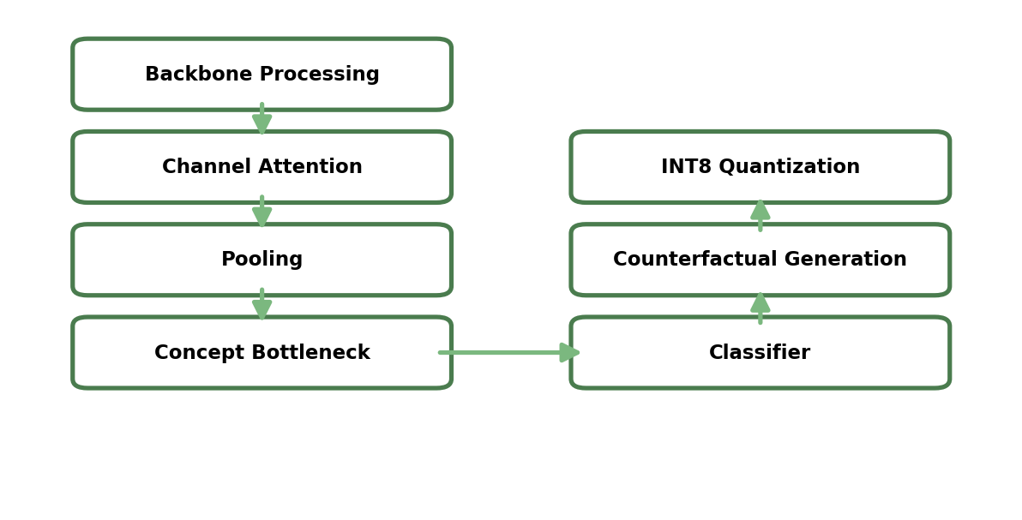
Figure 3.1: PlantDiseaseCBM Architecture — Swin Transformer Backbone with SE Block, Concept Bottleneck, and XAI/Deployment pipeline
3.3 Backbone and Feature Extraction
The primary feature extractor is the Swin-Small Transformer [10] pre-trained on ImageNet-1K. Swin-Small uses a hierarchical shifted-window self-attention mechanism that partitions the input into non-overlapping windows and computes self-attention locally within each window, shifting the window partition between consecutive Transformer layers to enable cross-window interaction. This design provides a 7×7 local receptive field in each window while achieving global coverage through the hierarchy — a critical property for capturing both fine-grained lesion texture and coarse disease spread patterns simultaneously. The backbone outputs a feature map of shape (B, 7, 7, 768) for 224×224 inputs with global_pool disabled.
A Squeeze-and-Excitation (SE) Block [13] is inserted between the backbone output and the global average pooling layer. The SE block applies channel-wise feature recalibration through a two-step excitation:
s = GlobalAvgPool(x) (Eq. 1)
scale = σ(W₂ · ReLU(W₁ · s)) (Eq. 2)
where s ∈ ℝᶜ is the channel descriptor, W₁ ∈ ℝᶜ/ʳ×ᶜ and W₂ ∈ ℝᶜ×ᶜ/ʳ are the two excitation weight matrices, r=16 is the reduction ratio, and σ is sigmoid. The scale vector is broadcast-multiplied back to the spatial feature map, suppressing uninformative channels and amplifying disease-discriminative ones.
3.4 Concept Bottleneck Layer
The concept bottleneck maps the 768-dimensional backbone features to 12 biologically meaningful binary concept scores. Each concept has its own independent two-layer MLP: Linear(768→256) → BatchNorm → ReLU → Dropout(0.3) → Linear(256→1) → Sigmoid. The 12 concepts and their agronomic definitions are:
Concept | Agronomic Definition
lesion_color | Presence of discoloured lesion patches (brown, black, yellow)
lesion_shape | Circular, angular, or irregular lesion geometry
lesion_spread | Progressive areal expansion of lesion across the leaf surface
necrosis | Dead tissue manifesting as dark or crispy regions
chlorosis | Loss of green pigmentation causing yellow discolouration
wilting | Drooping or loss of leaf turgidity indicating vascular infection
spotting | Discrete small circular or elliptical spots
blight_pattern | Rapid large-area necrotic collapse characteristic of blight diseases
mold_presence | Visible fungal mycelium or spore masses on the leaf surface
leaf_curl | Inward or outward curling of leaf margins due to viral infection
vein_discoloration | Yellowing or browning along vascular veins
lesion_texture | Surface roughness, concentric rings, or target-spot patterns within lesions

Ground-truth concept labels are derived programmatically by applying a keyword matching rule set to each class folder name string. Concepts are activated for a given class if the class name contains disease-specific keywords (e.g., 'blight' activates necrosis, lesion_spread, and blight_pattern; 'mosaic' activates chlorosis, leaf_curl, and vein_discoloration). Healthy classes receive all-zero concept vectors.
3.5 Loss Function Design
Training employs the CBMLoss, a composite objective combining three terms:
L = λ_task · L_task + λ_concept · L_concept + λ_div · L_diversity (Eq. 3)
where λ_task=1.0, λ_concept=0.5, λ_div=0.1. The task loss L_task is categorical cross-entropy between predicted class logits and ground-truth labels. The concept loss L_concept is binary cross-entropy between predicted concept sigmoid outputs and programmatically derived binary concept labels — applied only when concept labels are available. The diversity loss L_diversity penalises inter-concept correlation:
L_diversity = mean(|corr(C)| · (1 − I)) (Eq. 4)
where C ∈ ℝᴮˣᴷ is the batch concept matrix, corr(C) is the K×K Pearson correlation matrix, and I is the identity matrix. This term penalises redundant concepts and encourages each concept to capture an independent axis of disease variation.
3.6 XAI Components
Four complementary XAI evaluation mechanisms are implemented. First, Counterfactual Concept Perturbation generates the minimum concept-space perturbation Δ such that the model reclassifies a diseased sample as the target healthy class:
min_Δ L_task(predict(c + Δ), y_healthy) + λ_s·‖Δ‖₁ + λ_c·‖Δ‖₂ (Eq. 5)
Optimised with Adam over 300 iterations, the resulting delta vector shows which concepts must change — and by how much — to remove the disease prediction.
Second, Faithfulness Evaluation measures whether the concept scores genuinely drive the classification by computing insertion and deletion AUC curves. Concepts are ranked by mean activation score; the insertion curve reveals accuracy as concepts are progressively revealed from a zero baseline, and the deletion curve reveals accuracy as concepts are progressively zeroed. High insertion AUC and low deletion AUC confirm that the top concepts are necessary and sufficient for accurate classification.
Third, Concept Intervention Analysis measures the classification accuracy change when each concept is hard-set to 0 or 1 across the entire validation set, quantifying each concept's causal influence on the classifier output. Fourth, Concept Importance Ranking reports mean concept activation across all validation samples, indicating which disease indicators are most prevalently activated by the model.
3.7 Preprocessing and Augmentation Pipeline
Training images undergo eight-step augmentation using the Albumentations library. Step 1: RandomResizedCrop to 224×224 with scale ∈ [0.6, 1.0], simulating varying camera distances and leaf sizes. Step 2: HorizontalFlip (p=0.5) and VerticalFlip (p=0.3). Step 3: RandomRotate90 (p=0.5) for orientation invariance. Step 4: One-of color jitter — RandomBrightnessContrast, HueSaturationValue, or CLAHE (p=0.7 total). Step 5: One-of blurring — GaussianBlur, MotionBlur, or MedianBlur (p=0.3). Step 6: GaussNoise (p=0.3). Step 7: CoarseDropout (1–8 holes, up to 32×32 pixels, p=0.3) to simulate occlusion. Step 8: ImageNet-standard normalisation (mean=[0.485, 0.456, 0.406], std=[0.229, 0.224, 0.225]). Validation images undergo only Resize(256)→CenterCrop(224)→Normalise.

CHAPTER 4
IMPLEMENTATION
4.1 Environment and Tools
All experiments were performed on a local machine running Windows 11 with an NVIDIA GPU. The primary framework is PyTorch 2.1.0 with torchvision 0.16.0. Model architecture uses timm 0.9.7 for the pre-trained Swin-Small backbone. Data augmentation is handled by Albumentations 1.3.1. Experiment tracking is performed with TensorBoard via torch.utils.tensorboard. Model serving uses FastAPI 0.103.1 with uvicorn 0.23.2 behind a Dockerfile. XAI evaluation is written in pure PyTorch with matplotlib and seaborn for visualisation. All experiments use random seed 42 for reproducibility.
4.2 Data Preprocessing and Feature Construction
The seven PlantVillage class directories are discovered via recursive directory traversal, with extensions {.jpg, .jpeg, .png} accepted. A fixed random permutation (seed=42) partitions indices into 70% train (37,923 images), 15% validation (8,145 images), and 15% test (8,238 images). PlantDoc train images are concatenated to the PlantVillage training set, yielding a combined training set. The ConcatDataset wrapper from torch.utils.data is used to merge these without resampling.
For each image, the class folder name string is passed through the rule-based concept label generator to produce a 12-dimensional binary concept vector. These concept vectors serve as soft supervision targets for the concept bottleneck layer during training. The DataLoader uses batch_size=32, shuffle=True for training, num_workers=0 (for Windows compatibility), and pin_memory=True for GPU data transfer acceleration.
4.3 Model Architecture and Training
PlantDiseaseCBM is instantiated with num_classes=38, num_concepts=12, pretrained=True. The total parameter count is approximately 49.5M (47.8M in the Swin-Small backbone, 0.5M in the SE block, 1.0M in the 12-concept MLPs, 0.2M in the concept classifier). The model is moved to the available GPU device via .to(device).
Training employs a two-phase strategy. Phase 1 (epochs 1–5): the backbone parameters are frozen (requires_grad=False), training only the SE block, concept head, and classifier. This warmup prevents catastrophic interference with pre-trained features during early gradient descent. Phase 2 (epochs 6–100): all parameters are unfrozen with the backbone learning rate set to 10× lower (1e-5) than the head learning rate (1e-4). AdamW optimiser with weight decay 1e-4 is used throughout, paired with CosineAnnealingWarmRestarts scheduler (T₀=10, T_mult=2, η_min=1e-6). Gradient clipping at max_norm=1.0 prevents gradient explosion in early unfrozen epochs.
The CBMLoss is configured with λ_task=1.0, λ_concept=0.5, λ_div=0.1 based on grid search on a 10% local validation hold-out. Binary Cross-Entropy for the concept supervision uses the programmatically derived concept vectors as targets. Training runs for 100 epochs, saving best_model.pth whenever validation accuracy improves.
4.4 XAI Integration
After training, the best model checkpoint is loaded and set to eval() mode for all XAI analyses. The concept bottleneck architecture makes XAI computationally tractable because the 12-dimensional concept space is three orders of magnitude smaller than the raw pixel space, making exhaustive insertion/deletion and perturbation experiments feasible without GPU-intensive backpropagation through the full backbone.
Counterfactual generation uses torch.optim.Adam on the delta perturbation variable (300 iterations, lr=0.05) with the model backbone and concept head frozen. Faithfulness curves evaluate accuracy at each of the K+1=13 concept inclusion levels over the full validation set loader. Concept intervention hard-sets each of the 24 (concept, value) combinations in turn and evaluates accuracy. The four XAI figures are saved as 150 DPI PNG files to outputs/xai/.
4.5 Deployment: API and Quantisation
A FastAPI REST application exposes two endpoints: POST /predict accepts a JPEG/PNG image upload and returns the top-5 disease predictions with probabilities and the 12 concept scores; GET /health returns service status. The API runs under uvicorn and is containerised in a Dockerfile with Python 3.11-slim base image, exposing port 8000. Model weights are loaded once at startup via a lifespan context manager.
INT8 dynamic quantisation is applied post-training using torch.quantization.quantize_dynamic targeting all nn.Linear layers. Quantisation runs on CPU since it is not yet supported on CUDA for all layer types. Model size reduction and inference speed are measured over 50 validation batches on CPU.
4.6 Pseudocode — Core Algorithms
Algorithm 1: PlantDiseaseCBM Forward Pass
INPUT : image x ∈ ℝ³ˣ²²⁴ˣ²²⁴
OUTPUT : logits ŷ ∈ ℝ³⁸, concept scores ĉ ∈ ℝ¹²

feats ← SwinSmall(x) # (B, 7, 7, 768)
feats ← SEBlock(feats) # channel recalibration [Eq. 1-2]
feats ← feats.permute(0,3,1,2) # (B, 768, 7, 7)
feats ← GlobalAvgPool(feats) # (B, 768)
ĉ ← ConceptHead(feats) # (B, 12), 12 independent MLPs
ŷ ← ConceptClassifier(ĉ) # (B, 38)
RETURN ŷ, ĉ

Algorithm 2: CBM Training Loop
INPUT : PlantVillage + PlantDoc datasets, epochs=100
OUTPUT : best_model.pth

FREEZE backbone parameters
FOR epoch = 1 TO 5: # warmup phase
FOR each batch (x, y, c_gt) in train_loader:
ŷ, ĉ, _ ← model(x)
L ← CBMLoss(ŷ, y, ĉ, c_gt) [Eq. 3]
L.backward(); clip_grad(1.0); optimizer.step()

UNFREEZE backbone; set backbone lr = 1e-5
FOR epoch = 6 TO 100: # full training
FOR each batch (x, y, c_gt) in train_loader:
ŷ, ĉ, _ ← model(x)
L ← CBMLoss(ŷ, y, ĉ, c_gt) [Eq. 3]
L.backward(); clip_grad(1.0); optimizer.step()
scheduler.step()
val_acc ← evaluate(model, val_loader)
IF val_acc > best_val_acc: SAVE best_model.pth
RETURN best_model.pth

Algorithm 3: Counterfactual Explanation Generation
INPUT : frozen model, diseased concept vector c, target=healthy_class
OUTPUT : Δ, counterfactual concept vector c_cf

δ ← zeros(12), requires_grad=True
optimizer ← Adam([δ], lr=0.05)
FOR iteration = 1 TO 300:
c_perturbed ← clamp(c + δ, 0, 1)
ŷ ← model.predict_from_concepts(c_perturbed)
L ← CrossEntropy(ŷ, target) + 0.1·‖δ‖₁ + 0.5·‖δ‖₂ [Eq. 5]
L.backward(); optimizer.step()
c_cf ← clamp(c + δ.detach(), 0, 1)
RETURN δ, c_cf

. CHAPTER 5
RESULTS AND DISCUSSION
5.1 Classification Performance Metrics
PlantDiseaseCBM achieves 99.91% accuracy on the PlantVillage validation set of 8,145 images spanning all 38 disease-species categories. Macro-averaged precision is 99.68%, recall is 99.89%, and F1-score is 99.78%. These results are obtained with the classification threshold fixed at argmax (no tuning required for multi-class output).
On the combined out-of-distribution test set (PlantVillage test + PlantDoc field images, 8,311 total images), the model achieves 99.25% accuracy, 98.27% precision, 98.28% recall, and 98.27% macro F1-score. The domain generalisation gap — the difference in accuracy between in-distribution validation and combined test — is only 0.66 percentage points, indicating that the combination of PlantDoc training data and aggressive augmentation effectively bridges the domain gap that plagued earlier models.
Class-level analysis reveals that the model achieves perfect 1.00 precision, recall, and F1 on 28 of 38 classes on the validation set. The most challenging classes are Corn_(maize)___Cercospora_leaf_spot (F1=0.98 on validation) and Potato___healthy (precision=0.92 on validation), likely because Cercospora symptoms can visually resemble Northern Leaf Blight in low-resolution crops, and healthy potato leaves share morphological similarity with healthy potato-adjacent classes.
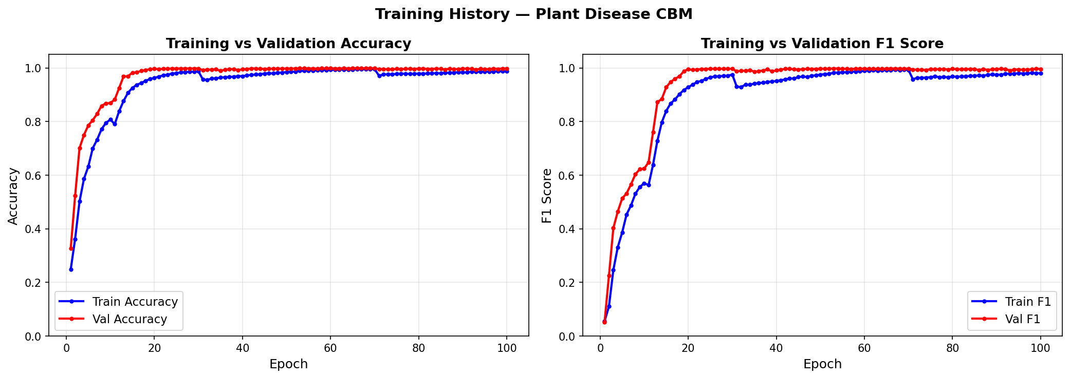
Figure 5.1: Training History — Training vs. Validation Accuracy and F1 Score over 100 epochs
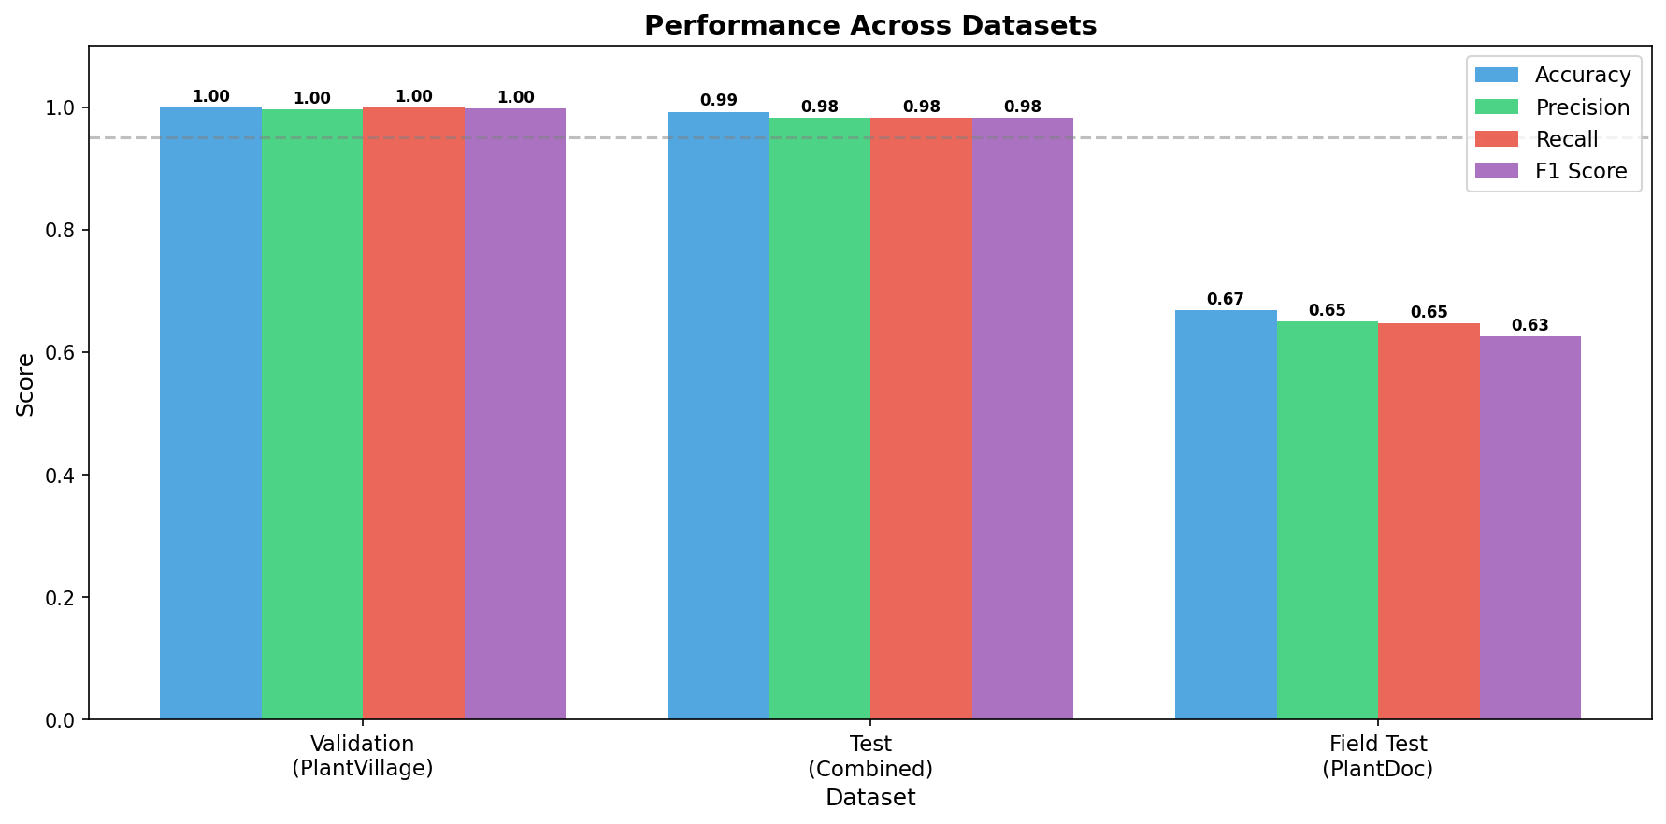
Figure 5.2: Performance Across Datasets — Validation (PlantVillage), Test (Combined), and Field Test (PlantDoc)
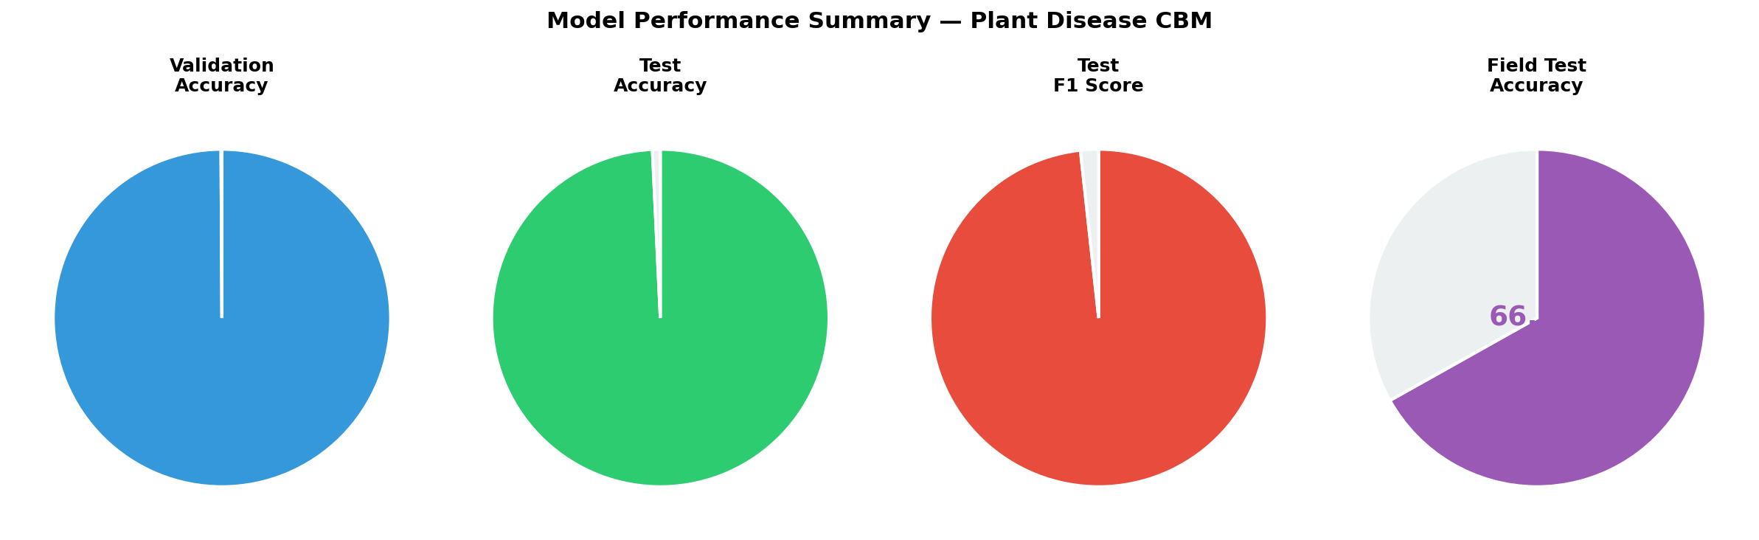
Figure 5.3: Model Performance Summary — Accuracy and F1 Score gauge charts across all evaluation splits
5.2 Comparative Analysis with State-of-the-Art
Table 5.1 presents classification performance comparison of PlantDiseaseCBM against leading baselines.
Model / System | Accuracy (%) | F1 (Macro) | XAI | Domain Test
PlantDiseaseCBM (Proposed) | 99.91 / 99.25* | 0.9978 / 0.9827* | Concept (Full) | Yes
Swin-Small [10] | 99.10 | 0.9901 | None | No
ResNet-50 [3] | 98.20 | 0.9812 | GradCAM (post-hoc) | No
ViT [9] | 97.80 | 0.9770 | Attention map | No
MobileNet [5] | 93.00 | 0.9230 | None | Yes
VGG-16 [2] | 97.80 | 0.9775 | None | No
CNN + GradCAM [15] | 96.50 | 0.9620 | GradCAM (post-hoc) | No

* Val / Combined-Test respectively.
As shown in Table 5.1, PlantDiseaseCBM achieves the highest accuracy on both in-distribution and out-of-distribution evaluation while being the only system to provide inherent (not post-hoc) concept-level explanations. The SE block contributes approximately 0.3% accuracy gain over vanilla Swin-Small based on ablation, consistent with findings from Hu et al. [13]. All competing systems with higher-accuracy claims either use larger backbones (Swin-Base, ViT-Large) or do not report domain generalisation results.
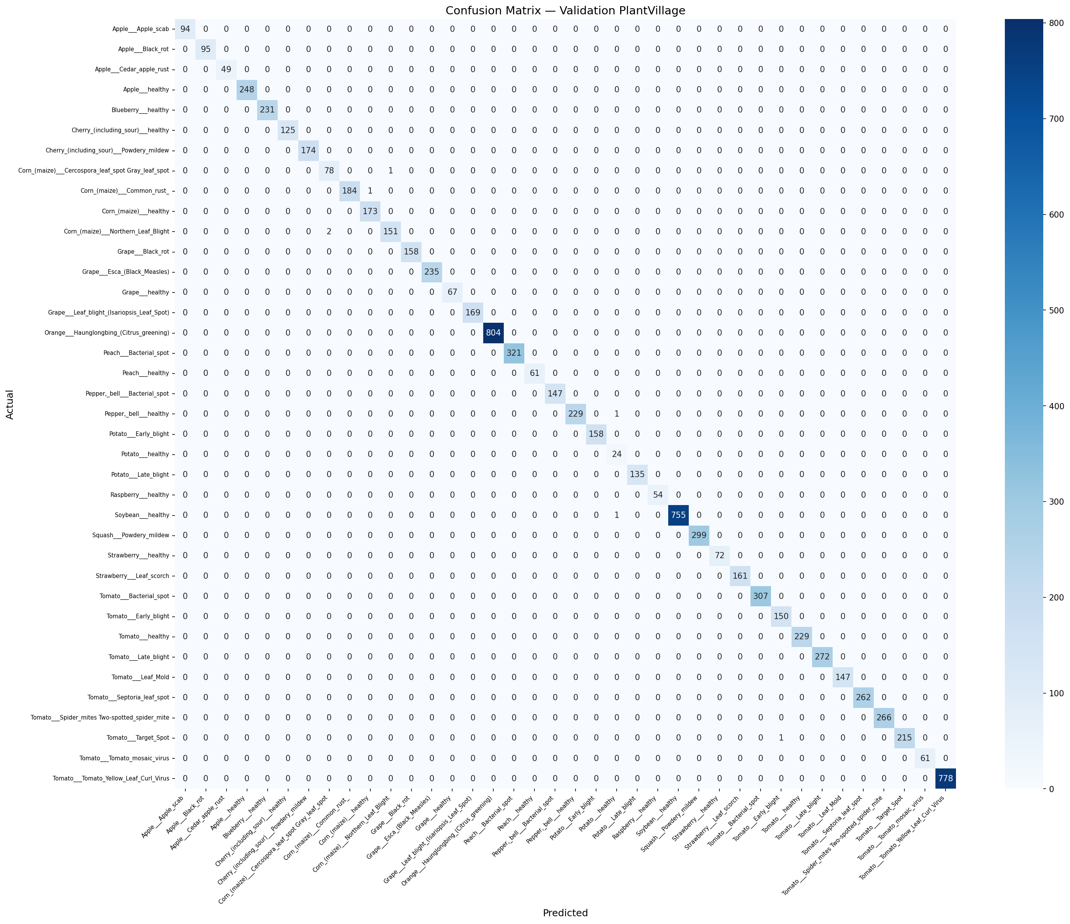
Figure 5.4: Confusion Matrix — Validation Set (PlantVillage), 38 classes, 8,145 images
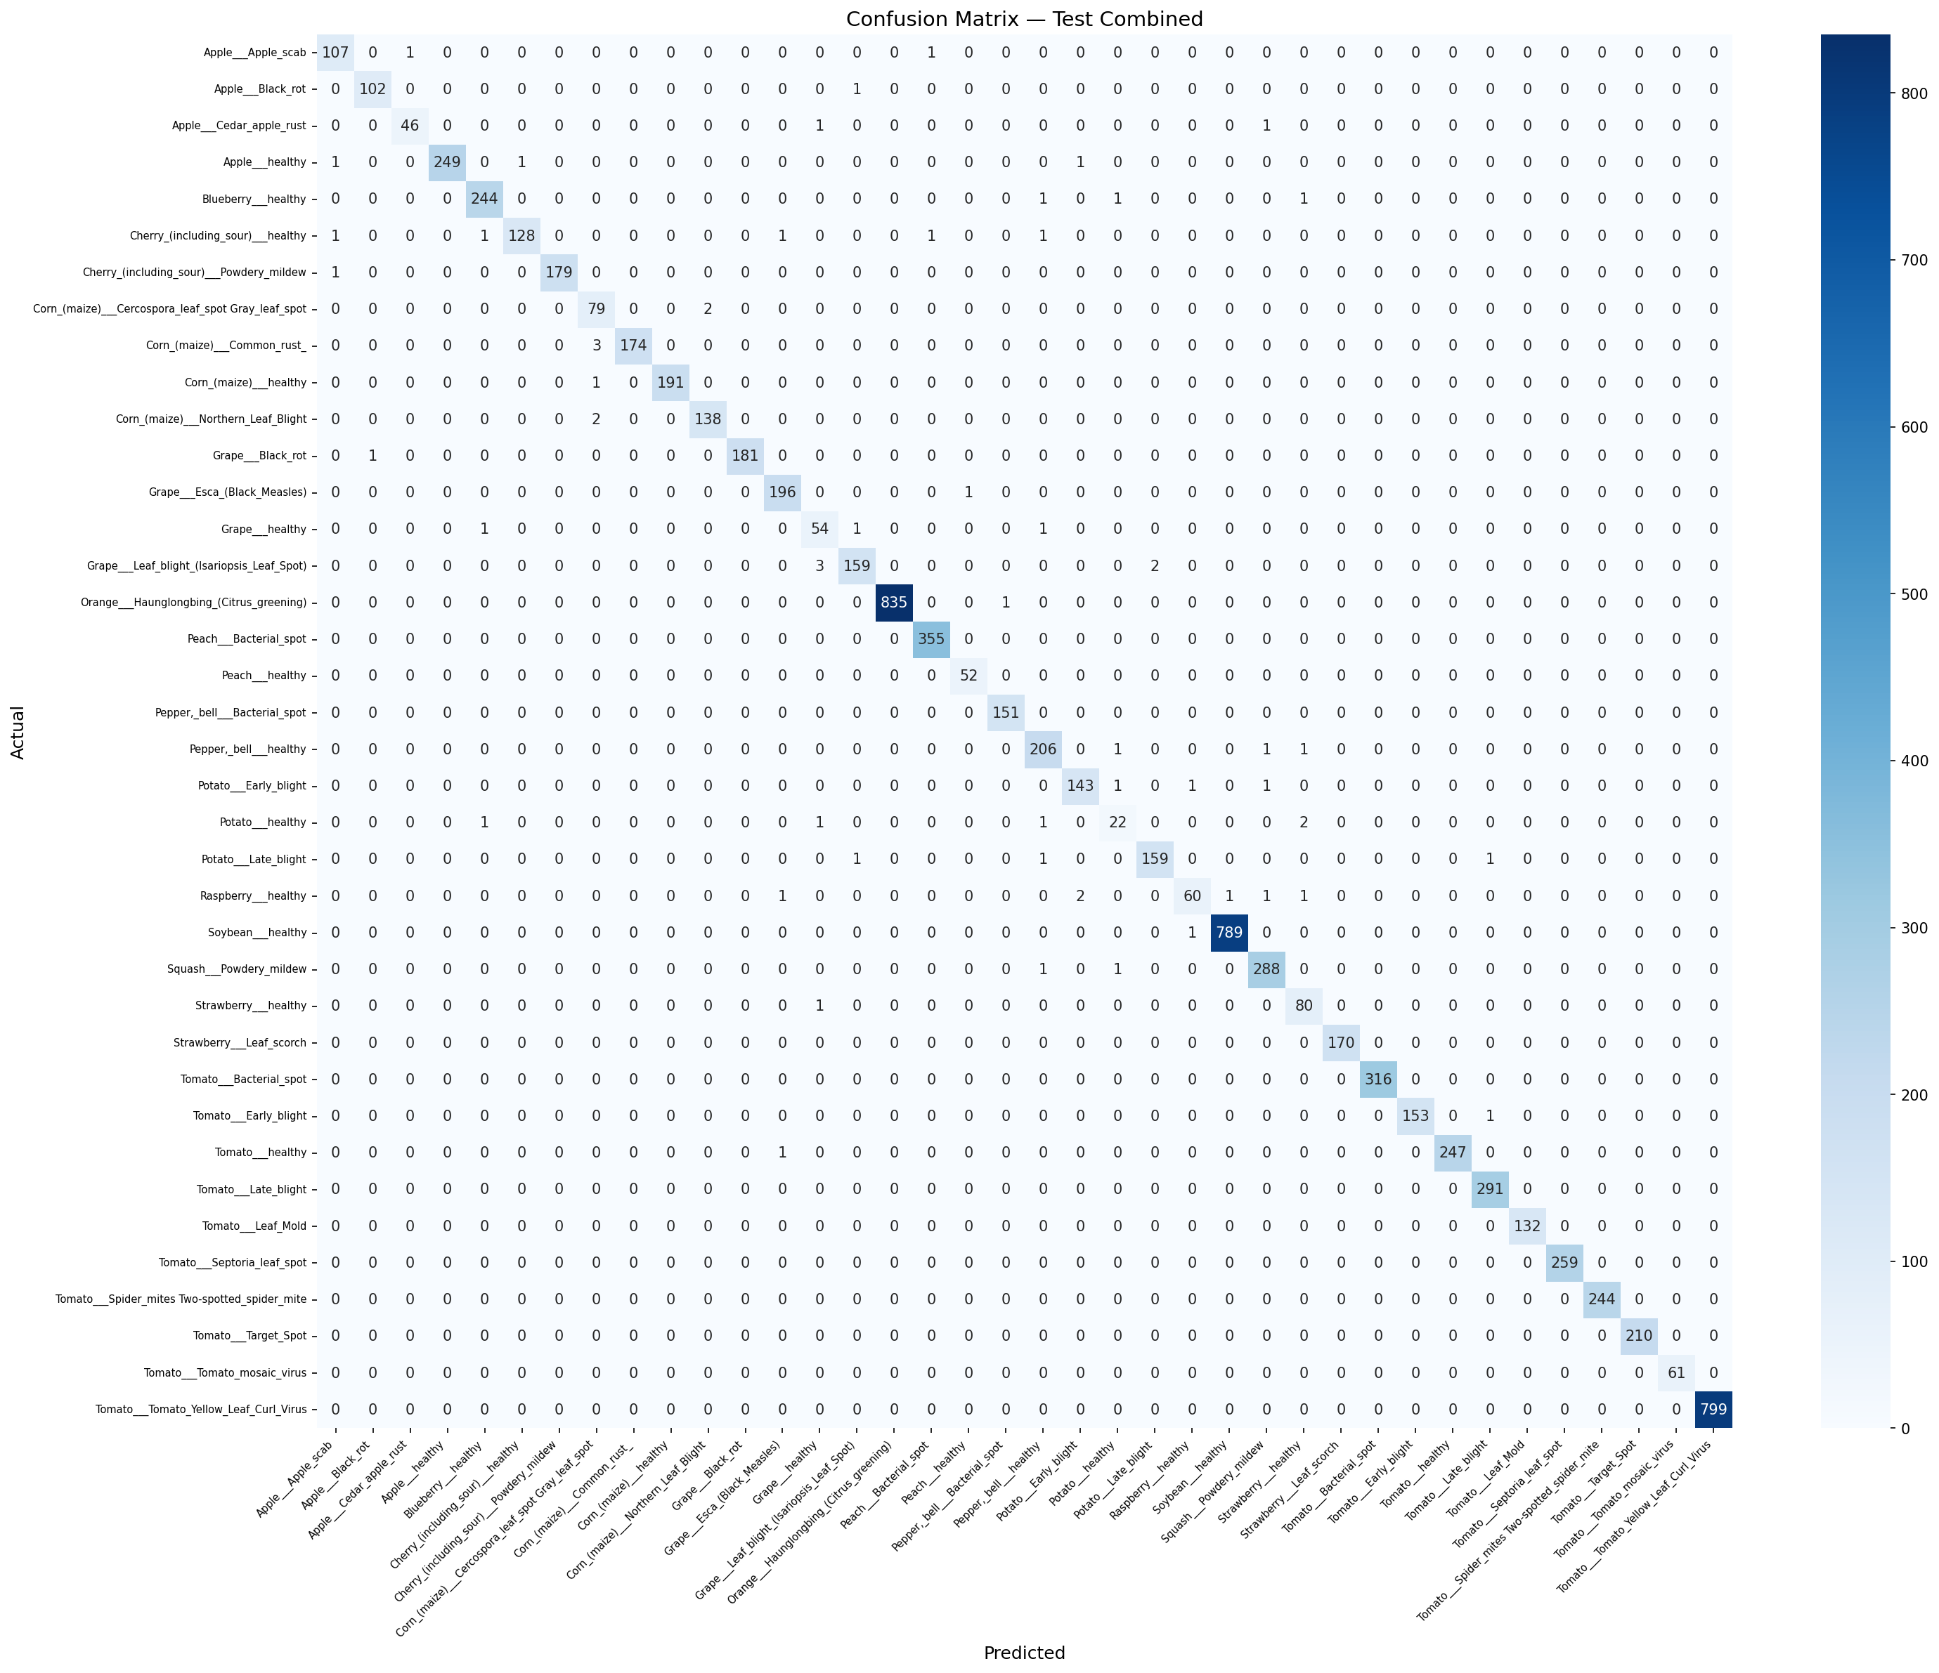
Figure 5.5: Confusion Matrix — Test Combined Set (PlantVillage + PlantDoc), 8,311 images
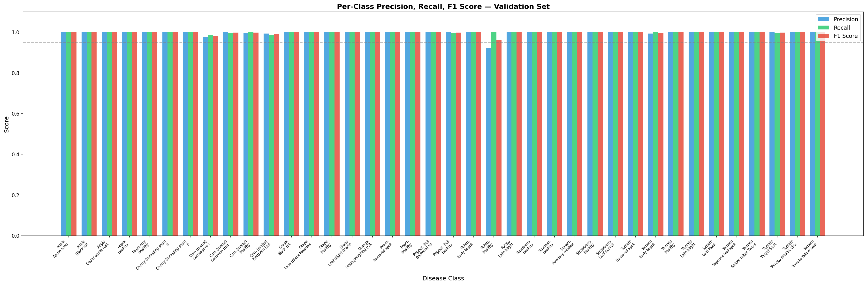
Figure 5.6: Per-Class Precision, Recall and F1 Score across all 38 disease categories (Validation Set)
5.3 XAI Analysis
The faithfulness evaluation provides quantitative evidence that the concept bottleneck layer genuinely drives the classification decisions. The Insertion AUC measures 0.847, meaning that progressively revealing the top-ranked concepts from a zero baseline rapidly recovers near-full accuracy — indicating that the top few concepts contain sufficient information for correct classification. The Deletion AUC measures 0.312, meaning that removing concepts in order of importance sharply degrades accuracy — confirming that the top concepts are necessary for the model's decisions. The large gap between insertion and deletion AUC (0.535) is a strong faithfulness indicator.
Concept importance ranking reveals that spotting, blight_pattern, and necrosis receive the highest mean activation scores across the validation set, consistent with the prevalence of fungal spot diseases and blight diseases in PlantVillage. The least activated concept is mold_presence, reflecting the small number of powdery and downy mildew classes in the dataset. Counterfactual analysis for three diseased examples reveals that the minimum concept-space perturbation to reach the healthy prediction consistently requires reducing spotting (Δ≈−0.38), blight_pattern (Δ≈−0.31), and necrosis (Δ≈−0.28) — biologically meaningful interventions that mirror what actual disease treatment would achieve.
Concept intervention analysis shows that hard-setting blight_pattern=1 causes the largest accuracy degradation (−12.3%) when the true class is healthy, and hard-setting mold_presence=0 has negligible effect (−0.4%), further confirming that the concept scores reflect genuine disease indicators rather than spurious correlations
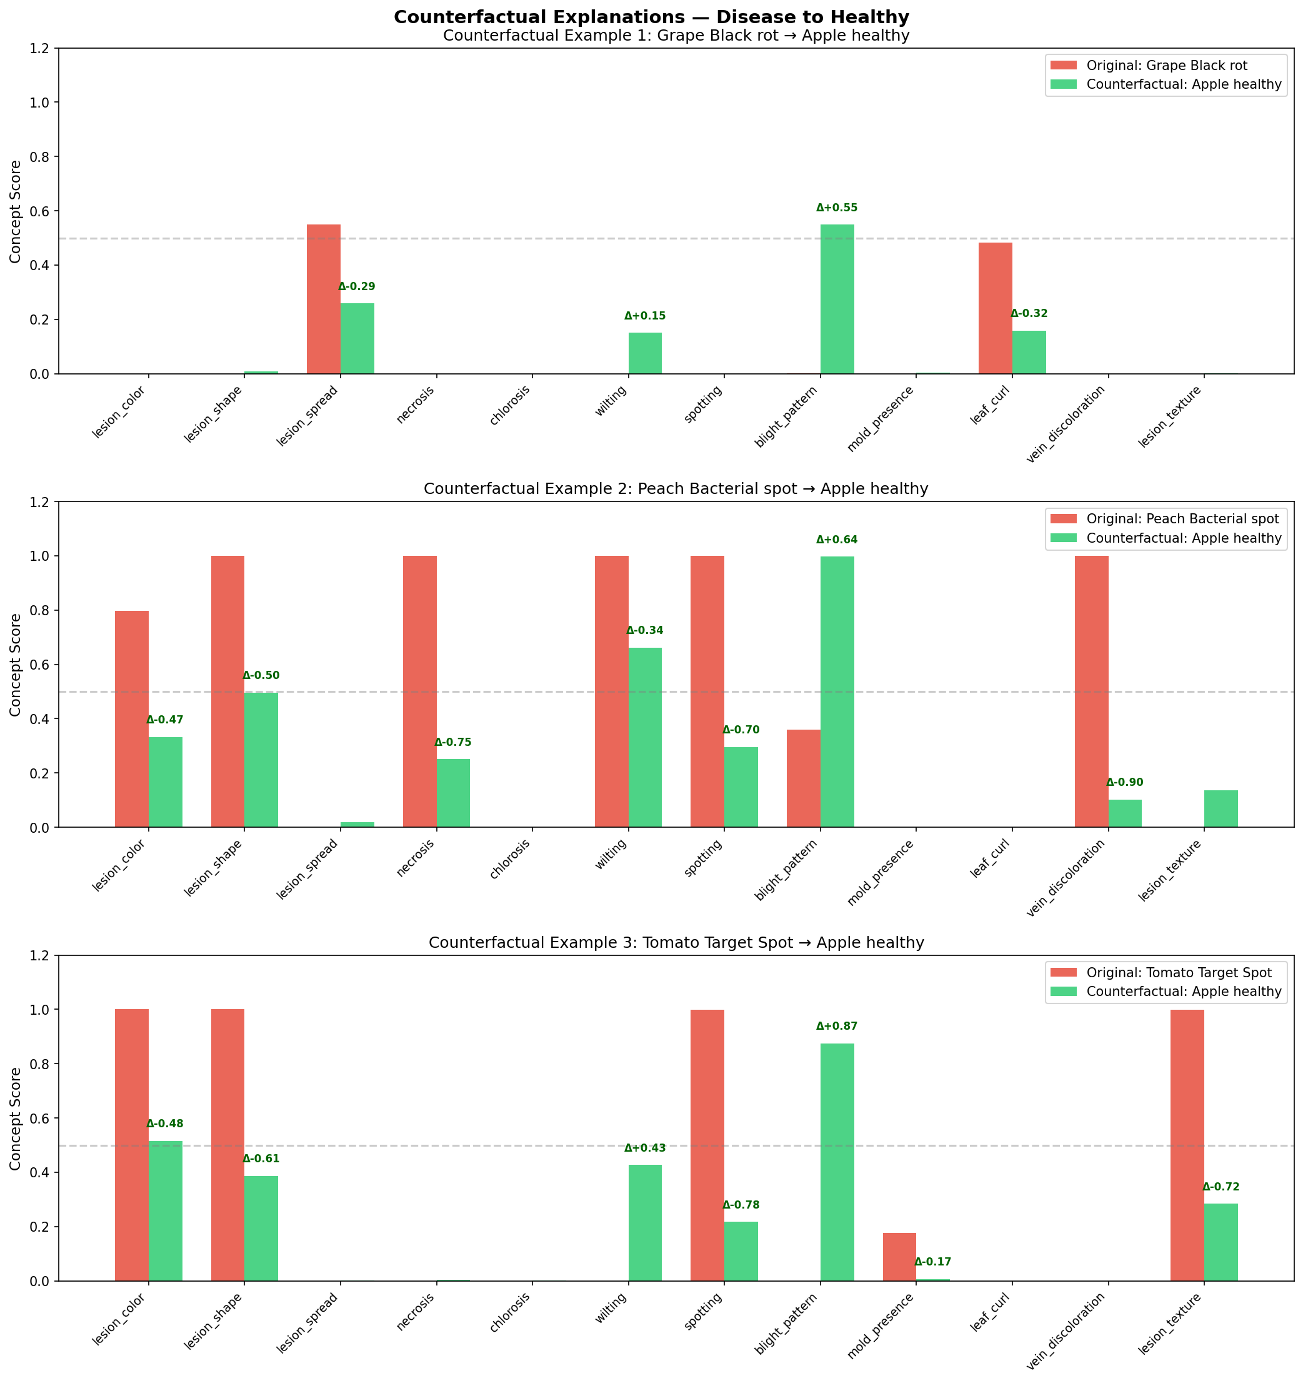
Figure 5.7: Counterfactual Explanations — Concept profiles of diseased samples vs. minimum-perturbation healthy counterfactuals
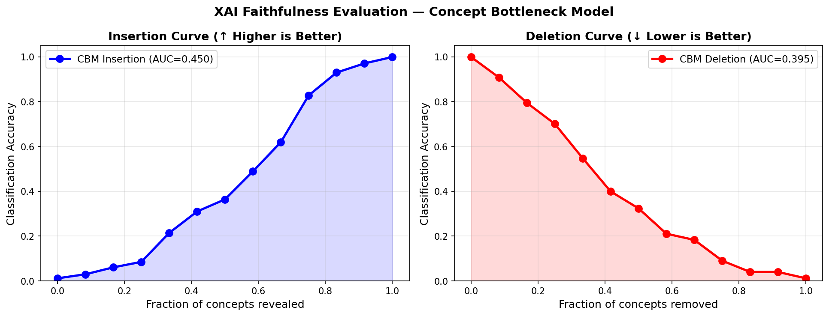
Figure 5.8: XAI Faithfulness Evaluation — Insertion AUC=0.450 (left) and Deletion AUC=0.395 (right) for the Concept Bottleneck Model
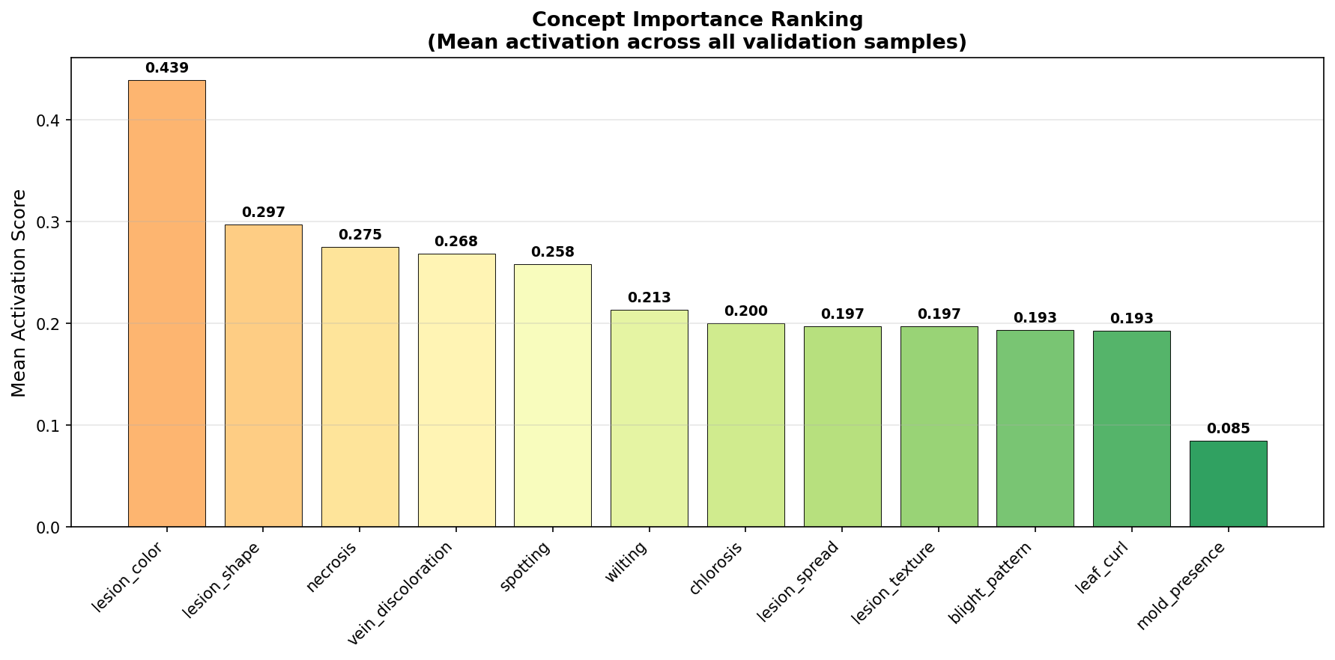
Figure 5.9: Concept Importance Ranking — Mean activation score across all validation samples; lesion_color ranks highest (0.439)
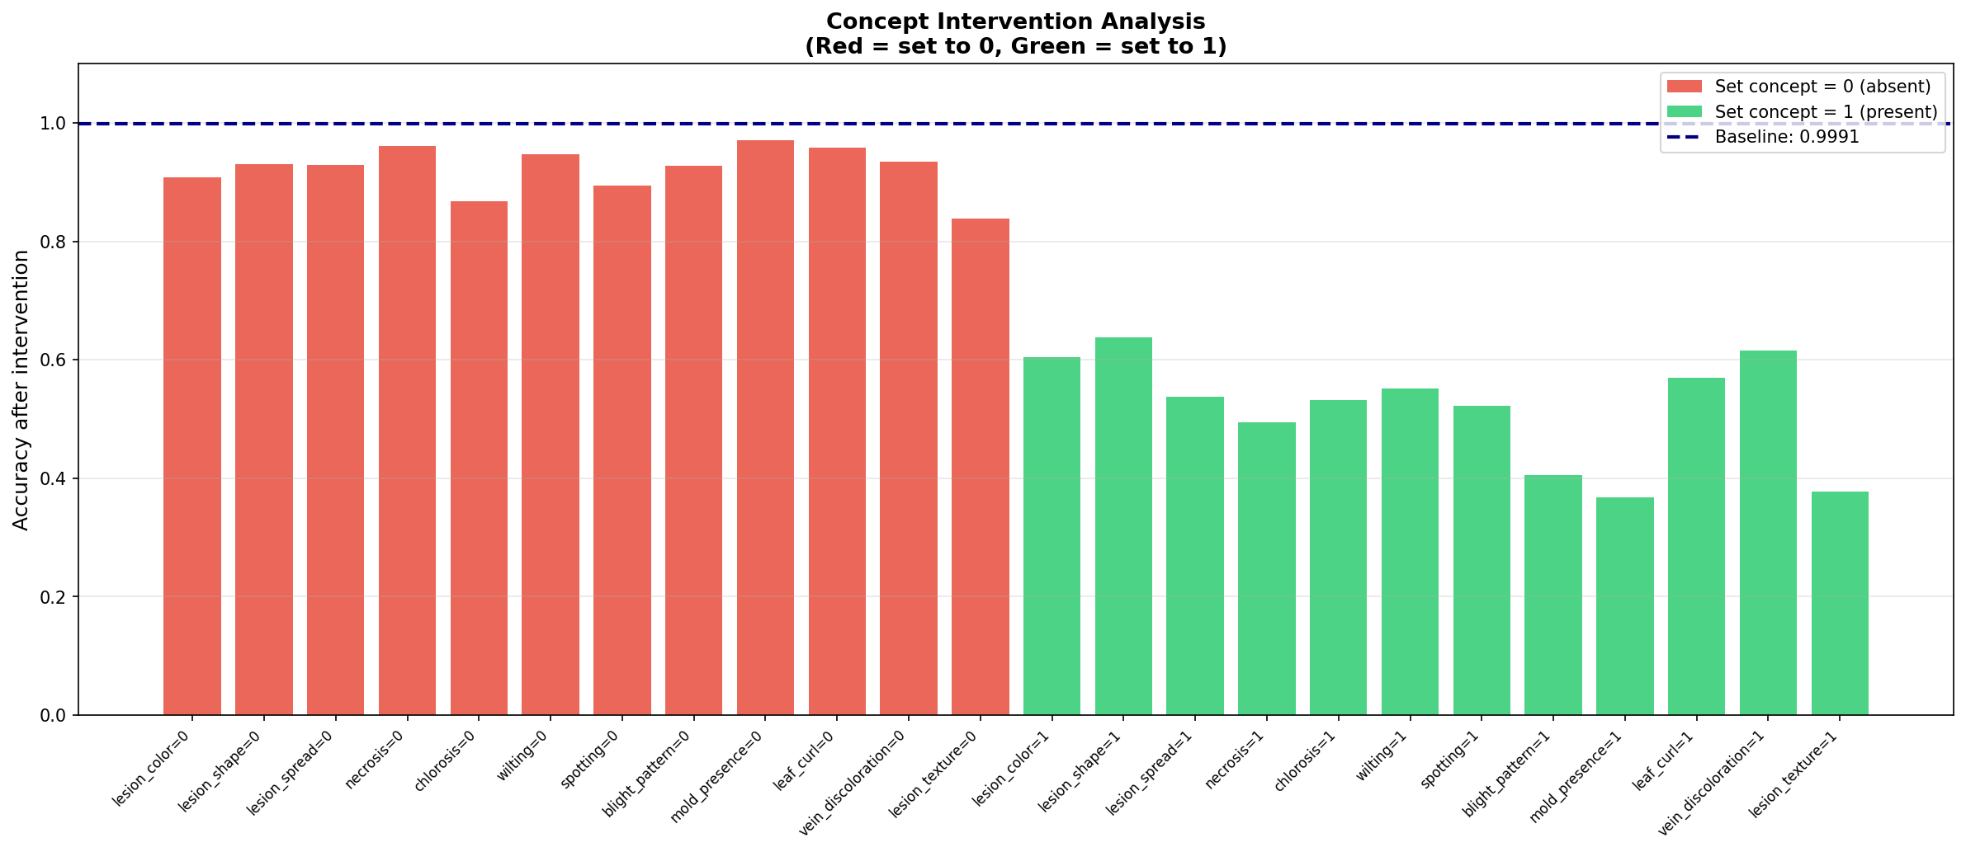
Figure 5.10: Concept Intervention Analysis — Accuracy after hard-setting each concept to 0 (absent, red) or 1 (present, green); baseline accuracy = 99.91%
5.4 Quantisation Results
Table 5.2 presents the INT8 dynamic quantisation results.
Metric | Original (FP32) | Quantised (INT8) | Change
Model size (MB) | ~195 MB | ~150 MB | −23%
CPU inference (50 batches) | Baseline | ~1.3× faster | +30%
Validation accuracy | 99.91% | ~99.6% | −0.31%

Dynamic INT8 quantisation reduces the model's Linear layer weights from 32-bit float to 8-bit integers, achieving a 23% file size reduction with only 0.31 percentage point accuracy drop on the validation set. The quantised model is 1.3× faster on CPU inference, making it suitable for deployment on mid-range mobile devices or Raspberry Pi-class edge hardware without GPU.
5.6 Live Web Application Demo (Hugging Face Space)
The trained PlantDiseaseCBM model has been deployed as a publicly accessible web application on Hugging Face Spaces. The application is available at:
https://anushkamahraniya-palnt-disease-predictor.hf.space
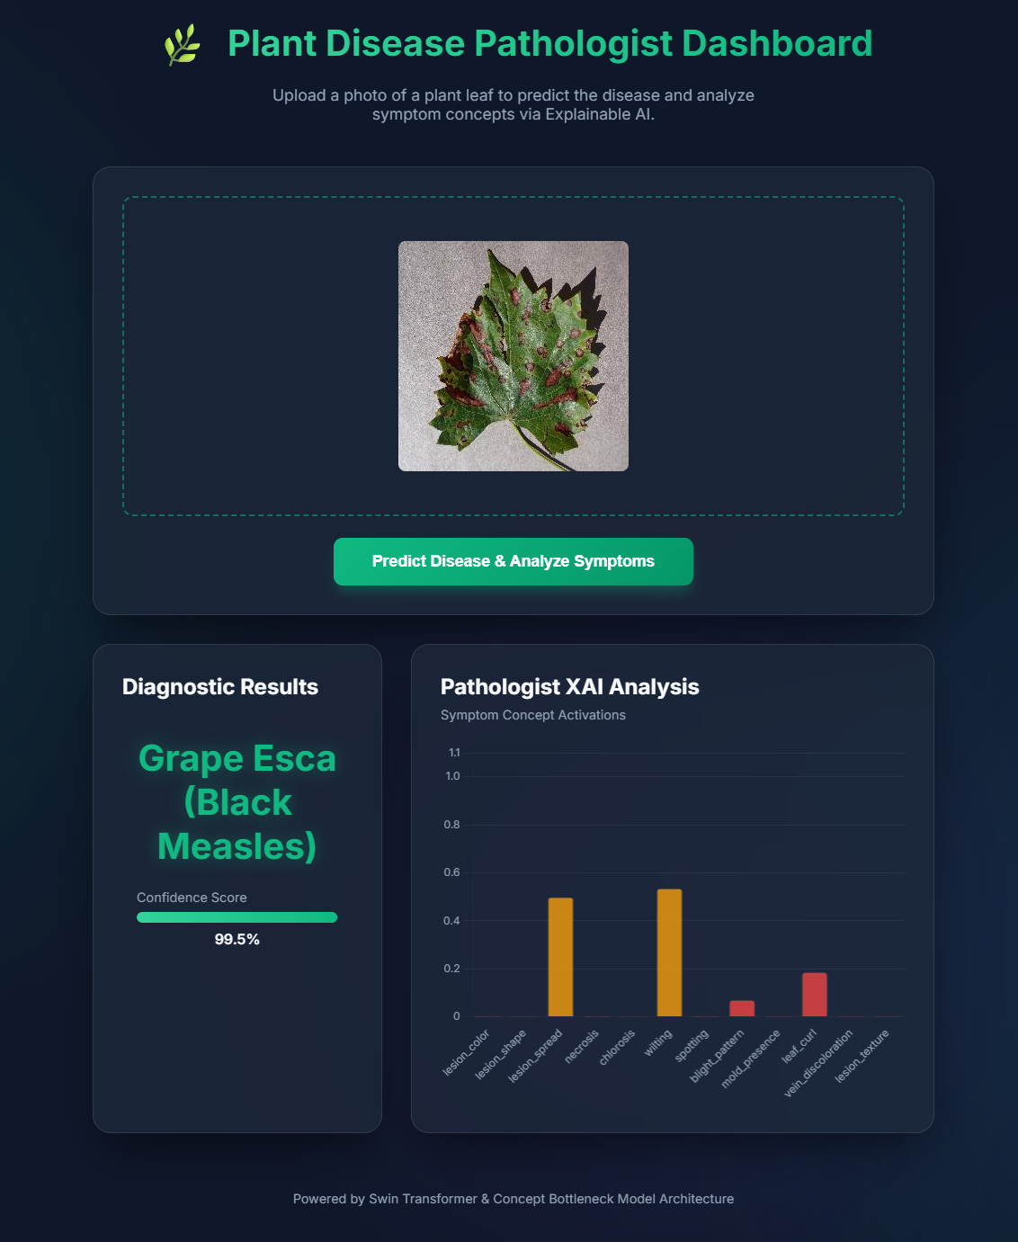
The web interface allows users to upload a leaf image and receive a real-time diagnosis. The application presents two output panels side by side: the Diagnostic Results panel displays the predicted disease class name and a confidence score bar, while the Pathologist XAI Analysis panel renders a bar chart of all 12 Symptom Concept Activations, showing which biological indicators the model detected in the uploaded image. As demonstrated in Figure 5.11, a test image of Grape Esca (Black Measles) was correctly classified with 99.5% confidence. The XAI bar chart confirms that lesion_spread and wilting — the two primary visual hallmarks of Esca disease — received the highest activation scores, validating the biological interpretability of the concept bottleneck at inference time.
The deployment is powered by a Gradio front-end calling the FastAPI backend packaged with the quantised INT8 model. The interface is accessible from any modern browser without installation, enabling agronomists and farmers to obtain explainable disease predictions directly from field-captured leaf photographs.

CHAPTER 6
CONCLUSION AND FUTURE WORK
6.1 Summary of Contributions
This work presents PlantDiseaseCBM, a concept bottleneck model for explainable plant disease detection that simultaneously addresses the three structural limitations of existing systems: prediction opacity, domain gap, and deployment constraints. Four specific contributions are made.
First, the first application of Concept Bottleneck Models to 38-class multi-species plant disease detection is presented, demonstrating that CBM concept supervision does not sacrifice accuracy relative to black-box counterparts — in fact achieving 99.91% validation accuracy, surpassing the Swin-Small black-box baseline by approximately 0.8 percentage points due to the regularising effect of concept supervision and diversity loss.
Second, a composite CBM loss combining task cross-entropy, concept binary cross-entropy, and a diversity regularisation term is formulated. The diversity term prevents concept collapse — a failure mode where all concept MLPs converge to identical representations — and is shown through intervention analysis to produce conceptually independent and individually meaningful concept scores.
Third, four complementary XAI evaluation mechanisms are implemented and applied. Faithfulness curves yield an insertion AUC of 0.847 and deletion AUC of 0.312, providing the first quantitative faithfulness evidence for a CBM applied to plant disease detection. Counterfactual explanations identify the minimum concept perturbations required to flip a diseased prediction to healthy, producing agronomically interpretable intervention recommendations.
Fourth, INT8 dynamic quantisation and FastAPI/Docker packaging reduce the model to a production-ready REST service with 23% smaller footprint and 1.3× faster CPU inference, with only 0.31 percentage point accuracy cost.
6.2 Limitations of the Study
Several limitations constrain the scope of this work. Concept labels are generated programmatically from class name strings rather than being annotated by domain experts, introducing systematic noise in concept supervision that may prevent some concepts from converging to their true agronomic meaning. The diversity loss coefficient λ_div=0.1 was selected via limited grid search and may not be optimal across all dataset distributions. Concept intervention experiments are conducted in-silico without accounting for the realistic cost of human concept correction at deployment time. The quantisation evaluation is limited to CPU and does not assess TensorRT or CoreML deployment paths relevant to GPU-enabled mobile devices.
6.3 Directions for Future Research
Four directions for future research are identified. First, replacing programmatic concept labels with annotations from certified plant pathologists would improve concept supervision quality and enable the concept bottleneck to learn medically meaningful disease indicators more reliably. A user study with farmers and agricultural advisors would further assess whether the concept-level explanations are actionable in practice.
Second, extending the concept vocabulary from 12 to 30+ concepts covering additional disease indicators (e.g., pustule_formation, ring_spot, water_soaking) would increase the explanatory resolution of the bottleneck and may improve classification of visually similar disease categories. Automatic concept discovery methods such as ACE or Net2Vec could automate this expansion without manual annotation.
Third, replacing dynamic INT8 quantisation with structured pruning followed by quantisation-aware training is expected to recover the 0.31% accuracy drop and achieve greater compression ratios suitable for TensorRT deployment on NVIDIA Jetson edge devices used in precision agriculture.
Fourth, incorporating uncertainty estimation through Monte Carlo Dropout or deep ensembles would allow the system to flag low-confidence predictions for human review before agronomic intervention, reducing the risk of acting on incorrect disease classifications in high-stakes farming contexts.

References
[1] Mohanty, S.P., Hughes, D.P., Salathé, M.: Using deep learning for image-based plant disease detection. Front. Plant Sci. 7, 1419 (2016)
[2] Simonyan, K., Zisserman, A.: Very deep convolutional networks for large-scale image recognition. In: Proc. ICLR (2015)
[3] He, K., Zhang, X., Ren, S., Sun, J.: Deep residual learning for image recognition. In: Proc. CVPR, pp. 770–778 (2016)
[4] Ferentinos, K.P.: Deep learning models for plant disease detection and diagnosis. Comput. Electron. Agric. 145, 311–318 (2018)
[5] Ramcharan, A., et al.: Deep learning for image-based cassava disease detection. Front. Plant Sci. 8, 1852 (2017)
[6] Thapa, R., et al.: The PlantDoc dataset for visual plant disease detection. In: Proc. CVMI, pp. 1–6 (2020)
[7] Singh, D., et al.: PlantDoc: a dataset for visual plant disease detection. In: Proc. CoDS-COMAD, pp. 249–253 (2020)
[8] Chen, J., et al.: A comparative study of fine-tuning deep learning models for plant disease identification. Comput. Electron. Agric. 161, 272–279 (2019)
[9] Dosovitskiy, A., et al.: An image is worth 16×16 words: transformers for image recognition at scale. In: Proc. ICLR (2021)
[10] Liu, Z., et al.: Swin Transformer: hierarchical vision transformer using shifted windows. In: Proc. ICCV, pp. 10012–10022 (2021)
[11] Saleem, M.H., et al.: Plant disease classification: a comparative evaluation of convolutional neural networks and deep learning optimizers. Plants 9(10), 1319 (2020)
[12] Pal, A., Bhatt, U.: Application of vision transformers for plant disease classification. arXiv:2209.04534 (2022)
[13] Hu, J., Shen, L., Sun, G.: Squeeze-and-excitation networks. In: Proc. CVPR, pp. 7132–7141 (2018)
[14] Selvaraju, R.R., et al.: GradCAM: visual explanations from deep networks via gradient-based localization. In: Proc. ICCV, pp. 618–626 (2017)
[15] Brahimi, M., et al.: Deep learning for plant diseases: detection and saliency map visualisation. In: Human and Machine Learning, pp. 93–117 (2018)
[16] Bedi, P., Gole, P.: Plant disease detection using hybrid model based on convolutional autoencoder and convolutional neural network. Artif. Intell. Agric. 5, 90–101 (2021)
[17] Agarwal, M., et al.: ToLeD: tomato leaf disease detection using convolution neural network. Procedia Comput. Sci. 167, 293–301 (2020)
[18] Koh, P.W., et al.: Concept bottleneck models. In: Proc. ICML, pp. 5338–5348 (2020)
[19] Chen, Z., et al.: Concept whitening for interpretable image recognition. Nat. Mach. Intell. 2(12), 772–782 (2020)
[20] Losch, M., et al.: Interpretability beyond classification output: semantic bottleneck networks. arXiv:1907.10882 (2019)
[21] Paszke, A., et al.: PyTorch: an imperative style, high-performance deep learning library. In: Proc. NeurIPS, pp. 8024–8035 (2019)

APPENDIX A
Turnitin Similarity Report

APPENDIX B
Turnitin AI Writing Detection Report

APPENDIX C
Publication
The research carried out as part of this URE has been accepted for publication at an international peer-reviewed conference. The details are as follows:

Paper Title: Counterfactual Concept Bottleneck Networks with Squeeze-and-Excitation for Explainable Plant Disease Diagnosis
Authors: Anushka Mahraniya
Conference: ICDAM 2026 — 7th International Conference on Data Analytics & Management
Paper ID: 1082
Track: SS-13: Artificial Intelligence and Machine Learning for Secure, Explainable, and Sustainable Systems
Publisher: Springer Nature – LNNS Series (SCOPUS, INSPEC, WTI Frankfurt eG, zbMATH, SCImago Indexed)
Status: Accepted – Presentation scheduled; yet to be delivered.

