**DHRM – WEB App UAT**

**Test Date:13.02.2023**

1. Unable to delete department in masters. Closed
2. deleted lines are showing while adding employees Closed
3. deleted plants are showing while adding department. Closed
4. Deleted plants and department are showing while adding line masters Closed
5. Deleted plant name, department and line are showing while adding the employee into master Closed
6. Line master unable to update the details Closed
7. If plant having same designation name it is conflicting while updating employee master
8. Employee master unable to update Plant and username Closed
9. Operation master showing deleted plants Closed
10. Shift master is not working as expected. Closed

1.Shift should be linked to some plant. Closed

2.Shift Type should be drop down Regular/Special Closed

3. IS security shift should be drop down Yes/No Closed

1. After submitting basic form of trainee application Hight, weight, dose dates Closed
2. Pass Percentage while adding module should automatically get update based on pass marks and max marks Closed
3. While adding question in to question bank answer should be updated automatically Closed
4. Deleted department, line and reporting person in onboarding Closed
5. Deleted department is also showing in skill development form. Closed
6. Operation trained is not showing in skill development form Closed
7. Supervisor Evaluation save button should be renamed as Approve Closed
8. Department Transfer showing deleted data in department and line Closed
9. File drop for SAP category Is not matching as per given format and file format should be in csv Closed
10. Unable to approve shift change. Closed
11. While rejecting forgot punch, comp-off and over time alert showing request accepted Closed

**Test Date:11.02.2023**

1. Permanent address should get updated same as current address when automatically if **yes** radio button is selected– Closed
2. While filling for trainee application Password should get updated immediately once the 10-digit mobile number is entered. – Closed
3. While relieving save button should be disabled is mandatory fields are not filled. – Closed
4. Only Varanavasi Plant department are displayed in Master. Need to display all Department from all Plants– Closed
5. While adding new plant Address and location is not updated. – closed
6. Priority value for test module should be separate for all plant– Closed
7. While adding employee into employee master Department, Line and designating is not updated– Closed
8. Some time login page UI is getting crashed– Open
9. Need to set default date for department transfer– Closed
10. Post evaluation summary should show tick mark for previous evaluation also– Closed
11. In skill development need to show approved evaluation for HR– Closed
12. In ARS data should load automatically for current month for attendance, comp-off

and overtime– Closed

**Test Date:06.02.2023**

1. UI of home page is overflowing the screen need to align within the screen (Scrolling should be avoided). – Closed
2. While applying application final submit button is disabled even if all the filed are filled and submitted. (Get enabled after refreshing) –closed
3. There is no ID number and Emergency contact number in temporary ID card– Closed

4.Question are not displaying in pre test evaluation– Closed

**Test Date:30.01.2023**

1. Home Page is aligning to screen(Should avoid scrolling)– Closed
2. Photo Is not showing in ID card- Closed
3. Plant, department, line, and shift master is loading blank page. -Closed
4. Unable to load Plant drop down while adding or editing Designation, Employee, Operation- Closed
5. Bank IFSC code not showing while adding the Bank Details- Closed
6. Delete Company from master is still showing while filing trainee Application. - Closed
7. Unable to choose plant name while filling trainee application . - Closed

**Test Date : 22.11.22**

1. Unable to log in into trainee test login-Closed

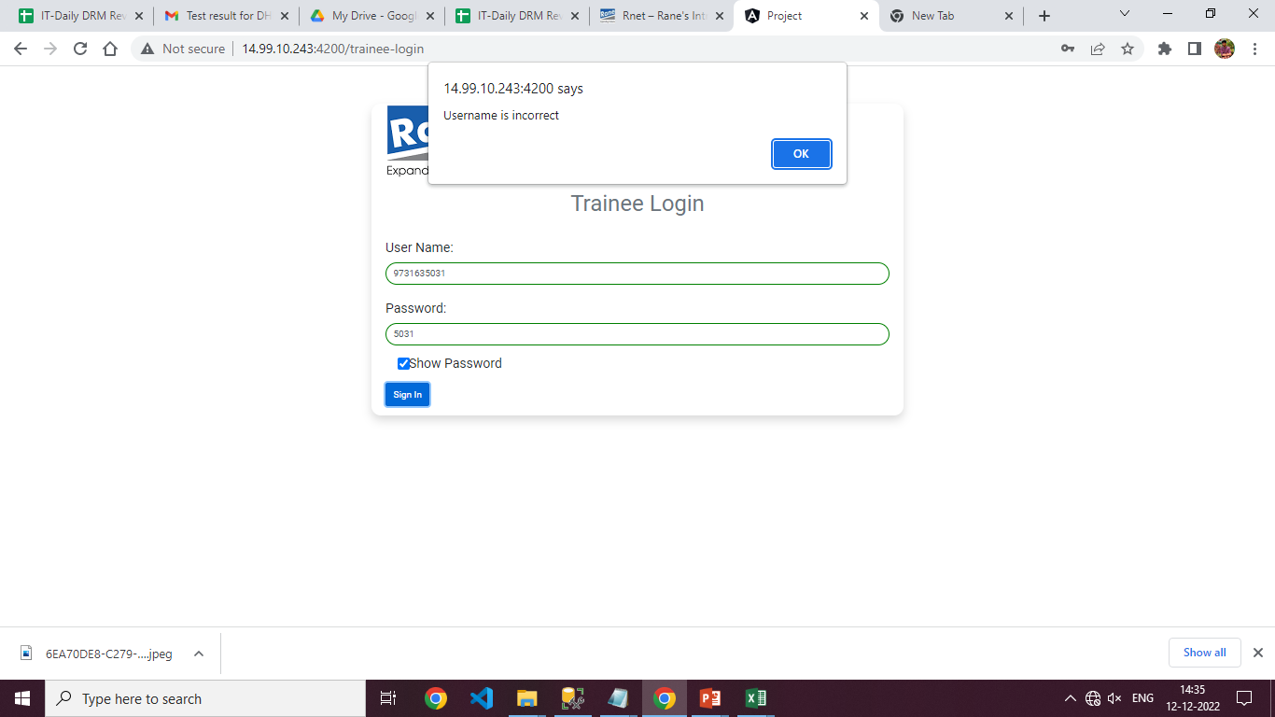

**Test Date : 22.11.22**

1. Some error is trigged while submitting the basic form-Closed
2. Photo Is not showing in ID card- Open

**Test Date : 18.11.22**

1. In some cases submit button in disabled even when all the required fields are filled with proper input – Closed
2. Backend is Getting crashed while submitting the forms. – Closed
3. Need to change the form input field feedback design-Closed

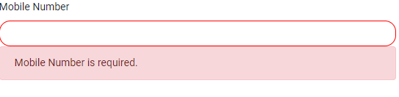

**Test Date : 23.10.22 ( Re-Test on 28.10.22)**

1. Home Page is not aligning for 14” Laptop. - Open
2. Logo Right Side - - Closed
3. Title “Digital HR Management” in Center - Closed

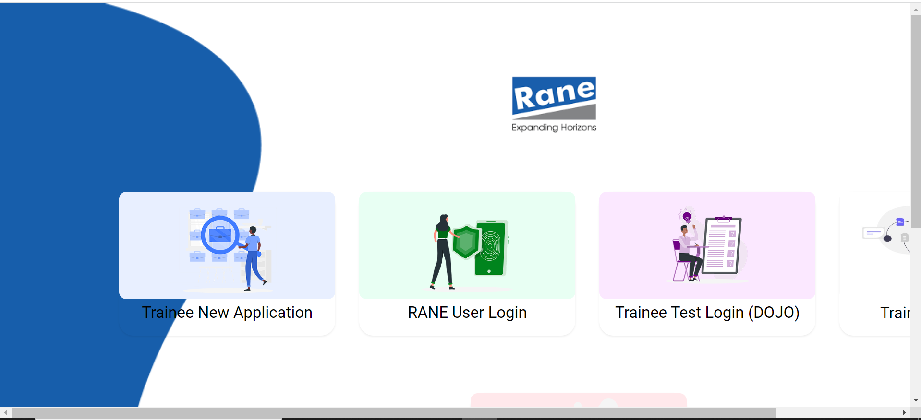

1. Trainee New Application
   1. Plant Code should be dependent LOV based on Company. - Closed
2. Same Mobile number should not be allowed (duplicate check is must) - - Closed
3. Basic Details;
   1. Title should be select value ( Mr / Miss / Mrs ) - - Closed
   2. Rane Logo – top Left corner -- Closed
   3. Adhaar Duplicate to be checked while entry itself - Closed
   4. Multiple values repeated like (Choose & Select ) for LOV-- Closed

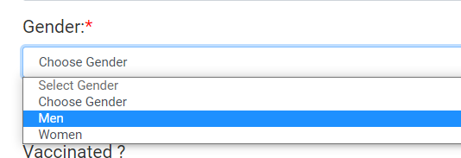

1. Save Button should be bigger- Closed
2. Bank Details;
   1. Account no should be varchar. -- Closed
   2. IFSC code should be varchar. -- Closed
   3. “Data Saved Successfully Message” missing while save each stage--- Closed
3. Education Details, Mandatory fields not validated while save --- Closed

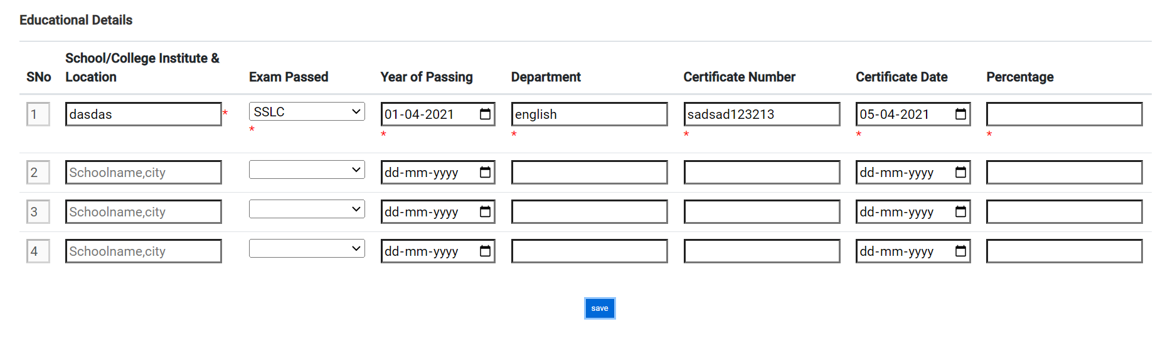

1. Previous Employment should be optional (Not mandatory) --- Closed
2. Application is submitted without verified all the mandatory records.
3. HR user :
   1. Validate all the mandatory doc sent for approval
      1. Mandatory check attachment are -- Closed
      2. Marksheet
      3. Aadhaar
      4. Photo
4. Cache to be handled / Refresh the page while submit
5. HR Manager – Rejection is not working.
6. Printout company name alignment to be corrected

**Test Date : 28.10.22**

1. <http://14.99.10.243:4200/trainee-application> - Pages size should be small. No scrolling. Closed
2. Data Allowing without company code & plant code. --- Closed

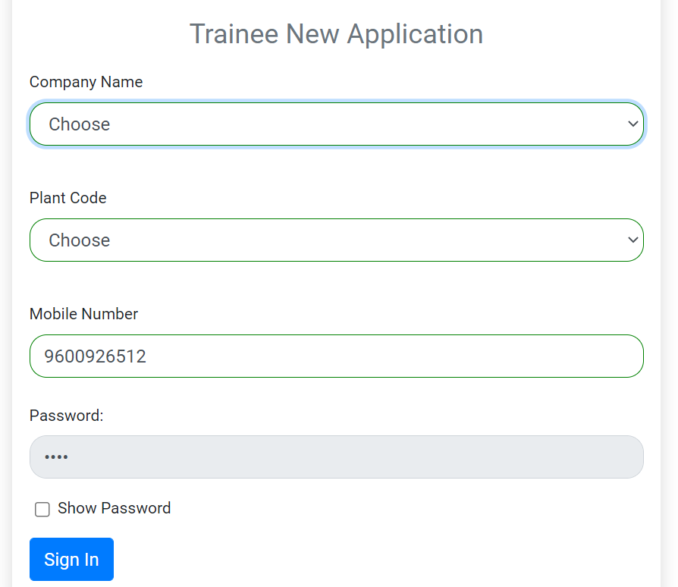

1. <http://14.99.10.243:4200/forms/9600926512> - Rane Logo should be left & Small in size.-Closed
2. Vaccinated Yes – Dose1 date not loading at first time, it is loading after select No>>Yes-Closed

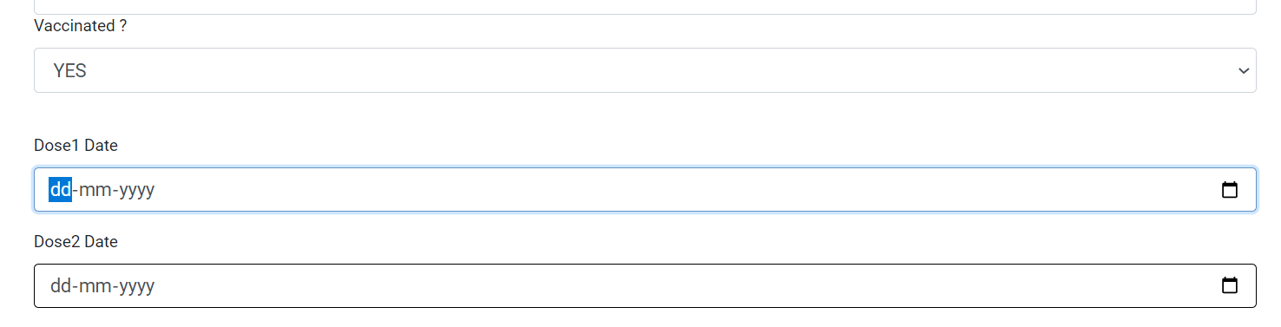

1. Load Physical Disability **No** as default. - -- Closed
2. After Entered the Pincode – City & State loading takes too much time. - -- Closed
3. Family Contact No 10 digit validation is must - -- Closed

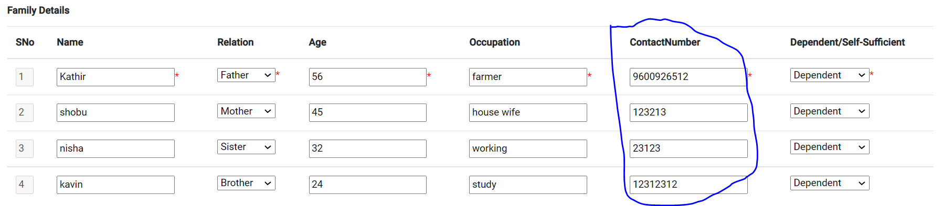

1. Submit button not visible in Trainee New Application--- Closed
2. Attachment - only allow ( PDF/JPEG/PNG) file formats. Other files should not be allowed. File size should be less than 2 MB only allowed. - -- Closed
3. Weight in Kg - -- Closed

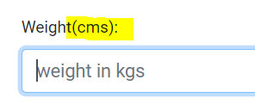

1. Name should be ( User Name (ID), Dept, Plant ) - -- Closed



1. Don’t Show Rane logo in all the pages.- -- Closed

**Test Date : 01.11.22**

1. Education Details Date picker year 4 digit validation-- Closed
2. HR Login-> application edit- font size should be bigger-- Closed
3. Add Company information above Basic details
   1. Application for
      1. Rane (Madras) Ltd, Velachery.
      2. Application Mobile no: xxxxxxxxxxxx
   2. Basic Details.
4. Attachment is not able to open. (Application & RML User login ) - Closed
5. Emergency Details not saved properly. – Closed
6. Rejected application not able to submit again. Status is not changed. - Open