Screens

We have the following screens in the program

1. Signup Screen : In this Screen user Signs in by giving his credentials , it appears as below , as in most of the cases user might or might not be a patient ,so the patient details need not be given here .the screen appear as follows

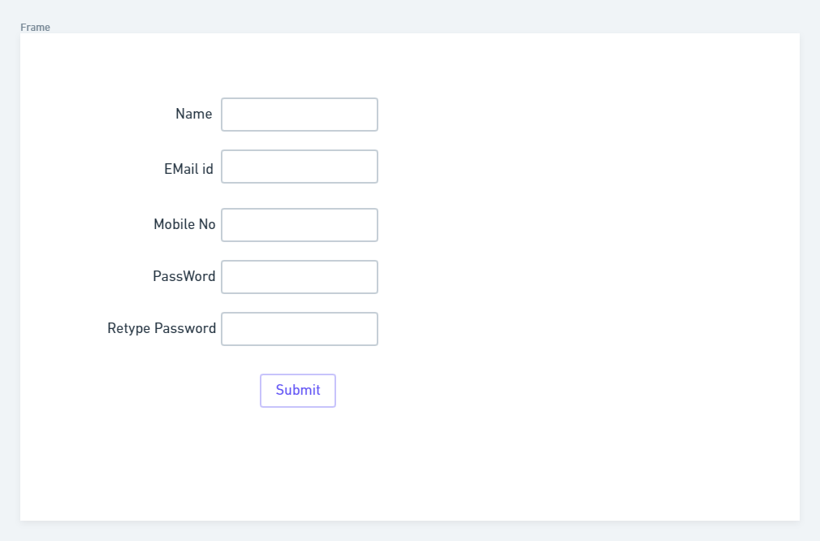

1. Sign in screen comes after the sign up screen where we have given an option to sign in through Facebook or Gmail and forgot password option too. If we click in forgot password it will take us to the new screen and from there we can get into Sign in Screen

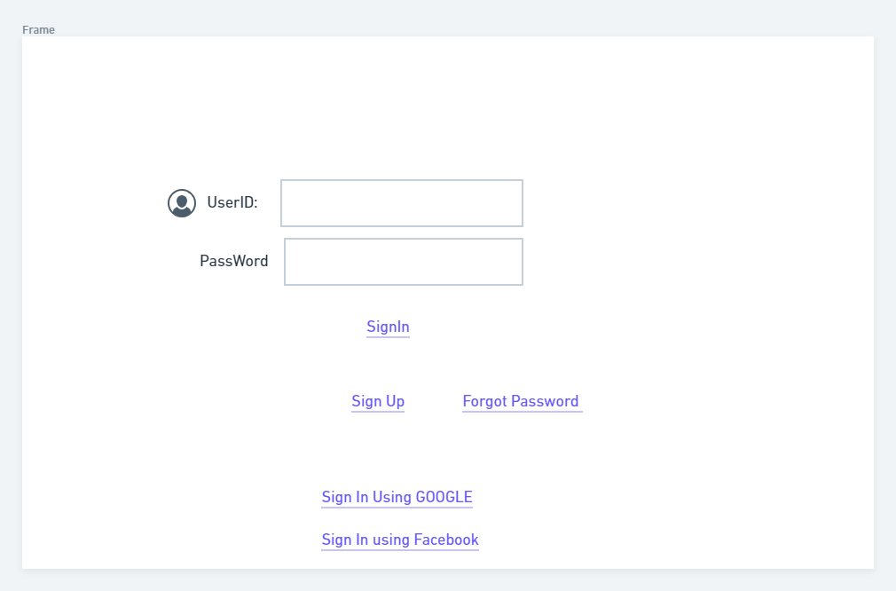

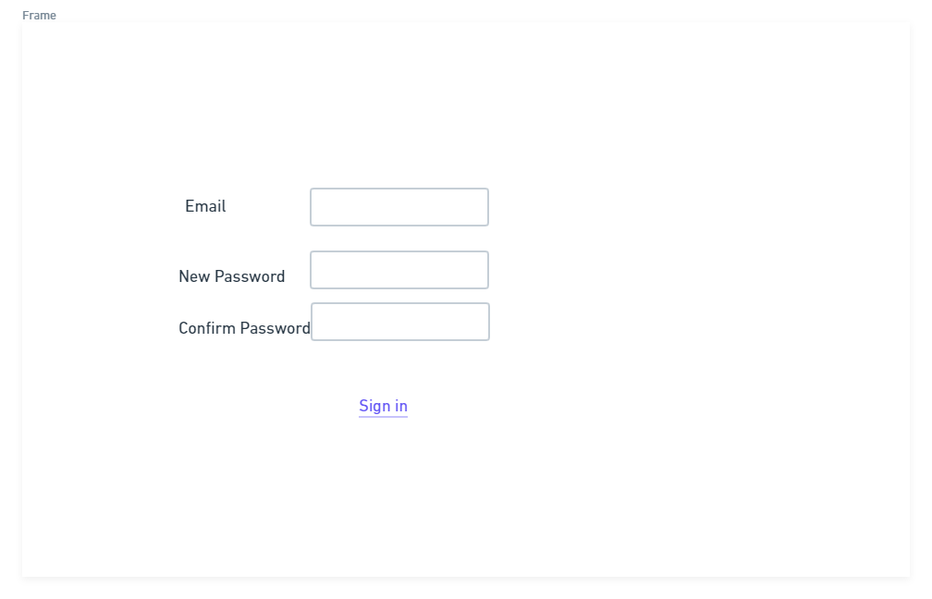

1. After Signing up or Signing in we go to the screen where we take the details about the Patient ,we ask even the comorbidities to know whether we have any dependencies and the age group(To know how the age effects in the bones ) and we would like to know about their way of work ( for research purpose) , we ask them to upload MRI Scan and give prediction option

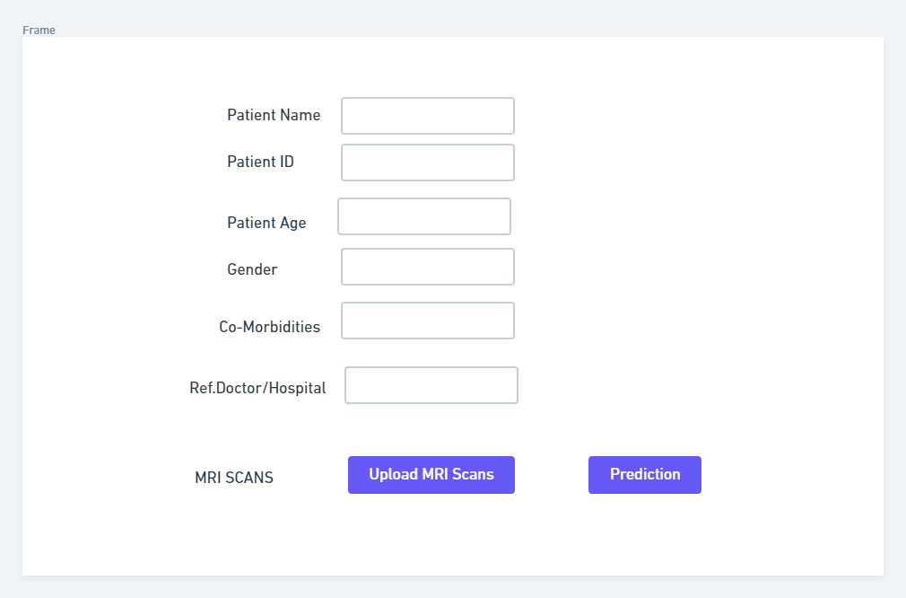

1. The moment user clicks on Prediction button , it takes the user to prediction screen where we tell the user whether the scan is abnormal by giving the word abnormality and since we have 3 types of abnormality we have given the user 3 drop down boxes like MCL,ACL, Tear

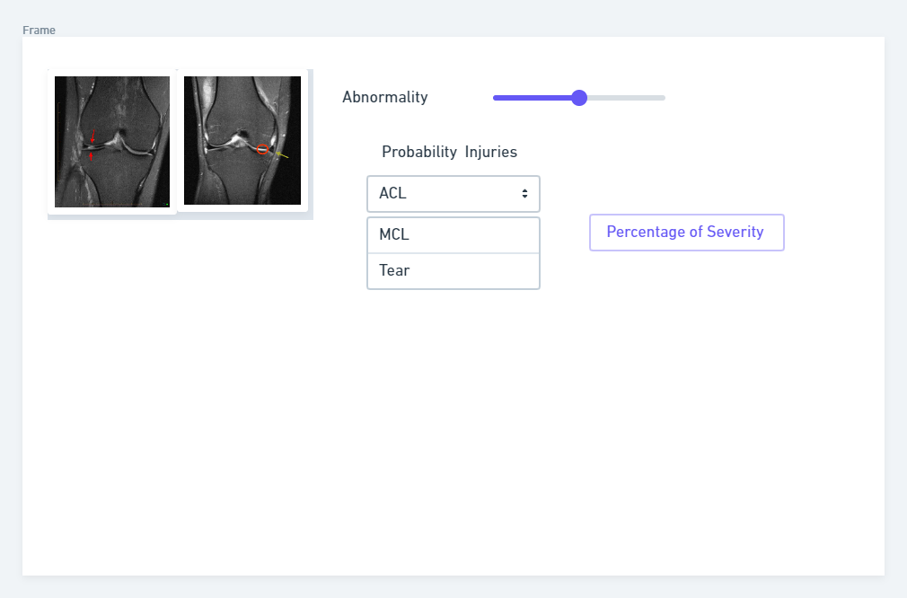

1. In case user wants to search his records then we have given option for search screen ,the screen contains name of Ref.Doctor , Modality , Accesion and the Modality

