Selina Narain DTSC 630 Homework 4

2023-03-31

## Question 1

**Generate the plot as follows using the mpg data frame, x is displ and y is hwy miles per gallon, with the color of the points from drv, and adding a smoother is included.**

library(ggplot2)  
head(mpg)

## # A tibble: 6 × 11  
## manufacturer model displ year cyl trans drv cty hwy fl class   
## <chr> <chr> <dbl> <int> <int> <chr> <chr> <int> <int> <chr> <chr>   
## 1 audi a4 1.8 1999 4 auto(l5) f 18 29 p compa…  
## 2 audi a4 1.8 1999 4 manual(m5) f 21 29 p compa…  
## 3 audi a4 2 2008 4 manual(m6) f 20 31 p compa…  
## 4 audi a4 2 2008 4 auto(av) f 21 30 p compa…  
## 5 audi a4 2.8 1999 6 auto(l5) f 16 26 p compa…  
## 6 audi a4 2.8 1999 6 manual(m5) f 18 26 p compa…

#ggplot(mpg, aes(x = displ, y = hwy)) + geom_point()  
  
#plot mpg data frame, x is displ, y is hwy, color drv, add smoother  
ggplot(data = mpg, mapping = aes(x = displ, y = hwy, color = drv)) +   
 geom_point() + #create scatterplot  
 geom_smooth(se = FALSE) #trend line over existing plot

## `geom_smooth()` using method = 'loess' and formula = 'y ~ x'

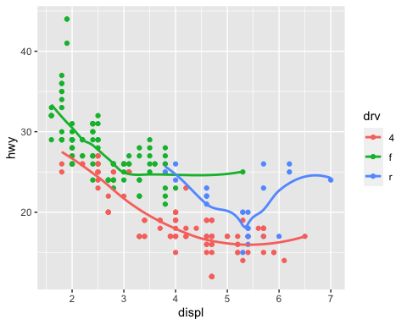

## Question 2

**Generate the plot as follows using the mpg data frame. (Hint: you might need to use coord flip(), labs() functions)**

#plot mpg data frame  
ggplot(data = mpg, mapping = aes(x = class, y = hwy)) +   
 geom_boxplot() +   
 coord_flip() + #flip x and y  
 #label graph  
 labs(title = "Highway MPG by car class",   
 subtitle = "1999-2008",   
 x = "Class",   
 y = "Highway MPG",   
 caption = "Source: http://fueleconomy.gov")

